Image Segmentation WIP document

Dataset Preparation

Install
- ffmpeg : to extract frames from the mp4 video.
  - mac : ‘brew install ffmpeg’
  - Windows : https://ffmpeg.org/download.html
- Supervisely :
  - Either download Webcatalog application and install supervisely within it.
  - Or working on Supervisely Web Interface
  - Note : Supervisely is a cloud application and stores projects,templates, dataset on servers. This allows for team collaboration.
- Google Drive App
  - Helps to locally mount the project GDrive and python code can easily read / write to it.
  - Once the folder is shared access it locally. E.g. for mac ‘/Users/username/Google Drive/My Drive/retina_segmentation’

Supervisely
- Create a new Project
- Define schema: classes, tags under (Definitions tab)
- Import Dataset (images) under (Data tab)
- Start annotating using polygons / masks (as decided)

Define Label Schema

- Classes
  - Forceps
  - Light tool
  - membrane
- Tags (phase of surgery)
- Surgery (only one for now)

Shape types
- Forceps & light tool as mask
- Membrane as mask

Exporting
- “Export as masks” in Supervisely gives the (following structure)
- With the Json files giving polygon coordinates + membrane bitmaps (if mask type)
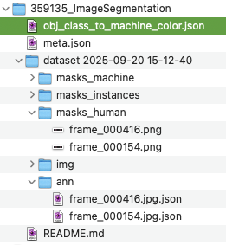

Single Channel Ground Truth image for training
Python generated in the pipeline to get a single channel image with different classes to form ground truth image (background=0, forceps=1, light=2, membrane=3), Or preferably Supervisely export.

Binary and Multi level masks

Steps (the pipeline for data prep)
Update
- extract images from video as below (below at 1fps, adjust to 2)
ffmpeg -i ./VIP/Epiretinal\ Membrane\ Peel\ -\ Edited\ \(Dr.\ Kozak\).mp4 -vf fps=1 -qscale:v 1 frames/frame_%06d.jpg

It generated 658 images for the movie length of 10.57

- Cropping/resizing: open question because the retina is not centred; camera movement complicates fixed cropping

- De-blur / de-duplication: Initial python utility drafted

- Augmentation: options include rotation/flip; could be done either inside Supervisely or in the preprocessing pipeline. Advise on the need for this?

- import all images into Supervisely and share the project (or identical templates) for distributed annotation: Split the work to prepare 100 - 200 images. Wait for other videos.

Annotated Images
Instruments are drawn as polygon shapes. The original image on left and annotated on right.
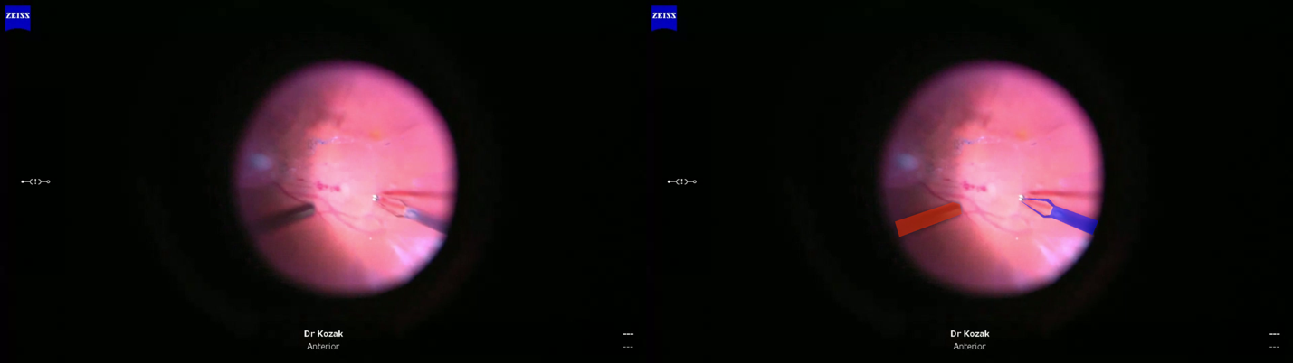

The single-channel greyscale mask: will serve as ground-truth for training. This corresponds to right image above.

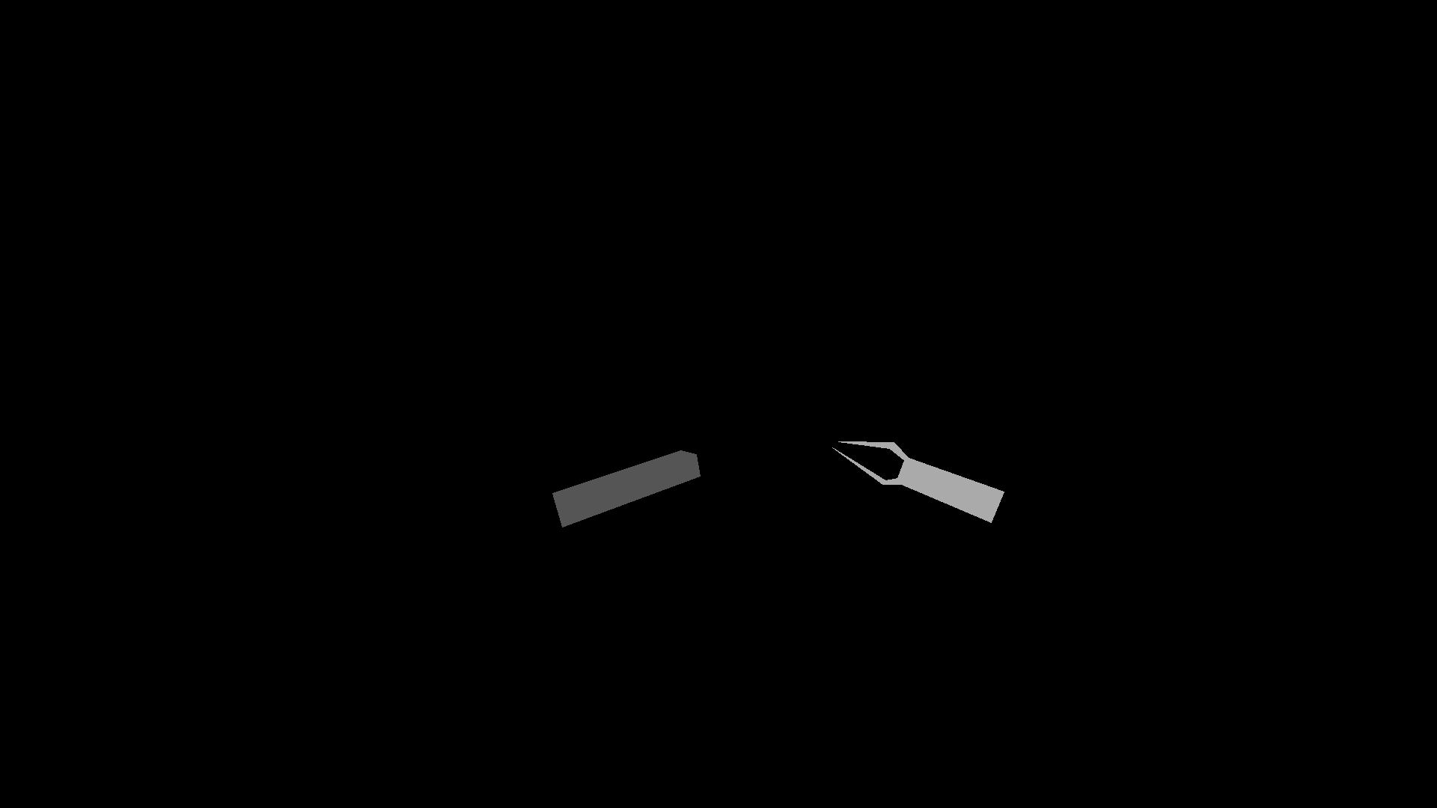

Dataset Log

Dataset Structure
Location in Google Drive

Videos

Training

Unet

TransUnet

MedSam

Results

References
- CholecTrack20: A Dataset for Multi-Class Multiple Tool Tracking in Laparoscopic Surgery
- A deep learning algorithm to detect chronic kidney disease from retinal photographs in community-based populations
- Association of retinal age gap with chronic kidney disease
- Deep learning algorithms to detect diabetic kidney disease from retinal photographs in multiethnic populations with diabetes
- Diagnosis of chronic kidney disease using retinal imaging and urine dipstick data
- Performance of deep learning for detection of chronic kidney disease from retinal fundus photographs: systematic review and meta-analysis
- Automated Detection of Retinal Detachment Using Deep Learning-Based Segmentation on Ocular Ultrasonography Images
- Interpretable detection of epiretinal membrane from optical coherence tomography with deep neural networks
- OphNet: A Large-Scale Video Benchmark for Ophthalmic Surgical Workflow Understanding

