🏗️ Project Architecture & File Structure
This project represents a Decoupled Architecture, splitting the application into a distinct Backend (FastAPI) and Frontend (Streamlit).
Why did we build it this way?
Previously, running complex Monte Carlo simulations with hundreds of thousands of synthetic child records inside Streamlit caused the web browser to freeze or crash. By moving the heavy mathematical computation to a dedicated FastAPI backend, the Streamlit UI remains lightning-fast, highly responsive, and capable of displaying loading bars while the server does the heavy lifting in the background.

📂 Directory Tree
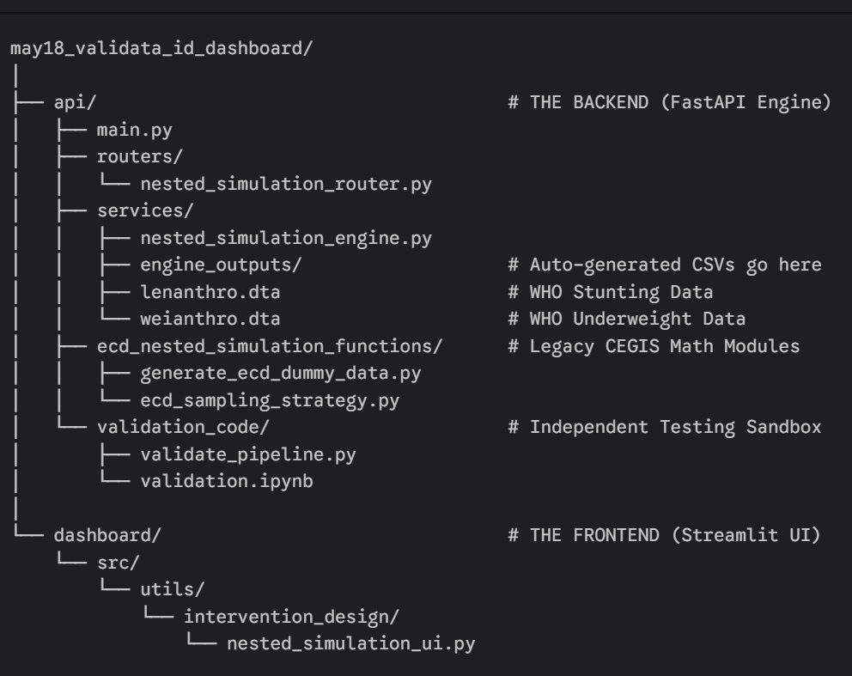
Plaintext

may18_validata_id_dashboard/
│
├── api/ # THE BACKEND (FastAPI Engine)
│ ├── main.py
│ ├── routers/
│ │ └── nested_simulation_router.py
│ ├── services/
│ │ ├── nested_simulation_engine.py
│ │ ├── engine_outputs/ # Auto-generated CSVs go here
│ │ ├── lenanthro.dta # WHO Stunting Data
│ │ └── weianthro.dta # WHO Underweight Data
│ ├── ecd_nested_simulation_functions/ # Legacy CEGIS Math Modules
│ │ ├── generate_ecd_dummy_data.py
│ │ └── ecd_sampling_strategy.py
│ └── validation_code/ # Independent Testing Sandbox
│ ├── validate_pipeline.py
│ └── validation.ipynb
│
└── dashboard/ # THE FRONTEND (Streamlit UI)
└── src/
└── utils/
└── intervention_design/
└── nested_simulation_ui.py

📁 1. The Backend Module (api/)
The api folder acts as the brain of the application. It receives parameters from the user, safely routes them, crunches the synthetic data, and saves the results.
- main.py
  - Purpose: The entry point for the FastAPI server.
  - Summary: It initializes the server, attaches the routers, configures CORS (so Streamlit can talk to it), and explicitly binds the application to Port 8005 to avoid ghost-server collisions with legacy CEGIS tools.
- routers/nested_simulation_router.py
  - Purpose: The "Traffic Cop" of the API.
  - Summary: Contains the HTTP endpoints (/start-nested-sim and /check-nested-sim). When Streamlit asks for data, this file assigns the request a unique task_id, pushes the heavy math to a "Background Task" (so the server doesn't freeze), and gives Streamlit a way to poll for status updates.
- services/nested_simulation_engine.py
  - Purpose: The Core Mathematical Engine.
  - Summary: This is the heavy lifter. It takes the parameters from the UI, feeds them into the legacy CEGIS Python modules, generates the synthetic children using the WHO .dta files, calculates the "God Mode" truth vs L1/L2 sampling strategies, and exports everything into readable CSVs inside engine_outputs/.
- ecd_nested_simulation_functions/
  - Purpose: The Legacy Math Library.
  - Summary: Contains the original, unaltered CEGIS statistical modeling code (generate_ecd_dummy_data.py, etc.). Keeping this in its own folder ensures the core statistical logic remains untouched and standardized.
📁 2. The Validation Module (api/validation_code/)
Because backend APIs operate as "black boxes" (where you can't easily see the math happening step-by-step), we built an isolated sandbox for the data scientists.
- validate_pipeline.py & validation.ipynb
  - Purpose: The Auditing Sandbox.
  - Summary: These files contain the exact math used by the API, but written linearly. They allow a data scientist or stakeholder to run the data generation cell-by-cell in Jupyter, inspecting the dataframe shapes and parameter logic manually without needing to spin up the web servers.
📁 3. The Frontend Module (dashboard/)
This folder mirrors the folder structure of the main CEGIS VALIData repository, allowing for seamless integration later.
- nested_simulation_ui.py
  - Purpose: The User Interface and Data Visualizer.
  - Summary: A Streamlit application that builds the interactive sidebars, sliders, and presets. It sends the user's choices to Port 8005. Once the backend finishes, this file dynamically generates the localized percentages and renders the Matplotlib/Seaborn visualization charts (Line Charts and Heatmaps) mirroring the exact design language of the core VALIData tool.

