**Wellness & Habit Tracker**

Project Report

Prepared by: Vaishnav

# Abstract

The Wellness & Habit Tracker is a personal productivity and health management system designed to help individuals build better habits, monitor wellness, and stay consistent with lifestyle goals. It allows users to create and track daily habits, log wellness metrics, receive reminders, and analyze progress.

# Introduction

Many individuals struggle with consistency in maintaining healthy habits and monitoring wellness. This project aims to provide a solution that helps users create, track, and analyze their daily habits, alongside monitoring wellness indicators such as water intake, sleep, and physical activity.

# System Requirements

Software Requirements: Python, FastAPI, MongoDB, Docker, Celery

Hardware Requirements: Minimum 4GB RAM, Dual-core processor, 10GB storage

# System Design

The system design consists of architecture, ER diagram, and workflow.

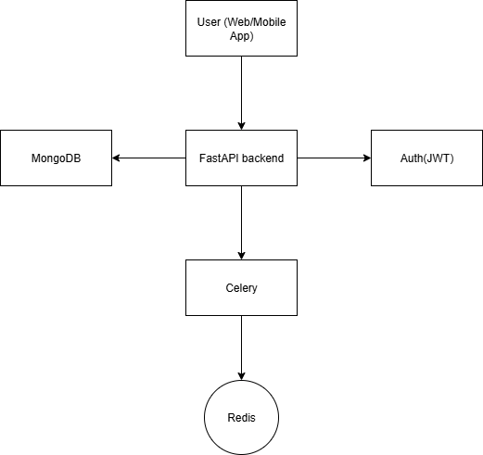System Architecture Diagram:

ER Diagram:

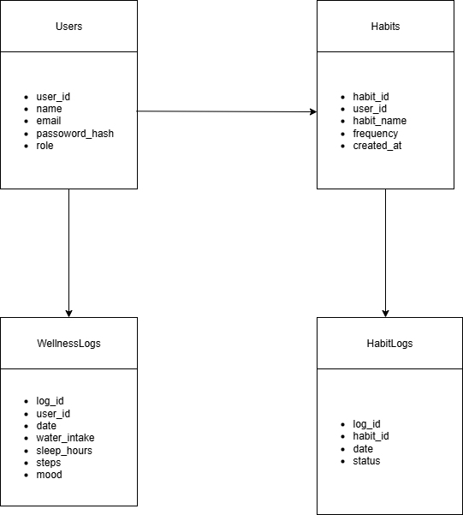

Workflow Diagram:

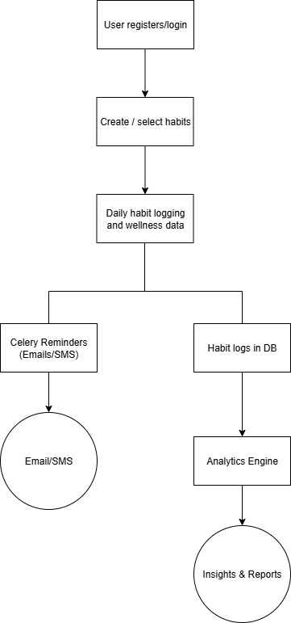

# Modules

* User & Role Management
* Habit Tracking Module
* Wellness Tracking Module
* Reminders & Notifications
* Analytics & Insights

# Technology Stack

Backend: Python (FastAPI)

Database: MongoDB

Authentication: JWT-based

Scheduling: Celery/Background tasks in FastAPI

Deployment: Docker + Cloud hosting

# Implementation

Example API: Create Habit

POST /habits  
Request: { 'name': 'Read 20 mins', 'frequency': 'daily' }  
Response: { 'status': 'success', 'habit_id': '12345' }

# Testing

Testing includes unit testing using Pytest, API testing via Postman, and integration testing of modules.

# Results / Example Use Case

Example: A user sets 3 habits (Drink 2L water, Walk 5,000 steps, Read 20 minutes). System tracks consistency and provides analytics (e.g., 85% walking consistency, correlation between exercise and sleep quality).

# Conclusion & Future Scope

The Wellness & Habit Tracker provides a holistic solution to improve productivity and health. Future scope includes integrating APIs like Fitbit/Google Fit, advanced analytics, and AI-powered habit recommendations.

# References

1. FastAPI Documentation - https://fastapi.tiangolo.com/

2. MongoDB Documentation - https://www.mongodb.com/docs/

3. Celery Documentation - https://docs.celeryq.dev/