MAVEN TOYS
Retail Sales & Inventory Performance Analysis
A Data Analytics Project

Student Name
Vaishnav Gopakumar
Degree Programme
BSc Data Science
Project Type
Data Analytics Project

Table of Contents
1. Executive Summary 3
2. Business Understanding 4
3. Dataset Description 5
4. Data Quality & Preparation 6
5. Feature Engineering 7
6. Sales Performance Analysis 8
7. Product Performance Analysis 10
8. Category Analysis 12
9. Store & Geographic Performance 13
10. Inventory Analysis 15
11. Profitability Analysis 17
12. Time / Seasonality Analysis 18
13. Answers to the Business Questions 19
14. Key Business Insights 21
15. Business Recommendations 23
16. Limitations 25
17. Conclusion 26

1. Executive Summary
Maven Toys is a toy retailer operating a network of 50 stores across 29 cities in Mexico. This project analyzes 829,262 individual sales transactions recorded between January 2022 and September 2023, together with product, store, and inventory reference data, to understand how the business has performed and where opportunities and risks exist.
Across the analysis period the business generated total revenue of $14,444,572.35 and total profit of $4,014,029.00, an overall profit margin of 27.79%, from 1,090,565 units sold across 35 products. Revenue and profit both trended upward over the two-and-a-half-year period, rising from a monthly low of $489,422.73 in August 2022 to a peak of $883,515.64 in March 2023, with December 2022 recorded as the strongest month for profit ($246,078.00).
The Toys category is the largest revenue generator ($5,093,241.00) but carries the lowest category profit margin (21.20%), while Electronics, despite generating less than half the revenue of Toys, produced the highest category profit margin (44.57%). At the product level, Colorbuds stands out as the single most profitable product ($834,944.00 in profit at a 53.37% margin) despite not being the top revenue earner, while Lego Bricks generates the most revenue ($2,388,882.63) but at a comparatively thin 12.50% margin. Store performance is led by Maven Toys Ciudad de Mexico 2, which outperforms every other location on both revenue and profit.
The inventory analysis identifies 226 store-product combinations (of 1,593 records) flagged for low inventory relative to sales, including several instances of fast-selling products such as Action Figure, Colorbuds, Dart Gun, Barrel O' Slime and Magic Sand recorded with very low stock on hand. These findings, together with detailed answers to all 27 business questions posed for this project, are presented in the sections that follow, along with data-driven recommendations for inventory planning, category strategy, and store-level performance management.

2. Business Understanding

2.1 Business Context
Maven Toys operates a chain of toy retail stores across multiple Mexican cities, selling products across five categories: Toys, Art & Crafts, Electronics, Games, and Sports & Outdoors. As with any multi-location retailer, management needs a clear, data-backed view of where revenue and profit are being generated, which products and stores are driving performance, and where inventory may be misaligned with actual demand.

2.2 Purpose of the Analysis
This project analyzes the company's sales, product, store, and inventory data to translate raw transaction records into actionable business insight. The goal is not simply to describe the dataset, but to answer specific, practical business questions about sales performance, product profitability, store performance, inventory risk, and seasonality.

2.3 Business Objectives
- Quantify overall sales and profit performance and how it has changed over time.
- Identify which products and categories drive the most revenue and profit.
- Identify which stores and locations are the strongest and weakest performers.
- Flag products where inventory levels appear misaligned with sales velocity.
- Translate the findings into concrete, evidence-based recommendations.

2.4 Key Questions
The analysis is structured around 27 specific business questions covering sales performance, product performance, store performance, inventory, profitability, and time-based seasonality. These are answered individually in Section 13, "Answers to the Business Questions."

3. Dataset Description
The analysis draws on a processed retail dataset covering Maven Toys' operations from January 1, 2022 through September 30, 2023 (21 months). The core table is a sales fact table, supplemented by product, store, and inventory reference data.

3.1 Tables Used
Table | Description | Records
sales_fact.csv | Transaction-level sales fact table: one row per sale, with store, product, date, revenue, cost, profit and profit margin | 829,262
product_performance.csv | Aggregated revenue, profit, units and margin by product | 35
category_performance.csv | Aggregated revenue, profit, units and margin by product category | 5
store_performance.csv | Aggregated revenue, profit, units and margin by store | 50
monthly_sales.csv | Aggregated revenue, profit and units by calendar month | 21
inventory_analysis.csv | Store-product level stock on hand, units sold, and sales velocity | 1,593
data_quality_audit.csv | Row counts, duplicate counts and missing-value counts by table, used to verify data cleanliness | 4

3.2 Important Columns
The sales fact table (sales_fact.csv) contains, among others, the following fields used throughout this analysis:
- date, year, month, month_name, year_month, quarter, day_of_week — time dimensions used for trend and seasonality analysis
- store_id, store_name, store_city, store_location, store_open_date — store dimensions
- product_id, product_name, product_category, product_cost, product_price — product dimensions
- units, revenue, cost, profit, profit_margin — the core transaction-level performance measures

3.3 Date Range and Relationships
The sales fact table spans 2022-01-01 to 2023-09-30. Each sales record links to a product (via product_id/product_name and product_category) and a store (via store_id/store_name, store_city and store_location), which is how category-, store-, and city-level aggregates in this report were produced. The inventory table links to the same product and store identifiers, allowing stock on hand to be compared against actual units sold for each store-product combination.

4. Data Quality & Preparation
A structured data-quality audit was run across the four core tables (sales, products, stores, inventory) prior to analysis, checking row counts, duplicate records, and missing values after cleaning. The results are summarized below.
Table | Initial Rows | Final Rows | Duplicates Removed | Missing Values After Cleaning
sales | 829,262 | 829,262 | 0 | 0
products | 35 | 35 | 0 | 0
stores | 50 | 50 | 0 | 0
inventory | 1,593 | 1,593 | 0 | 0

No duplicate records and no missing values were found in any of the four tables at the point of analysis, and no rows were removed during the audit. A column-level check of the sales fact table confirmed zero null values across all 23 fields (date, store, product, revenue, cost, profit, margin, and the associated time and category dimensions), and all numeric fields (units, revenue, cost, profit, profit_margin) were correctly typed as numeric rather than text.

4.1 Data Quality Summary
Issue Checked | Impact if Present | Treatment / Outcome
Duplicate transaction records | Would inflate revenue, profit and unit totals | None found — 0 duplicates removed across sales, products, stores and inventory
Missing values | Would bias aggregates or require row exclusion | None found — 0 missing values after cleaning in all four tables
Incorrect data types | Would prevent correct aggregation (e.g. revenue stored as text) | Verified — revenue, cost, profit, profit_margin and units are numeric
Zero stock-on-hand in inventory | Produces an undefined sales-velocity ratio (division by zero) | Retained as-is and treated separately as a stock-out risk rather than dropped

One item worth noting rather than 'fixing': a small number of store-product combinations in the inventory table have a stock_on_hand value of zero, which makes the sales_velocity (units sold ÷ stock on hand) mathematically undefined for that row. Rather than discard these rows, they were kept and treated separately in the inventory analysis (Section 11), since a stock level of zero next to non-zero historical unit sales is itself a meaningful signal of a potential stock-out.

5. Feature Engineering
The following calculated fields, present in the analysis, underpin every result in this report:
Field | Definition | Used For
Revenue | units × product_price, summed per transaction | All revenue-based rankings and totals
Cost | units × product_cost | Basis for profit calculation
Profit | Revenue − Cost | All profit-based rankings and totals
Profit Margin (%) | (Profit ÷ Revenue) × 100 | Comparing profitability independent of scale
Year / Month / Quarter | Extracted from the transaction date | Monthly and quarterly trend and seasonality analysis
Sales Velocity | units_sold ÷ stock_on_hand (inventory table) | Identifying fast-moving and low-inventory products

These fields were calculated in the EDA notebook (03_eda.ipynb) and validated against the pre-aggregated performance tables (product_performance.csv, category_performance.csv, store_performance.csv, monthly_sales.csv) supplied alongside the transaction-level sales_fact.csv.

6. Sales Performance Analysis

6.1 Total Revenue and Overall Scale
Across the full analysis period (January 2022 – September 2023), Maven Toys generated total revenue of $14,444,572.35 from 1,090,565 units sold, across 829,262 individual sales transactions, 35 products, and 50 stores.

6.2 Sales Trend Over Time
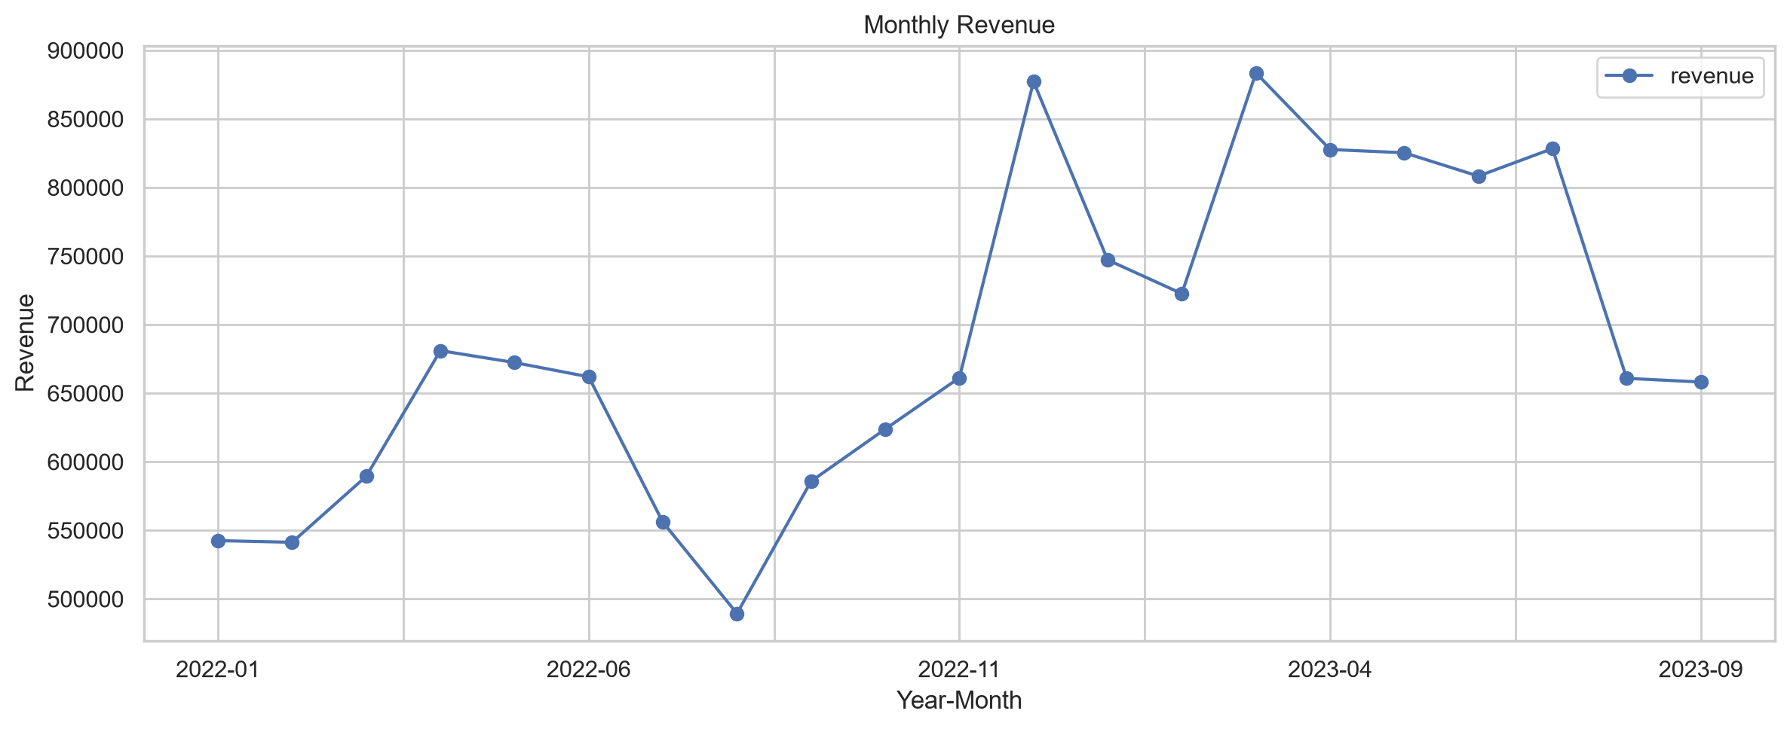
Figure 1. Monthly Revenue Trend (Jan 2022 – Sep 2023)
Monthly revenue shows a clear upward trend across the period, rising from roughly $540,000–$590,000 per month in the first quarter of 2022 to a range of $800,000–$880,000 per month for most of 2023. The trend is not perfectly smooth: there is a pronounced dip in mid-2022 (bottoming out in August 2022 at $489,422.73, the single lowest month in the dataset) followed by a sharp recovery into the final quarter of 2022, and a similar, smaller dip appears again in the second half of 2023.
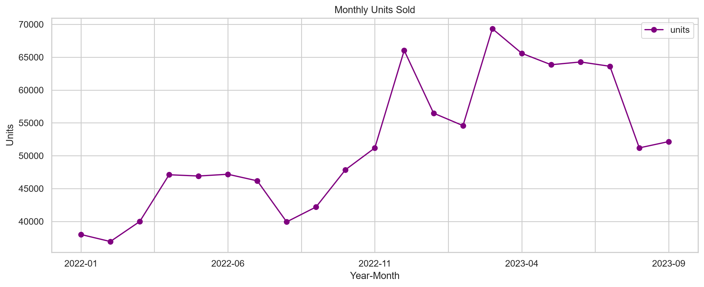
Figure 2. Monthly Units Sold (Jan 2022 – Sep 2023)
Units sold follow a very similar pattern to revenue, moving from roughly 37,000–40,000 units per month in early 2022 up to a peak of 69,336 units in March 2023, with the same mid-2022 dip and a comparable softening late in the series.

6.3 Best and Worst Performing Months
Rank | Month | Revenue | Profit | Units Sold
Best (1) | March 2023 | $883,515.64 | $231,909.00 | 69,336
Best (2) | December 2022 | $877,203.69 | $246,078.00 | 66,031
Best (3) | July 2023 | $828,348.86 | $209,807.00 | 63,614
Worst (1) | August 2022 | $489,422.73 | $158,931.00 | 39,927
Worst (2) | February 2022 | $541,351.65 | $161,861.00 | 36,935
Worst (3) | January 2022 | $542,554.91 | $167,126.00 | 38,009
Table 1. Best and Worst Performing Months by Revenue
March 2023 was the single highest-revenue month in the dataset, while December 2022 delivered the highest profit of any month ($246,078.00), even though its revenue was slightly below March 2023. August 2022 stands out as a clear low point across revenue, profit, and units simultaneously, and is examined further in Section 15, Seasonality.

6.4 Category Revenue Performance
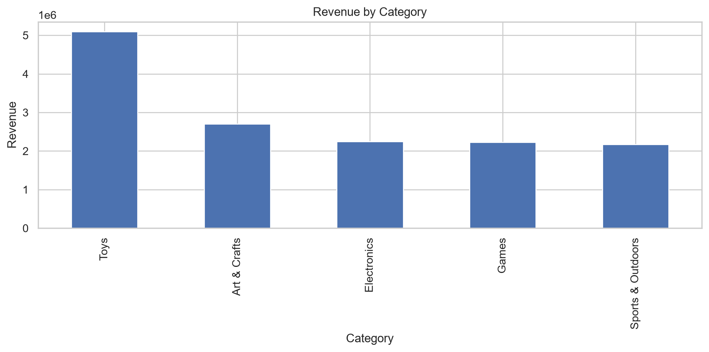
Figure 3. Revenue by Category
Toys is by a wide margin the largest revenue-generating category at $5,093,241.00, more than double the revenue of the second-placed category. Art & Crafts follows at $2,705,364.26, with Electronics ($2,246,771.25), Games ($2,226,836.27) and Sports & Outdoors ($2,172,359.57) clustered closely together behind it.

6.5 Units Sold
Total units sold across the period were 1,090,565. At the category level, Art & Crafts sold the most units (325,574) despite ranking second in revenue, reflecting its mix of lower-priced items, while Toys led on revenue (267,200 units) and Electronics sold the fewest units of any category (134,075) despite generating substantial revenue and the highest profit margin — evidence of a higher average selling price in that category.

7. Product Performance Analysis

7.1 Top Products by Revenue
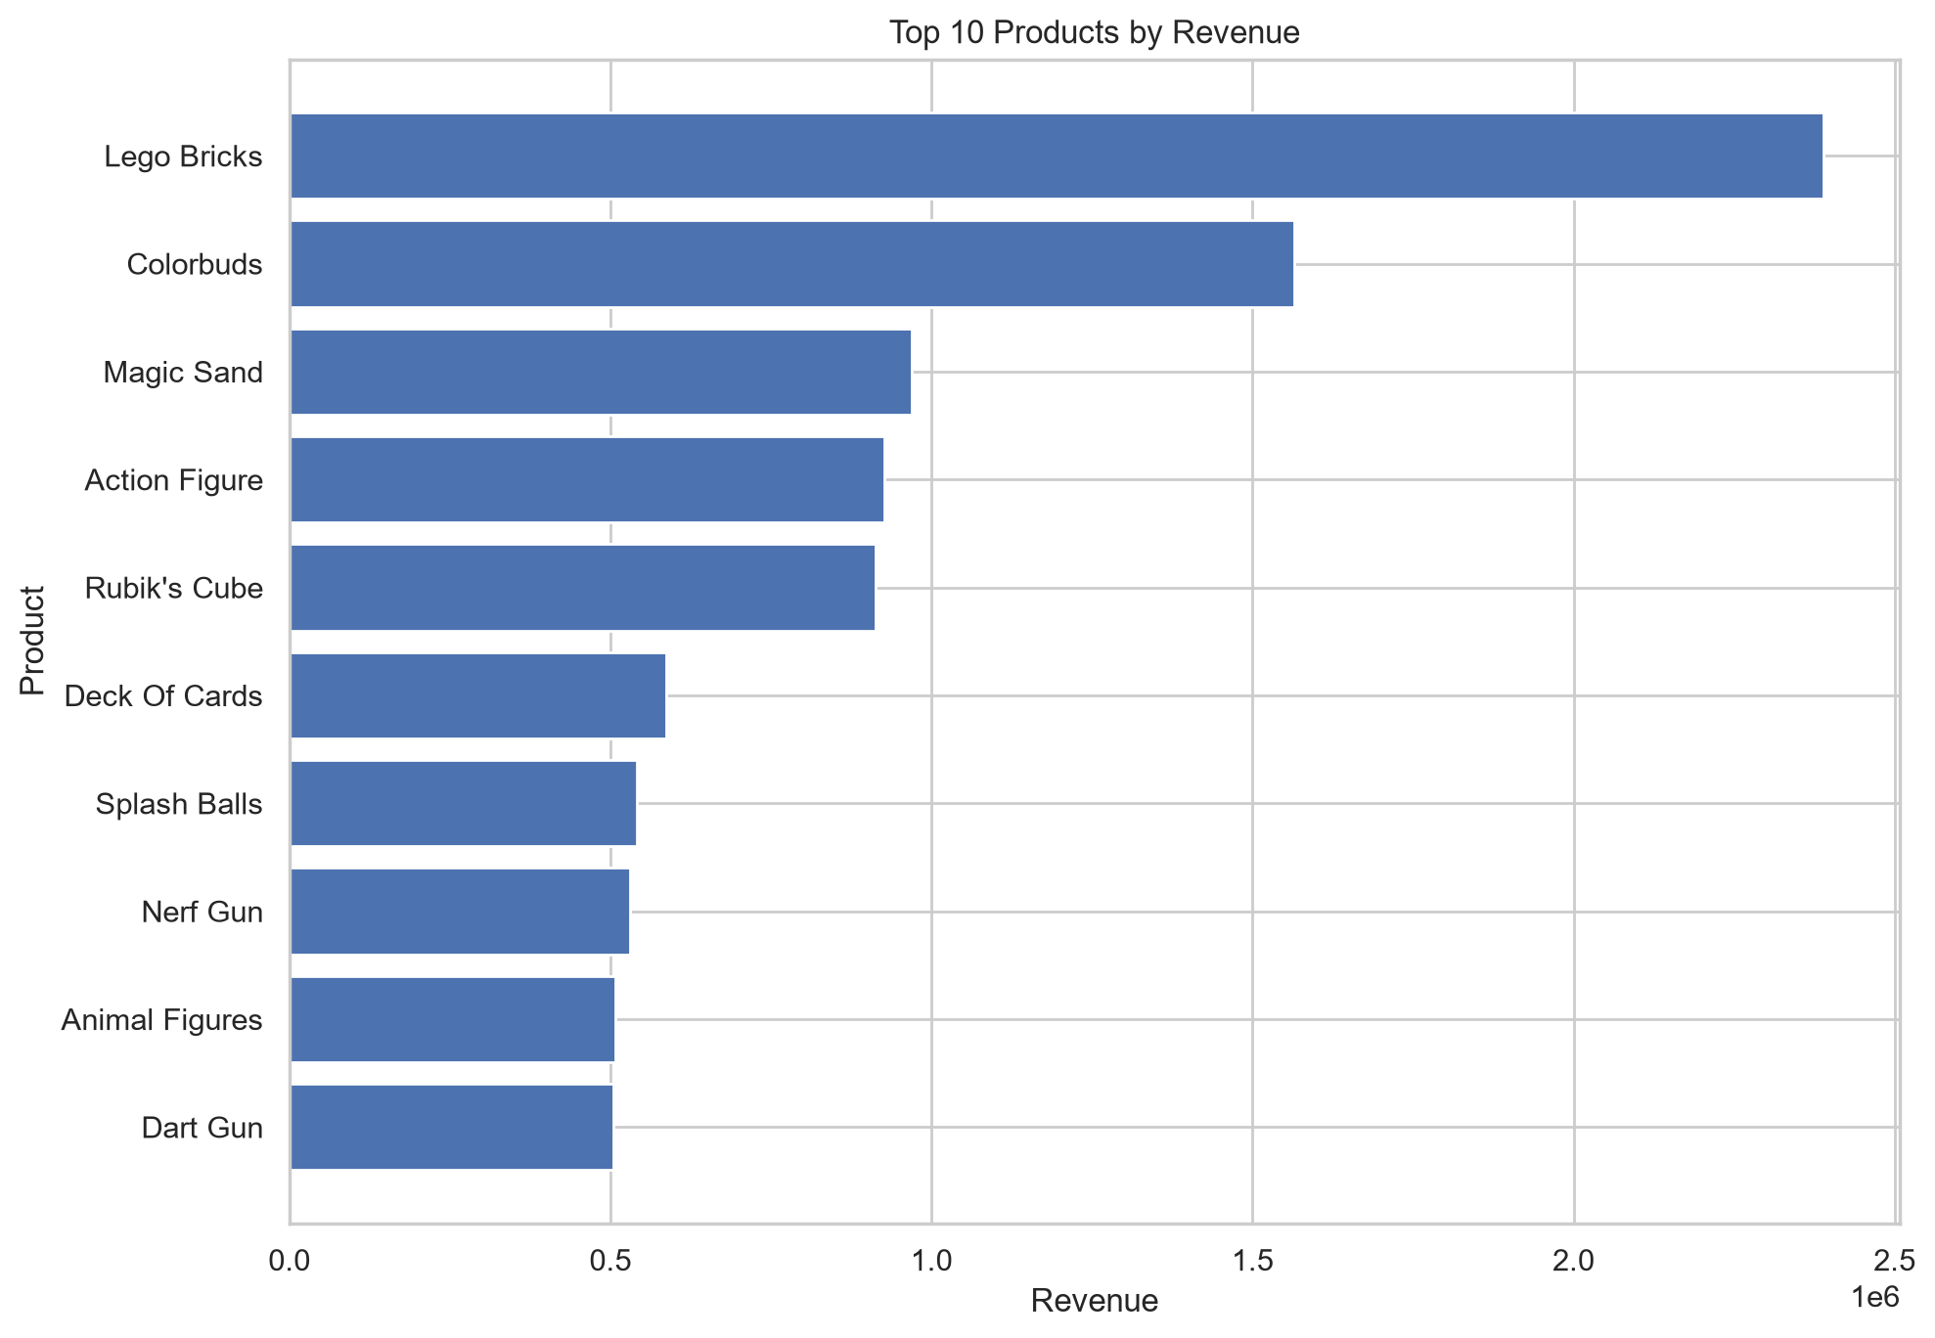
Figure 4. Top 10 Products by Revenue
Lego Bricks is the clear revenue leader at $2,388,882.63, well ahead of Colorbuds ($1,564,476.32) in second place. Magic Sand, Action Figure and Rubik's Cube round out the top five, each generating between roughly $0.9 million and $1.0 million in revenue.
Rank | Product | Revenue | Units Sold | Avg. Price
1 | Lego Bricks | $2,388,882.63 | 59,737 | $39.99
2 | Colorbuds | $1,564,476.32 | 104,368 | $14.99
3 | Magic Sand | $968,962.02 | 60,598 | $15.99
4 | Action Figure | $926,748.42 | 57,958 | $15.99
5 | Rubik's Cube | $912,983.28 | 45,672 | $19.99
Table 2. Top 5 Products by Revenue

7.2 Top Products by Profit
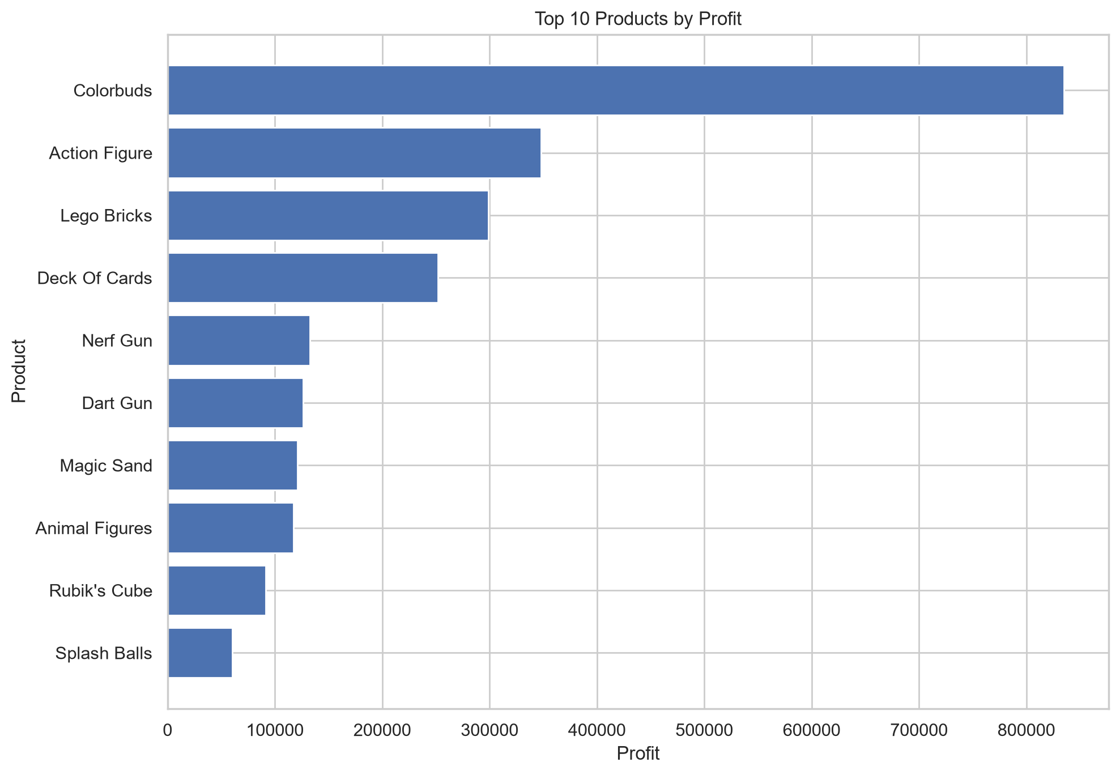
Figure 5. Top 10 Products by Profit
The profit ranking tells a different story from the revenue ranking. Colorbuds generates by far the highest profit of any product, $834,944.00, more than double the second-placed Action Figure ($347,748.00), even though Colorbuds ranks only second in revenue. Lego Bricks, the revenue leader, drops to third place in profit ($298,685.00) because of its comparatively low margin.

7.3 Products with the Highest Profit Margins
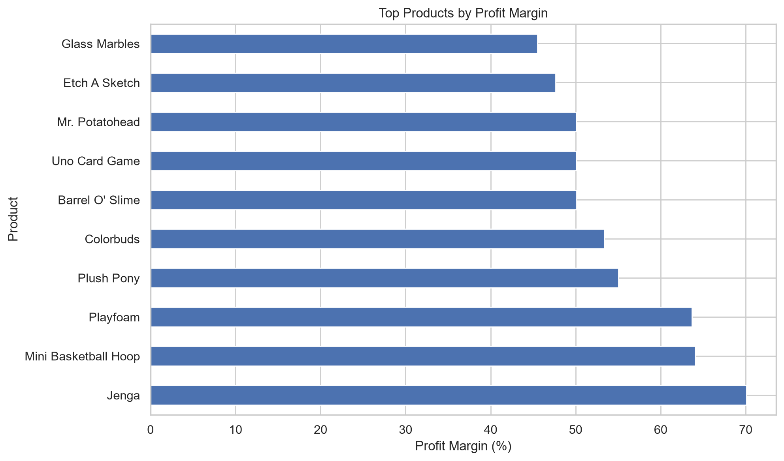
Figure 6. Top Products by Profit Margin
Jenga has the highest profit margin of any product at 70.07%, followed by Mini Basketball Hoop (64.03%) and Playfoam (63.69%). These are all comparatively low-revenue, low-volume products, illustrating that the highest-margin items are not the same as the highest-revenue or highest-profit items.

7.4 High Sales, Comparatively Low Profit
Several products combine strong revenue or unit sales with a relatively low profit margin. Lego Bricks is the most notable example: it is the top revenue-generating product ($2,388,882.63) but earns only a 12.50% margin, the second-lowest margin of any product with meaningful revenue. Magic Sand (revenue rank 3, 12.51% margin) and Rubik's Cube (revenue rank 5, 10.01% margin, the lowest margin in the dataset) show the same pattern. Splash Balls likewise sells well (60,248 units, $541,629.52 in revenue) at an 11.12% margin.

7.5 Weaker-Performing Products
At the other end of the scale, Uno Card Game ($21,652.90), Classic Dominoes ($44,665.29), Playfoam ($45,696.42) and Chutes & Ladders ($49,738.71) generated the least revenue of the 35 products, and Classic Dominoes ($8,942.00), Uno Card Game ($10,840.00) and Chutes & Ladders ($11,487.00) generated the least profit. Notably, Playfoam still carries a strong 63.69% margin despite low revenue, so it is weak on scale rather than on profitability; Classic Dominoes and Chutes & Ladders are comparatively weak on both scale and margin (20.02% and 23.09% respectively).

8. Category Analysis
Category | Revenue | Profit | Units Sold | Profit Margin
Toys | $5,093,241.00 | $1,079,527.00 | 267,200 | 21.20%
Art & Crafts | $2,705,364.26 | $753,354.00 | 325,574 | 27.85%
Electronics | $2,246,771.25 | $1,001,437.00 | 134,075 | 44.57%
Games | $2,226,836.27 | $673,993.00 | 194,673 | 30.27%
Sports & Outdoors | $2,172,359.57 | $505,718.00 | 169,043 | 23.28%
Table 3. Category Performance Summary
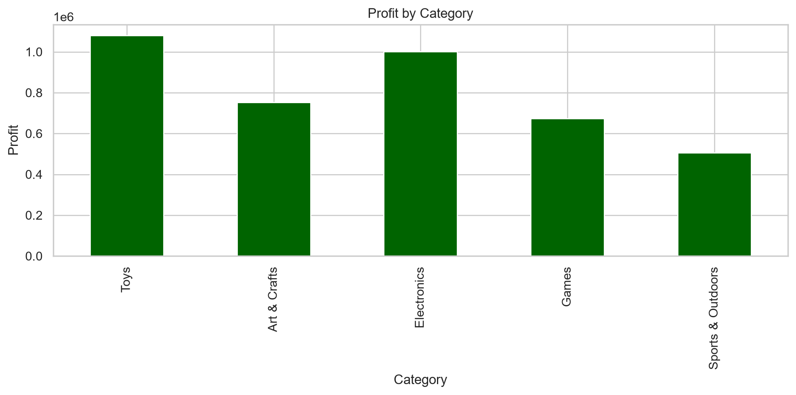
Figure 7. Profit by Category
Ranked by profit, the order changes from the revenue ranking: Toys leads narrowly ($1,079,527.00) but Electronics is close behind ($1,001,437.00) despite generating less than half of Toys' revenue, confirming Electronics as the most profitable category on a margin basis (44.57%). Art & Crafts ($753,354.00), Games ($673,993.00) and Sports & Outdoors ($505,718.00, the lowest of the five) follow.
Overall, Electronics is the standout category on profitability: it produces the highest profit margin (44.57%) and the second-highest total profit, from the second-lowest unit volume, indicating high-value items sold at healthy margins. Toys, by contrast, drives the business on scale — highest revenue, most units, and the highest absolute profit — but at the lowest margin of any category (21.20%), meaning its profit performance depends more on volume than on per-unit profitability.

9. Store & Geographic Performance

9.1 Top Stores by Revenue
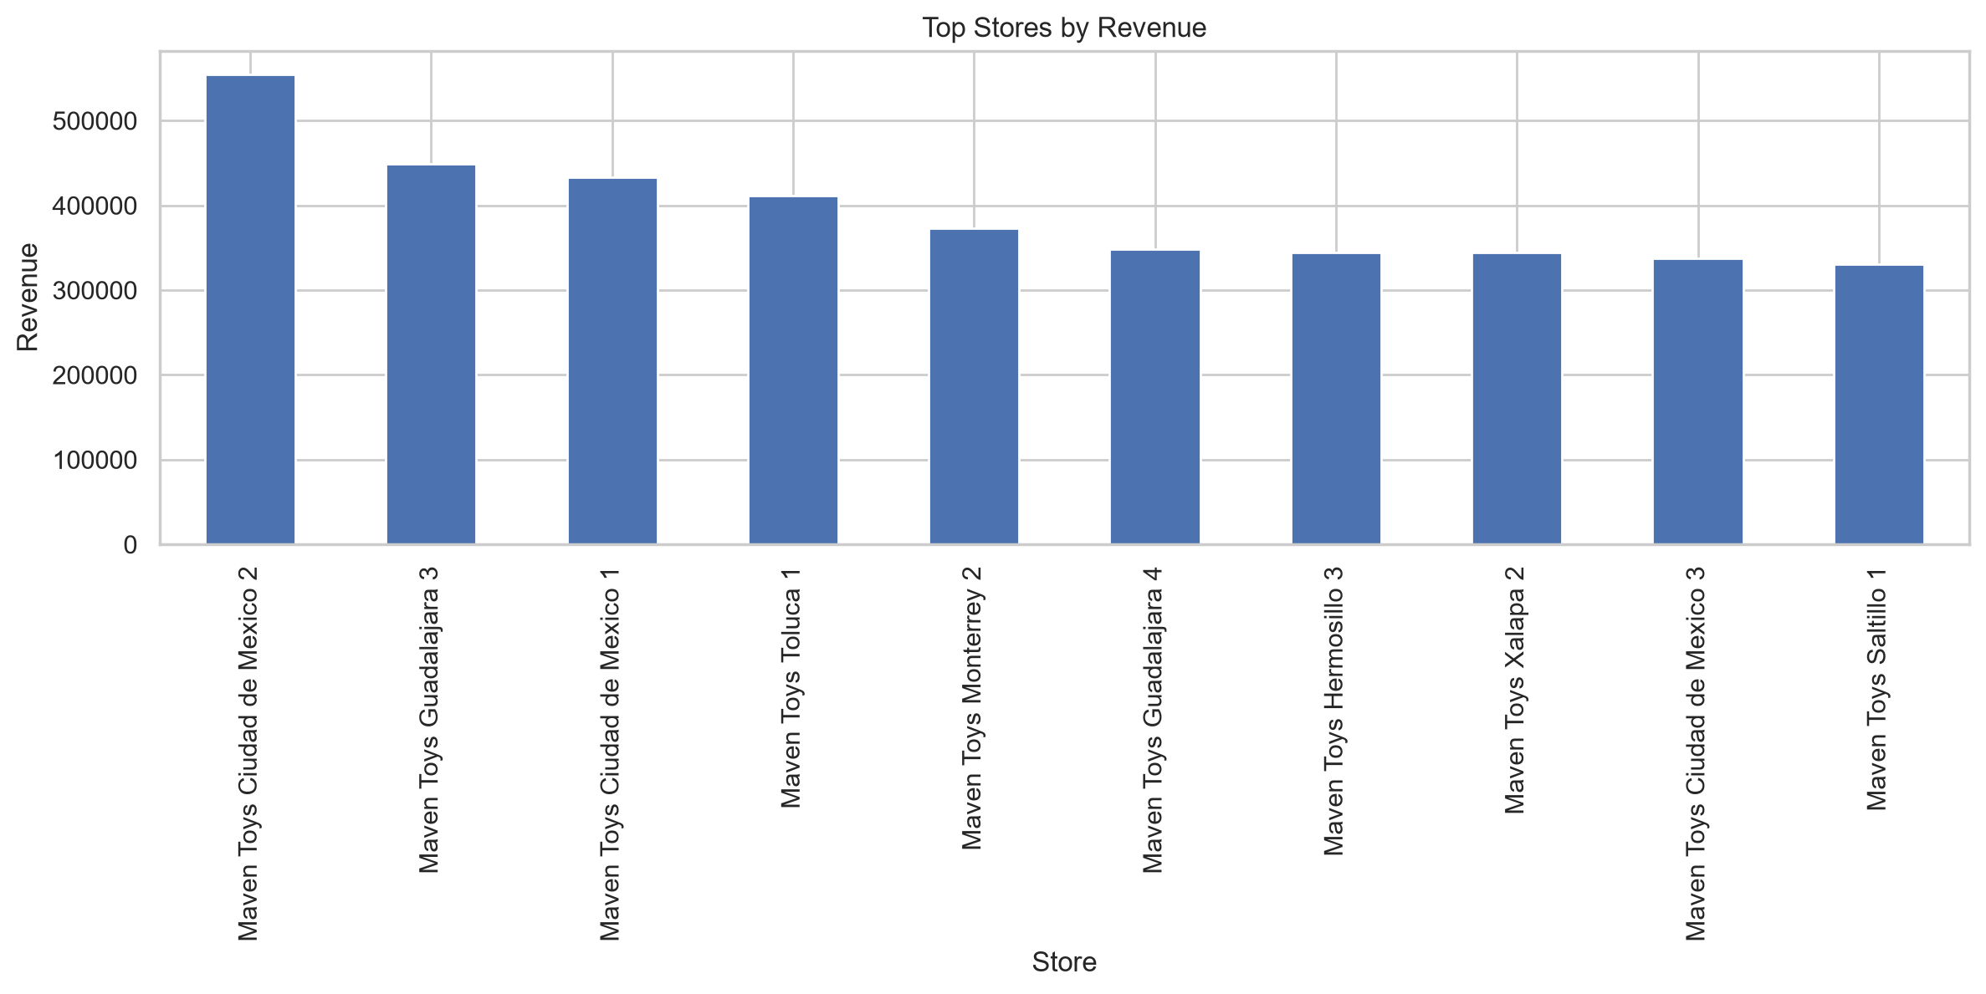
Figure 8. Top 10 Stores by Revenue
Maven Toys Ciudad de Mexico 2 is the clear leading store, generating $554,553.43 in revenue — over $100,000 ahead of the next-closest store. Maven Toys Guadalajara 3 ($449,354.91) and Maven Toys Ciudad de Mexico 1 ($433,556.21) round out the top three.

9.2 Top Stores by Profit
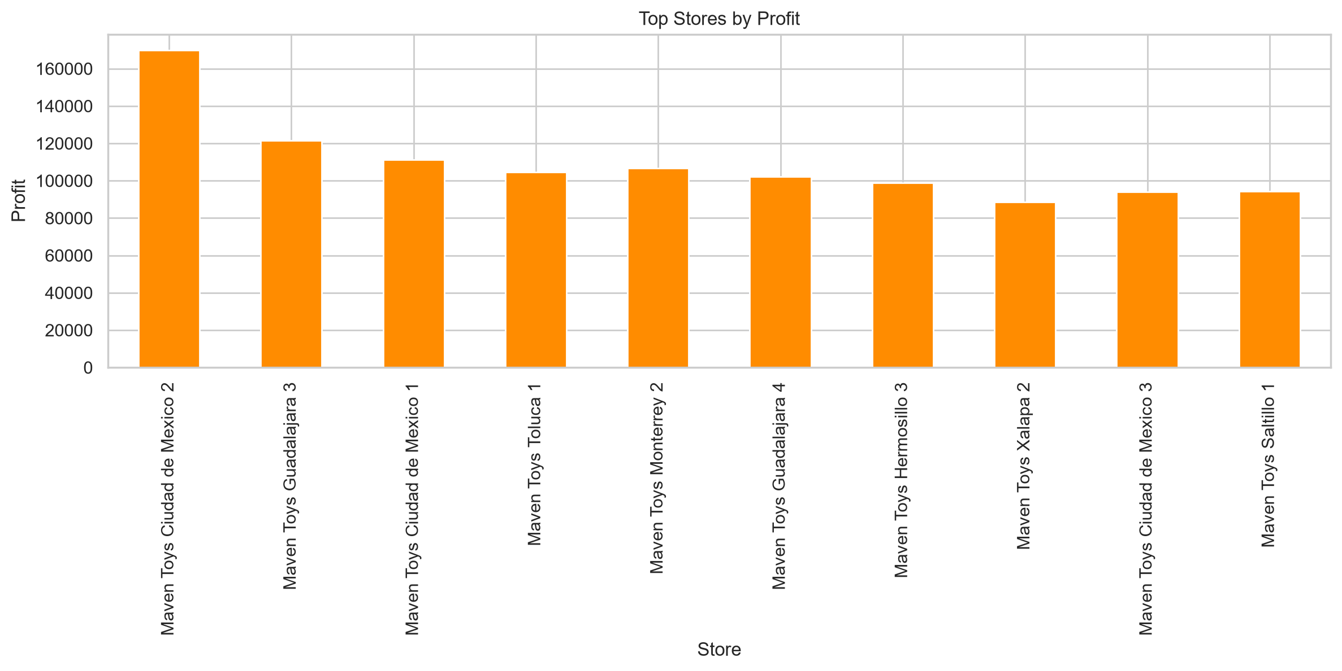
Figure 9. Top 10 Stores by Profit
The profit ranking closely mirrors the revenue ranking for the top stores. Maven Toys Ciudad de Mexico 2 again leads with $169,856.00 in profit, followed by Guadalajara 3 ($121,571.00) and Ciudad de Mexico 1 ($111,296.00).
Rank | Store | Revenue | Profit | Profit Margin
1 | Maven Toys Ciudad de Mexico 2 | $554,553.43 | $169,856.00 | 30.63%
2 | Maven Toys Guadalajara 3 | $449,354.91 | $121,571.00 | 27.05%
3 | Maven Toys Ciudad de Mexico 1 | $433,556.21 | $111,296.00 | 25.67%
4 | Maven Toys Monterrey 2 | $372,998.82 | $106,783.00 | 28.63%
5 | Maven Toys Toluca 1 | $411,157.32 | $104,612.00 | 25.44%
Table 4. Top 5 Stores by Profit

9.3 Geographic / City-Level Performance
Aggregating sales up to the 29 cities in which Maven Toys operates, Ciudad de Mexico is the top-performing city overall, with $1,649,492.01 in revenue and $465,558.00 in profit across its stores, followed by Guadalajara ($1,322,099.46 revenue, $368,930.00 profit) and Monterrey ($1,261,845.70 revenue, $346,729.00 profit). These three cities together account for a substantial share of total company revenue, consistent with them being the locations with the most Maven Toys stores in the dataset.

9.4 Weaker-Performing Stores
At the other end of the scale, Maven Toys Campeche 2 ($206,055.23 revenue, $58,091.00 profit), Maven Toys La Paz 1 ($210,897.83 revenue, $57,407.00 profit) and Maven Toys Cuernavaca 1 ($221,587.26 revenue, $56,811.00 profit) recorded the lowest revenue among the 50 stores; Cuernavaca 1 also recorded the lowest profit of any store. On average, a Maven Toys store generates approximately $288,891 in revenue, so these locations sit meaningfully below the network average, though none of them show a profit margin outside the broad 25%–29% band seen across most of the store network — their weakness is one of scale (lower footfall or smaller catchment) rather than an unusually poor margin.

10. Inventory Analysis
Inventory was analyzed at the store-product level using stock_on_hand (units currently in stock at that store) against units_sold and a calculated sales_velocity ratio (units sold ÷ stock on hand), across all 1,593 store-product inventory records.

10.1 Inventory Risk Overview
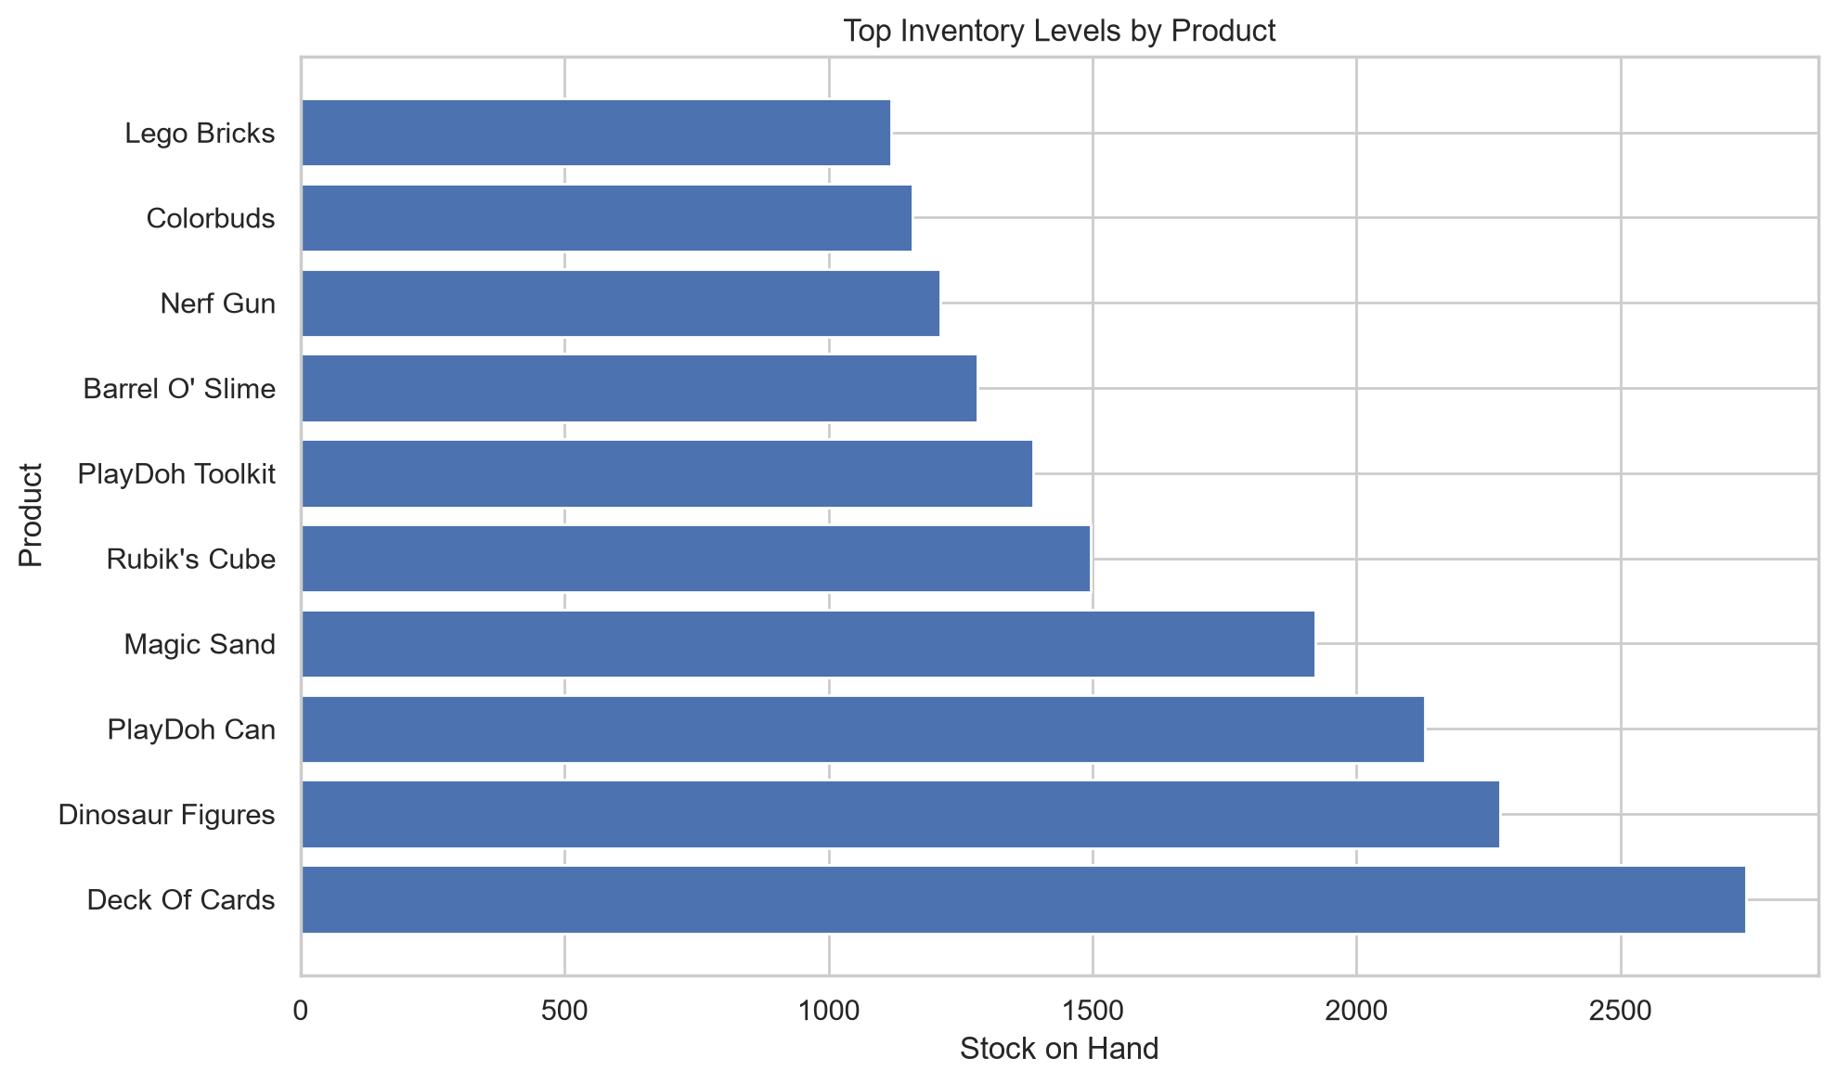
Figure 10. Inventory Risk — Top Inventory Levels by Product
This chart shows the highest aggregate stock-on-hand levels by product (summed across stores). Deck Of Cards (2,738 units), Dinosaur Figures (2,272) and PlayDoh Can (2,129) carry the largest total inventory holdings of any products in the dataset.
Of the 1,593 store-product inventory records, 226 (about 14.2%) are explicitly flagged in the data as low_inventory_flag = True, indicating stock on hand that is relatively low set against that product's sales history.

10.2 Fast-Moving Products with Relatively Low Inventory
The available analysis shows several store-product combinations with very high sales velocity alongside very low stock on hand. The single highest sales-velocity record in the dataset is Action Figure at one store, with only 1 unit on hand against 57,958 total units historically sold for that product (velocity of 57,958). Colorbuds shows the same pattern at two separate stores (2 and 3 units on hand respectively), as does Dart Gun (1 unit on hand), and Barrel O' Slime, Magic Sand and Lego Bricks each appear multiple times with only 2–3 units on hand relative to tens of thousands of units sold historically. These products require inventory attention, since a very small stock buffer against consistently high historical demand raises the risk of running out of stock.

10.3 Products That May Require Inventory Attention
A small number of inventory records show stock_on_hand of exactly 0 alongside substantial historical unit sales — for example, individual store records for Barrel O' Slime, Splash Balls, and Action Figure with 0 units on hand and thousands of units sold historically at that location. Because sales velocity cannot be computed when stock on hand is zero, these records are not captured by a simple velocity ranking, but they represent the inventory positions with the highest apparent risk in the dataset and are flagged accordingly (low_inventory_flag = True).

10.4 Relatively High Inventory Against Weaker Sales
At the other extreme, some store-product records show comparatively high stock on hand against modest historical unit sales, producing a low sales-velocity ratio — for instance, individual records for Uno Card Game, Mini Basketball Hoop, Playfoam, and Plush Pony, each showing stock levels of roughly 15–48 units against sales-velocity figures well under 200. These are consistent with the same products' relatively low total revenue and unit sales identified in Section 7.5, suggesting inventory at these locations is comparatively well-supplied, or even overstocked, relative to actual demand.

11. Profitability Analysis

11.1 Overall Profitability
Total profit across the analysis period was $4,014,029.00 on total revenue of $14,444,572.35, giving an overall profit margin of 27.79%. This means that, on average, roughly 28 cents of every dollar in sales was retained as profit after accounting for product cost.

11.2 Category Profitability
As shown in Section 8, Electronics is the most profitable category by margin (44.57%), followed by Games (30.27%), Art & Crafts (27.85%), Sports & Outdoors (23.28%) and Toys (21.20%, the lowest of the five). In absolute profit terms, Toys ($1,079,527.00) narrowly leads Electronics ($1,001,437.00), because its much larger revenue base offsets its lower margin.

11.3 Product-Level Margin Strength
As detailed in Section 7.3, Jenga (70.07%), Mini Basketball Hoop (64.03%), Playfoam (63.69%), Plush Pony (55.03%) and Colorbuds (53.37%) are the five highest-margin products. Colorbuds is the only one of these five that also ranks among the highest-revenue products, which is why it dominates the profit ranking in Section 7.2.

11.4 High Revenue, Comparatively Low Margin
The clearest examples of high revenue paired with comparatively low margin are Lego Bricks (revenue rank 1, 12.50% margin), Magic Sand (revenue rank 3, 12.51% margin) and Rubik's Cube (revenue rank 5, 10.01% margin, the lowest margin of any product in the dataset). Together these three products alone account for over $4.27 million in revenue but a comparatively modest combined profit of roughly $511,000, underscoring the difference between a revenue-driven product and a profit-driven one.

12. Time / Seasonality Analysis
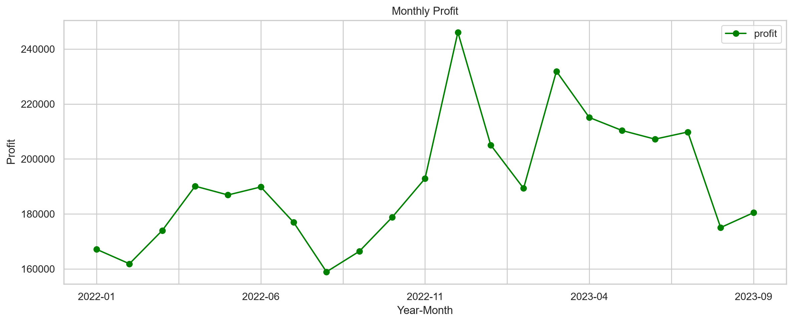
Figure 11. Monthly Profit Trend (Jan 2022 – Sep 2023)
Monthly profit broadly tracks the revenue trend shown in Figure 1, with two sharp peaks — November-to-December 2022 (profit rising to $246,078.00 in December) and February-to-March 2023 (rising to $231,909.00 in March) — each followed by a pull-back the following month. A similarly sharp dip occurs in August 2022, the lowest-profit month in the dataset ($158,931.00).

12.1 Seasonal Patterns
The clearest seasonal pattern in the data is a year-end effect: revenue, profit and units all rise sharply into November and December, consistent with holiday-season toy buying, before a sales pull-back in the following one to two months. A second, smaller rise appears around March of both years. Conversely, mid-year months — July/August 2022 in particular — show the weakest performance of their respective years.

12.2 Highest-Revenue and Highest-Profit Periods
At the quarterly level, revenue rose in every quarter from 2022 Q3 ($1,631,301.00) through 2023 Q2 ($2,461,309.81, the highest-revenue quarter in the dataset), before easing slightly in 2023 Q3 ($2,147,420.41). Profit followed the same broad pattern, peaking in 2023 Q2 at $632,655.00. At the individual month level, March 2023 was the single highest-revenue month ($883,515.64) and December 2022 the single highest-profit month ($246,078.00), as detailed in Section 6.3.

13. Answers to the Business Questions
This section answers all 27 business questions posed for the project directly, with supporting evidence referenced from the tables and figures above.
Business Question | Answer | Supporting Evidence
1. How much revenue did the business generate? | Total revenue of $14,444,572.35 across the analysis period (Jan 2022–Sep 2023). | Section 6.1
2. How did sales change over time? | Revenue and units rose overall from early 2022 to mid-2023, with a mid-2022 dip (low in Aug 2022) and a late-2023 softening. | Figures 1–2
3. Which months performed best and worst? | Best: March 2023 ($883,515.64 revenue); worst: August 2022 ($489,422.73 revenue). Best profit month: December 2022 ($246,078.00). | Table 1
4. Which product categories generated the most revenue? | Toys generated the most revenue ($5,093,241.00), more than double the next category. | Fig. 3, Table 3
5. Which products sold the most units? | Colorbuds sold the most units of any single product (104,368 units). | Table 2, product_performance.csv
6. Which products generated the most revenue? | Lego Bricks generated the highest revenue of $2,388,882.63. | Fig. 4, Table 2
7. Which products generated the most profit? | Colorbuds generated the highest profit of $834,944.00. | Fig. 5
8. Which products had the highest profit margins? | Jenga had the highest profit margin at 70.07%. | Fig. 6
9. Are there products with high sales but relatively low profit? | Yes — Lego Bricks (12.50% margin), Magic Sand (12.51%) and Rubik's Cube (10.01%) combine high revenue with low margins. | Section 7.4
10. Which products had weaker performance? | Uno Card Game ($21,652.90 revenue) and Classic Dominoes ($8,942.00 profit) were the weakest on revenue and profit respectively. | Section 7.5
11. Which stores generated the most revenue? | Maven Toys Ciudad de Mexico 2 ($554,553.43). | Fig. 8, Table 4
12. Which stores generated the most profit? | Maven Toys Ciudad de Mexico 2 ($169,856.00). | Fig. 9, Table 4
13. Which locations/cities performed best? | Ciudad de Mexico ($1,649,492.01 revenue, $465,558.00 profit), followed by Guadalajara and Monterrey. | Section 9.3
14. How did store performance differ? | Revenue ranged from $206,055.23 to $554,553.43 across the 50 stores (network average ≈ $288,891), a roughly 2.7x spread. | Section 9.4, store_performance.csv
15. Which stores showed weaker performance? | Maven Toys Campeche 2, La Paz 1, and Cuernavaca 1 had the lowest revenue; Cuernavaca 1 had the lowest profit. | Section 9.4
16. Which products had high sales but relatively low inventory? | Action Figure, Colorbuds, Dart Gun, Barrel O' Slime and Magic Sand each appear with only 1–3 units on hand at individual stores against tens of thousands of historical units sold. | Section 10.2
17. Which products appeared to be fast-moving? | The same products above show the highest sales-velocity ratios in the dataset (e.g. Action Figure at 57,958). | Section 10.2, inventory_analysis.csv
18. Which products may require inventory attention? | 226 of 1,593 store-product records (14.2%) are flagged low_inventory_flag = True, including several with 0 units on hand. | Section 10.1, 10.3
19. Were there products with relatively high inventory but weak sales? | Yes — records for Uno Card Game, Mini Basketball Hoop, Playfoam and Plush Pony show comparatively high stock against low sales velocity. | Section 10.4
20. What was the overall profit? | $4,014,029.00. | Section 11.1
21. What was the overall profit margin? | 27.79%. | Section 11.1
22. Which categories were most profitable? | Electronics had the highest margin (44.57%); Toys had the highest absolute profit ($1,079,527.00). | Table 3
23. Which products had the strongest margins? | Jenga (70.07%), Mini Basketball Hoop (64.03%) and Playfoam (63.69%). | Fig. 6
24. Which products generated high revenue but comparatively low margins? | Lego Bricks, Magic Sand and Rubik's Cube (see Q9). | Section 11.4
25. Were there noticeable seasonal patterns? | Yes — a year-end rise into Nov/Dec, a smaller rise around March, and a mid-year (Jul/Aug) softening, most pronounced in Aug 2022. | Fig. 11, Section 12.1
26. Which periods had the highest revenue? | March 2023 (month); 2023 Q2 (quarter, $2,461,309.81). | Section 12.2
27. Which periods had the highest profit? | December 2022 (month, $246,078.00); 2023 Q2 (quarter, $632,655.00). | Section 12.2
Table 5. Answers to All 27 Business Questions

14. Key Business Insights

Insight 1
Finding: Revenue leadership and profit leadership are held by different products.
Evidence: Lego Bricks leads on revenue ($2,388,882.63) but ranks third on profit ($298,685.00, 12.50% margin); Colorbuds leads on profit ($834,944.00, 53.37% margin) despite ranking second on revenue.
Business implication: Category and product strategy should track profit and margin alongside revenue, not revenue alone, when deciding what to promote, discount, or prioritize for shelf space.

Insight 2
Finding: The Toys category drives scale, but Electronics drives margin.
Evidence: Toys generates the most revenue ($5,093,241.00) and units (267,200) but the lowest category margin (21.20%); Electronics generates the highest margin (44.57%) from the second-lowest unit volume.
Business implication: The business may want to protect Toys' volume-driven contribution while looking for ways to grow Electronics' share of the sales mix, given its stronger unit economics.

Insight 3
Finding: A small number of high-velocity products are running on very thin inventory buffers.
Evidence: Individual store records for Action Figure, Colorbuds, Dart Gun, Barrel O' Slime and Magic Sand show 1–3 units on hand against tens of thousands of units sold historically; 226 of 1,593 inventory records (14.2%) are flagged as low inventory.
Business implication: These specific store-product combinations are the most exposed to stock-outs and lost sales, and are the most urgent candidates for replenishment review.

Insight 4
Finding: Some records show zero stock on hand against substantial historical demand.
Evidence: Individual store-level inventory records for products including Barrel O' Slime, Splash Balls and Action Figure show stock_on_hand = 0 alongside thousands of historical units sold at that location.
Business implication: These positions warrant an urgent, targeted stock check, since a velocity ratio cannot even be calculated for them and they may already represent a lost-sales situation.

Insight 5
Finding: December 2022 and March 2023 are the two standout peak periods.
Evidence: December 2022 recorded the highest monthly profit ($246,078.00); March 2023 recorded the highest monthly revenue ($883,515.64) and the highest quarterly revenue was 2023 Q2 ($2,461,309.81).
Business implication: Inventory, staffing and marketing planning can be aligned in advance of these recurring peak windows to capture the demand more fully.

Insight 6
Finding: August 2022 was an isolated low point across every measure.
Evidence: August 2022 recorded the lowest monthly revenue ($489,422.73), the lowest profit ($158,931.00) and among the lowest unit sales (39,927) in the dataset.
Business implication: Understanding what drove this specific dip (promotional gaps, external factors, etc.) could help avoid a repeat in future mid-year periods, though the available analysis does not itself identify a cause.

Insight 7
Finding: Store performance varies by roughly 2.7x between the strongest and weakest locations.
Evidence: Store revenue ranges from $206,055.23 (Campeche 2) to $554,553.43 (Ciudad de Mexico 2), against a network average of approximately $288,891.
Business implication: The gap between top and bottom stores is large enough to warrant a closer look at what the leading Ciudad de Mexico 2 location is doing differently, and whether any of that is transferable to underperforming stores.

Insight 8
Finding: Overall profitability is healthy but concentrated in a handful of products.
Evidence: The five highest-profit products (Colorbuds, Action Figure, Lego Bricks, Deck Of Cards, Glass Marbles) contributed a combined $1,972,079.00 of the company's $4,014,029.00 total profit — roughly 49%.
Business implication: Concentration in a small number of high-profit products means availability and continued demand for these items deserve close, ongoing monitoring.

15. Business Recommendations
Finding: Action Figure, Colorbuds, Dart Gun, Barrel O' Slime and Magic Sand show extremely low stock on hand (1–3 units) at individual stores against very high historical unit sales.
Recommendation: Review replenishment thresholds and reorder frequency specifically for these products at the flagged store locations, since they are the highest-risk stock-out candidates identified in the inventory analysis.

Finding: A number of inventory records show stock_on_hand = 0 against substantial historical unit sales for products such as Barrel O' Slime, Splash Balls and Action Figure.
Recommendation: Prioritize an immediate stock check and reorder for these specific store-product combinations, as a zero balance alongside strong historical demand is the clearest inventory-risk signal in the dataset.

Finding: Lego Bricks, Magic Sand and Rubik's Cube generate high revenue but comparatively low margins (10–13%).
Recommendation: Review supplier cost or pricing for these three specific products, since even a modest margin improvement would have an outsized effect on total company profit given their revenue scale.

Finding: Electronics has the highest category profit margin (44.57%) but the second-lowest unit volume of the five categories.
Recommendation: Evaluate options to grow Electronics' share of the assortment or floor space, since its unit economics are the strongest of any category in the current data.

Finding: Toys drives the most revenue and units but the lowest category margin (21.20%).
Recommendation: Because Toys already anchors overall volume, focus any margin-improvement work within this category on its specific low-margin, high-revenue products (Lego Bricks, Magic Sand) rather than broad category-wide pricing changes.

Finding: Store revenue varies substantially, from $206,055.23 to $554,553.43, a roughly 2.7x spread across the 50-store network.
Recommendation: Examine what distinguishes the top-performing Ciudad de Mexico 2 store from the lowest three (Campeche 2, La Paz 1, Cuernavaca 1) and assess whether any transferable practices could lift the weaker locations.

Finding: Revenue and profit consistently rise into the November–December period and again in March, with a recurring mid-year (July–August) softening.
Recommendation: Align inventory build-up, staffing and promotional planning with these recurring peaks, and investigate the drivers of the mid-2022 low (particularly August 2022) to see whether a similar dip can be anticipated or mitigated in future years.

16. Limitations
- The dataset covers a fixed window (January 2022 – September 2023); performance outside this range, including the most recent activity after September 2023, is not captured.
- The inventory table appears to represent stock levels as of the point of analysis rather than a full time series of stock movements, so it is not possible to say when a low-inventory position first arose or how long it has persisted.
- No customer-level information (e.g. repeat purchase behavior, demographics, loyalty) is included in the supplied dataset, so this report cannot speak to customer-level drivers of the trends observed.
- The data does not include marketing, promotional, or external/macroeconomic information, so the report describes what happened in sales and inventory rather than definitively explaining why (for example, the exact cause of the August 2022 dip cannot be determined from this dataset alone).
- Sales velocity, as calculated, is undefined for store-product records with zero stock on hand; these records were treated qualitatively as high-risk rather than ranked numerically alongside the rest.

17. Conclusion
This project analyzed 829,262 sales transactions, together with product, store, and inventory reference data, covering Maven Toys' operations from January 2022 through September 2023. The analysis found total revenue of $14,444,572.35 and total profit of $4,014,029.00, an overall margin of 27.79%, with a generally rising trend in both revenue and profit over the period, punctuated by a clear year-end peak and a mid-2022 low point.
The Toys category and Lego Bricks product lead on revenue, while Electronics and Colorbuds lead on margin and profit respectively, illustrating the value of looking at profitability alongside sales volume. Maven Toys Ciudad de Mexico 2 is the strongest single store on both measures, and the Ciudad de Mexico, Guadalajara and Monterrey markets are the company's strongest geographies. The inventory analysis identified a specific, actionable set of fast-moving products running on very low stock levels — most notably Action Figure, Colorbuds, Dart Gun, Barrel O' Slime and Magic Sand — that represent the clearest near-term operational risk surfaced by this analysis.
Taken together, the findings in this report answer all 27 business questions posed for the project and translate the underlying transaction data into a concise set of evidence-based recommendations covering inventory replenishment, product and category margin management, store performance, and seasonal planning.

