ANALYZING NETWORK PACKET STREAM USING WIRESHARK

Wireshark is one of the best network protocols for analysing freely available packages. Previously known as Ethereal, Wireshark is widely used by industries and educational institutes.

Features
Wireshark contains several useful features, the foremost of which are listed below:
- Inspecting thousands of protocols
- New protocols being added with every update
- Live-capturing of protocols with offline analysis
- Three-way handshake

Step 1: Update APT
First, as always, update and upgrade your APT through the following command.
$ sudo apt update

$

sudo

apt upgrade

Step 2: Download and Install Wireshark
$ sudo apt install wireshark

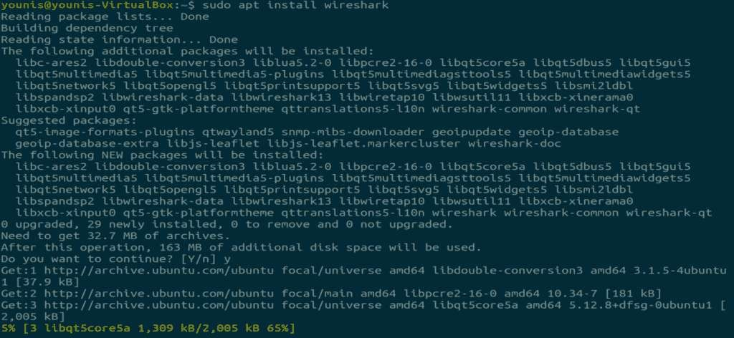

Step 3: Enable Root Privileges
When Wireshark installs on your system, you will be prompted by the following window. As Wireshark requires super user/root privileges to operate, this option asks to enable or disable permissions for all every user on the system. Press the “Yes” button to allow other users, or press the “No” button to restrict other users from using Wireshark.
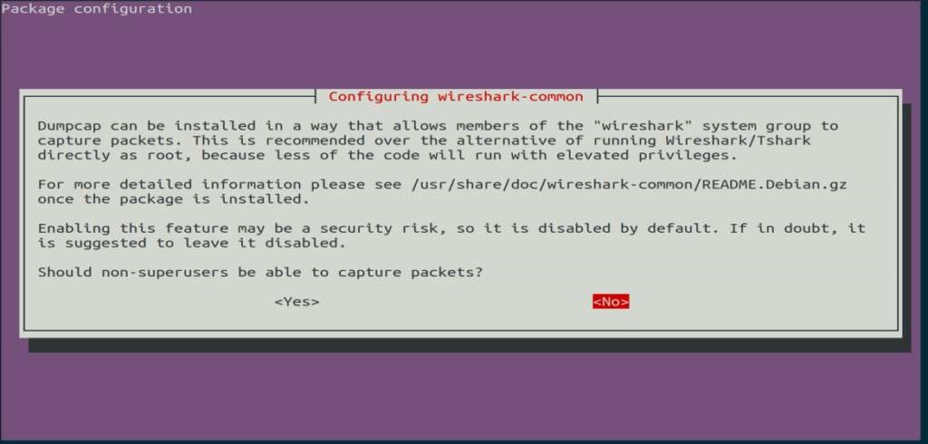

Step 4: (Optional) Reconfigure Permission Settings
If you have selected “No” in the above scenario, then you can change this selection again by executing the following command, which will reconfigure the Wireshark permission settings.
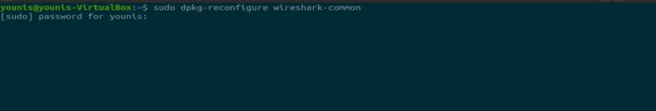
$

sudo

dpkq
-
reconfigure wireshark
-
common

Select the “Yes” button to change the configuration settings to allow other users access to Wireshark.
In the terminal window, type the following command to start the Wireshark application.
$ wireshark
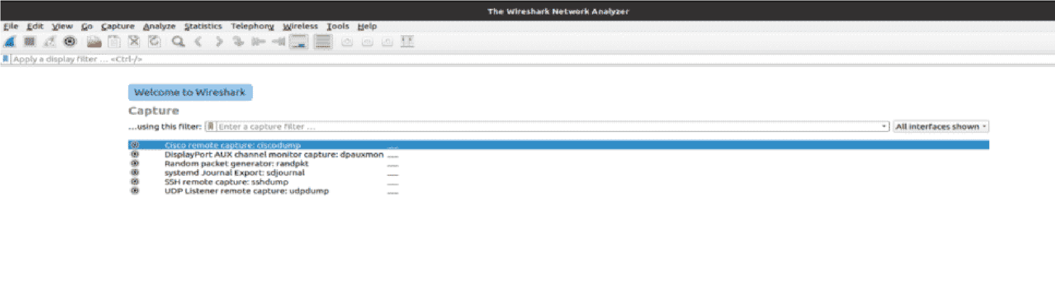

RESULT
Study about analyzing network packet stream using Wireshark

