MCP Testing Report - AI Scholarship Finder
Date: 2026-10-28 Application: Streamlit web app at http://localhost:8501 MCP server: @playwright/mcp@0.0.83

1. Objective
To show how the Model Context Protocol (MCP) can test the website: an MCP client sends tool calls to a Playwright MCP server, which controls a real Chromium browser. The client opens the site, clicks, types, reads the page and takes screenshots, then compares what it sees with the expected result.

2. How MCP testing works here
- Python MCP client (mcp_testing/mcp_harness.py) starts the server with 'npx @playwright/mcp' over stdio.
- The client lists the tools the server offers (25 tools, e.g. browser_navigate, browser_snapshot, browser_click, browser_type, browser_evaluate, browser_take_screenshot, browser_console_messages).
- browser_snapshot returns the page's accessibility tree; every element gets a ref id. The test finds the element by name and passes its ref to browser_click / browser_type.
- browser_evaluate reads page text and DOM facts (e.g. 'Showing 1 of 8', injected elements, page width).
- Each test case compares the observed result with the expected result and records PASS/FAIL plus a screenshot.
- Every MCP tool call is logged (name, arguments, duration, success) in mcp_testing/results.json.

3. Summary of results
MCP UI test cases executed: 16 Passed: 15 Failed: 1 MCP tool calls: 226
Existing automated suite (pytest): 175 passed, 1 skipped (the live test, run separately), 0 failed - covers eligibility rules, normalizer, red flags, ranking, repository, source safety, Gemini service (mocked), Streamlit AppTest flows.

4. MCP tools used
MCP tool | Calls
browser_wait_for | 75
browser_snapshot | 36
browser_click | 30
browser_evaluate | 20
browser_resize | 17
browser_navigate | 16
browser_press_key | 13
browser_take_screenshot | 12
browser_type | 5
browser_console_messages | 2

5. Test cases and results
ID | Title | Steps (via MCP) | Expected | Actual | Result
TC-01 | Home page loads | Open http://localhost:8501; read title, text, console | Title 'AI Scholarship Finder', heading + Find button visible, 0 console errors | title='AI Scholarship Finder'; heading and Find button present; browser console errors: 0 | PASS
TC-02 | Initial empty state | Open page without searching | Prompt 'Fill in your profile…' is shown | Info prompt shown before any search | PASS
TC-03 | Demo search, empty profile | Select Demo data; click Find scholarships | 8 fictional cards, demo banner, 'Showing 8 of 8' | Demo banner shown; 8 cards labelled DEMO RECORD; 'Showing 8 of 8' present=True | PASS
TC-04 | Profile: Karnataka + OBC | Demo data; pick State=Karnataka, Category=OBC; search | Results and eligibility metrics render without errors | Results rendered for Karnataka/OBC: Showing 8 of 8; eligibility metrics visible | PASS
TC-05 | Text filter narrows list | Search demo; type 'Karnataka' in name filter | Count drops below 8 but stays >=1 | Text filter 'Karnataka' -> Showing 1 of 8 | PASS
TC-06 | Filter with no match | Type nonsense in name filter | Friendly 'No results match' warning | Warning 'No results match these filters' shown, no crash | PASS
TC-07 | Missing-field warning | Search with a blank profile | Warning lists blank details / potential matches | Warning about blank profile fields (potential matches only) displayed | PASS
TC-08 | Income input mode switch | Click radio 'Exact amount' | Exact-amount number box appears | DEFECT: after selecting 'Exact amount' the radio changed but the form still showed the 'Income range' dropdown; the 'Amount' box only appears after pressing Find (widgets inside st.form do not re-render until submit). See screenshot. | FAIL
TC-09 | HTML/script injection in text field | Enter <img onerror><script> in course; search | Text escaped; nothing injected; no crash | Hostile HTML in course field: injected elements in DOM = 0; no dialog/crash | PASS
TC-10 | Out-of-range number | Type 99 in Current year; search | App does not crash | Out-of-range year (99) did not crash the app (Streamlit enforces max 8) | PASS
TC-11 | Gemini status indicator | Read sidebar | Shows configured / not-configured status | Sidebar status: Gemini: configured ✅ | PASS
TC-12 | Clear saved searches button | Click 'Clear saved searches & AI cache' | 'Cleared.' confirmation | Confirmation 'Cleared.' shown | PASS
TC-13 | Mobile layout (390x844) | Resize to phone size after search | No horizontal scrolling | Mobile 390px: scrollWidth=390, viewport=390 -> no horizontal scroll | PASS
TC-14 | Opt-in search history | Tick 'Save my search summary' | Search history panel appears | Opt-in history checkbox reveals the 'Search history' panel | PASS
TC-15 | Result cards show labels | Search demo; read cards | Eligibility status + DEMO label on each card | Cards show eligibility status and DEMO label | PASS
TC-16 | Live search against official sites | Live search; Karnataka, Undergraduate, B.E.; wait for completion | Real scholarships returned (or problems clearly reported), no crash | Live search finished: Showing 29 of 29; 1 problem(s) | PASS

6. Evidence (screenshots taken through browser_take_screenshot)
TC-01 - Home page loads (PASS)
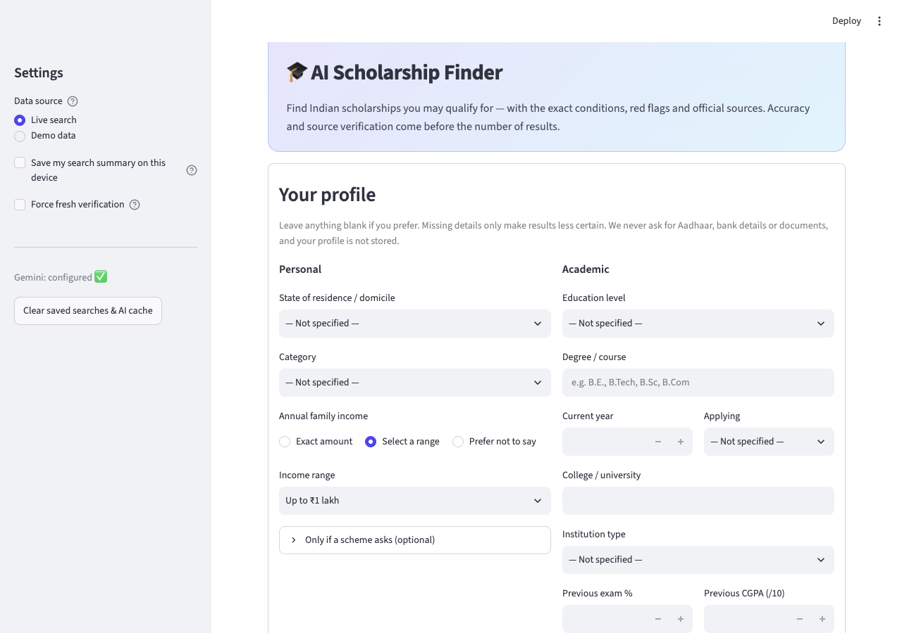
TC-03 - Demo search, empty profile (PASS)
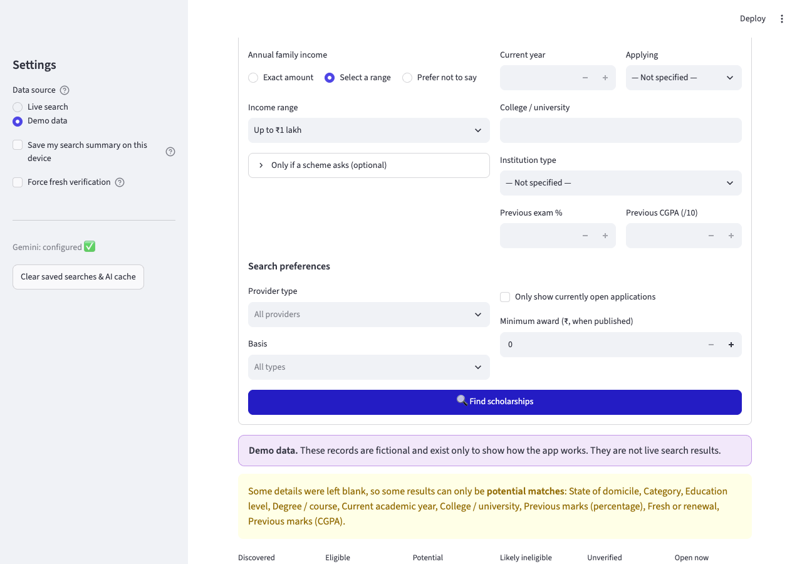
TC-04 - Profile: Karnataka + OBC (PASS)
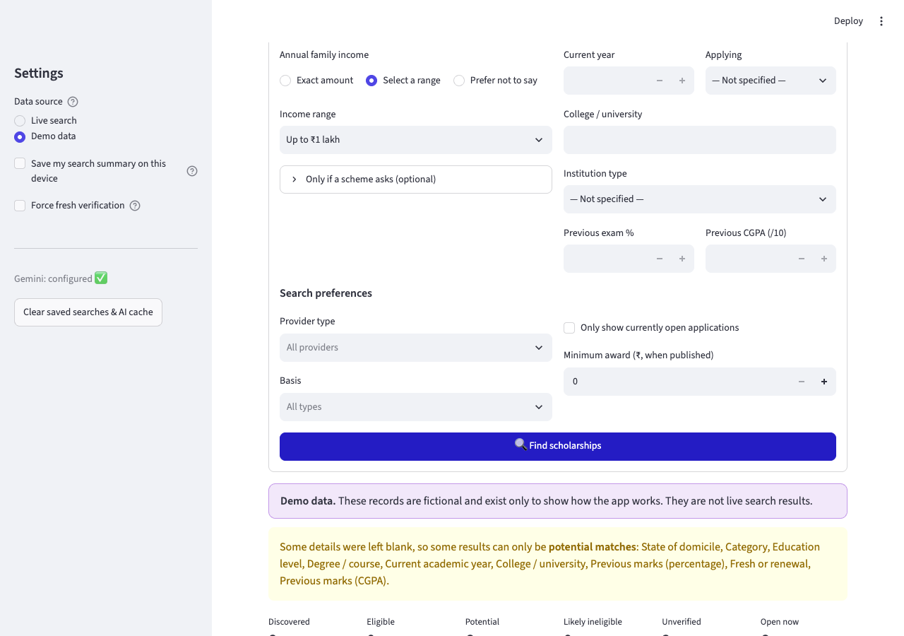
TC-05 - Text filter narrows list (PASS)
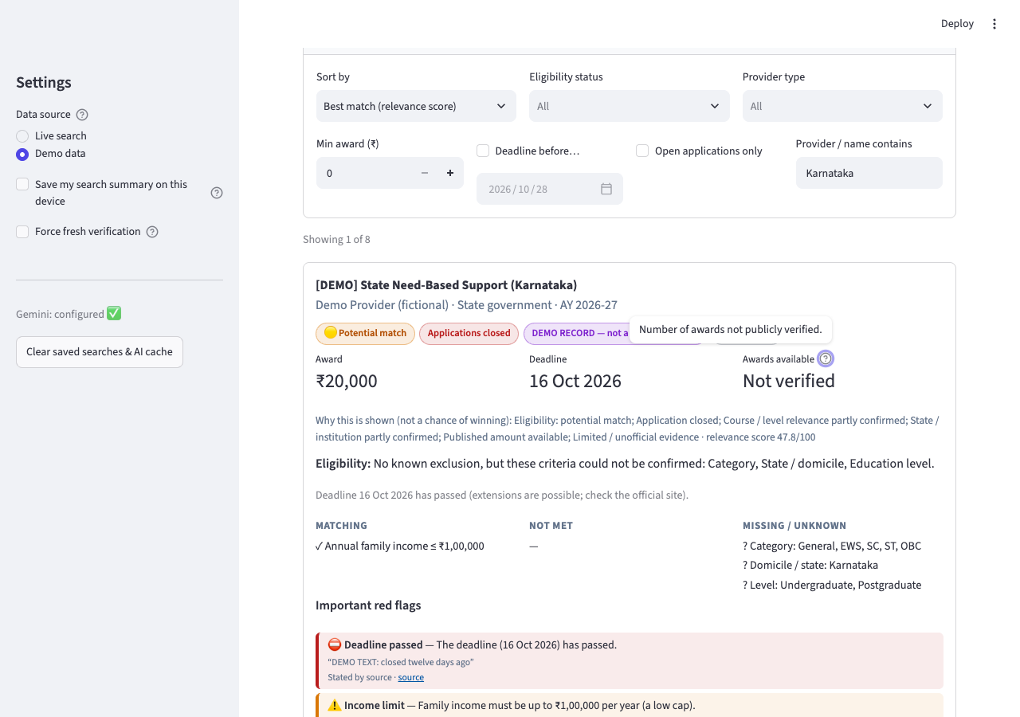
TC-06 - Filter with no match (PASS)
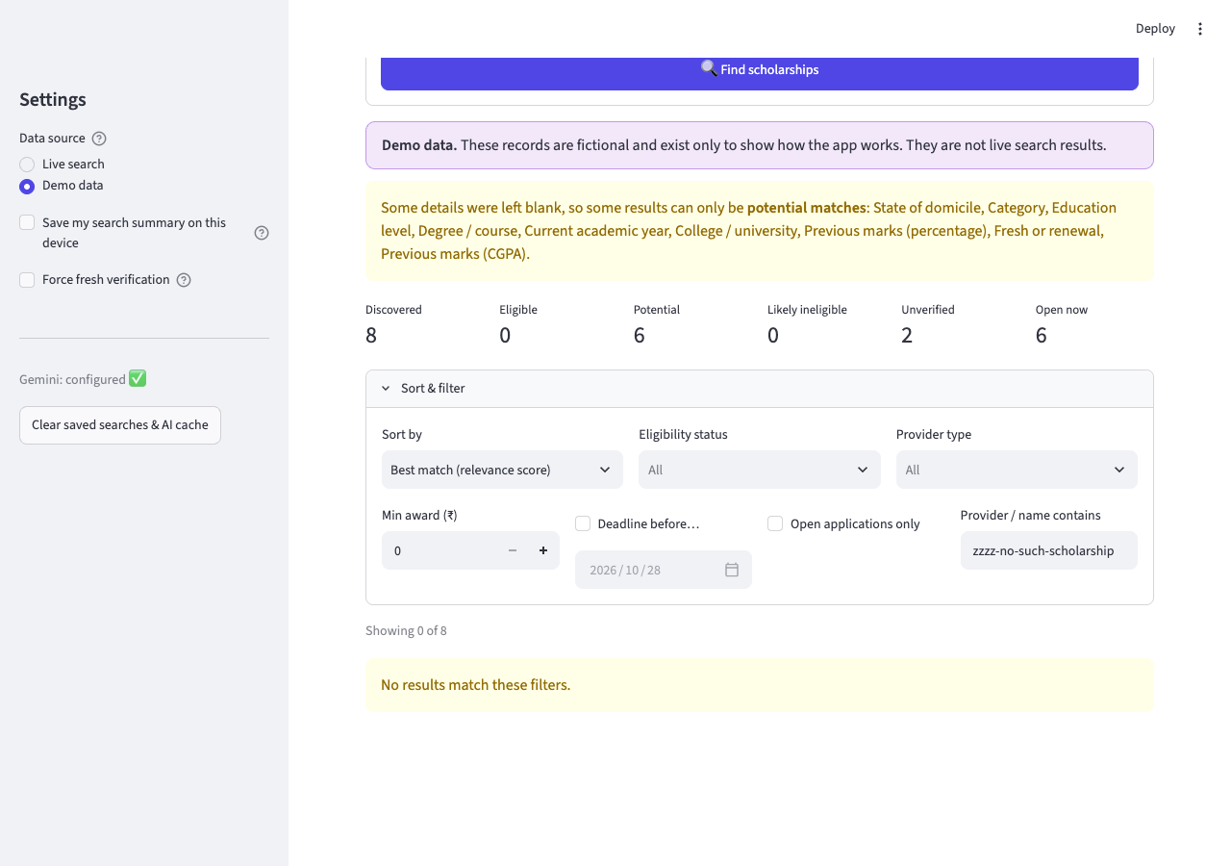
TC-08 - Income input mode switch (FAIL)
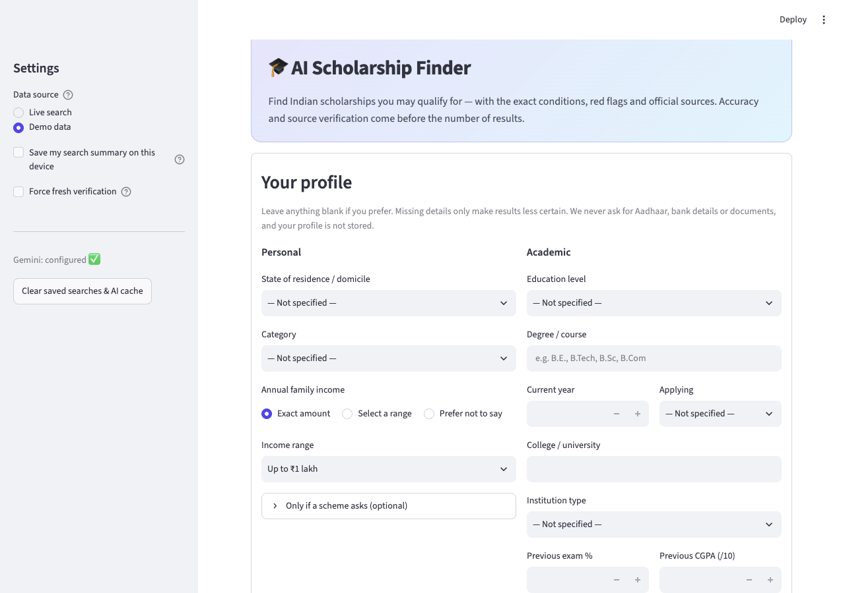
TC-09 - HTML/script injection in text field (PASS)
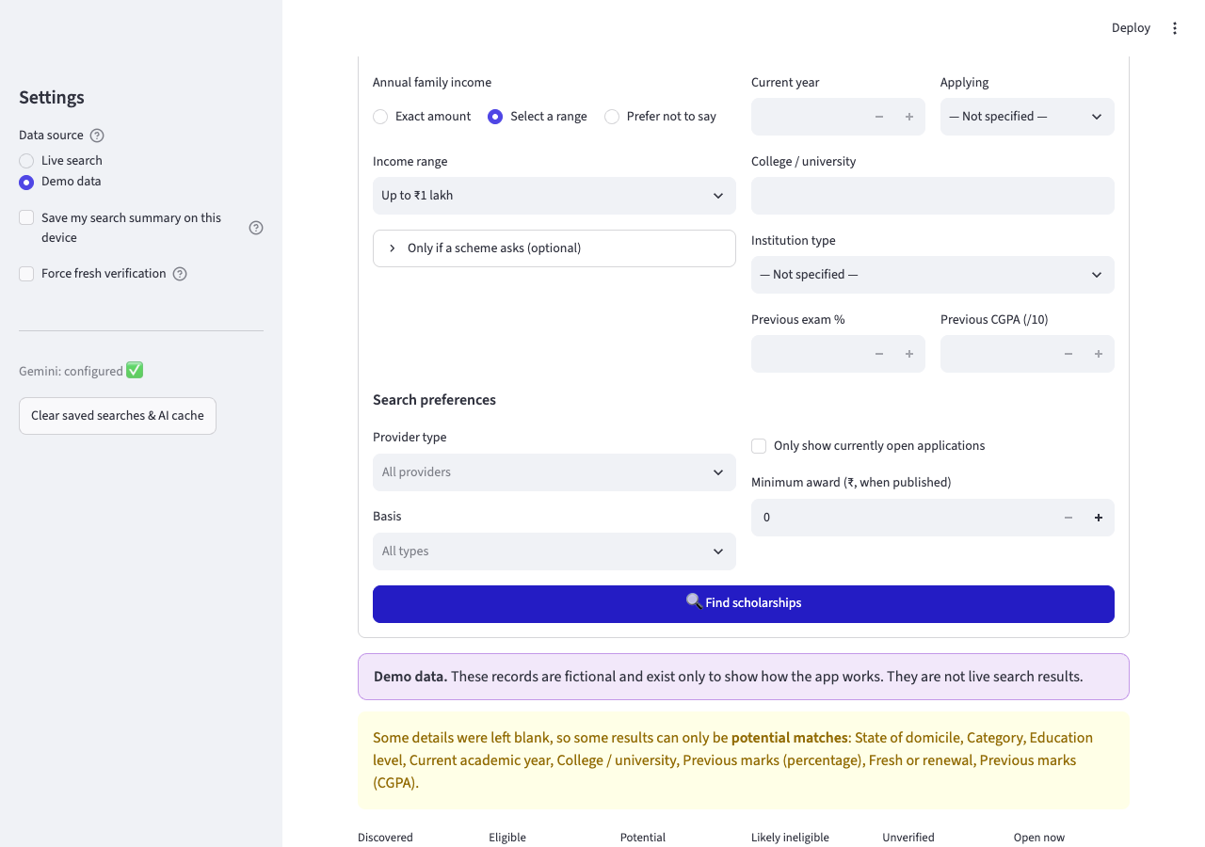
TC-10 - Out-of-range number (PASS)
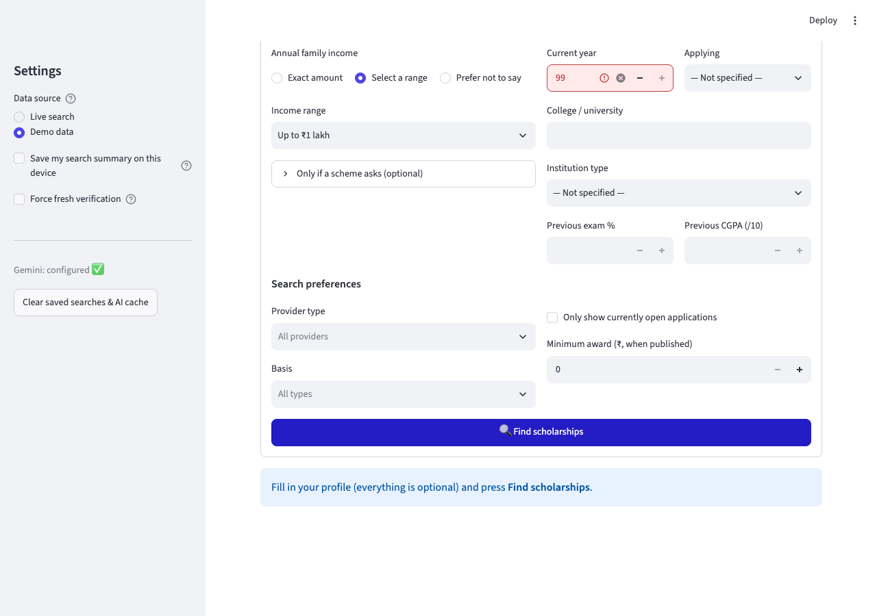
TC-12 - Clear saved searches button (PASS)
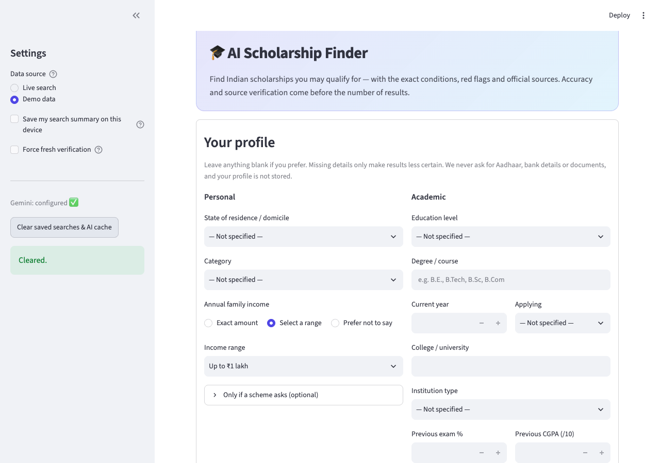
TC-13 - Mobile layout (390x844) (PASS)
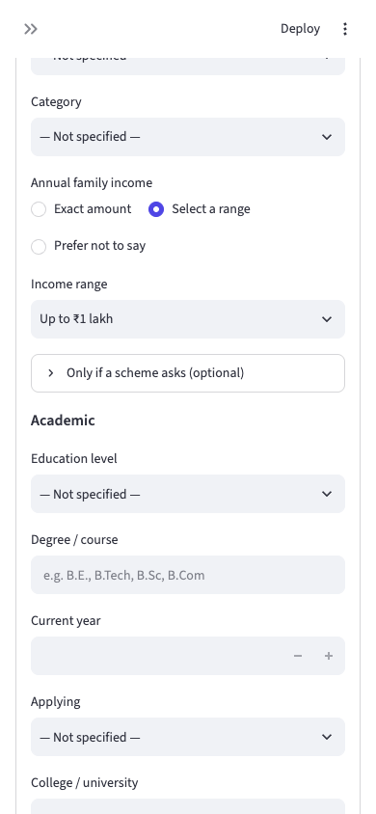
TC-14 - Opt-in search history (PASS)
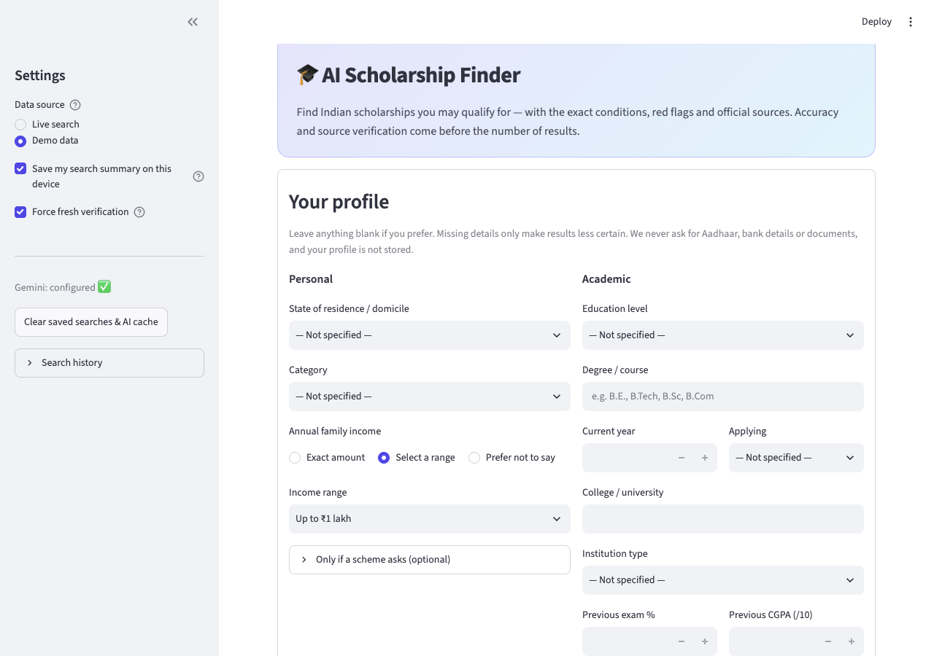
TC-16 - Live search against official sites (PASS)
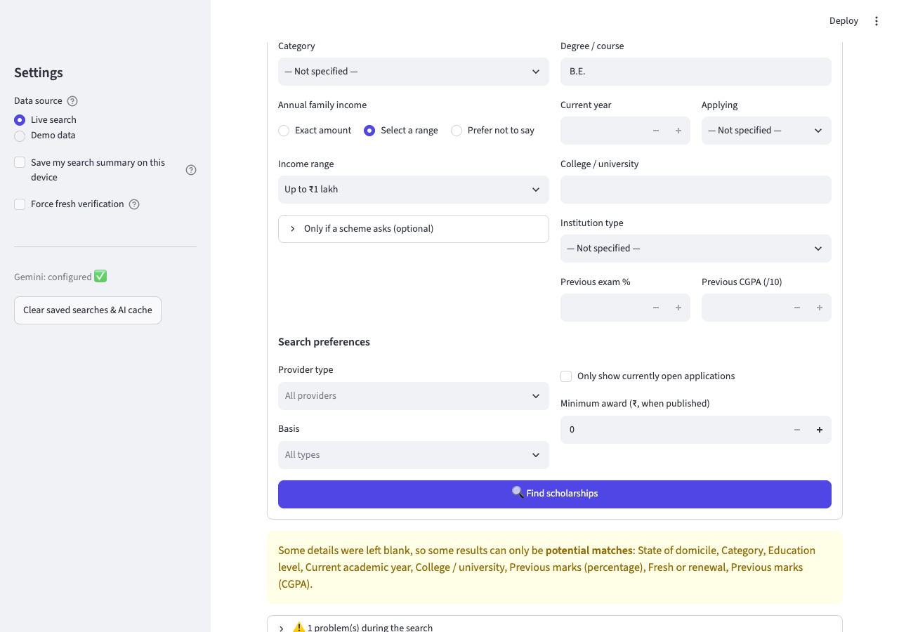

7. Failures and observations
- TC-08 Income input mode switch: DEFECT: after selecting 'Exact amount' the radio changed but the form still showed the 'Income range' dropdown; the 'Amount' box only appears after pressing Find (widgets inside st.form do not re-render until submit). See screenshot.
During test development the first runs failed because of problems in the test script, not the website (MCP element refs change after navigation; Streamlit radio inputs are covered by their labels so the label text must be clicked). These were fixed in the harness. Console check: ### Result Total messages: 28 (Errors: 0, Warnings: 28) Returning 0 messages for level "error"
Live-search note (TC-16): depends on internet, DuckDuckGo and official sites, so the result can vary between runs.

8. Conclusion
MCP lets an AI/automation client test the site the way a user does - through the real UI - without writing browser-specific code, and returns structured evidence (page snapshot, text, console, screenshots). It complements the 175 unit tests, which check the logic but not the rendered interface.

