Department of Artificial Intelligence – Data Science and Machine Learning
Program name :- Artificial Intelligence – Data Science and Machine Learning Class: S.Y. B. Tech Div:- B
Name of Student: Vaishnavee Sutar Batch:- B2 Course Name:- Digital Finance
PRN No :- 251012097 Roll No:- 32236 Sem :- 3rd Course :- AI Specialist - BFSI

 | 
SMARTBRIDGE | SKILLWALLET
Finora: AI-Powered Financial Management and Insights
Project Description :-
Finora is an AI-powered web application designed to help users manage their personal finances in one place. It allows users to record income and expenses, review recent transactions, understand spending by category, monitor savings, and set a savings goal through a simple dashboard.
The dashboard calculates total recorded income, expenses, net savings, and savings rate from the user's transaction records. The application is built with Python and Flask, and uses Flask-SQLAlchemy with an SQLite database to store transactions. Its AI Advisor sends relevant financial summaries to Google Gemini to generate plain-language observations and practical budgeting suggestions.
The application is maintained in a public GitHub repository and deployed as a web service on Render. The Gemini API key is configured as a server-side environment variable rather than being placed in the frontend or committed to the repository. The project includes a Reset Demo Data control for clearing recorded transactions when preparing a demonstration.
Technology & AI :-
Frontend: HTML5 / CSS3 / JavaScript
Backend: Python / Flask
AI: Google Gemini API using the Google GenAI Python SDK
Data Storage: SQLite with Flask-SQLAlchemy
Deployment: Render
Source Control: GitHub; API key configured through environment variables

Key Features :-
- Financial dashboard showing recorded income, expenses, net savings, and savings rate
- Transaction management for adding income and expenses with category and description
- Spending breakdown that groups recorded expenses by category
- AI Advisor that summarizes financial activity and generates budgeting suggestions
- Savings Goal feature for entering a target amount and tracking progress
- Transaction history showing recorded financial activity and dates
- Reset Demo Data control to clear transactions after user confirmation
- Responsive light-theme interface with navigation for Overview, Transactions, Insights, and Savings Goal
Scenarios :-
Scenario 1: A user records monthly income and expenses using the transaction form. The dashboard updates the recorded totals and calculates net savings and savings rate.
Scenario 2: A user records expenses in categories such as rent or food. The spending section groups the recorded expenses to help the user see which category accounts for the spending shown.
Scenario 3: A user opens the Insights section and selects Generate Insights. The backend prepares a summary of the recorded financial activity and requests a plain-language analysis from Google Gemini.
Scenario 4: A user creates a savings goal, such as purchasing a laptop, enters the target and current savings, and reviews the displayed completion percentage. Before a demonstration, the user can use Reset Demo Data to clear the transaction records.
Milestones :-
Milestone 1 – Project Planning & UI/UX Design
Define the purpose of the application, identify the main financial tracking requirements, and design a clear dashboard with Overview, Transactions, Insights, and Savings Goal sections.
Milestone 2 – Flask Backend & Transaction Management
Develop the Flask application, transaction data model, database setup, and API routes for retrieving and adding transaction records.
Milestone 3 – Dashboard, Spending Analysis & Savings Goals
Implement the dashboard calculations, category-based spending display, transaction history, savings goal progress, and the reset-demo-data endpoint and button.
Milestone 4 – Google Gemini AI Integration
Connect the backend to Google Gemini for financial insights, configure the API key through an environment variable, and provide a local fallback when AI analysis is unavailable.
Milestone 5 – Testing, Documentation & Deployment
Test the core transaction and insight workflows, publish the source code to GitHub, prepare project documentation, and deploy the web application using Render.
Conclusion :-
Finora brings income tracking, expense management, spending analysis, savings goals, and AI-generated insights together in one web application. By combining calculated financial summaries with plain-language AI explanations, it helps users understand their recorded activity and consider practical budgeting improvements. The project demonstrates the use of web development, database management, API integration, and cloud deployment to address a common Finora need.
Expected Outcome :-
The expected outcome is a working web application where users can record transactions, review financial totals, inspect category-based spending, track a savings goal, and request AI-generated financial insights. The deployed demo makes the application accessible through a public link. Financial results depend on the completeness and accuracy of the data entered by the user.

Detailed Technical Documentation
This section adds implementation detail to the original Finora report. The original three-page report, including its college branding, student-information block, existing section order, and original formatting, has been retained unchanged.

1. Detailed User Scenarios

Scenario 1: Record income
The user selects Income, enters a positive amount, chooses a category such as Salary, and optionally adds a description. The backend validates the fields and saves the transaction. The dashboard can then reflect the recorded income.

Scenario 2: Record an expense
The user selects Expense, enters a positive amount, chooses a category such as Rent or Food, and submits the form. The transaction is saved and contributes to the expense total and category-based spending breakdown.

Scenario 3: Review transaction history
The user opens Transactions to review saved entries. The backend returns the transaction records ordered by creation time, with the newest entries first.

Scenario 4: Generate AI insights
The user opens Insights and requests an analysis. The backend calculates recorded income, expenses, net savings, savings rate, and category totals, then requests plain-language guidance from Google Gemini. If there is no transaction data, the user is prompted to add records first. A local-advice fallback is available when AI service access fails.

Scenario 5: Create a savings goal
The user enters a goal name and target amount on the Savings Goal page. The interface displays the goal and progress based on the data available in the application. Displayed progress is demonstration data and is not a verified bank balance.

Scenario 6: Reset demo records
When preparing a demonstration, the user can use Reset Demo Data. The backend deletes transaction records and commits the change, with rollback handling if an exception occurs.

2. Technical Architecture
Finora uses a browser–server–database architecture. The browser presents the HTML, CSS, and JavaScript interface. Flask handles page rendering and API requests. Flask-SQLAlchemy manages transaction records in SQLite. The backend uses the Google GenAI Python SDK to request AI-generated financial explanations from Google Gemini.
User / Browser
↓
HTML5 + CSS3 + JavaScript
↓ HTTP requests
Python Flask application
├── Flask-SQLAlchemy → SQLite database
└── Google GenAI SDK → Google Gemini API
↓
JSON responses and rendered financial insights
The Gemini API key is read on the server from an environment variable. GitHub is used for source control, and Render hosts the web application.

3. Prerequisites and Environment Setup
Prerequisites include Python, the project dependencies listed in requirements.txt, a code editor such as Visual Studio Code, and a Google Gemini API key for the external AI-analysis path.

Activity 3.1: Prepare the project
Clone or download the latest GitHub repository and open the project folder in Visual Studio Code or a terminal.

Activity 3.2: Create and activate a virtual environment
python -m venv venv
venv\Scripts\activate

Activity 3.3: Install dependencies
python -m pip install -r requirements.txt

Activity 3.4: Configure the Gemini API key
Create a local .env file in the project root and add a placeholder entry. Replace the placeholder locally with a valid key. Never publish the real key in the report, frontend code, or public repository.
GEMINI_API_KEY=your_gemini_api_key_here

Activity 3.5: Run the application
python app.py
Open the local address printed by Flask in the terminal. Exact startup behavior depends on the current app.py configuration.

4. Backend Implementation and API Workflow

Activity 4.1: Flask application setup
The Flask home route renders the main interface. API routes are used to retrieve transaction data, create transactions, reset demonstration records, and generate financial analysis.

Activity 4.2: Transaction data model
The Transaction model contains an integer ID, transaction type, amount, category, optional description, and creation timestamp. Flask-SQLAlchemy maps this model to SQLite.

Activity 4.3: Validate and store transactions
The transaction-creation endpoint checks required fields, converts the amount to a number, rejects invalid or non-positive amounts, and saves valid records. Database errors are handled using rollback logic.

Activity 4.4: Main API routes
Route | Method | Purpose
/ | GET | Render the main Finora interface.
/api/entries | GET | Return saved transactions ordered by creation time.
/api/entries | POST | Validate and save a transaction.
/api/reset | POST | Clear transaction records for a demo reset.
/api/analyze | POST | Calculate financial summaries and return AI or fallback advice.

Activity 4.5: Financial calculations
Net savings = total recorded income − total recorded expenses. Savings rate = (net savings ÷ total recorded income) × 100 when income is greater than zero; otherwise, the application uses zero to avoid division by zero. Expense totals are grouped by category.

5. Frontend Page Walkthrough

Activity 5.1: Overview dashboard
The Overview page displays recorded income, expenses, net savings, and savings rate. It also contains a transaction-entry form, category spending bars, and recent activity.

Activity 5.2: Transactions page
The Transactions page presents a consolidated history of recorded financial activity, distinguishing income from expenses.

Activity 5.3: Insights page
The Insights page lets users request a plain-language explanation of recorded activity and practical budgeting suggestions.

Activity 5.4: Savings Goal page
The Savings Goal page accepts a goal name and target amount and displays progress based on available application data.

Activity 5.5: Navigation
The navigation menu links Overview, Transactions, Insights, and Savings Goal. The supplied screenshots document these interface areas.

6. Testing Plan and Evidence
The following are proposed functional test cases based on the application routes and interface. They are not claimed as completed or passed. Record the actual result after running each test.
Test ID | Test action | Expected result
TC-01 | Open the home page | The Finora overview page loads.
TC-02 | Submit a valid income transaction | The transaction is saved and appears in the list.
TC-03 | Submit a valid expense transaction | The expense is saved and contributes to spending totals.
TC-04 | Submit a missing, invalid, or non-positive amount | The request is rejected by validation.
TC-05 | Request the transaction list | Saved entries are returned newest first.
TC-06 | Generate insights with transaction records | AI analysis or the configured local fallback is returned.
TC-07 | Generate insights without records | The user is asked to add transaction data first.
TC-08 | Reset demonstration data | Transaction records are cleared.
TC-09 | Use an invalid or unavailable Gemini key | The AI failure path is handled without exposing the key.
Testing evidence should include the test input, observed result, date, and PASS/FAIL status. Do not mark a test as passed until it has been executed.

7. Deployment and Source Control

Activity 7.1: Maintain source control
The GitHub repository contains the Flask application, dependency list, HTML template, CSS stylesheet, JavaScript file, and README documentation.

Activity 7.2: Configure deployment
Configure GEMINI_API_KEY as a server-side environment variable in the hosting service. Keep the actual key out of the public repository.

Activity 7.3: Verify the deployed application
Open the deployed application and review the navigation, transaction entry, transaction history, insights, and savings-goal screens. Record observed results before describing deployment checks as passed.

8. Application Screenshots
The following screenshots were supplied for inclusion in this report. Values shown are demonstration data and should not be treated as verified financial records.
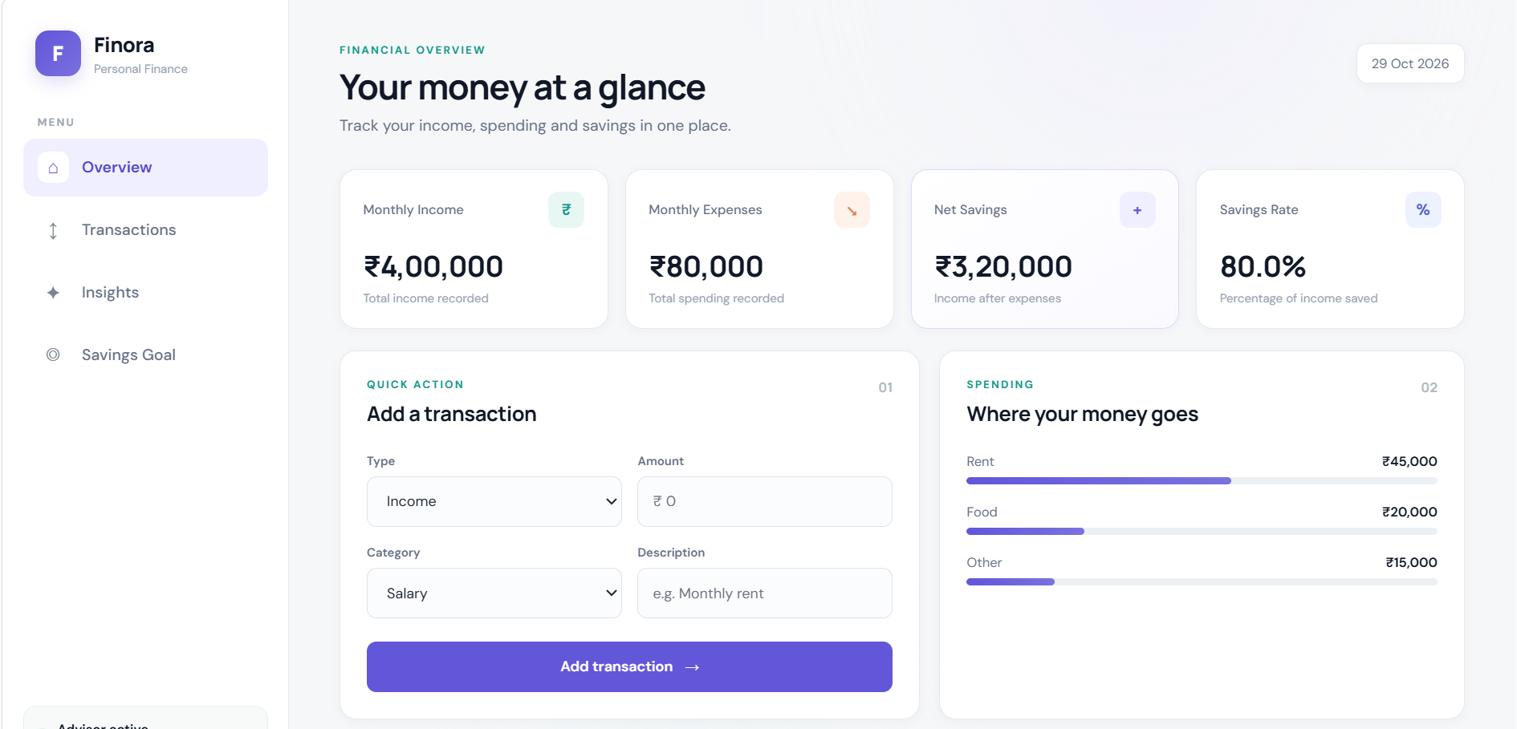
Figure 1. Overview dashboard with financial summary cards and quick transaction entry.
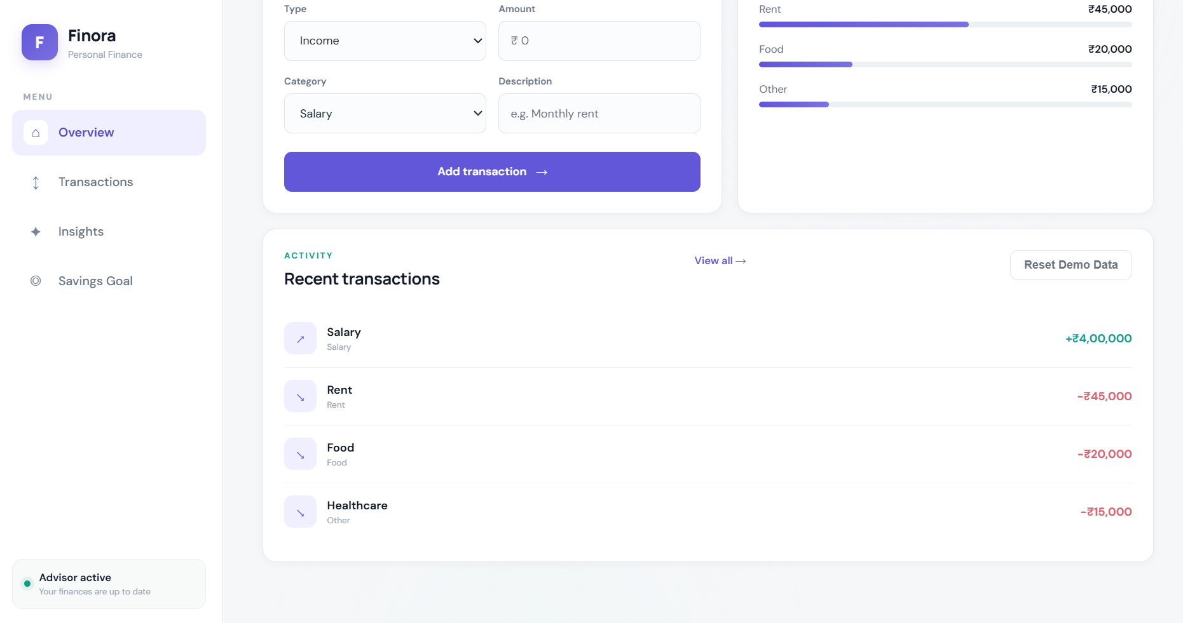
Figure 2. Overview dashboard activity section with recent transactions and the demo-reset control.
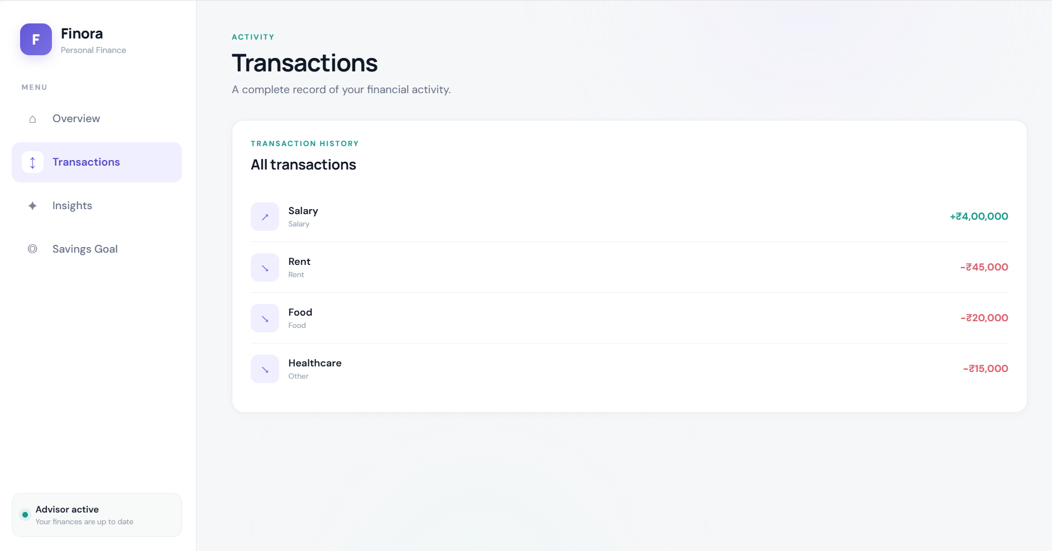
Figure 3. Transactions page showing recorded financial activity.
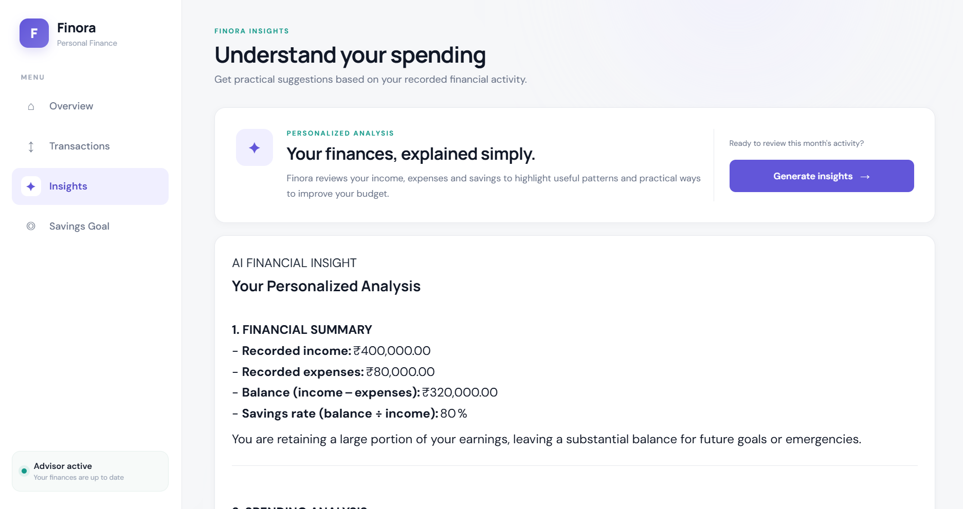
Figure 4. Insights page introducing personalized financial analysis.
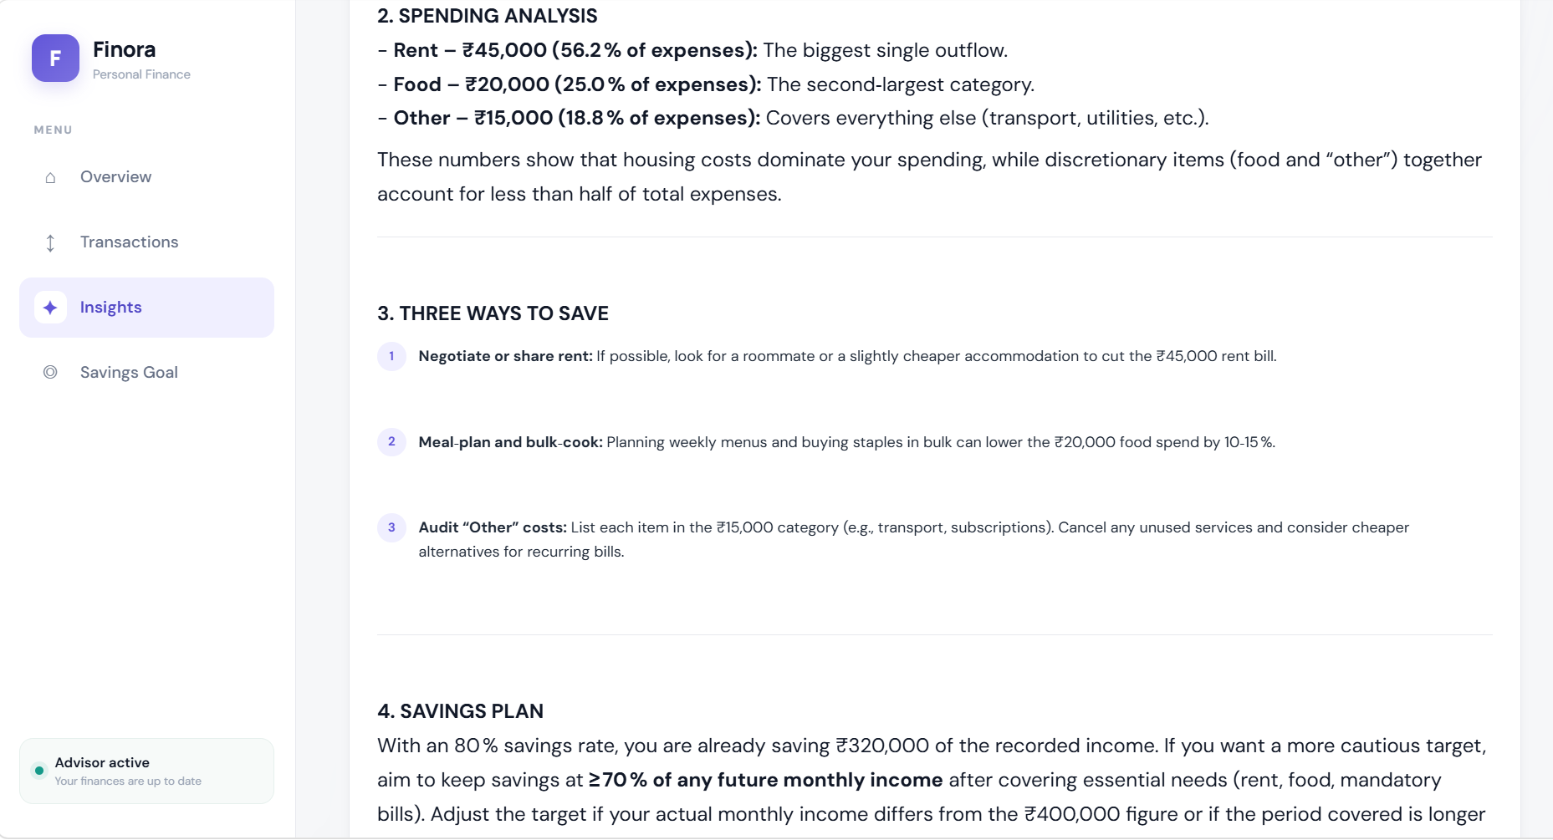
Figure 5. Financial summary and spending-category analysis output.
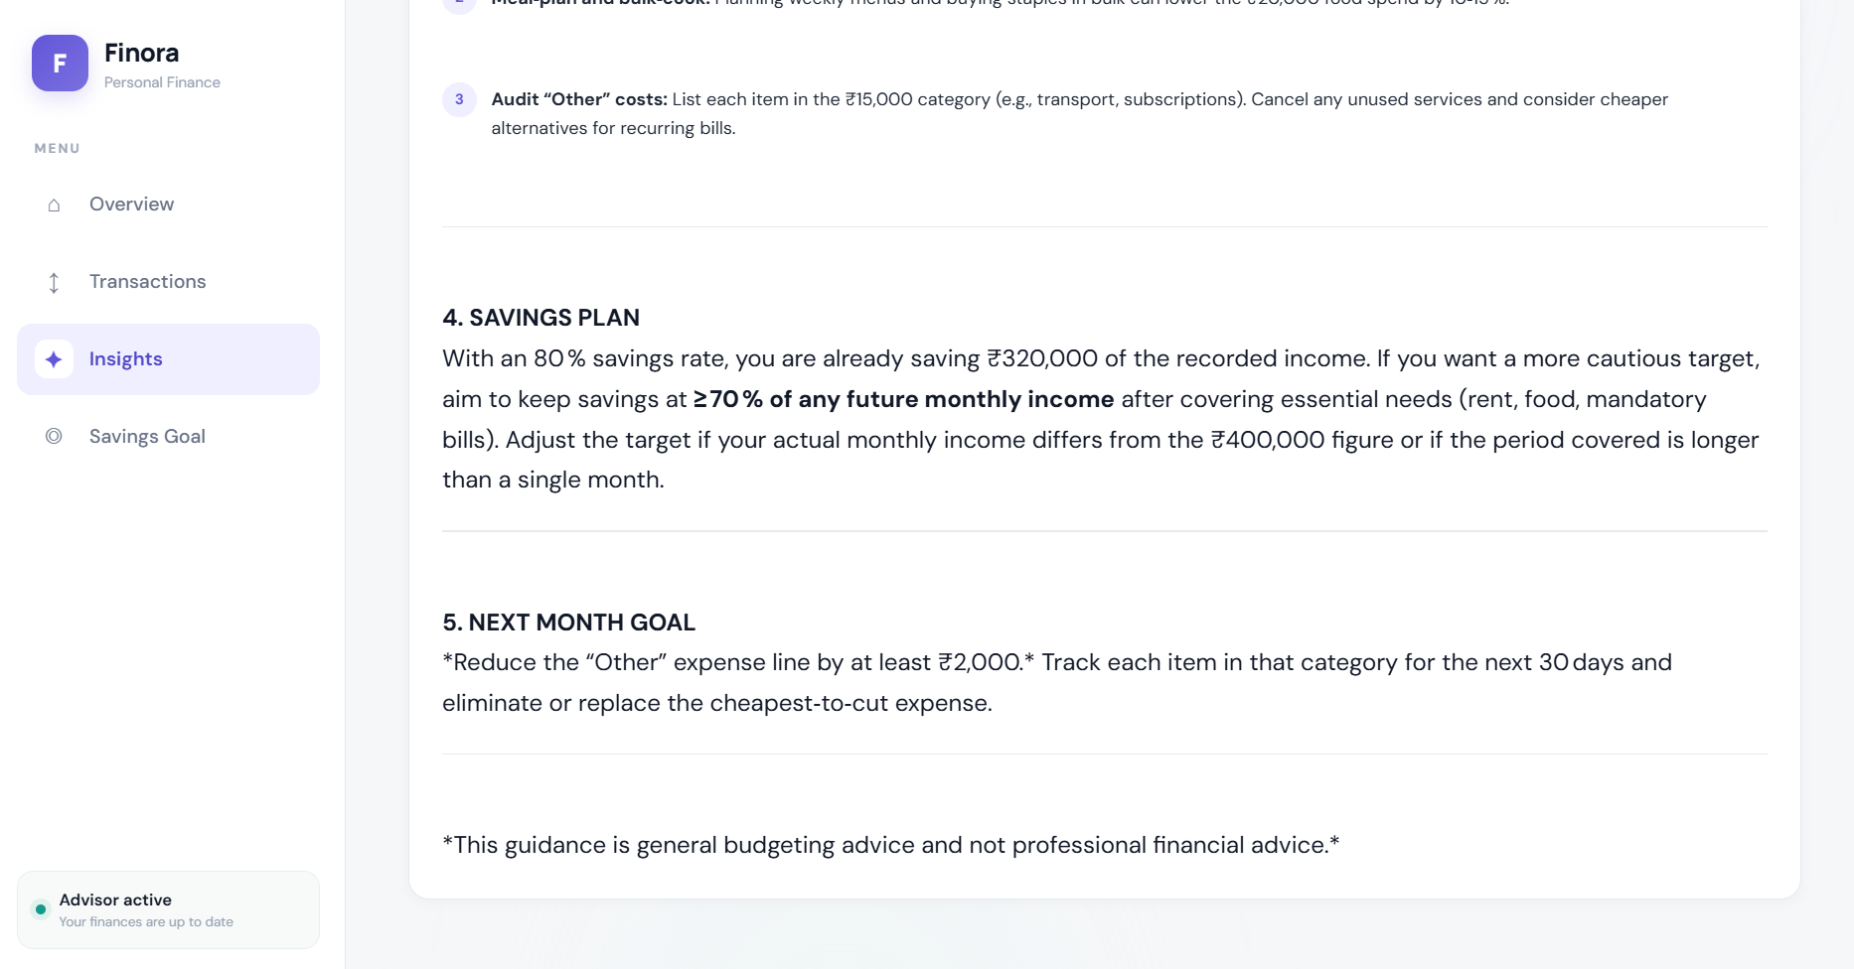
Figure 6. Budget suggestions, savings plan, and next-month goal.
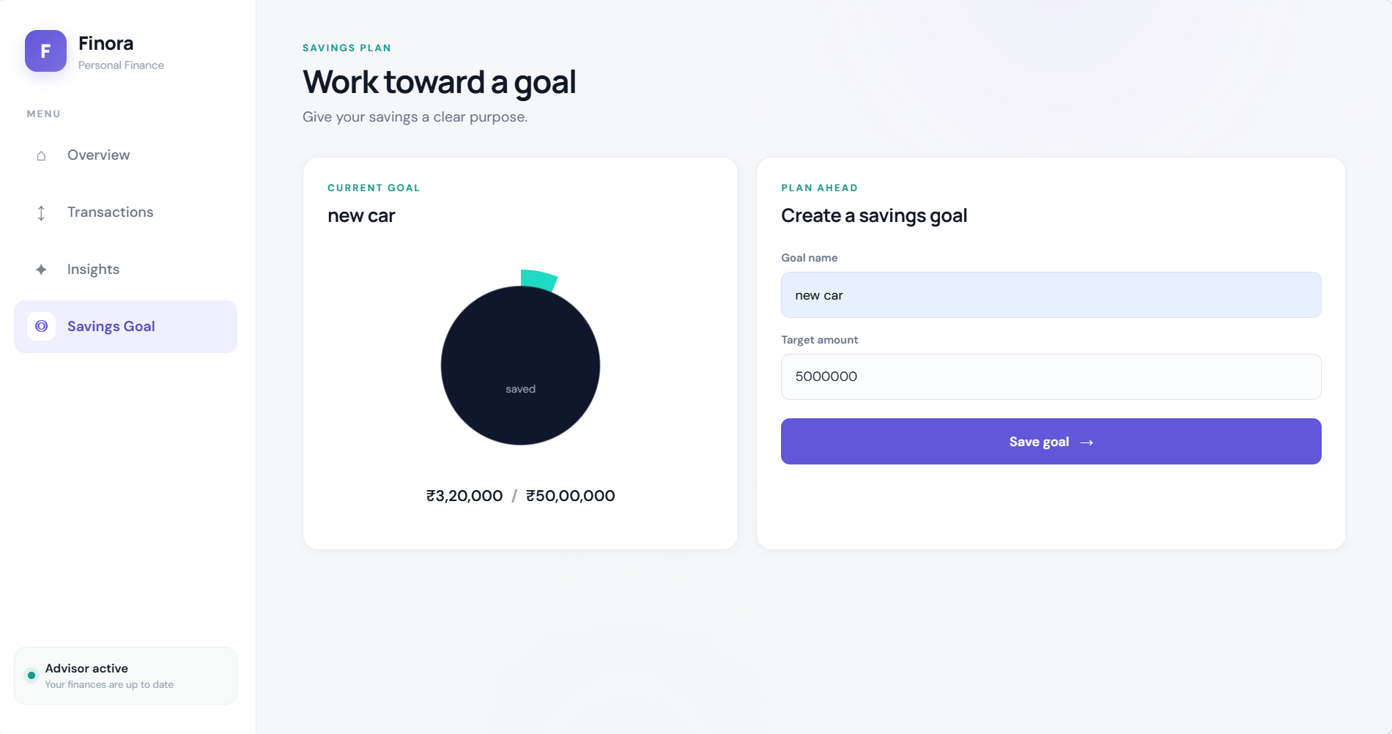
Figure 7. Savings Goal page with the current goal and target-amount form.

