Aim:
To understand the fundamental concepts of JavaScript including primitive operations, expressions, operators, control structures (loops), arrays, functions, and pattern matching using regular expressions.
1.Basics of JavaScript:
JavaScript is a lightweight, interpreted scripting language used to create dynamic and interactive web pages. It runs in the browser and supports event-driven, functional, and object-oriented programming.
- Primitive Operations and Expressions:
Primitive data types in JavaScript include Number, String, Boolean, Undefined, Null, and Symbol. Expressions combine variables, values, and operators to produce a result. Example:
let x = 10; let y = 5; let sum x + y; let isEqual = (x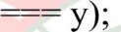
- Operators in JavaScript:
Operators are symbols used to perform operations on operands. JavaScript supports arithmetic, relational, logical, assignment, and conditional operators. Example:
let a = 8, b = 3; let add = a + b; //
Arithmetic let compare = a > b; //
Relational let logic = (a > 5 && b < 5); //Logical
- Loops in JavaScript:
Loops are used to execute a block of code repeatedly as long as a specified condition is true. Common loops in JavaScript are for, while, and do-while. Example (for loop): for(let i — console.log(i);
UTE OF TECHNOLOGY
- Arrays:
Arrays store multiple values in a single variable and can grow dynamically. Example:
let numbers = [10, 20, 30]; numbers.push(40); console.log(numbers.length);
- Functions:
Functions are reusable blocks of code that perform specific tasks. Example:
function multiply(p, q) { return p * q;
let result = multiply(4, 5);
- Pattern Matching Using Regular Expressions:
Regular expressions are patterns used for searching and matching text. Example:
let regex = /\d+/; let text = "Order 123"; console.log(regex.test(text));
Task - 1:
Aim : Display multiplication table for the given number.
Code :
<!DOCTYPE html>
<html lang="en">
<head>
<meta charset="UTF-8">
<meta name="viewport" content="width=device-width, initial-scale=1.0">
<title>Document</title>
</head>
<body>
<script>
let num=parseInt(prompt("enter a number: "));
document.write("<h3> The Multiplication Table of "+ num+"</h3>");
for(let i=1;i<=10;i++){
document.write(num+" * "+i+" = "+num*i +"<br>");
}
console.log("hello world");
alert("hiii");

</script>
</body>
</html>
OUTPUT:
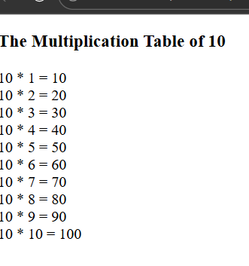
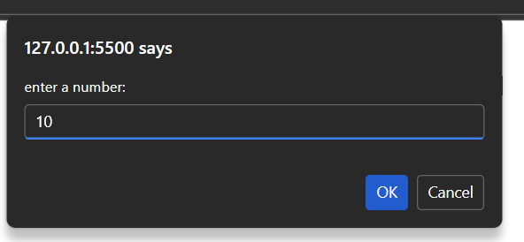
Task - 2:
Aim: To write a java script function which converts Fahrenheit to Celsius.
Code: <!DOCTYPE html>
<html>
<head>
<title>Temperature Converter</title>
</head>
<body>
<h2>Fahrenheit to Celsius Converter</h2>
<input type="number" id="fahrenheit" placeholder="Enter Fahrenheit">
<button onclick="convert()">Convert</button>
<p id="result"></p>
<script>
function convert() {
let f = document.getElementById("fahrenheit").value;
let c = (f - 32) * 5 / 9;
document.getElementById("result").innerHTML =
"Temperature in Celsius: " + c.toFixed(2) + " °C";
alert("temp is "+c);
console.log( "temp is " +c);
}
</script>
</body>
</html>
OUTPUT:
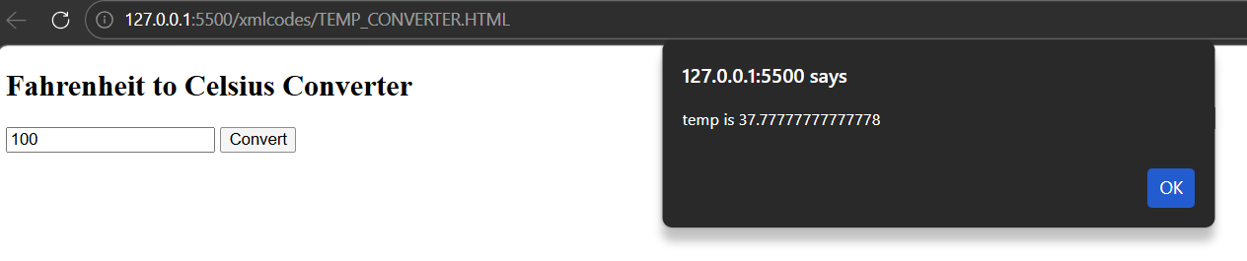
TASK-3:
Aim: To write a JavaScript program which accept a number as input and insert dashes (-) between each two even numbers.
For example if you accept 025468 the output should be 0-254-6-8.
CODE:
<!DOCTYPE html>
<html lang="en">
<head>
<meta charset="UTF-8">
<meta name="viewport" content="width=device-width, initial-scale=1.0">
<title>Document</title>
</head>
<body>
<input id="num" placeholder="enter a number" type="text">
<button onclick="get_dashedNumber()">Convert</button>
<p id="converted"></p>
<script>
function get_dashedNumber(){

let input_value = document.getElementById("num").value;

let len=input_value.length;
let a=[];
let r="";
for(let i=0;i<len;i++){
a.push(input_value[i]);
}
for(let i=0;i<len;i++){
r+=a[i]
if((parseInt(a[i])%2)===0 && (parseInt(a[i+1])%2)===0){
r+="_"
}
document.getElementById("converted").innerHTML=r;
}

}
</script>

</body>
</html>
OUTPUT:
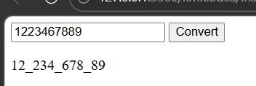
Task - 4:
Aim: To write a JavaScript program to find the most frequent item of an array.
Sample array : var arr1=[3, 'a', 'a', 'a', 2, 3, 'a', 3, 'a', 2, 4, 9, 3]; Sample Output : a ( 5 times )
CODE:
<!DOCTYPE html>
<html lang="en">
<head>
<meta charset="UTF-8">
<meta name="viewport" content="width=device-width, initial-scale=1.0">
<title>Document</title>
</head>
<body>
<script>
var arr=[3,'a','b','a','a','a','c'];
var len=arr.length;
var completed=[]
var mostFreq;
var maxcount=0;
for(let i=0;i<len;i++){
let count=0;
if (!(completed.includes(arr[i]))){
for (let j=i; j<len;j++){
if (arr[i]===arr[j]){
count+=1;
}
if (count>maxcount){
maxcount=count;
mostFreq=arr[i]
}
completed.push(arr[i])
}
document.write(mostFreq +" : "+maxcount +" times")
</script>

</body>
</html>
OUTPUT:
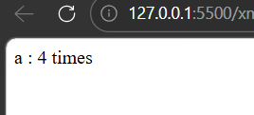
Task - 5:
Aim: To create an array of integers and write JavaScript code to:
- Find the largest and smallest element
- Count even and odd numbers
- Calculate the sum of all elements
Constraint: Use loops only (no built-in Math functions).
Code:
<!DOCTYPE html>
<html lang="en">
<head> <meta charset="UTF-8"> <meta name="viewport" content="width=device-width, initial-scale=1.0">
<title>Document</title>
</head>
<body> <input id="inputelement" type="text" placeholder="enter array numbers" > <br>
<button onclick="findsum()">Sum of array</button>
<br> <button onclick="findlargest()">largest Element</button> <br>
<button onclick="findsmallest()">smallest Element</button>
<br> <button onclick="counteven()">Count of even</button>
<br> <button onclick="countodd()">Count of odd </button>
<br>
<p id="wanted"></p>

<script>
let para = document.getElementById("wanted");
para.textContent = "";

function getArray() {
let input = document.getElementById("inputelement").value;
return input.split(",").map(Number);
}

function findsum() {
let a = getArray();
let sum = 0;

for (let i = 0; i < a.length; i++) {
sum += a[i];
}

para.textContent = "Sum is: " + sum;
}

function findlargest() {
let a = getArray();
let largest = a[0];

for (let i = 1; i < a.length; i++) {
if (a[i] > largest) {
largest = a[i];
}
}

para.textContent = "Largest is: " + largest;
}

function findsmallest() {
let a = getArray();
let smallest = a[0];

for (let i = 1; i < a.length; i++) {
if (a[i] < smallest) {
smallest = a[i];
}
}

para.textContent = "Smallest is: " + smallest;
}

function counteven() {
let a = getArray();
let evencount = 0;

for (let i = 0; i < a.length; i++) {
if (a[i] % 2 === 0) {
evencount++;
}
}
para.textContent = "Even count is: " + evencount;
}
function countodd() {
let a = getArray();
let oddcount = 0;
for (let i = 0; i < a.length; i++) {
if (a[i] % 2 !== 0) {
oddcount++;
}
}
para.textContent = "Odd count is: " + oddcount;
}
</script>
</body>
OUTPUT:
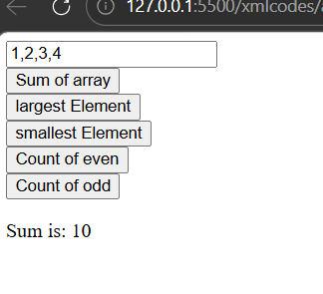
Task - 6:
Aim: Create a Java script code to generate a multiplication table asking the user to enter number of rows and columns. If user enters nothing or 0 then display multiplication table with 10 rows and 10 columns.
 |  |  |  |  |  |  |  |  | 10
 |  |  |  | 10 | 12 | 14 | 16 |  | 20
 |  |  | 12 |  |  | 21 | 24 | 27 | 30
 |  | 12 | 16 | 20 |  | 28 | 32 | 36 | 40
 | 10 | 15 | 20 | 25 | 30 | 35 | 40 | 45 | 50
 | 12 |  | 24 | 30 | 36 |  | 48 | 54 | 60
 | 14 | 21 | 28 | 35 | 42 | 49 | 56 | 63 | 70
 | 16 | 24 | 32 | 40 | 48 | 56 |  | 72 | so
 |  | 27 | 36 | 45 | 54 | 63 | 72 | 81 | 90
10 | 20 | 30 | 40 | so | 60 | 70 | so | 90 | 100
Code:
<!DOCTYPE html>
<html>
<head>
<title>Muliplication Table</title>
</head>
<body>
<input type="number" id="mtl " placeholder="Enter row size 0 -
<input type="number" id="mt2" placeholder="Enter column size 0 <button onclick=" generate()">Sumbit</button>
<table border=" I " id="table">
</table>
<script>
function generate() {
var row document.getElementById("mt1 ").value; v
ar column = document.getElementById("mt2").value; if(row == 0 Il column == 0){
- row = 10;
- column = 10;
var table — document.getElementById("table");
table.InnerHTML for(var i 1; i <= row; i++) {
- var tr = "<tr>", for(varj = 1; j <= column; j++){
- tr += "<td>" + (i * j) + "</td>";

table.innerHTML tr;
</script>
</body>
</html>
OUTPUT:
15 10  1234567 8 9 10  3 6 9 12 15 1821 24 27 30  5 10 15 20 25 3035 40 45 50  7 1421 28 35 42 49 56 63 70  8 16 24 32 40 48 56 64 72 80  11 22 33 44 55 66 77 88 99 110  12 24 36 48 60 72 84 | Sumbit

