Aim: To Design a Student Registration Form
HTML-code:
<!DOCTYPE html>
<html lang="en">
<head>
<meta charset="UTF-8">
<meta name="viewport" content="width=device-width, initial-scale=1.0">
<title>Student Registration Form</title>
<link rel="stylesheet" href="https://cdn.jsdelivr.net/npm/bootstrap@4.4.1/dist/css/bootstrap.min.css" integrity="sha384-Vkoo8x4CGsO3+Hhxv8T/Q5PaXtkKtu6ug5TOeNV6gBiFeWPGFN9MuhOf23Q9Ifjh" crossorigin="anonymous">
</head>
<style>
.cont1{
background-color: orange;
height:100vh;
padding:15px;
padding-left:20px;

}
.heading{
font-size:28px;
font-family:"Roboto";
}
</style>
<body>
<div class="cont1">
<h1 class="heading">Student Registration Form</h1>
<p>Fill in this from to register</p>
<label for ="firstname" >First Name : </label>
<input type="text" name="firstname">
<br>
<br>
<label for ="lastname" >Last name : </label>
<input type="text" name="last Name">
<br>
<br>
<label for ="email" >E-mail : </label>
<input type="email" name="email">
<br>
<br>
<label for="Date">Date of Birth: </label>
<input type="date" name="Date">
<br>
<br>
<label for ="user-name" >Set Username : </label>
<input type="text" name="user-name">
<br>
<br>
<label for ="password" >Password : </label>
<input type="password" name="password">
<br>

<h1 style="font-size:18px;">Gender :</h1>
<input type="radio" name="radiobutton" value="1">Male<br>
<input type="radio" name="radiobutton" value="1">Female<br>
<input type="radio" name="radiobutton" value="1">Others<br>
<br>
<label for="course">Course : </label>
<select name="course">
<option value="0">Course</option>
<option value="1">CSE</option>
<option value="2">IT</option>
<option value="3">ECE</option>
</select>
<br>
<br>
<button>Register</button>
</div>

</body>
</html>
OUTPUT:
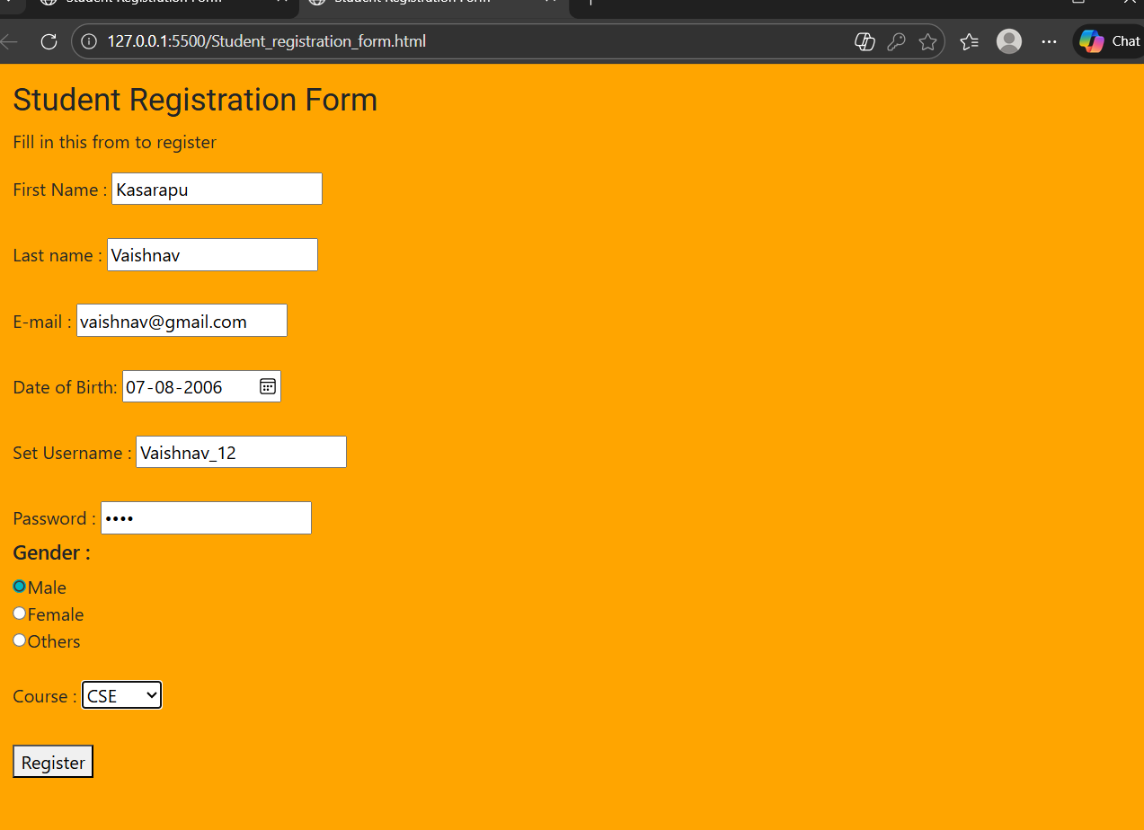

Aim: To create a resume
HTML-code:
<!DOCTYPE html>
<html lang="en">
<head>
<meta charset="UTF-8">
<meta name="viewport" content="width=device-width, initial-scale=1.0">
<title>Resume</title>
<link rel="stylesheet" href="https://cdn.jsdelivr.net/npm/bootstrap@4.4.1/dist/css/bootstrap.min.css" integrity="sha384-Vkoo8x4CGsO3+Hhxv8T/Q5PaXtkKtu6ug5TOeNV6gBiFeWPGFN9MuhOf23Q9Ifjh" crossorigin="anonymous">
<style>
.imagee{
height: 150px;
width:150px;
border-radius:75px;
}
.top-section{
background-color:rgb(183,160,133);
padding:10px
}
.top-para{
font-size:13px;
}
.bottom-section{
padding:15px;
}
.grid-container{
display: grid;
grid-template-rows: repeat(4, 50px);
grid-template-columns: 25% 75%;
column-gap: 1rem;
grid-column: 1/3;
}

.event-role{
font-weight: bold;;
}
.skills-intrests{
margin-left: 2rem;
margin-right: 2rem;
}
.skills{
display: grid;
grid-template-columns: repeat(3, 1fr);
column-gap: 1rem;
}
.skill-name{
margin-left: 1.5rem;
}

</style>
</head>
<body>
<div class="top-section">
<div class="d-flex flex-row">
<div>
<h1 style="font-size:24px">Vaishnav</h1>
<div class="d-flex flex-column">
<div style="padding:10px">
<p class="top-para">
Computer Science undergraduate with a strong interest in full-stack web development.
Passionate about building efficient, user-friendly applications using modern technologies.
Quick learner with a keen interest in exploring new tools, frameworks, and real-world problem solving.
</p>
</div>
<div class="d-flex flex-row justify-content-between" style="margin-left:10px;margin-right:10px;">
<p style="margin-right:50px"><svg xmlns="http://www.w3.org/2000/svg" width="16" height="16" fill="red" class="bi bi-telephone " viewBox="0 0 16 16">
<path d="M3.654 1.328a.678.678 0 0 0-1.015-.063L1.605 2.3c-.483.484-.661 1.169-.45 1.77a17.6 17.6 0 0 0 4.168 6.608 17.6 17.6 0 0 0 6.608 4.168c.601.211 1.286.033 1.77-.45l1.034-1.034a.678.678 0 0 0-.063-1.015l-2.307-1.794a.68.68 0 0 0-.58-.122l-2.19.547a1.75 1.75 0 0 1-1.657-.459L5.482 8.062a1.75 1.75 0 0 1-.46-1.657l.548-2.19a.68.68 0 0 0-.122-.58zM1.884.511a1.745 1.745 0 0 1 2.612.163L6.29 2.98c.329.423.445.974.315 1.494l-.547 2.19a.68.68 0 0 0 .178.643l2.457 2.457a.68.68 0 0 0 .644.178l2.189-.547a1.75 1.75 0 0 1 1.494.315l2.306 1.794c.829.645.905 1.87.163 2.611l-1.034 1.034c-.74.74-1.846 1.065-2.877.702a18.6 18.6 0 0 1-7.01-4.42 18.6 18.6 0 0 1-4.42-7.009c-.362-1.03-.037-2.137.703-2.877z"/>
</svg> +91 6281788585</p>
<p><svg xmlns="http://www.w3.org/2000/svg" width="16" height="16" fill="red" class="bi bi-envelope" viewBox="0 0 16 16">
<path d="M0 4a2 2 0 0 1 2-2h12a2 2 0 0 1 2 2v8a2 2 0 0 1-2 2H2a2 2 0 0 1-2-2zm2-1a1 1 0 0 0-1 1v.217l7 4.2 7-4.2V4a1 1 0 0 0-1-1zm13 2.383-4.708 2.825L15 11.105zm-.034 6.876-5.64-3.471L8 9.583l-1.326-.795-5.64 3.47A1 1 0 0 0 2 13h12a1 1 0 0 0 .966-.741M1 11.105l4.708-2.897L1 5.383z"/>
</svg> my@gmail.com</p>
</div>
</div>
</div>

<div style="padding:20px">
<img src="mypic.jpeg" class="imagee">
</div>

</div>
</div>
<div class="bottom-section">
<h1 style="font-size:18px;color:rgb(195,179,13);">Work Experience</h1>
<ul>
<li style="font-weight:bold">created a small website in nextwave platform.</li>
<p style="font-size:12px;"> sudhee 2025</p>
<ul>
<li style="list-style-type:disc;font-size:14px;">Maintained branched pull request in git hub.</li>
<li style="list-style-type:disc;font-size:14px;">Participated in hackathon </li>
</ul>
</ul>
<ul>

</ul>
<h1 style="font-size:18px;color:rgb(195,179,13);">Education</h1>
<h1 style="font-size:16px"> Chaitanya Bharathi Institute of Technology</h1>
<h1 style="font-size:14px"> CGPA : 9.7</h1>
<h1 style="font-size:12px">2024-2028</h1>

<h2 class="font-size:18px;color:rgb(195,179,13);">Extracurricular Activities</h2>
<div class="grid-container">
<p class="event-role">Volunteer in Chaitanya spandhana </p>
<p>Been part of technical events</p>
<p class="time">2026</p>
<p class="event-role">Member in CS</p>
<p>Conducted Interviews inorder to filter out volunteers for sudhee 2026</p>
<p class="time">2026</p>
</div>
</div>
<div class="skills-intrests">
<h2 class="sub-title">Skills & Interests</h2>
<div class="skills">
<div class="soft-skills">
<h3 class="skill-name">Soft Skills</h3>
<hr>
<ul>
<li>Problem Solving</li>
<li>sql</li>
<li>Video Editing</li>
<li>Python</li>
</ul>
</div>
<div class="hard-skills">
<h3 class="skill-name">Hard Skills</h3>
<hr>
<ul>
<li>Good Communication Skills</li>
<li>Team Work</li>
<li>Crisis Handling</li>
</ul>
</div>
<div class="intrests">
<h3 class="skill-name">Interests</h3>
<hr>
<ul>
<li>Travel</li>
<li>Programming</li>
</ul>
</div>
</div>

</div>

</body>
</html>
OUTPUT:
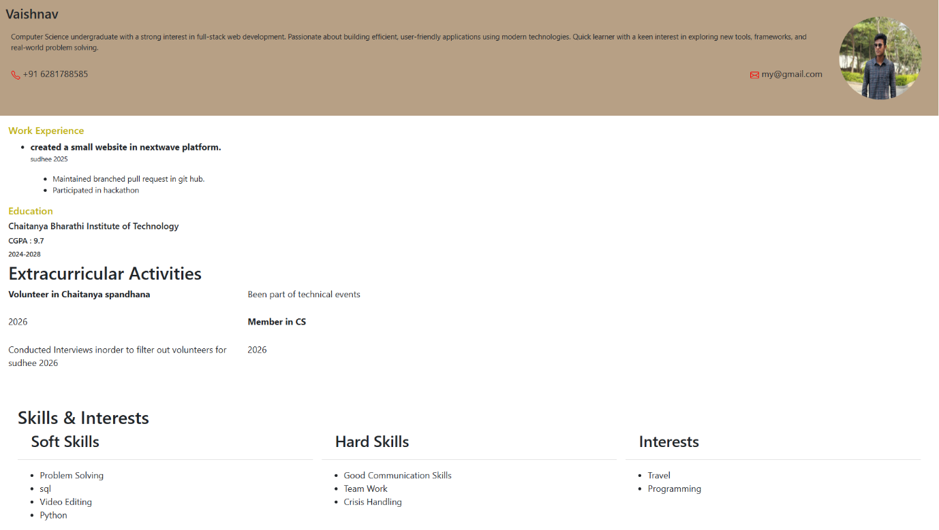

Aim: To create web page given image using Box Model CSS
HTML-code:
<!DOCTYPE html>
<html lang="en">
<head>
<title>CSS Box Model</title>
<style>
.box1{
background-color: #ff776a;
border: 3px solid black;
}
.heading1{
padding: 1rem;
font-size: 24px;
}
.box2{
background-color: paleturquoise;
border: 8px solid darkblue;
margin-top: 1rem;
}
p{
padding-left: 1rem;
}
.para3{
background-color: paleturquoise;
border: 8px solid darkblue;
margin-top: 1rem;
}
.yellow-bg{
background-color: yellow;
color: red;
}
li{
color: magenta;
}
.box3{
background-color: paleturquoise;
border: 8px solid darkblue;
}
#white-bg{
background-color: white;
display: inline-block;
}
.white-bg{
background-color: white;
padding: 1rem 4px;
border:4px solid black;
}

</style>
</head>
<body>
<div class="box1">
<h1 class="heading1">Box Model</h1>
</div>
<div class="box2">
<p class="para2">Every element on the page has its own box, which can be styled using CSS.</p>
</div>
<div class="box3">
<p class="para2">From the inside out: </p>
</div>
<ul>
<li class="yellow-bg">content</li>
<li>padding</li>
<li class="yellow-bg">border</li>
<li>margin</li>
</ul>
<h2>Background</h2>
<div class="para3-div">
<p class="para3">Keep in mind that a <span class="white-bg">background</span> will cover the content ans the padding.</p>
</div>
</body>
</html>

OUTPUT:

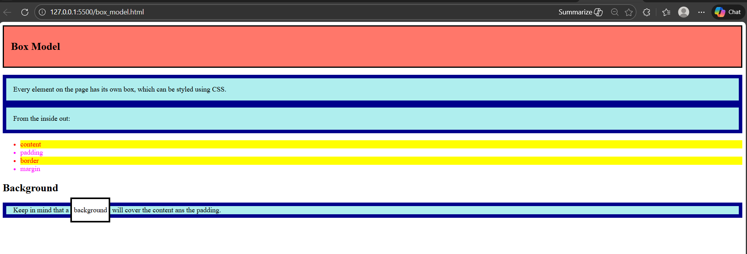

Aim: To Design an 8x8 checkerboard pattern where alternating cells are black and white.
And to Add a hover effect that changes the background color of any square when the mouse
is over it.

HTML-code:
<!DOCTYPE html>
<html lang="en">
<head>
<title>Chess Board</title>
<style>
.board{
display: grid;
width: 817px;
grid-template-columns: repeat(8, 100px);
row-gap: 2px;
column-gap: 2px;
border: 1px solid red;
padding: 3px;
}
.cell{
width: 100px;
height: 100px;
}
.black-cell{
background-color: black;
transition: background-color 0.5s ease-out;
&:hover{
background-color: darkslategray;
}
}
.white-cell{
background-color: white;
transition: background-color 0.5s ease-out;
&:hover{
background-color: lightgoldenrodyellow;
}
}

</style>
</head>
<body>
<div class="board">
<div class="cell black-cell"></div>
<div class="cell white-cell"></div>
<div class="cell black-cell"></div>
<div class="cell white-cell"></div>
<div class="cell black-cell"></div>
<div class="cell white-cell"></div>
<div class="cell black-cell"></div>
<div class="cell white-cell"></div>
<div class="cell white-cell"></div>
<div class="cell black-cell"></div>
<div class="cell white-cell"></div>
<div class="cell black-cell"></div>
<div class="cell white-cell"></div>
<div class="cell black-cell"></div>
<div class="cell white-cell"></div>
<div class="cell black-cell"></div>
<div class="cell black-cell"></div>
<div class="cell white-cell"></div>
<div class="cell black-cell"></div>
<div class="cell white-cell"></div>
<div class="cell black-cell"></div>
<div class="cell white-cell"></div>
<div class="cell black-cell"></div>
<div class="cell white-cell"></div>
<div class="cell white-cell"></div>
<div class="cell black-cell"></div>
<div class="cell white-cell"></div>
<div class="cell black-cell"></div>
<div class="cell white-cell"></div>
<div class="cell black-cell"></div>
<div class="cell white-cell"></div>
<div class="cell black-cell"></div>
<div class="cell black-cell"></div>
<div class="cell white-cell"></div>
<div class="cell black-cell"></div>
<div class="cell white-cell"></div>
<div class="cell black-cell"></div>
<div class="cell white-cell"></div>
<div class="cell black-cell"></div>
<div class="cell white-cell"></div>
<div class="cell white-cell"></div>
<div class="cell black-cell"></div>
<div class="cell white-cell"></div>
<div class="cell black-cell"></div>
<div class="cell white-cell"></div>
<div class="cell black-cell"></div>
<div class="cell white-cell"></div>
<div class="cell black-cell"></div>
<div class="cell black-cell"></div>
<div class="cell white-cell"></div>
<div class="cell black-cell"></div>
<div class="cell white-cell"></div>
<div class="cell black-cell"></div>
<div class="cell white-cell"></div>
<div class="cell black-cell"></div>
<div class="cell white-cell"></div>
<div class="cell white-cell"></div>
<div class="cell black-cell"></div>
<div class="cell white-cell"></div>
<div class="cell black-cell"></div>
<div class="cell white-cell"></div>
<div class="cell black-cell"></div>
<div class="cell white-cell"></div>
<div class="cell black-cell"></div>
</div>
</body>
</html>

OUTPUT:
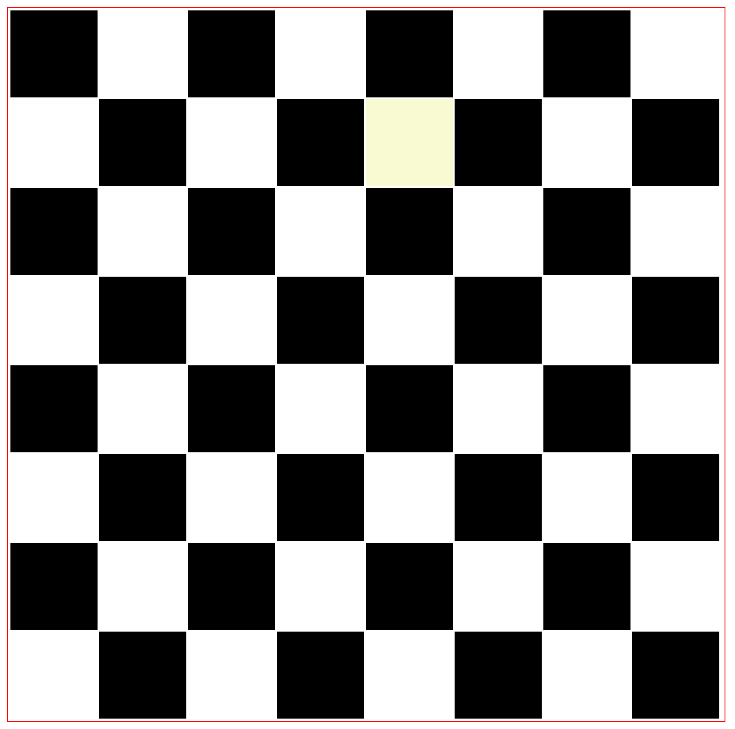

Aim: To Create a page with:
• A heading that reads "VIBGYOR IMPLEMENTATION" styled appropriately.
• A set of vertically aligned, evenly spaced colored columns (matching the VIBGYOR
sequence).
• Add hover effects to change the brightness of each column when hovered over.

HTML-code:
<!DOCTYPE html>
<html lang="en">
<head>
<title>Vibgyor</title>
<style>
.vibgyor{
display: grid;
grid-template-columns: repeat(7, 1fr);
column-gap: 1rem;
& > div{
height: 100vh;
transition: filter 0.3s ease;
&:hover{
filter: brightness(1.3);
}
}
}
.violet{
background-color: #7F00FF;
}
.indigo{
background-color: indigo;
}
.blue{
background-color: blue;
}
.green{
background-color: green;
}
.yellow{
background-color: yellow;
}
.orange{
background-color: orange;
}
.red{
background-color: red;
}

</style>
</head>
<body>
<div class="vibgyor">
<div class="violet"></div>
<div class="indigo"></div>
<div class="blue"></div>
<div class="green"></div>
<div class="yellow"></div>
<div class="orange"></div>
<div class="red"></div>
</div>
</body>
</html>

OUTPUT:
