

CSE1030
C# PROGRAMMING AND .NETFARMEWORK

Submitted By:
Vaishnavi P
A86605224221
BCA

INDEX
Sl.No. |  | Program Title |  | Page No. |  | Signature
1. |  | Write a C# program to display system date , time and user details
2. |  | Write a program to perform arithmetic , relational and logical operations using user input
3. |  | Write a program to check eligibility for voting using conditional statements.
4. |  | Program to generate multiplication table using loops
5. |  | Write a program to generate Fibonacci series and amstrong numbers.
6. |  | Write a C# program to find fractorial of a number and the sum of digits using Recursion
7. |  | Write a C# program to validate a username and password using conditional logic.
8. |  | Write a C# program to demonstrate one dimensional array operations such as calculating the sum and average of elements.
9. | Write a C# program to sort elements in an array in ascending order.
10. | Write a C# program to demonstrate string operations (length, concatenation, comparison).
11. | Write the sample program to print a different greeting, for example, "Good Day!"
12. | Write a console application that prints your first and last name on the console.
13. | Write a program that prints the following numbers on the console: 1, 101, 1001, each on a new line.
14. | Write a program that prints on the console the current date and time.
15. | Write a program that prints the square root of 12345.
16. | Write a program that prints the first 100 members of the sequence 2, -3, 4, -5, 6, -7, 8.
17. | Write a program that reads your age from the console and prints your age after 10 years.

01. Write a C# program to display system date , time and user details
using System;
using System.Data;
using System.Threading.Tasks;

namespace FirstProgram
{
internal class Program
{
static void Main(string[] args)
{
Console.WriteLine("System Time : " + DateTime.Now.ToShortTimeString());
Console.WriteLine("System Date : " + DateTime.Today.ToString());
Console.WriteLine("System Name : " + Environment.UserName);
Console.WriteLine("Machine Name : "+ Environment.MachineName);
}
}
}

OUTPUT
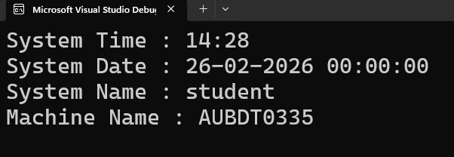

02. Write a program to perform arithmetic , relational and logical operations using user input

using System;
class Program
{
static void Main()
{

Console.Write("Enter first number: ");
int num1 = Convert.ToInt32(Console.ReadLine());

Console.Write("Enter second number: ");
int num2 = Convert.ToInt32(Console.ReadLine());
Console.WriteLine("--- Arithmetic Operations ---");
Console.WriteLine("Addition: " + (num1 + num2));
Console.WriteLine("Subtraction: " + (num1 - num2));
Console.WriteLine("Multiplication: " + (num1 * num2));
Console.WriteLine("Division: " + (num1 / num2));
Console.WriteLine("Modulus: " + (num1 % num2));

Console.WriteLine("--- Relational Operations ---");
Console.WriteLine("Equal: " + (num1 == num2));
Console.WriteLine("Not Equal: " + (num1 != num2));
Console.WriteLine("Greater Than: " + (num1 > num2));
Console.WriteLine("Less Than: " + (num1 < num2));
Console.WriteLine("Greater or Equal: " + (num1 >= num2));
Console.WriteLine("Less or Equal: " + (num1 <= num2));

Console.WriteLine("--- Logical Operations ---");
Console.WriteLine("AND (num1 > 0 && num2 > 0): " + (num1 > 0 && num2 > 0));
Console.WriteLine("OR (num1 > 0 || num2 > 0): " + (num1 > 0 || num2 > 0));
Console.WriteLine("NOT (num1 > 0): " + !(num1 > 0));
Console.ReadLine();
}
}

OUTPUT
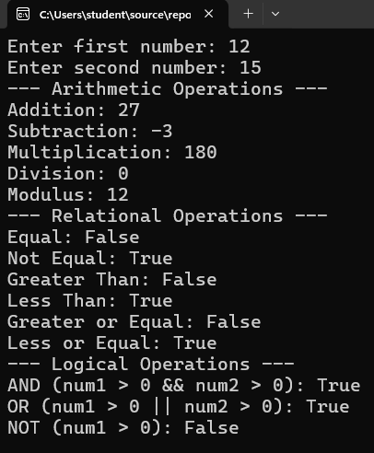

03. Write a program to check eligibility for voting using conditional statements.
using System;
using System.Collections.Generic;
using System.Linq;
using System.Text;
using System.Threading.Tasks;

namespace _3_program
{
internal class Program
{
static void Main(string[] args)
{
Console.Write("Enter your age: ");
int age = Convert.ToInt32(Console.ReadLine());

if (age >= 18)
{
Console.WriteLine("You are eligible to vote.");
}
else
{
Console.WriteLine("You are not eligible to vote.");
}
Console.ReadLine();
}
}
}

OUTPUT
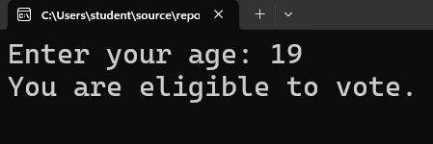

04. Program to generate multiplication table using loops

using System;
class Program
{
static void Main()
{
Console.Write("Enter a number: ");
int number = Convert.ToInt32(Console.ReadLine());

Console.WriteLine("\nMultiplication Table for " + number);

for (int i = 1; i <= 10; i++)
{
Console.WriteLine(number + " x " + i + " = " + (number * i));
}

Console.ReadLine();
}
}

OUTPUT
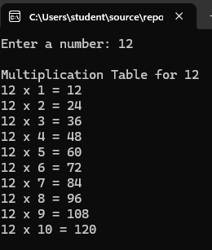

05. Write a program to generate Fibonacci series and amstrong numbers

using System;
class Program
{
static void Main()
{
Console.Write("Enter the number of terms for the Fibonacci series: ");
int n = Convert.ToInt32(Console.ReadLine());

int first = 0, second = 1;

Console.WriteLine("\nFibonacci Series:");
for (int i = 1; i <= n; i++)
{
Console.Write(first + " ");
int next = first + second;
first = second;
second = next;
}

Console.WriteLine();
Console.ReadLine();
}
}

OUTPUT
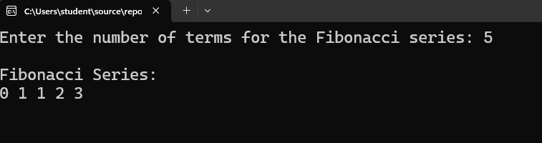

06. Program to find factorial and sum of digits using recursion

using System;

class RecursionExample
{
static int Factorial(int n)
{
if (n == 0 || n == 1)
return 1;
return n * Factorial(n - 1);
}

static int SumOfDigits(int n)
{
if (n == 0)
return 0;
return (n % 10) + SumOfDigits(n / 10);
}

static void Main()
{
Console.Write("Enter a number: ");
int num = int.Parse(Console.ReadLine());

Console.WriteLine("Factorial: " + Factorial(num));
Console.WriteLine("Sum of Digits: " + SumOfDigits(num));
}
OUTPUT
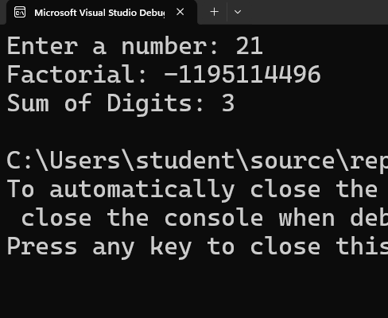
07. Program to validate a username and password using conditional logic.

using System;

class LoginValidation
{
static void Main()
{
string correctUsername = "admin";
string correctPassword = "1234";

Console.Write("Enter Username: ");
string username = Console.ReadLine();

Console.Write("Enter Password: ");
string password = Console.ReadLine();

if (username == correctUsername && password == correctPassword)
{
Console.WriteLine("Login Successful!");
}
else
{
Console.WriteLine("Invalid Username or Password.");
}
}
}

OUTPUT
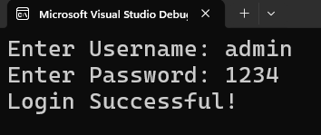

08. Program to demonstrate one-dimensional array operations (sum, average)

using System;
class ArrayOperations
{
static void Main()
{
int[] numbers = new int[5];
int sum = 0;

Console.WriteLine("Enter 5 numbers:");
// Input elements into array
for (int i = 0; i < numbers.Length; i++)
{
Console.Write("Element " + (i + 1) + ": ");
numbers[i] = int.Parse(Console.ReadLine());
}
// Calculate sum
for (int i = 0; i < numbers.Length; i++)
{
sum += numbers[i];
}
// Calculate average
double average = (double)sum / numbers.Length;
Console.WriteLine("\nSum = " + sum);
Console.WriteLine("Average = " + average);
}
}
OUTPUT
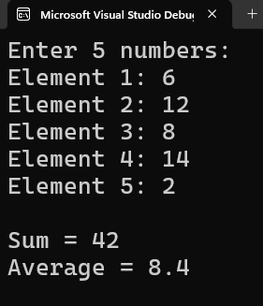

09. Program to sort elements in an array in ascending order.

using System;

class SortArray
{
static void Main()
{
int[] arr = { 5, 2, 8, 1, 3 };

Array.Sort(arr);

Console.WriteLine("Sorted Array (Ascending):");
foreach (int num in arr)
{
Console.Write(num + " ");
}
}
}

OUTPUT
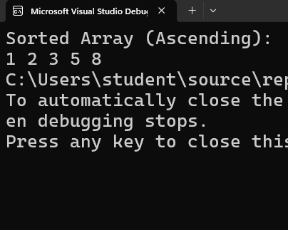

10. Program to demonstrate string operations (length, concatenation, comparison).

using System;

class StringOperations
{
static void Main()
{
Console.Write("Enter first string: ");
string str1 = Console.ReadLine();

Console.Write("Enter second string: ");
string str2 = Console.ReadLine();

// Length
Console.WriteLine("Length of first string: " + str1.Length);

// Concatenation
string combined = str1 + " " + str2;
Console.WriteLine("Concatenated String: " + combined);

// Comparison
if (str1.Equals(str2))
{
Console.WriteLine("Both strings are equal.");
}
else
{
Console.WriteLine("Strings are not equal.");
}
}
}

OUTPUT
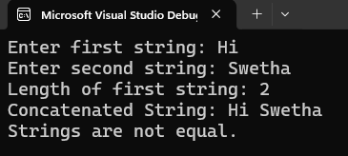

11. Write the sample program to print a different greeting, for example, "Good Day!"

using System;

class Program
{
static void Main()
{
Console.WriteLine("Good Day!");
}
}

OUTPUT
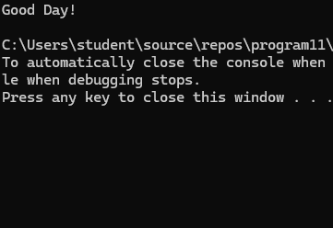
12. Write a console application that prints your first and last name on the console.
using System;

class Program
{
static void Main(string[] args)
{
string firstName = "Arhaan";
string lastName = "Aryan";
Console.WriteLine("First Name: " + firstName);
Console.WriteLine("Last Name: " + lastName);
Console.ReadKey();
}
}

OUTPUT
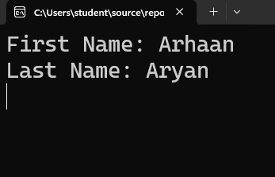

13. Write a program that prints the following numbers on the console: 1, 101, 1001, each on a new line.
using System;

class Program
{
static void Main()
{
Console.WriteLine(1);
Console.WriteLine(101);
Console.WriteLine(1001);
}
}

OUTPUT
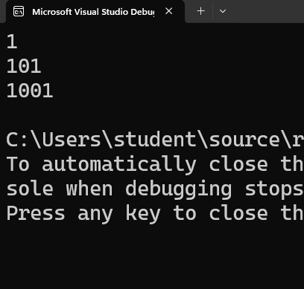
14. Write a program that prints on the console the current date and time.
using System;

class Program
{
static void Main()
{
DateTime now = DateTime.Now;
Console.WriteLine("Current Date and Time: " + now);
}
}
OUTPUT
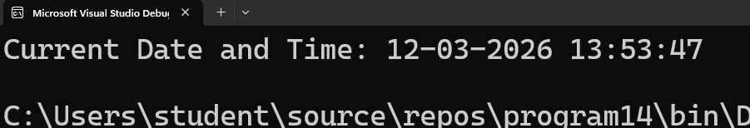

15. Write a program that prints the square root of 12345.
using System;

class Program
{
static void Main()
{
double number = 12345;
double result = Math.Sqrt(number);
Console.WriteLine("The square root of " + number + " is " + result);
}
}
OUTPUT
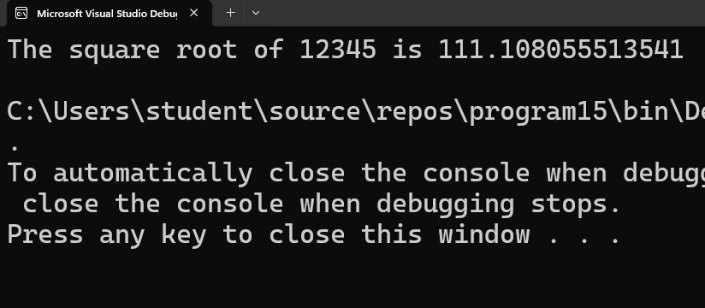

16. Write a program that prints the first 100 members of the sequence 2, -3, 4, -5, 6, -7, 8.
using System;

class Program
{
static void Main()
{
int count = 100;
for (int i = 0; i < count; i++)
{
int number = i + 2;
if (i % 2 == 1)
{
number = -number;
}
Console.Write(number);
if (i < count - 1)
{
Console.Write(", ");
}
}
}
}

OUTPUT
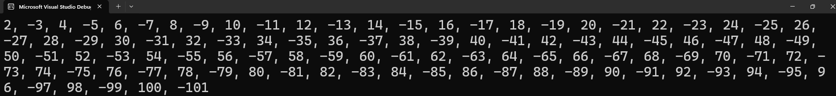

17. Write a program that reads your age from the console and prints yourage after 10 years.
using System;

class Program
{
static void Main()
{
Console.Write("Enter your age: ");
int age = Convert.ToInt32(Console.ReadLine());
int futureAge = age + 10;
Console.WriteLine("Your age after 10 years will be: " + futureAge);
}
}

OUTPUT
