📄 PriceOptima – Dynamic Pricing System
Project Documentation
1. Project Overview
Price Optima is a data-driven Dynamic Pricing System designed to optimize product prices based on demand patterns, competitor behaviour, seasonality, inventory levels, and profitability.
The system uses machine learning models to recommend prices that maximize revenue, profit, and conversion rates.
3. Key Performance Indicators (KPIs)
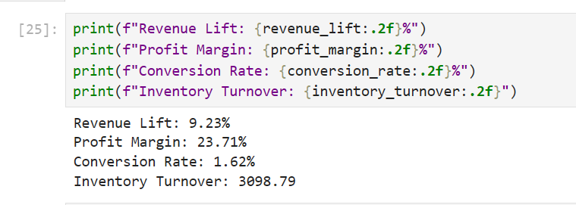
3.1 Revenue Lift
- Measures increase in revenue due to dynamic pricing.
- Formula:
((New Revenue – Old Revenue) / Old Revenue) × 100
- Expected Target: 8–12% improvement.
3.2 Profit Margin Improvement
- Ensures dynamic pricing does not reduce profitability.
- Evaluated per product and overall profit margin.
3.3 Conversion Rate
- Percentage of visitors who completed a purchase.
- Helps measure demand sensitivity.
3.4 Inventory Turnover
- Measures how fast inventory moves after applying new pricing.
- Helps prevent overstock and stockouts.

4. Dataset Description

4.1 Datasets Used
- dataset includes:
Column Name | Description
Date | Transaction date
Product ID | Unique product code
Product Name | Product label
Category | Product category
Pricing_Type | Baseline or dynamic pricing
Price | Selling price
Cost Price | Cost of the product
Units Sold | Quantity sold
Visitors | Page or store visitors
Conversion Rate % | Visitors → buyers
Revenue | Total revenue
Profit | Profit per transaction
Profit Margin % | Profit %
Stock Level | Current inventory
Inventory Turnover | Movement of stock
Competitor Price | Price of competitor product
Restock Date | Next stock date
5. Data Preparation & Validation
5.1 Validation Checks
- Missing values check
- Duplicates removal
- Correct data types
- Outlier detection using boxplots
- Dropping columns with 100% missing values
- Ensuring consistency in date format

6. Static Revenue Vs Rule Based Revenue
With static pricing, the total revenue was around 123.8 million.
After applying rule-based pricing, revenue increased to 130.5 million.
This resulted in a revenue lift of 5.42%, which shows that rule-based pricing is more effective than static pricing.

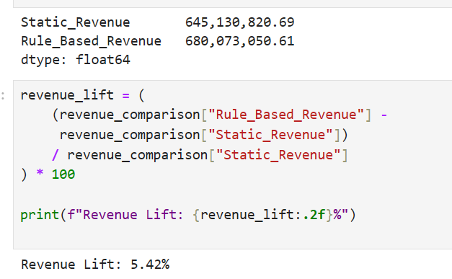

7. LightGBM and XGBoost Model Evaluation
MAE, or Mean Absolute Error, measures the average difference between predicted and actual values.
Lower MAE means better prediction accuracy.
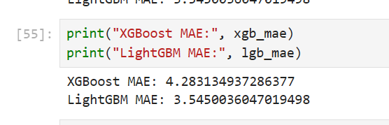

8. Static Revenue, rule based Revenue and ML Revenue
Revenue increased because prices were adjusted only when demand was high and discounts were given only when stock was high. This avoids unnecessary discounts and captures maximum value during high-demand periods. The ML-based approach generated a revenue of around 125.9 million, with a lift of 1.70%.
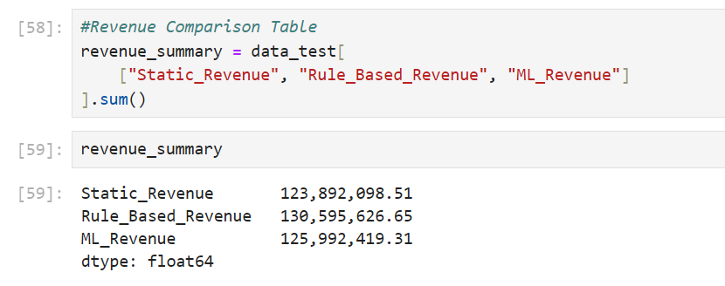

9. LightGBM Model Creation
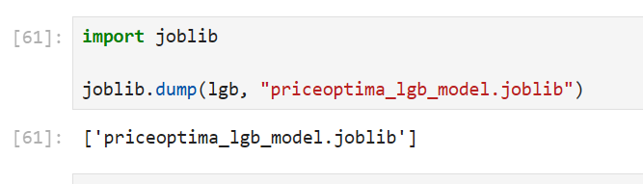
10. Fast API Dashboard
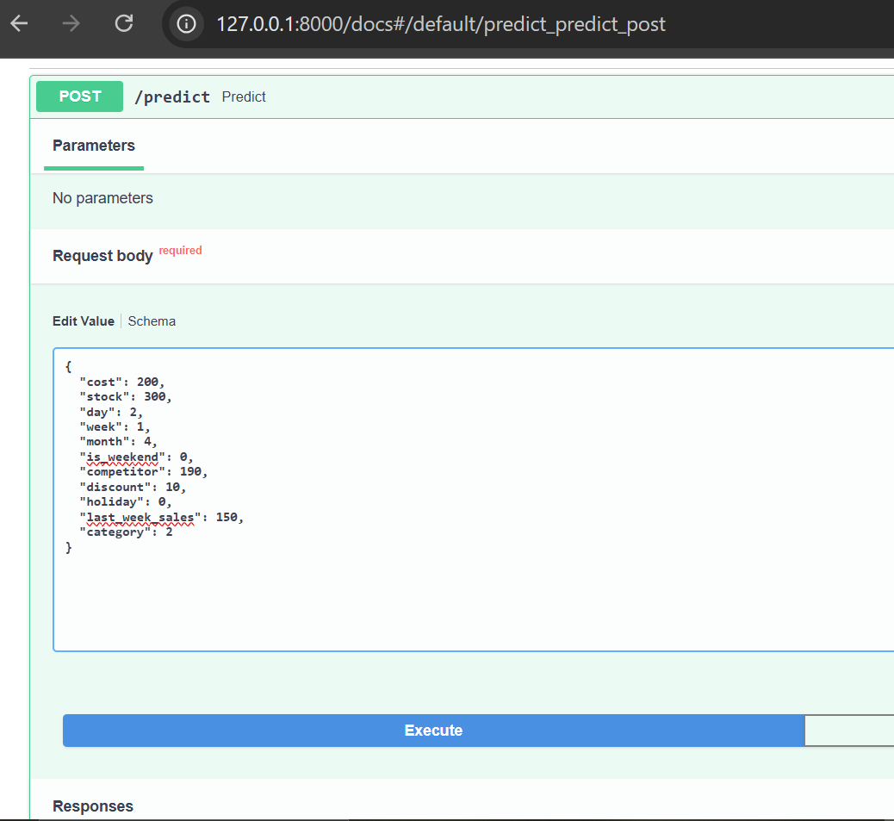

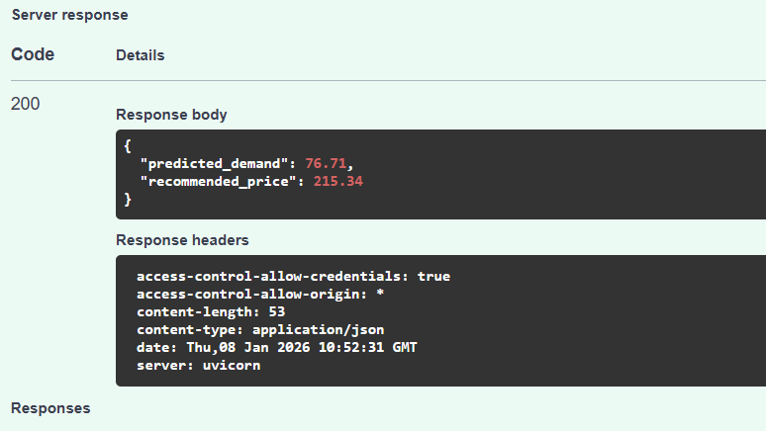
11. React Dashboard
