📄 PriceOptima – Dynamic Pricing System
Project Documentation
1. Project Overview
PriceOptima is a data-driven Dynamic Pricing System designed to optimize product prices based on demand patterns, competitor behaviour, seasonality, inventory levels, and profitability.
The system uses machine learning models to recommend prices that maximize revenue, profit, and conversion rates.
2. Objectives of the Project
- Implement a dynamic pricing strategy using data science.
- Improve revenue, profit margin, and inventory efficiency.
- Analyse factors affecting demand (season, price, competitor price, etc.)
- Build a predictive model that suggests optimal price points.
3. Key Performance Indicators (KPIs)
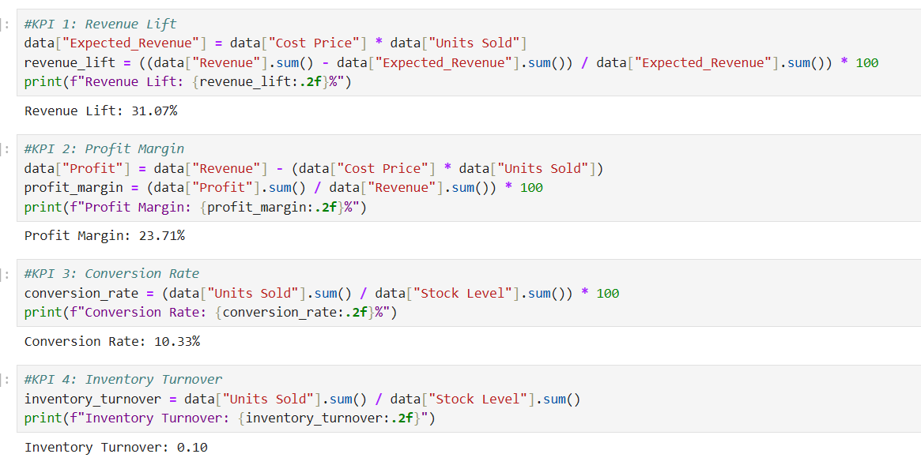
3.1 Revenue Lift
- Measures increase in revenue due to dynamic pricing.
- Formula:
((New Revenue – Old Revenue) / Old Revenue) × 100
- Expected Target: 8–12% improvement.
3.2 Profit Margin Improvement
- Ensures dynamic pricing does not reduce profitability.
- Evaluated per product and overall profit margin.
3.3 Conversion Rate
- Percentage of visitors who completed a purchase.
- Helps measure demand sensitivity.
3.4 Inventory Turnover
- Measures how fast inventory moves after applying new pricing.
- Helps prevent overstock and stockouts.

4. Dataset Description

4.1 Datasets Used
- dataset includes:
Column Name | Description
Date | Transaction date
Product ID | Unique product code
Product Name | Product label
Category | Product category
Pricing_Type | Baseline or dynamic pricing
Price | Selling price
Cost Price | Cost of the product
Units Sold | Quantity sold
Visitors | Page or store visitors
Conversion Rate % | Visitors → buyers
Revenue | Total revenue
Profit | Profit per transaction
Profit Margin % | Profit %
Stock Level | Current inventory
Inventory Turnover | Movement of stock
Competitor Price | Price of competitor product
Restock Date | Next stock date
5. Data Preparation & Validation
5.1 Validation Checks
- Missing values check
- Duplicates removal
- Correct data types
- Outlier detection using boxplots
- Dropping columns with 100% missing values
- Ensuring consistency in date format
5.2 Issues Found
- Some columns had 30,000 missing values → dropped
- Outliers detected in Price, Units Sold, Revenue → treated using IQR
- Some date fields converted to datetime format

6. Feature Engineering
6.1 Time-Based Features
- Day, Month, Year
- Day of Week, Weekend Flag
- Season
- Holiday Indicator
6.2 Price-Based Features
- Lag Price (previous day/week)
- Price Change %
- Discount %
6.3 Demand Features
- Lag sales (1, 7, 30 days)
- Rolling averages
- Demand volatility
6.4 Price Elasticity
- Elasticity = % change in quantity / % change in price
- Classifications: High / Medium / Low elasticity
6.5 Competitor Features
- Competitor price difference
- Competitor cheaper flag
6.6 Inventory Features
- Inventory ratio
- Days until stock-out
- Low-stock & Overstock indicators
6.7 Profit Features
- Profit per unit
- Profit margin
6.8 Interaction Features
- Weekend × Price
- Season × Discount
- Inventory × Price
6.9 Categorical Encoding
Applied one-hot encoding for:
- Category
- Season
- Elasticity Class

