**GITHUB BASIC IMPLEMENTATION**

1. Initialize the git repository and config the credentials

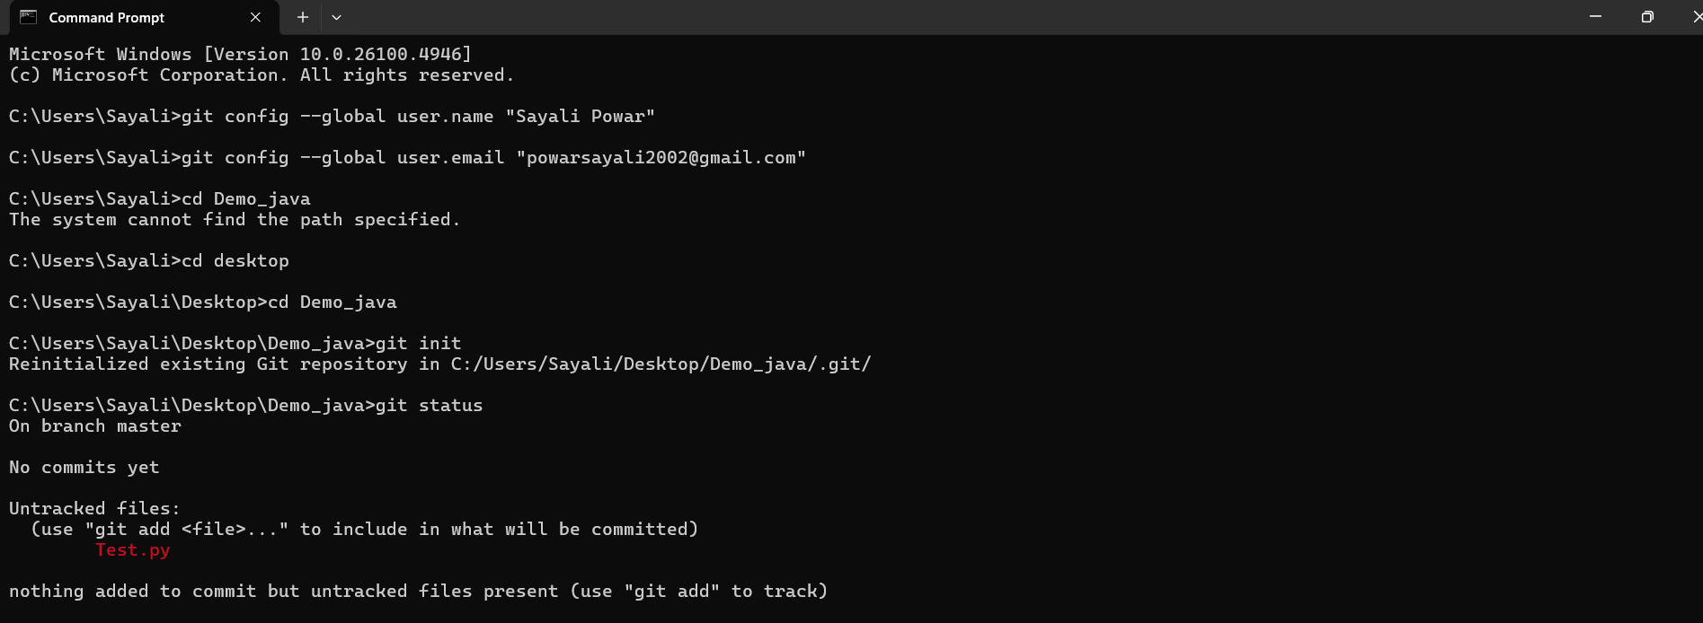

2. Created the remote repository

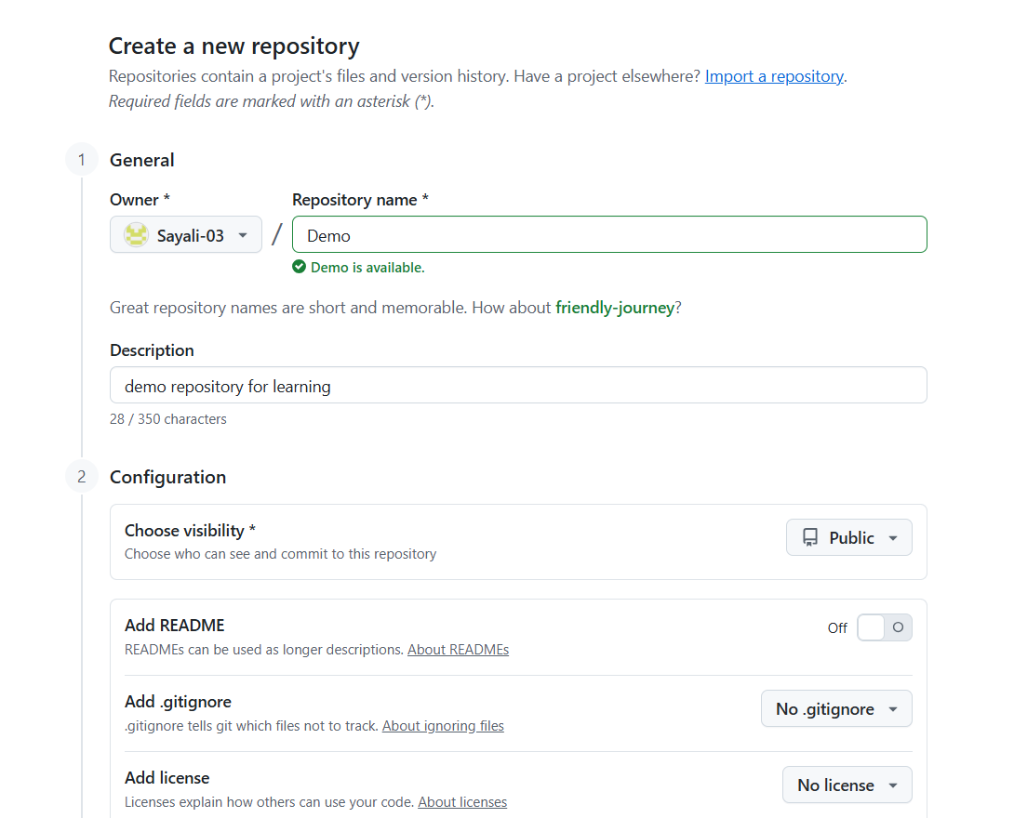

3. Created file test.py

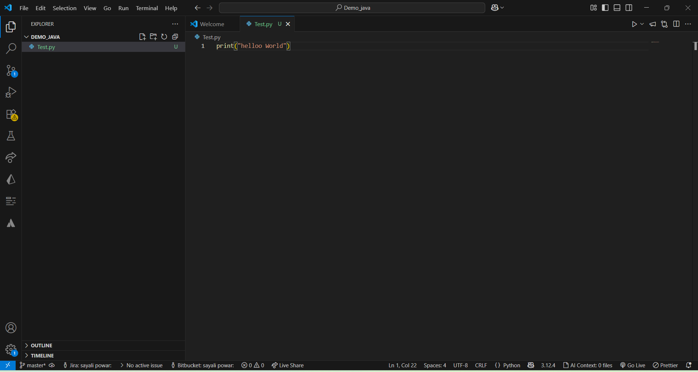

4. Added the file test.py

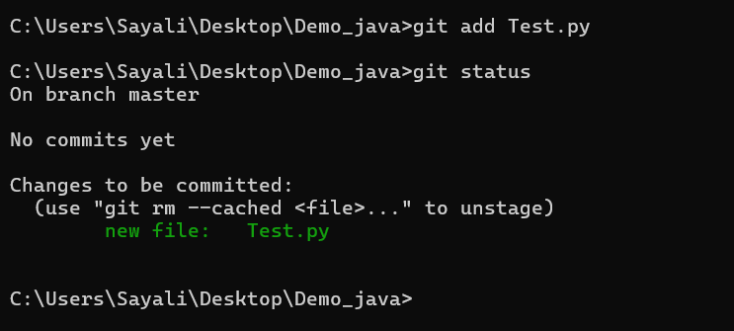

5. Initial commit to stage the file.

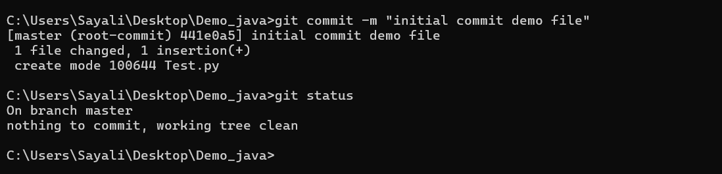

6. Change the Branch name to main

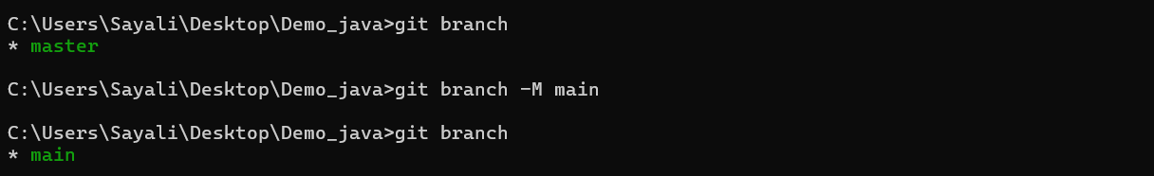

7. Push the local files to remote repository.

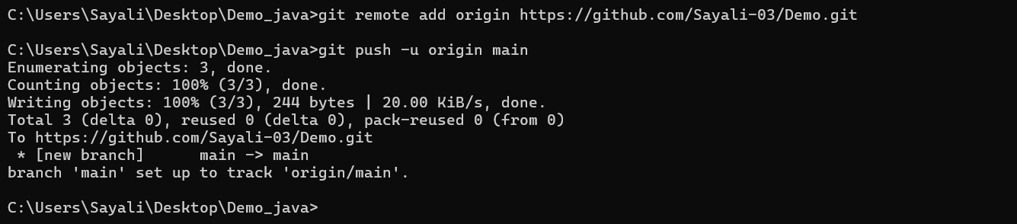

8. Remote repository with pushed files -

