***1.binary to decimal***

let n = (prompt("Enter the number:"));

let sum = 0;

let p = 1;

while (n > 0) {

let n1 = n % 10;

n = Math.floor(n / 10);

sum += n1 * p;

p *= 2;

}

console.log("Decimal =", sum);

***output:***

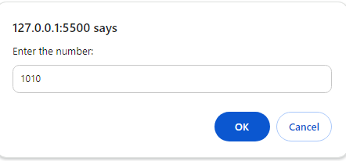

Decimal = 10

***2. decimal to binary***

let n =(prompt("Enter the number:"));

let sum = 0;

let p = 1;

while (n > 0) {

let n1 = n % 2;

n = Math.floor(n / 2);

sum += n1 * p;

p *= 10;

}

console.log("Decimal =", sum);

***output:***

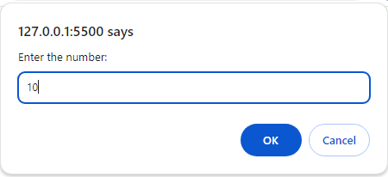

Decimal = 1010