***1.factorial***

number = 5;

let factorial = 1;

let i = 1;

while (i <= number) {

factorial *= i;

i++;

}

console.log("Factorial of " + number + " is " + factorial);

***output:***

Factorial of 5 is 120

***2.prime***

let number = 5;

let flag = 0;

let isPrime = true;

let i = 2;

while (i <= number / 2) {

if (number % i == 0) {

isPrime = false;

break;

}

i++;

}

if (isPrime) {

console.log(number + " is a prime number.");

} else {

console.log(number + " is not a prime number.");

}

***Output:***

5 is a prime number.

***3.multiplication table***

let n = 5;

let i = 1;

while (i <= 10) {

console.log(n + "*" + i + "=" + n * i);

i++;

}

***Output:***

5*1=5

5*2=10

5*3=15

5*4=20

5*5=25

5*6=30

5*7=35

5*8=40

5*9=45

5*10=50

***4.pronic number***

let number = 20;

let flag = 0;

let isPronic = false;

let i = 1;

while (i <= number) {

if (i * (i + 1) == number) {

isPronic = true;

break;

}

i++;

}

if (isPronic) {

console.log(number + " is a pronic number.");

} else {

console.log(number + " is not a pronic number.");

}

***Output:***

20 is a pronic number.

***5.perfect number***

let number = 28;

let flag = 0;

let sum = 0;

let i = 1;

while (i < number) {

if (number % i == 0) {

sum = sum + i;

}

i++;

}

if (sum == number) {

console.log(number + " is a perfect number.");

} else {

console.log(number + " is not a perfect number.");

}

***Output:***

28 is a perfect number.

***6.reverse number***

let n = 123;

let n1;

let sum = 0;

while (n > 0) {

n1 = n % 10;

n = Math.floor(n / 10);

sum = sum * 10 + n1;

}

console.log("sum is:" + sum);

***output:***

sum is:321

***7.palindrome number***

let n = prompt("enter the number");

let n1,

sum = 0;

let p;

p = n;

while (n > 0) {

n1 = n % 10;

n = Math.floor(n / 10);

sum = sum * 10 + n1;

}

if (p == sum) {

console.log(" palendrome number ");

} else {

console.log(" not palindrome number");

}

***Output:***

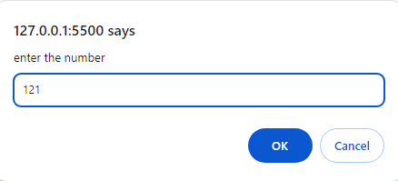

palendrome number

***8.sum ofdigit***

let n = 123;

let n1,

sum = 0;

while (n > 0) {

n1 = n % 10;

n = Math.floor(n / 10);

sum = sum + n1;

}

console.log("sum is:" + sum);

***output:***

sum is:6

***9.armstrong number***

let n = prompt("enter the number");

let n1,

sum = 0,

p;

p = n;

while (n > 0) {

n1 = n % 10;

n = Math.floor(n / 10);

sum = sum + n1 * n1 * n1;

}

if (sum == p) {

console.log(" armstrong number ");

} else {

console.log(" not armstrong number");

}

***Output:***

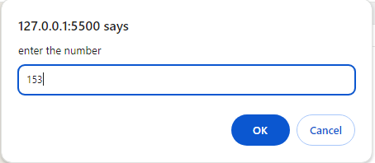

armstrong number

***10.krishnmurty number***

let n = 145;

let sum = 0;

let t = n;

while (n > 0) {

n1 = n % 10;

f1 = 1;

for (i = 1; i <= n1; i++) {

f1 *= i;

}

sum += f1;

n = Math.floor(n / 10);

}

if (sum == t) {

console.log("Krishnmurty ");

} else {

console.log("Not Krishnmurty");

}

***Output:***

Krishnmurty