***1.password check using do while***

let password;

do {

password = prompt("enter your pin:");

} while (password !== "1234");

console.log("your device is unlocked ");

***output:***

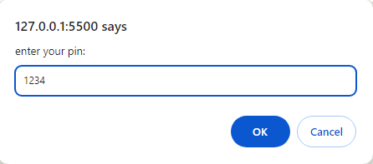

your device is unlocked

***2.sum of digit using do while***

let n = 22;

let sum = 0;

do {

n1 = n % 10;

n = Math.floor(n / 10);

sum = sum + n1;

} while (n > 0);

console.log("Sum of digit =" + sum);

***output:***

Sum of digit =4

***3.prime using do while***

let n = 2;

let limit = 10;

do {

let isPrime = true;

for (let i = 2; i < n; i++) {

if (n % i === 0) {

isPrime = false;

break;

}

}

if (isPrime) {

console.log(n + " is the prime number");

} else {

console.log(n + "is not prime number");

}

n++;

} while (n <= limit);

***Output:***

2 is the prime number

3 is the prime number

4is not prime number

5 is the prime number

6is not prime number

7 is the prime number

8is not prime number

9is not prime number

10is not prime number

***4.print even 2 to 10 using while loop***

let i = 2;

do {

console.log(i);

i += 2;

} while (i <= 10);

***Output:***

2

4

6

8

10

***5.series of square using do while***

let n = 1;

do {

let square = n * n;

console.log(square);

n++;

} while (n <= 10);

***Output:***

1

4

9

16

25

36

49

64

81

100

***6.find factorial using do while***

let n = prompt("enter a number");

let i = 1;

let fact = 1;

do {

fact *= i;

i++;

} while (i <= n);

console.log("factorial is :", fact);

***output:***

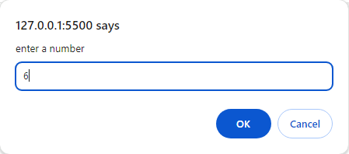

factorial is : 720

***7.decimal to binary***

let n = 15;

let binary = "";

while (n > 0) {

let n1 = n % 2;

binary += n1;

n = Math.floor(n / 2);

}

console.log("binary:", Number(binary));

***output:***

binary: 1111

***8.binary to decimal***

let n = 1101;

let sum = 0;

let power = 0;

while (n > 0) {

let rem = n % 10;

sum += rem * Math.pow(2, power++);

pow = n = Math.floor(n / 10);

// power++;

}

console.log(sum);

***output:***

13

***9.reverse***

let n = 234;

let rev = 0;

while (n > 0) {

let n1 = n % 10;

rev = rev * 10 + n1;

n = Math.floor(n / 10);

}

console.log(rev);

***output:***

432

***10.series***

let p = 1;

let n = 10;

let i = 1;

while (i < n) {

console.log(p);

p *= 2;

i++;

}

***Output:***

1

2

4

8

16

32

64

128

256