***1.sum of even number use for loop***

let n = prompt("enter the number");

let sum = 0;

for (i = 2; i <= n; i = i + 2) {

sum = sum + i;

console.log(" " + i);

}

console.log("sum is: " + sum);

output:

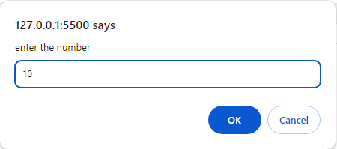

***Output:***

2

4

6

8

10

sum is: 30

***2. find power use for loop***

let n = prompt("enter the number");

let x = prompt("enter tne valueox x");

let f1 = 1;

for (i = 1; i <= n; i++) {

f1 = f1 * x;

}

console.log("power :" + f1);

***output:***

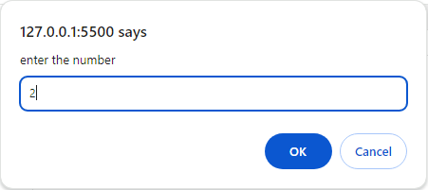

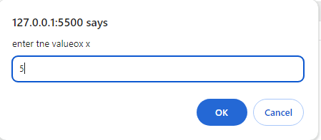

power :25

***3.factorial using for loop***

let n = Number(prompt("Enter your Number"));

let fact = 1;

for (let i = 2; i <= n; i++) {

fact *= i;

}

console.log(Factorial of ${n} is ${fact});

console.log(${n}!=${fact});

***Output:***

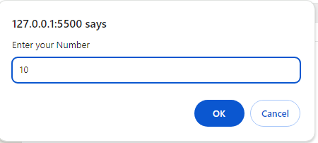

Factorial of 10 is 3628800

10!=3628800

***4.series of cube***

let n = Number(prompt("enter your number"));

for (let i = 1; i <= n; i++) {

console.log(i * i * i);

}

***Output:***

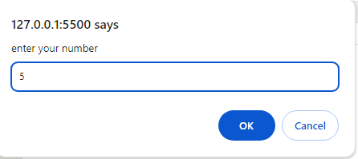

1

8

27

64

125

***5.pronic using for loop***

let n = prompt("enter number");

let flag = 0;

for (i = 1; i <= n; i++) {

if (n == i * (i + 1)) {

flag = 1;

break;

}

}

if (flag == 1) {

console.log(n + " is pronic");

} else {

console.log(n + " is not pronic");

}

Output:

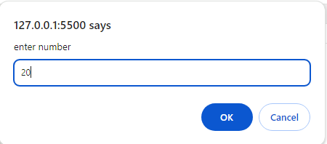

Output:

20 is pronic

***6.factors find using for loop***

let n = prompt("enter number");

for (i = 1; i <= n / 2; i++) {

if (n % i == 0) {

console.log(" " + i);

}

}

***Output:***

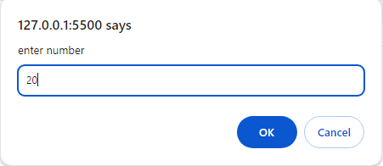

1

2

4

5

10

***7.fibonacci series using for loop***

let n = 10;

let f1 = 0;

let f2 = 1;

let f3;

console.log(" " + f1);

console.log(" " + f2);

for (i = 2; i < n; i++) {

f3 = f1 + f2;

console.log(" " + f3);

f1 = f2;

f2 = f3;

}

***Output:***

0

1

1

2

3

5

8

13

21

34

***8.find gcd and lcm use for loop***

let n1 = 8;

let n2 = 6;

min = n1 > n2 ? n2 : n1;

for (i = 1; i <= min; i++) {

if (n1 % i == 0 && n2 % i == 0) gcd = i;

}

console.log("GCD is :" + gcd);

lcm = 1;

lcm = (n1 * n2) / gcd;

console.log("LCM is:" + lcm);

output:

GCD is :2

LCM is:24

***9.find perfect number using for loop***

let n = prompt("enter the number");

let n1 = Math.sqrt(n);

if (n1 * n1 == n) {

console.log("it is perfect number");

} else {

console.log("it is not perfect number");

}

***Output:***

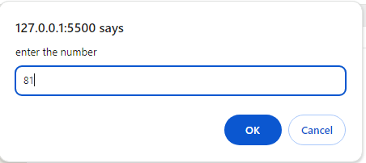

it is perfect number

***10.number is divisibal by 5 and 7 upto n use for loop***

let n = prompt("enter number");

for (let i = 1; i <= n; i++) {

if (i % 5 == 0 && i % 7 == 0) {

console.log(i);

}

}

***Output:***

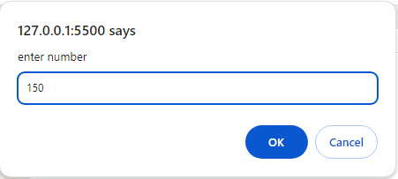

35

70

105

140