***1.factorial program using with parameter with return value.***

function fact(n) {

let i;

f1 = 1;

for (i = n; i >= 1; i--) {

f1 = f1 * i;

}

return f1;

}

{

let n = prompt("enter the number");

let f1 = fact(n);

console.log("fact is:" + f1);

}

***Output:***

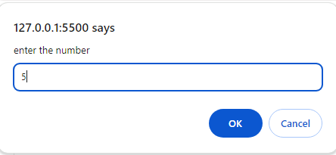

fact is:120

***2.prime number using with parameter and with return value.***

function prime(n) {

let i;

let flag = 0;

for (i = 2; i <= n / 2; i++) {

if (n % i == 0) {

flag = 1;

break;

}

}

if (flag == 0) {

return "number is prime";

} else {

return "number is not prime";

}

}

{

let n = prompt("enter the number:");

console.log(" " + prime(n));

}

***Output:***

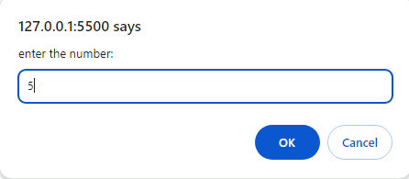

number is prime

***3.dissarium number using with parameter and with return value.***

function isDisariumNumber(num) {

let original = num;

let sum = 0;

let digitCount = 0;

let temp = num;

while (temp > 0) {

digitCount++;

temp = Math.floor(temp / 10);

}

temp = num;

while (temp > 0) {

let digit = temp % 10;

temp = Math.floor(temp / 10);

sum += Math.pow(digit, digitCount);

digitCount--;

}

return sum === original;

}

let number = 135;

if (isDisariumNumber(number)) {

console.log(number + " is a Disarium number.");

} else {

console.log(number + " is not a Disarium number.");

}

***Output:***

135 is a Disarium number.

***4.armstrong number using with para with return.***

function armstrong(n) {

let p;

let sum = 0;

let n1;

p = n;

while (n > 0) {

n1 = n % 10;

n = Math.floor(n / 10);

sum = sum + n1 * n1 * n1;

}

if (sum == p) {

return "number is armstrong";

} else {

return "number is not armstrong";

}

}

{

let n = prompt("enter the value of number:");

console.log(" The number is " + armstrong(n));

}

***Output:***

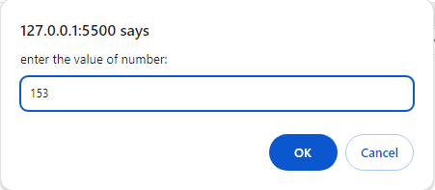

The number is number is Armstrong

***5.area of circle use with para with return***

function circle(r) {

let area;

area = 3.14 * r * r;

return area;

}

let r = prompt("enter the value of radius:");

console.log("area is: " + circle(r));

***output:***

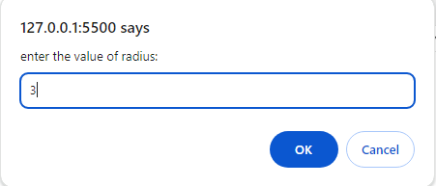

area is: 28.259999999999998

***6.pronic number use no para no return***

function pronic_r(num) {

isPronic = false;

for (let i = 1; i <= num - 1; i++) {

if (i * (i + 1) == num) {

isPronic = true;

break;

}

}

if (isPronic) return num + " is a pronic number";

else return num + " is not a pronic number";

}

let num = prompt("Enter the number to check: ");

console.log(" " + pronic_r(num));

***output:***

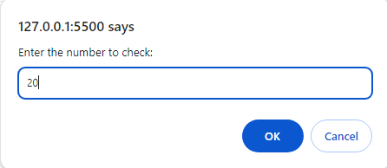

20 is a pronic number

***7. sum of digit use no para no return***

function sum_pr(n) {

let n1,

sum = 0;

while (n > 0) {

n1 = n % 10;

sum += n1;

n = Math.floor(n / 10);

}

return sum;

}

let n = prompt("Enter number");

console.log("Sum :" + sum_pr(n));

***output:***

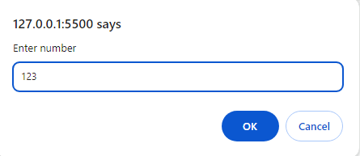

Sum :6

***8.palindrome number use with para with return.***

function pal(n) {

let p = n;

let sum = 0;

while (p > 0) {

n1 = p % 10;

p = Math.floor(p / 10);

sum = sum * 10 + n1;

}

if (sum == n) return "Number is pal";

else return "Number is not pal";

}

let n = prompt("enter number");

console.log(" " + pal(n));

***output:***

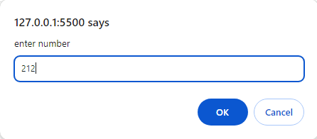

Number is pal

***9.power use with para with return***

function power(x, n) {

let f1 = 1;

for (let i = 1; i <= n; i++) {

f1 = f1 * x;

}

return f1;

}

let n = prompt("enter number");

let x = prompt("enter number");

console.log("number" + n + " power " + x + " is = ", power(x, n));

***output:***

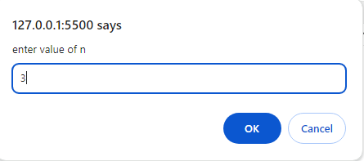

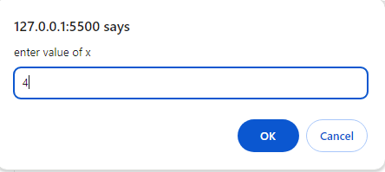

number3 power 4 is = 64

//(4*4*4)

***10.lcm use with para with return***

function gcd(x, y) {

let gcd = 1;

for (let i = 2; i <= x && i <= y; i++) {

if (x % i == 0 && y % i == 0) {

gcd = i;

}

}

return gcd;

}

let x = Number(prompt("enetr 1 number:"));

let y = Number(prompt("enetr 2 number:"));

let GCD = gcd(x, y);

console.log("GCD is:", +GCD);

let lcm = (x * y) / GCD;

console.log("LCM IS :", lcm);

***output:***

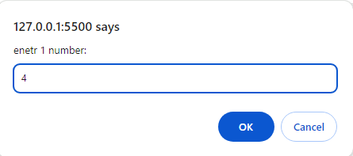

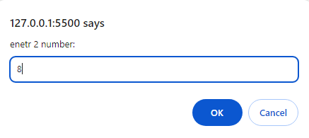

GCD is : 4

LCM IS : 8