***1.find arithmetic mean and harmonic mean use function***

function mean(a, b) {

let arithMean = (a + b) / 2;

let harmonic = (a - b) / 2;

return { arithMean, harmonic };

}

let a = prompt("enter a");

let b = prompt("enter b");

let result = mean(Number(a), Number(b));

console.log("arithmatic mean :" + result.arithMean);

console.log("harmonic mean is" + result.harmonic);

***output:***

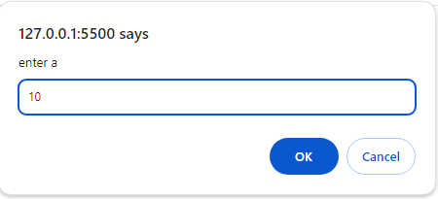

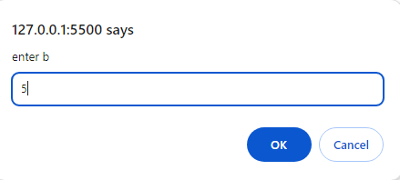

arithmatic mean :7.5

harmonic mean is2.5

***2.find total average if 3 marks use function***

function marks_total(m1, m2, m3) {

let total = m1 + m2 + m3;

let avg = total / 3;

return { total, avg };

}

let m1 = prompt("enter m1");

let m2 = prompt("enter m2");

let m3 = prompt("enter m3");

let result = marks_total(Number(m1), Number(m2), Number(m3));

console.log("total is:" + result.total);

console.log("average is:" + result.avg);

***output:***

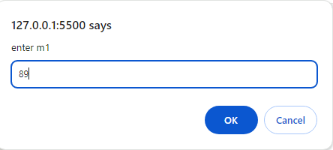

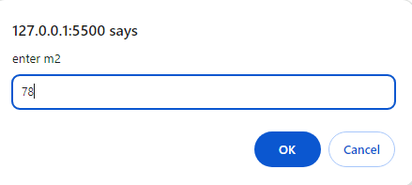

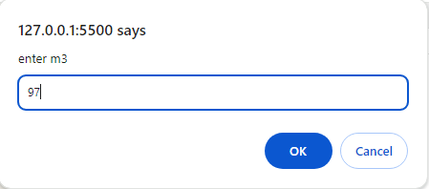

total is:264

average is:88

***3.find potential energy use function***

function potential(m, g, h) {

PE = m * g * h;

return PE;

}

let m = prompt("enter mass");

let g = prompt("enter gravity");

let h = prompt("enter height");

console.log("potential energy is :" + potential(m, g, h));

***output:***

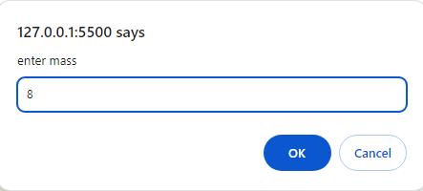

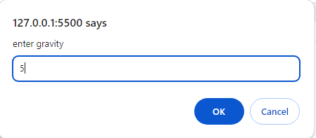

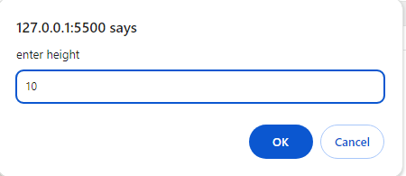

potential energy is :400

***4.cube of given number***

let cube = (a) => a * a * a;

let a = prompt("enter the number");

console.log("cube is :" + cube(a));

***output:***

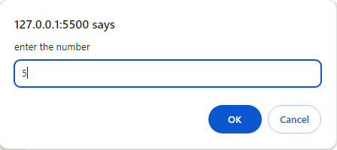

cube is :125

***5.square root of number use function***

let square = (a) => Math.sqrt(a);

let a = prompt("enter the number");

console.log("square root of " + a + " is =", square(a).

**output:**

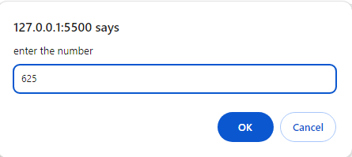

square root of 625 is = 25

***6.calculate area and perimeter of square***

function calculateSquare(sideLength) {

let perimeter = 4 * sideLength;

let area = sideLength * sideLength;

return { perimeter, area };

}

let sideLength = prompt("Enter the side length of the square:");

let result = calculateSquare(Number(sideLength));

console.log("Perimeter: " + result.perimeter);

console.log("Area: " + result.area);

**output:**

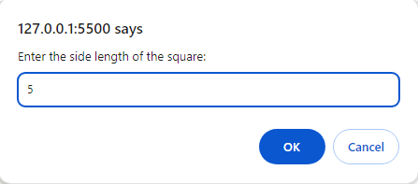

Perimeter: 20

Area: 25

***7. find area of sphere***

let sphere = (r) => 4 * 3.14 * r * r;

let r = prompt("enter the number");

console.log("cube is :" + sphere(r));

***output:***

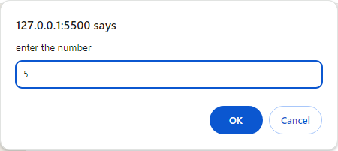

cube is :314

***8.swap two number use function***

function swap(a, b) {

let temp = a;

a = b;

b = temp;

return { a, b };

}

let a = prompt("Enter first number:");

let b = prompt("Enter second number:");

result = swap(Number(a), Number(b));

console.log("Swapped numbers:");

console.log("First number: " + result.a);

console.log("Second number: " + result.b);

***output:***

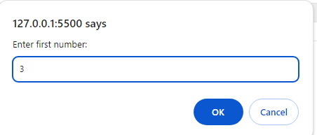

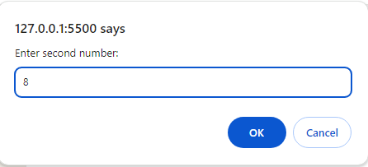

Swapped numbers:

First number: 8

Second number: 3

***9.find hra, da accept basic salary***

let salary = (bs) => {

let hra = bs * 0.1;

let da = bs * 0.9;

return { hra, da };

};

let bs = prompt("enter the number");

console.log("hra is :" + salary(bs).hra);

console.log("da is :" + salary(bs).da);

***output:***

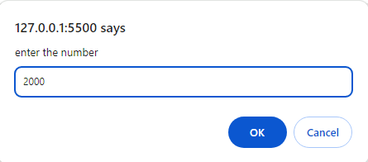

hra is :200

da is :1800

***10.check even odd use function***

function checkOddEven(num) {

if (num % 2 == 0) {

return "Even";

} else {

return "Odd";

}

}

let num = prompt("Enter a number:");

console.log(checkOddEven(Number(num)));

***output:***

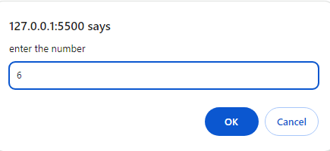

Even