***DML(DATA MANIPULATION LANGUAGE)***

***INSERT***

***UPDATE***

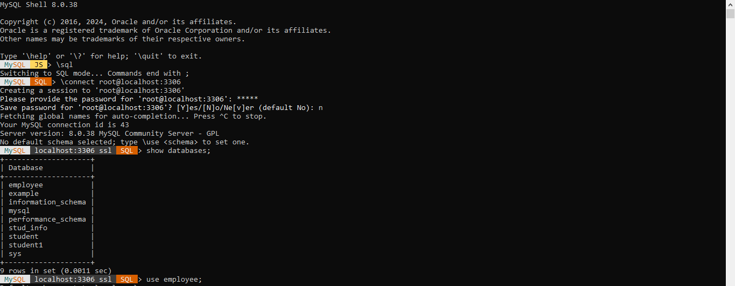

***CREATE TABLE AND ADD EMAIL***

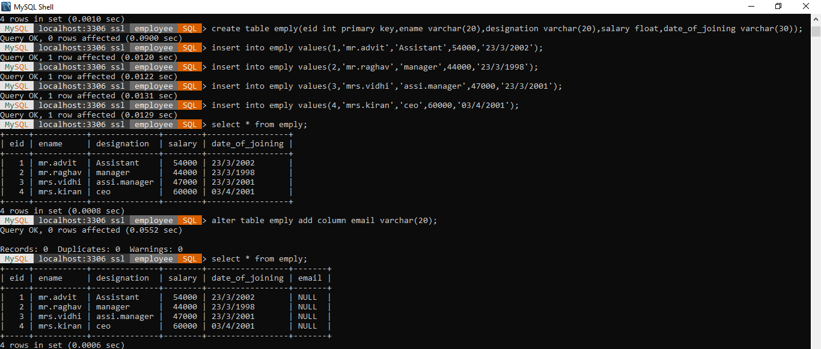

***UPDATE EMAIL***

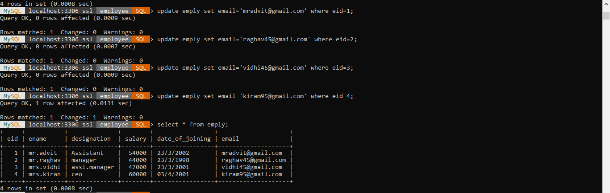

***UPDATE SALARY WITH 5% INCREMENT***

***UPDATE DESIGNATION***

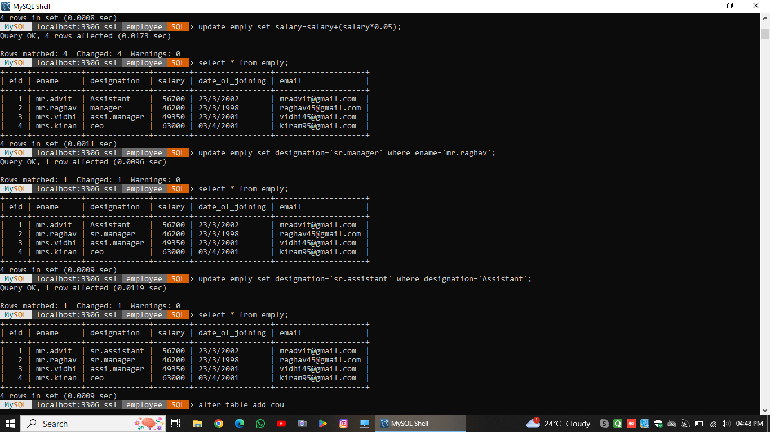

***ADD CITY COLUMN***

***UPDATE CITY***

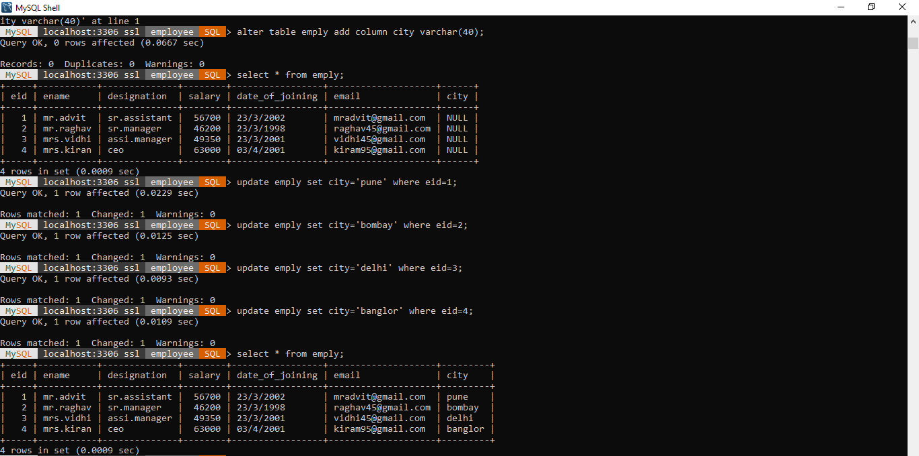

***UPDATE SALARY WITH 5% DECREMENT***

***ADD COLUMN PHONE NUMBER***

***UPDATE DATE_OF_JOINING***

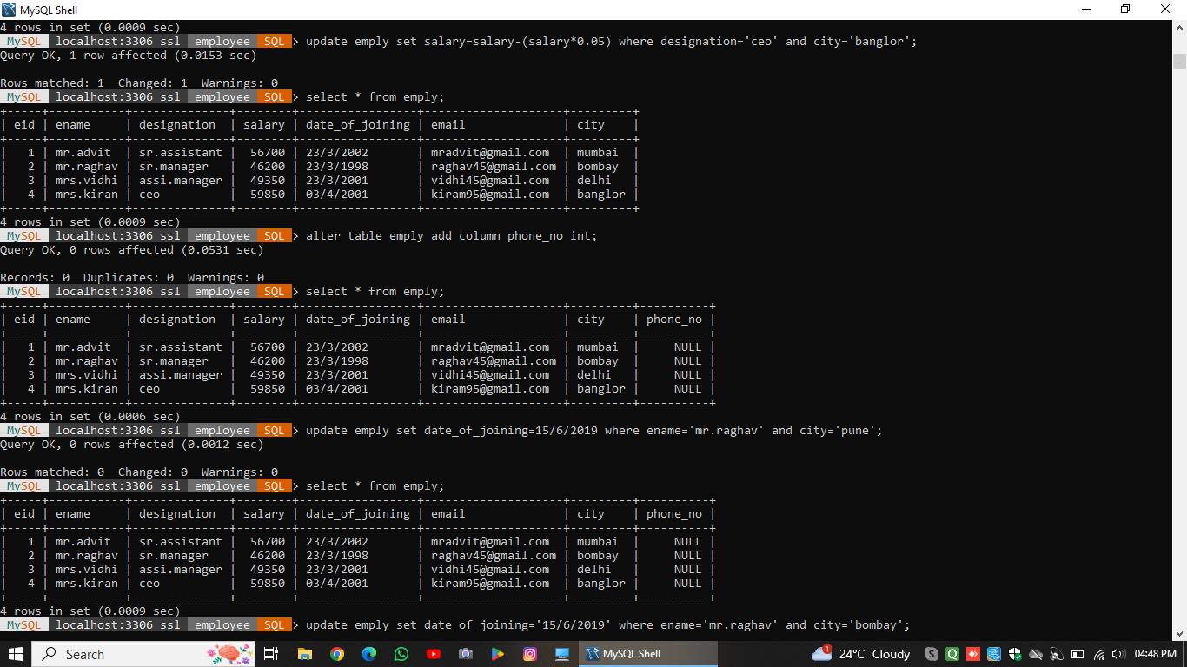

***UPDATE DATE_OF_JOINING***

***DELETE COLUMN***

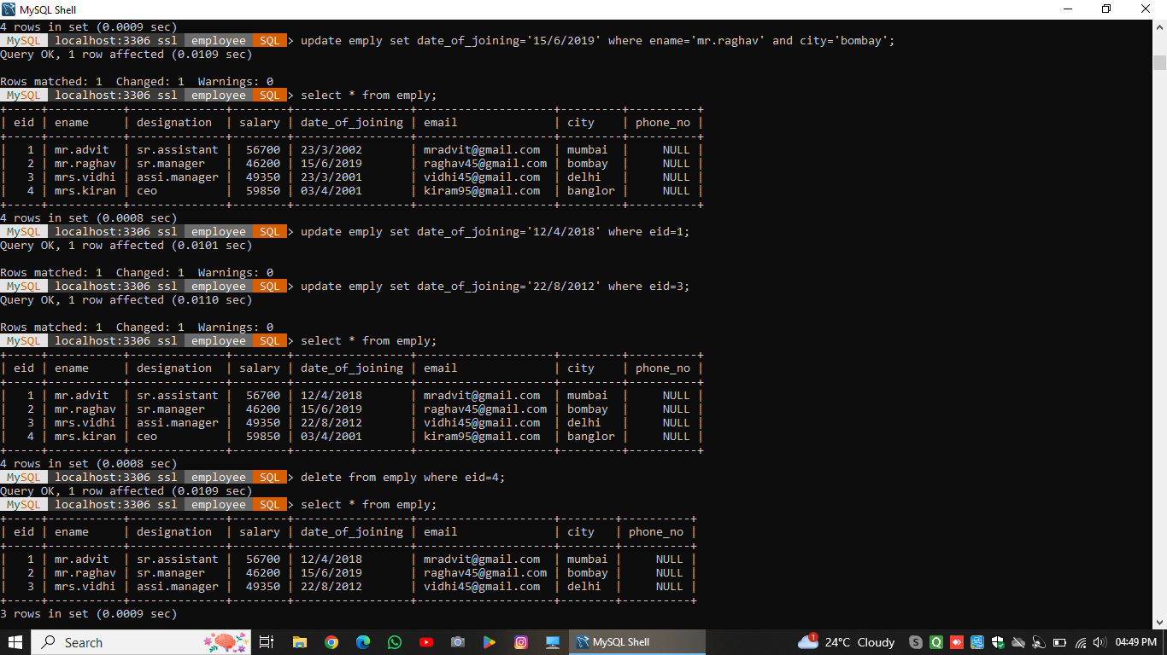

***SELECT***

