***LIKE,NOT,ORDER***

select * from emp;

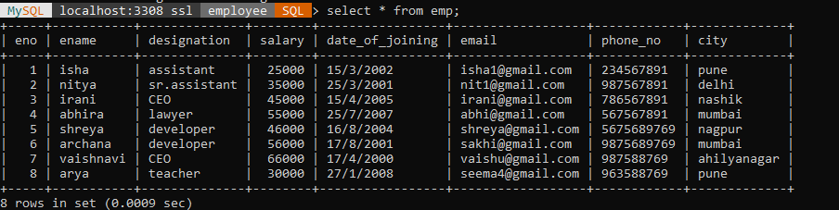

select ename from emp where ename like 'a%a' and designation='lawyer' and city IN ('pune','mumbai','nagpur');



select * from emp where email like '%.%' and salary between 25000 and 35000 or eno IN(1,3,5,7);

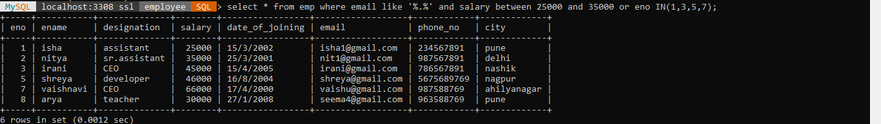

select ename,designation,phone_no from emp where ename like '__i%i' and email='%@%.%' or phone_no='987588769';



select * from emp where NOT city='pune';

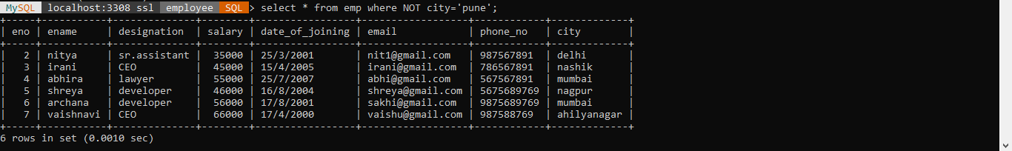

select * from emp where ename like '_____' order by ename desc;



select * from emp where city like '_____' order by city desc;

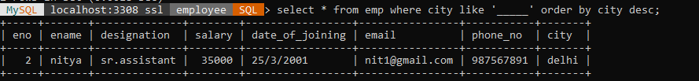

select * from emp where city like '____' order by city desc;

