***Aggrigate,Alice,group by,having***

select * from emp;

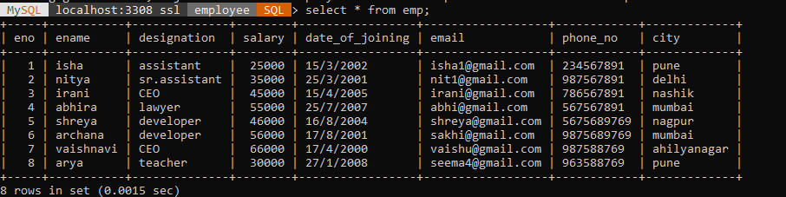

select min(salary) from emp;

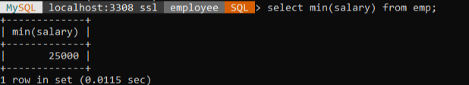

select max(salary) as largestPrice from emp;

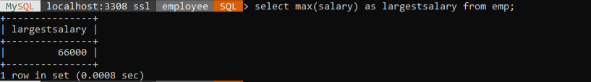

select max(salary) as salarymax from emp as employee where ename like '%i%' and date_of_joining='25/7/2007';



SELECT count(*) AS total_employees

-> FROM emp

-> WHERE (city = 'Pune' OR city = 'ahilyanagar')

-> AND designation = 'CEO';



select count(*) ,designation from emp group by designation;

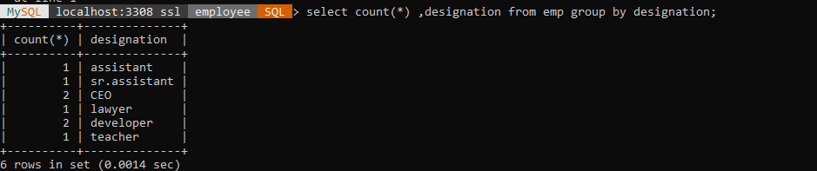

select count(salary) as maxSalary from emp group by city;

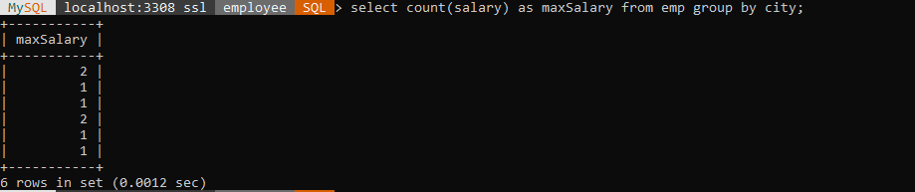

SELECT city, SUM(salary) AS total_salary FROM emp WHERE salary > 50000 GROUP BY city;

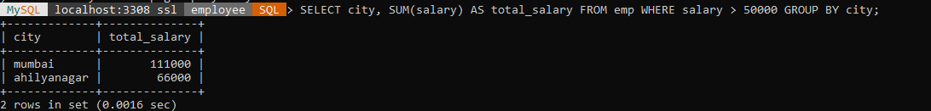

select * from emp where designation='ceo';

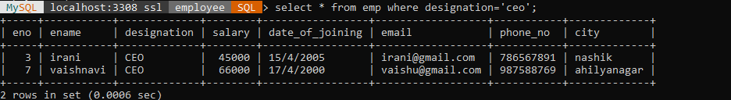

select eno, count(*) as no_emp from emp group by eno;

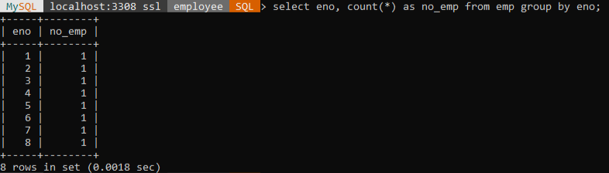

select * from emp where city='pune' and salary>='2500' order by city limit 5;

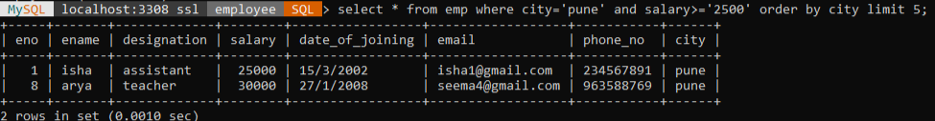

update emp set city='mumbai' where city='pune';

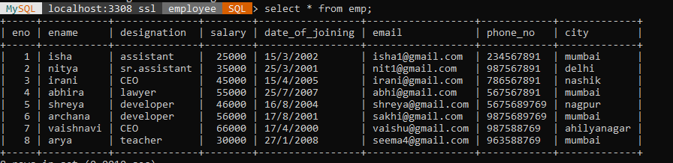

update emp set salary=salary+(salary*0.95) where salary between 25000 and 60000;

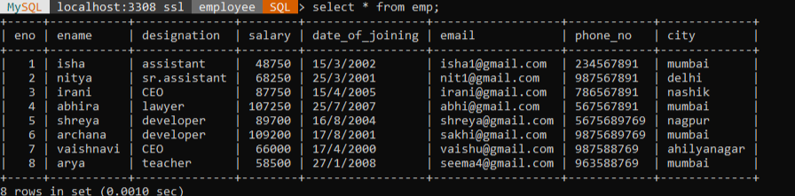

select eno,ename,salary*12 as anual_salary from emp where ename='abhira';

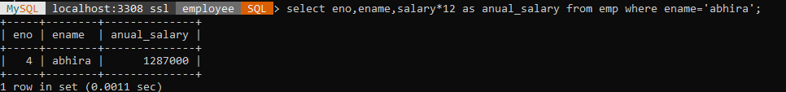

select min(salary) as min_sal from emp;

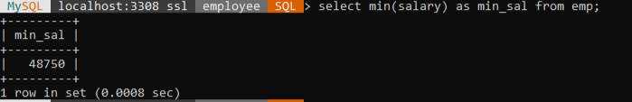

select eno,ename,salary*12 as anual_salary from emp ;

