Create database:

create database practice1;

create table:

create table salesmans(salesmans_id int primary key,name varchar(20),city varchar(30),commission varchar(20));

desc salesmans;

+--------------+-------------+------+-----+---------+-------+

| Field | Type | Null | Key | Default | Extra |

+--------------+-------------+------+-----+---------+-------+

| salesmans_id | int | NO | PRI | NULL | |

| name | varchar(20) | YES | | NULL | |

| city | varchar(30) | YES | | NULL | |

| commission | varchar(20) | YES | | NULL | |

+--------------+-------------+------+-----+---------+-------+

Insert values:

insert into salesmans values(5001,'james hoong','new york','0.15');

insert into salesmans values(5002,'Nail knite','paris','0.13');

insert into salesmans values(5005,'pit alex','london','0.11');

insert into salesmans values(5006,'mc lyon','paris','0.14');

insert into salesmans values(5007,'paul adam','rome','0.13');

insert into salesmans values(5003,'lauson hen','san jose','0.12');

insert into salesmans values(5008,'rose willy','NULL','0.17');

insert into salesmans values(5009,'lauson hen','itly','NULL');

insert into salesmans values(50010,'rose willy',NULL,'0.17');

insert into salesmans values(50011,'lauson hen','itly',NULL);

1. Write a SQL statement that displays all the information about all salespeople.

select * from salesmans;

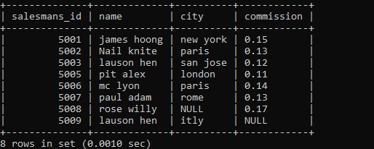

1. Write a SQL statement to display specific columns such as names and commissions for all salespeople.

select name ,commission from salesmans;

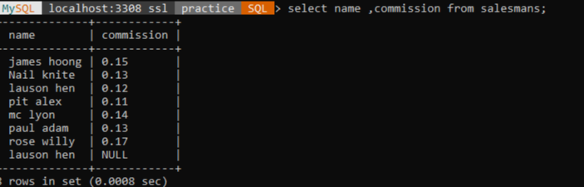

1. write a SQL query to locate salespeople who live in the city of 'Paris'. Return salesperson's name, city.

select name ,city from salesmans where city='paris';

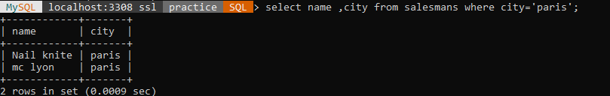

1. write a SQL query to locate salespeople who live in the city of 'San Jose'. Return salesperson's name, commission.

select name ,commission from salesmans where city='san jose';

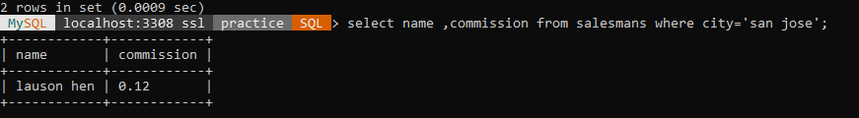

5. Write a SQL statement to display columns such as salesman_id ,names and city for all salespeople.

select salesmans_id, name,city from salesmans;

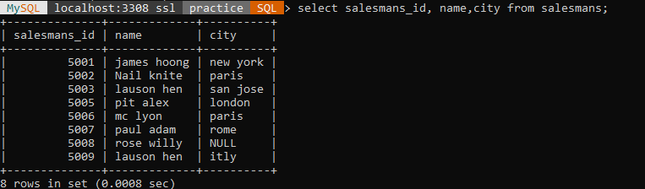

6. Write a SQL query to display columns such as salesman_id ,names and city for all salespeople.

select salesmans_id, name,city from salesmans;

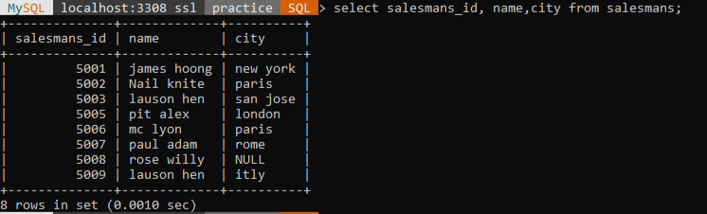

7. Write a SQL statement that displays all the information Arranged the output in ascending order by name.

select * from salesmans order by name asc;

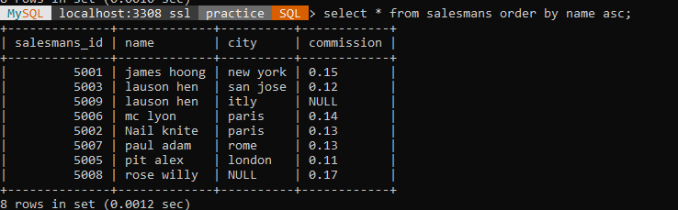

8. Write a SQL statement that displays all the information Arranged the output in ascending order by salesman_id

select * from salesmans order by salesmans_id asc;

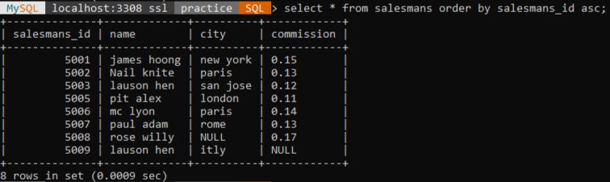

9. Write a SQL statement that displays all the information Sort the output in descending order on salesman_id.

select * from salesmans order by salesmans_id desc;

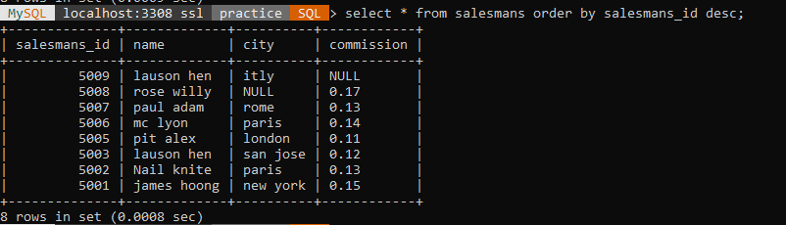

10. Write a SQL statement that displays all the information who live in the city of 'San Jose' AND 'Paris' Sort the output in descending order on salesman_id.

select * from salesmans where city in ('san jose','paris') order by salesmans_id desc;

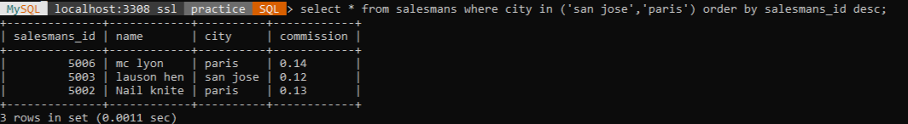

11. write a SQL query to locate who live in the city of 'San Jose' AND 'Paris' Sort the output in ascendingorder on salesman_id.

select * from salesmans where city in ('san jose','paris') order by salesmans_id asc;

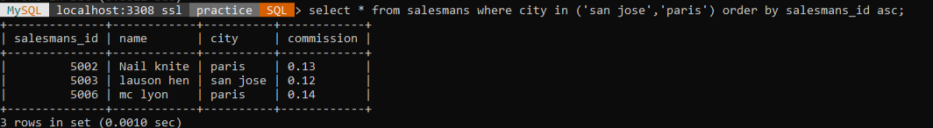

12. Write a SQL statement who live in the city of 'San Jose' AND 'Paris' Sort the output in descending order on name.

select * from salesmans where city in ('san jose','paris') order by name desc;

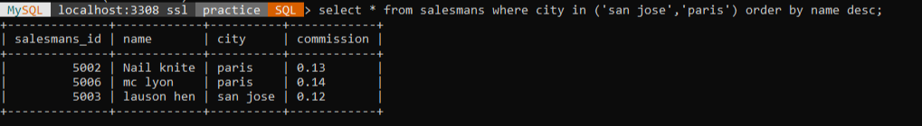

13. write a SQL query to locate who live in the city of 'Rome' OR'London' Sort the output in ascending order on salesman_id.

select * from salesmans where city in ('rome','london') order by salesmans_id asc;

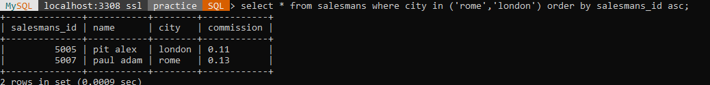

// write a SQL statement who live in the city of 'San Jose' AND 'Paris' Sort the output in descending order on name.

select * from salesmans where city='san jose' and city='paris' order by name desc;

empty set.

14. write a SQL query to locate who live in the city of 'New York' OR'London' Sort the output in ascending order on city

select * from salesmans where city in ('new york','london') order by city asc;

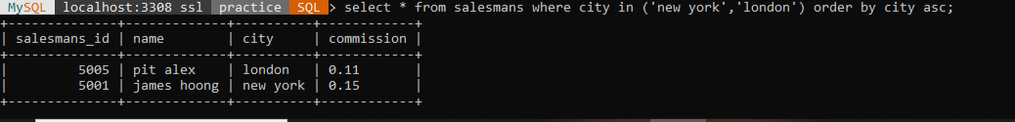

15. write a SQL query to locate who live in the name of 'James Hoog' OR 'Paul Adam' Sort the output in ascending order on commission.

select * from salesmans where name in ('james hoong','paul adam') order by commission asc;

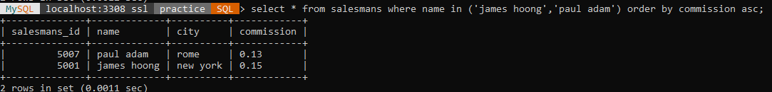

16. Write a SQL statement to display specific columns such as names and commissions,city for all salespeople having commission 0.13.

select name, commission,city from salesmans where commission='0.13';



17. Write a SQL statement to display specific columns such as names and commissions for all salespeople having commission greater than 0.12.

select name, commission from salesmans where commission>=0.12 ;

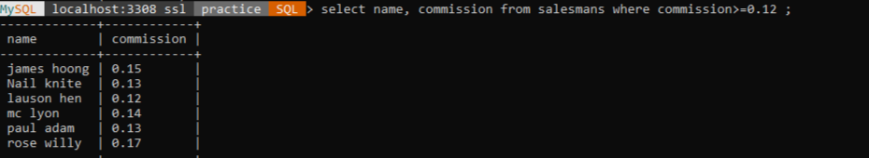

18. Write a SQL statement to display all salespeople having commission greater than 0.12.

select * from salesmans where commission>=0.12 ;

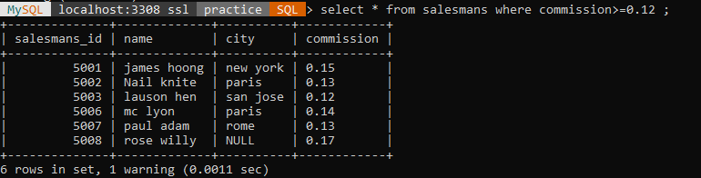

19. Write a SQL statement that displays all the information salespeople having city is NULL.

select * from salesmans where city IS NULL ;

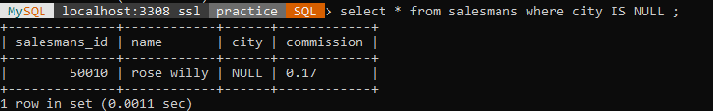

20. Write a SQL statement that displays all the information salespeople having commission is NULL.

select * from salesmans where commission IS NULL ;

