**Data Visualization & Storytelling: Graph Explanations Report**

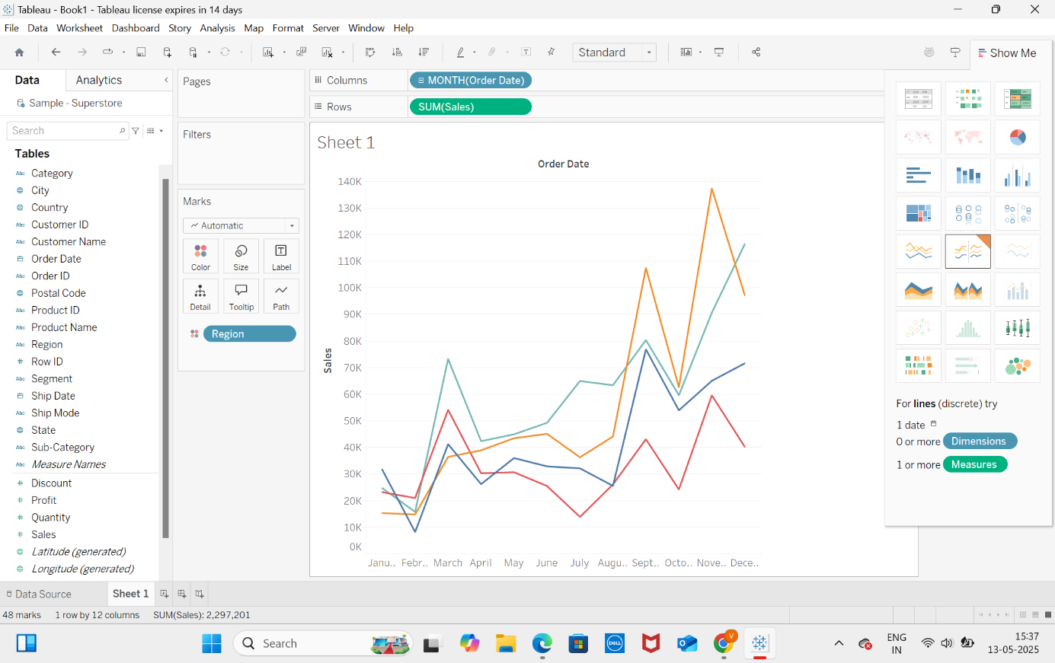

“Sales have shown consistent year-over-year growth, with clear spikes in Q4, indicating strong seasonal trends. A minor dip in 2018 suggests a need to analyze sales strategies during that period.”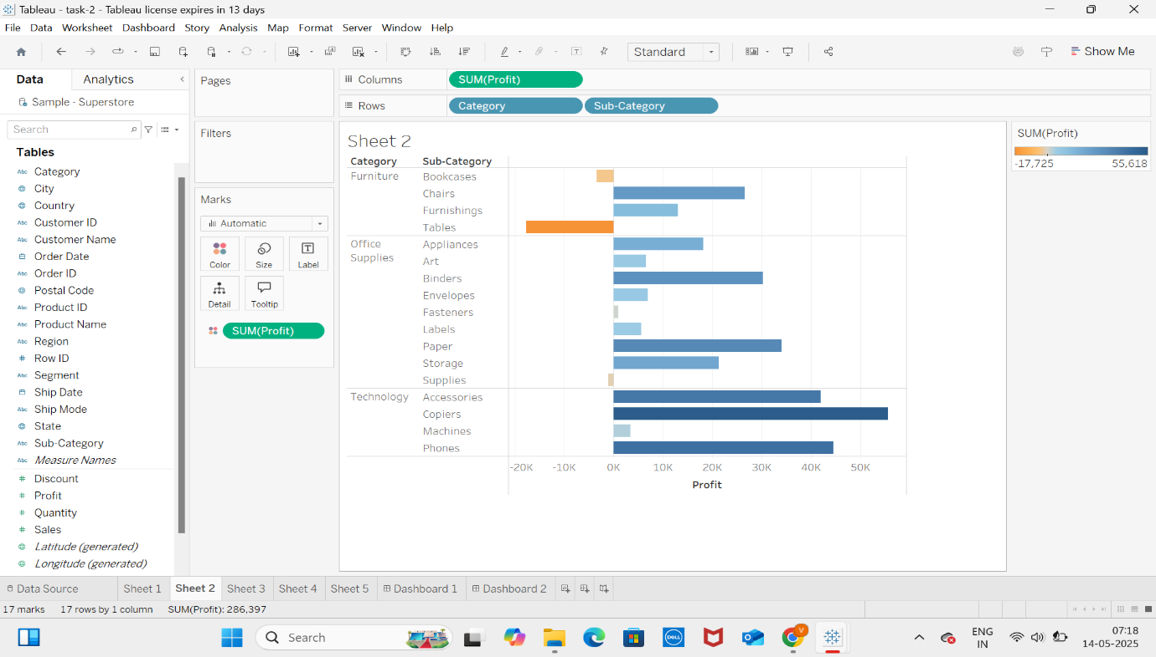

“Tables and Bookcases generate high sales but incur frequent losses. This suggests a need to review cost structure or pricing strategy in these categories.”

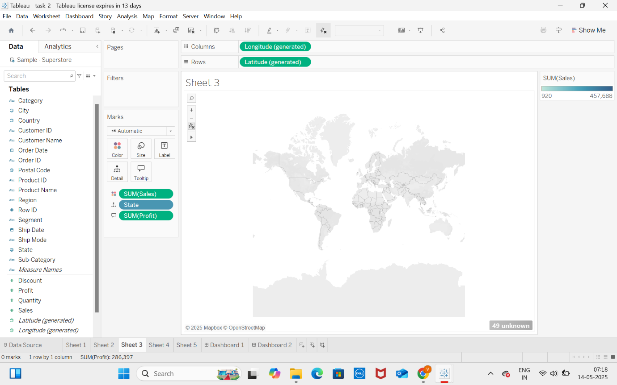

“This filled map highlights state-wise performance in terms of sales and profit. California and New York lead both in revenue and profitability. In contrast, Texas shows high sales but low profit, suggesting issues with discounting or operational cost.”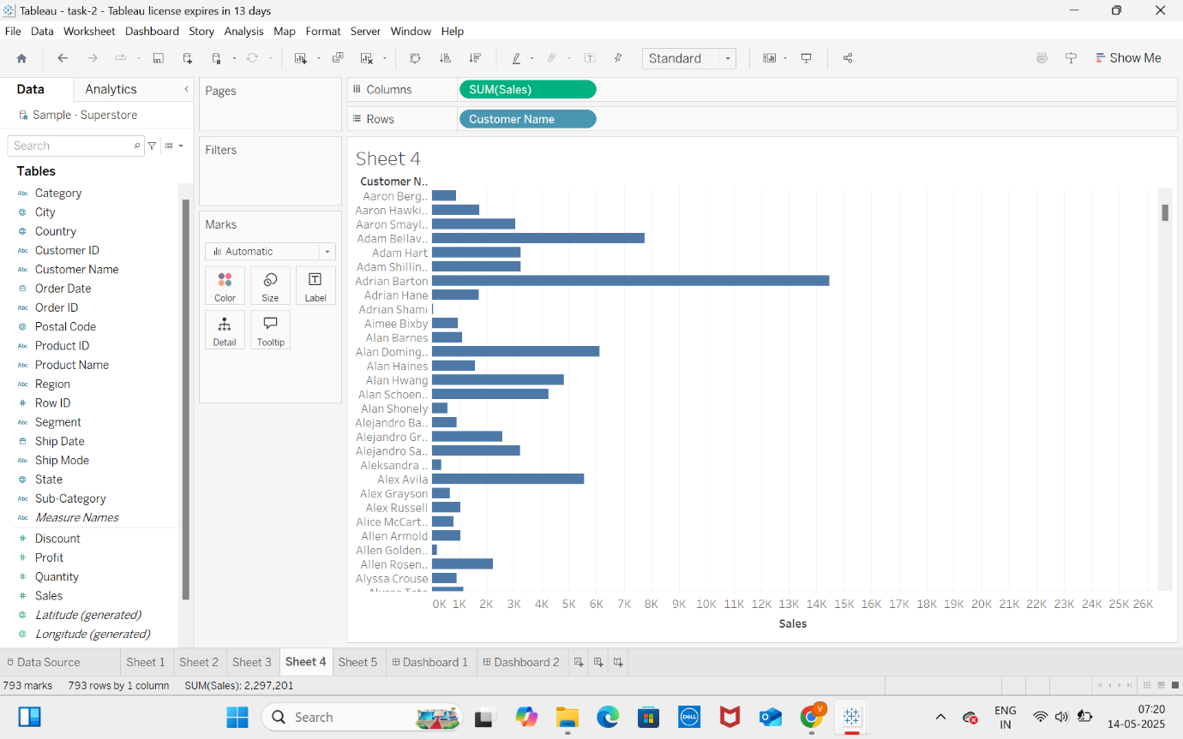

“It displays profit across different product sub-categories. Accessories and Copiers generate the highest profit, while Tables and Bookcases consistently report losses despite strong sales. The visual makes it easy to compare profitability across all product lines and quickly identify underperforming categories that need business attention.”

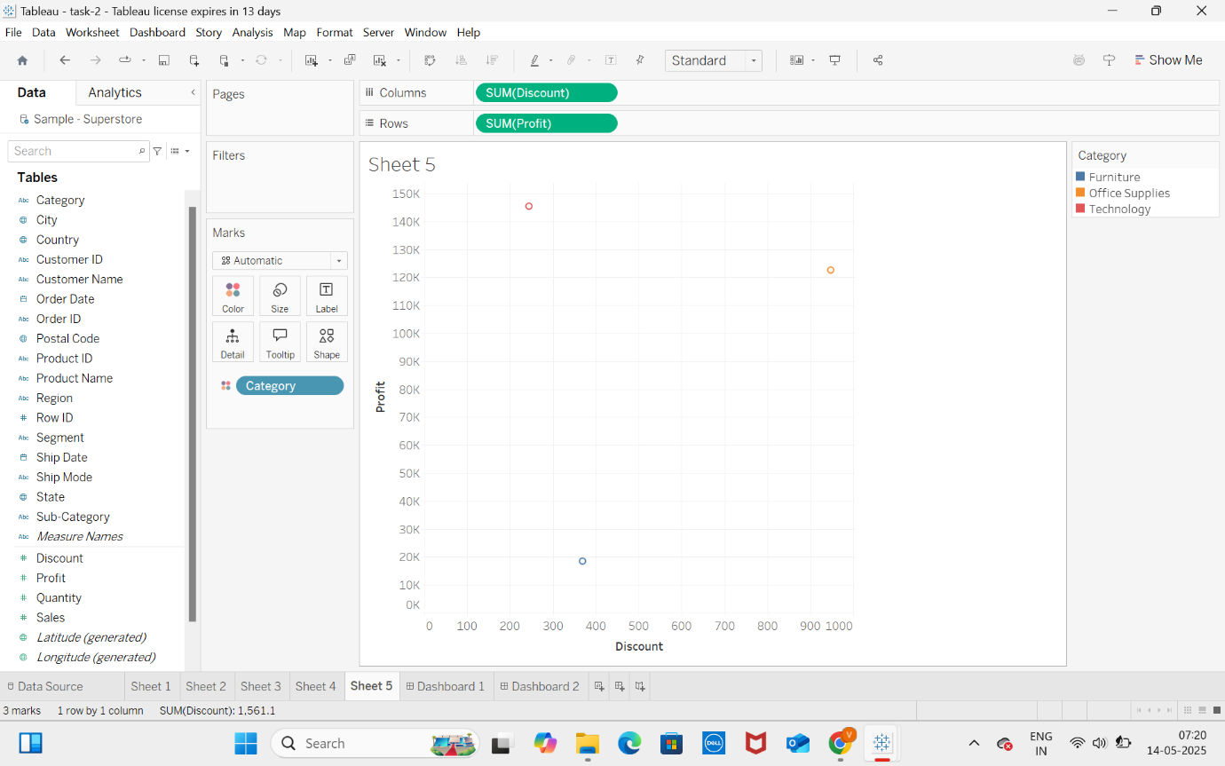

“This scatter plot reveals a negative relationship between discount rate and profitability. Transactions with discounts above 20% tend to result in a loss, especially in Technology and Furniture categories.”