AWS Cloud Detection Engineering Lab (MITRE – ATT&CK Aligned)

CloudWatch Alert Triggered:
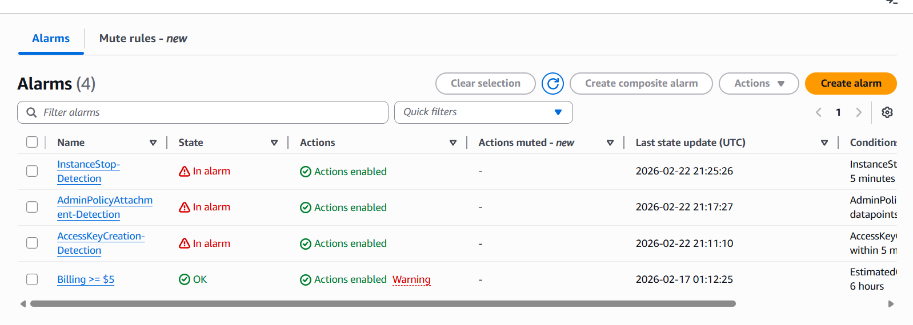
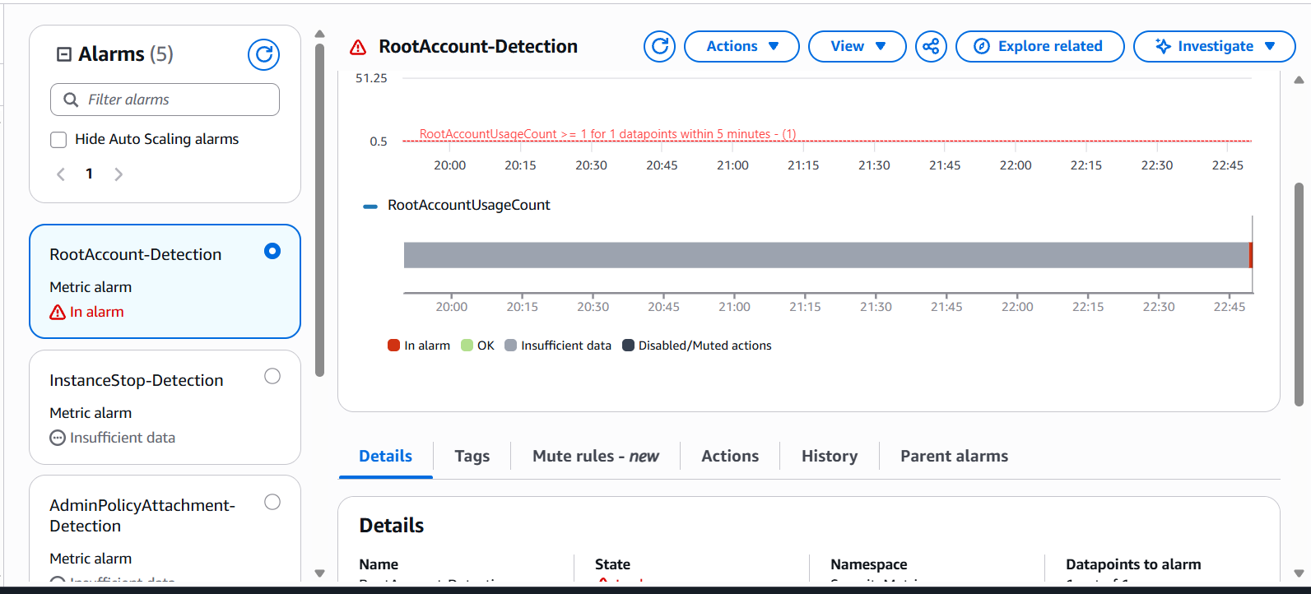

Email Notifications:
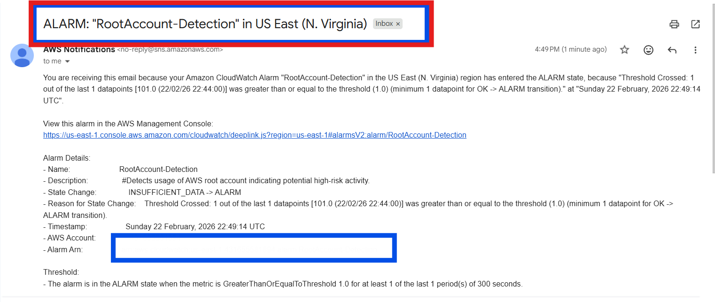
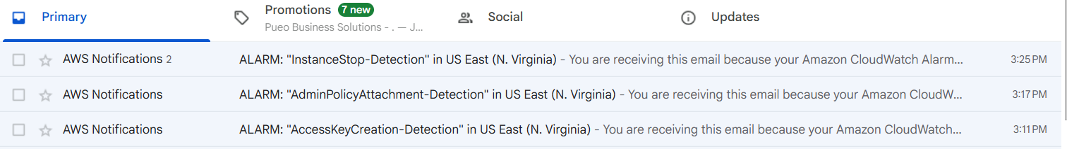
CloudTrail Events
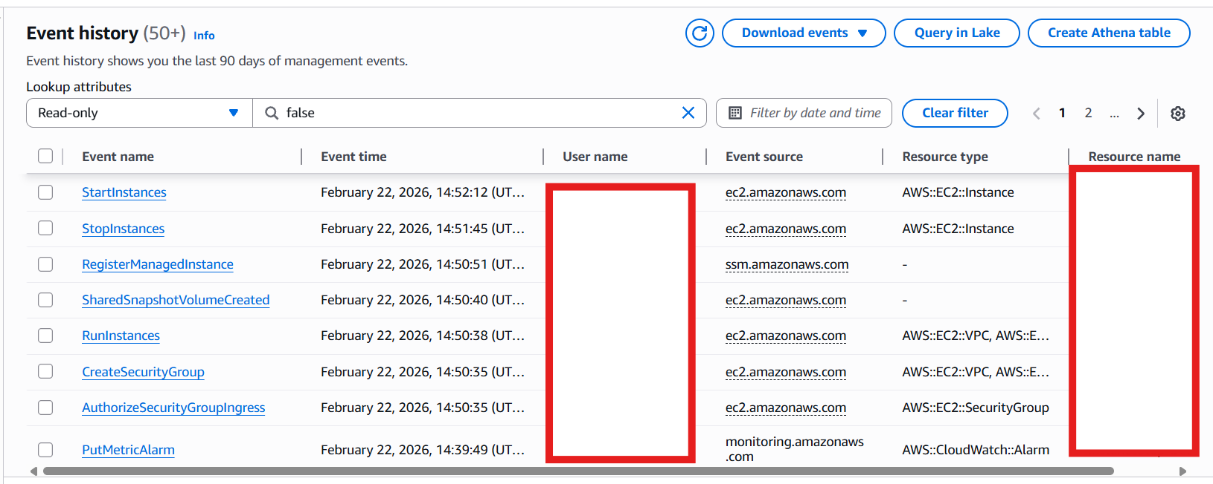

Metric Filters Showing Detection Pattern
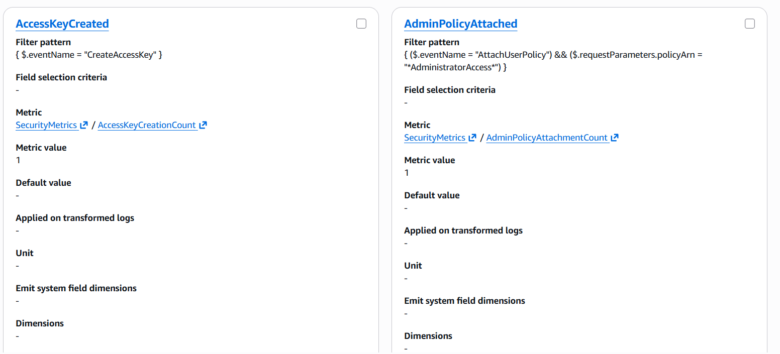

MITRE ATT&CK Table:
Detection Name | CloudTrail Event | MITRE Tactic | MITRE Technique | Technique ID | Rationale
Access Key Creation | CreateAccessKey | Persistence | Account Manipulation | T1098 | Attackers create API keys to maintain long-term programmatic access.
Administrator Policy Attachment | AttachUserPolicy (AdministratorAccess) | Privilege Escalation | Exploitation for Privilege Escalation | T1068 | Privilege escalation through high-privilege IAM policy attachment.
Root Account Usage | userIdentity.type = Root | Privilege Escalation | Valid Accounts | T1078 | Root usage represents full administrative access.
EC2 Stop Event | StopInstances | Impact | Service Stop | T1489 | Service disruption or operational interference.
EBS Snapshot Creation | CreateSnapshot | Exfiltration | Transfer Data to Cloud Account | T1537 | Snapshots may enable unauthorized data extraction.
Public Security Group Exposure | AuthorizeSecurityGroupIngress (0.0.0.0/0) | Defense Evasion / Resource Modification | Modify Cloud Infrastructure | T1578 | Weakens security posture by exposing infrastructure publicly.
CloudTrail Tampering | StopLogging / DeleteTrail | Defense Evasion | Impair Defenses | T1562 | Disabling logs prevents detection and investigation.

