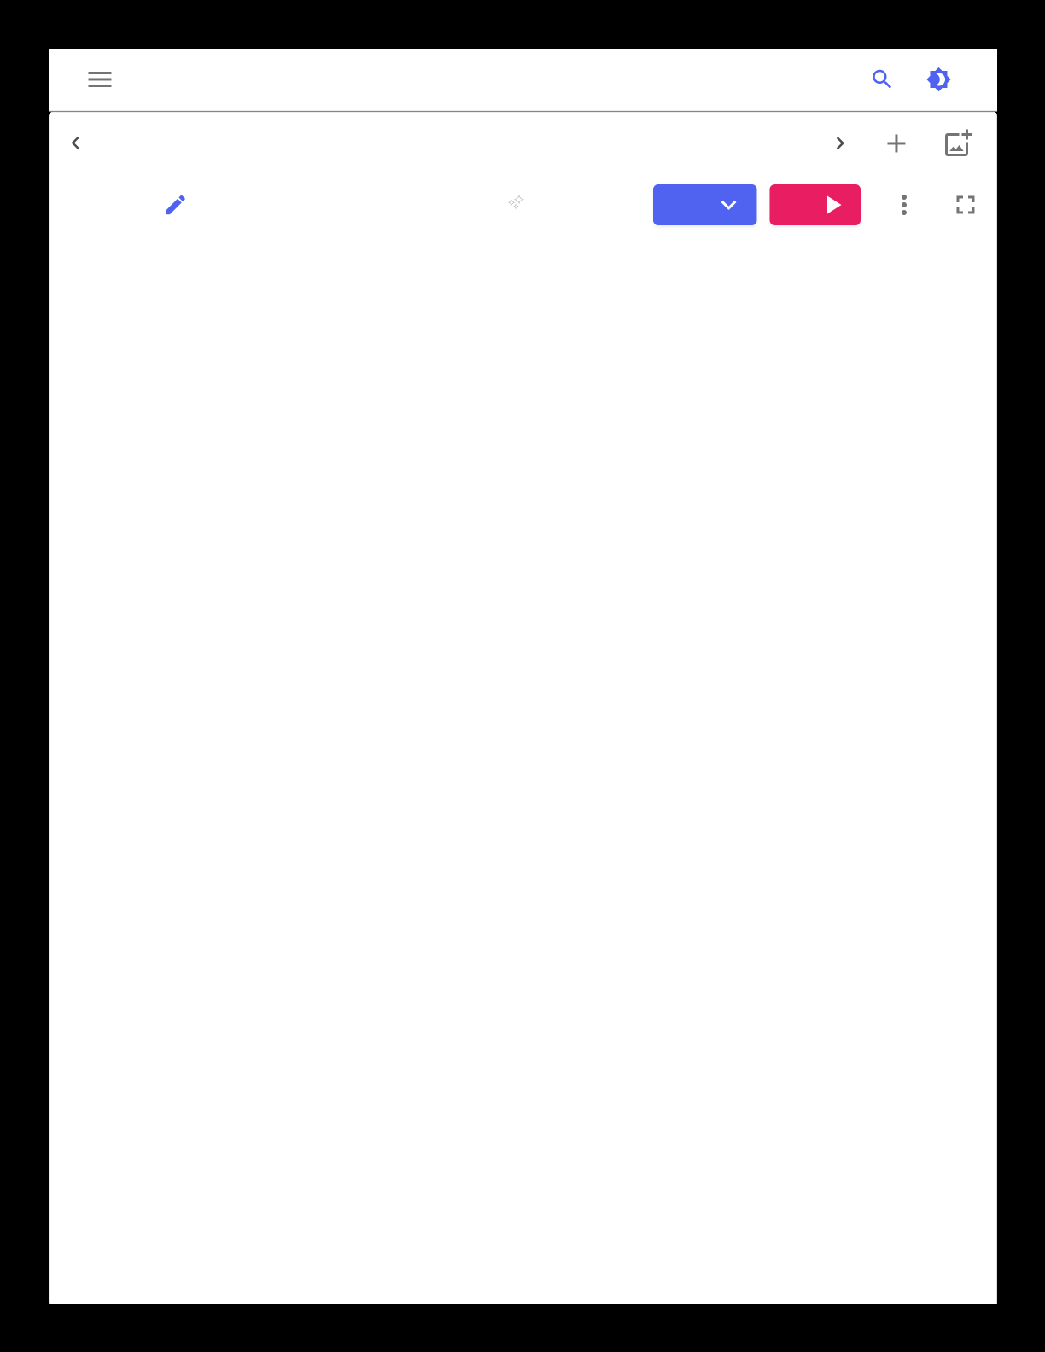

|  |  |  |  |
| --- | --- | --- | --- |
| index.html | styles.css | script.js | page1.html |

|  |  |  |  |  |
| --- | --- | --- | --- | --- |
| 43c776c4e | AI | NEW | HTML | RUN |

|  |  |  |
| --- | --- | --- |
| 1 | index.html | Click on RUN button to see the ou |
| 2 | <!DOCTYPE html> |
| 3 |
| 4 | <html> |
| 5 | <body> |
| 6 | <p>page1</p> |
| 7 | </body> |
| 8 | </html><!DOCTYPE html> |
| 9 | <html> |
| 10 | <head> |
| 11 | <title>Page Title</title> |
| 12 | </head> |
| 13 | <body> |
| 14 | <h1>This is a Heading</h1> |
| 15 |
| 16 | <p>This is a paragraph.</p> |
| 17 | </body> |
| 18 |
| 19 | </html> |
| 20 | main.CSS |
| 21 |
| 22 | <!DOCTYPE html> |
| 23 |
| 24 | <html> |
| 25 | <head> |
| 26 | <style> |
| 27 | body { |
| 28 | background-color: lightblue; |
| 29 | } |
| 30 | h1 { |
| 31 |
| 32 | color: white; |
| 33 | text-align: center; |
| 34 | } |
| 35 | p { |
| 36 |
| 37 | font-family: verdana; |
| 38 | font-size: 20px; |
| 39 | } |
| 40 | </style> |
| 41 | </head> |
| 42 | <body> |
| 43 | <h1>My First CSS Example</h1> |
| 44 |
| 45 | <p>This is a paragraph.</p> |
| 46 | </body> |
| 47 |