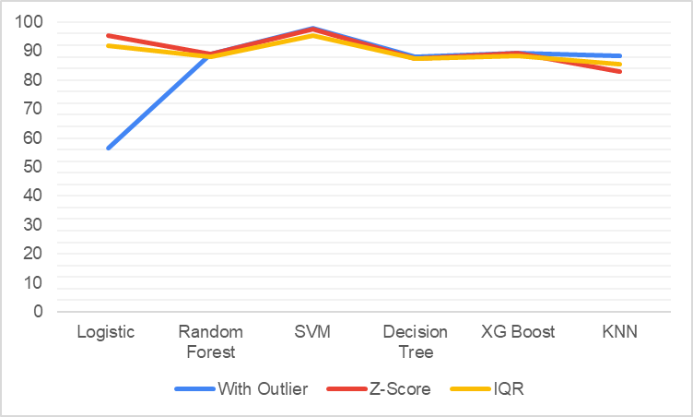

Testing Included in report

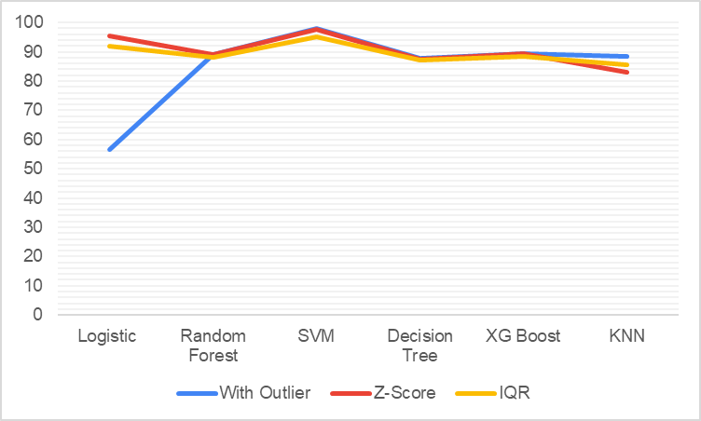

Cross Validation

Z-Score With SMOTE without SMOTE

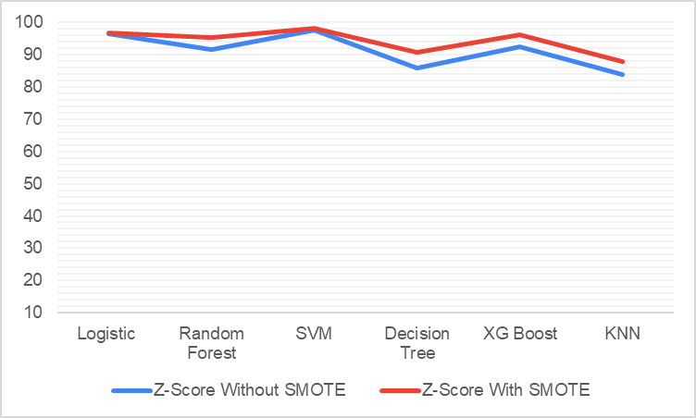

Testing

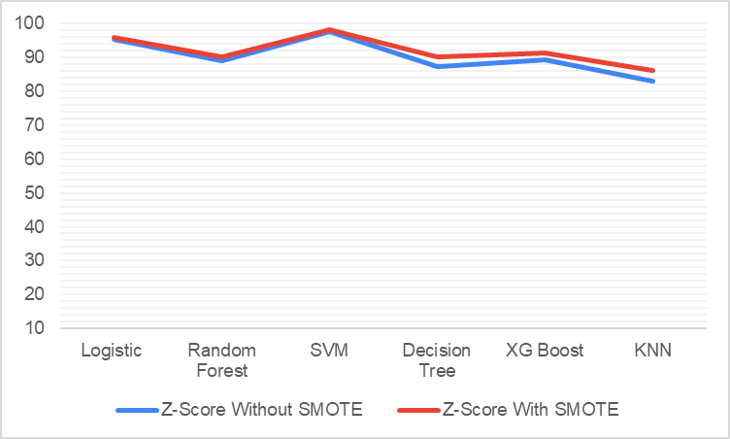

Cross validation

WQI+ Zscore + Corrr

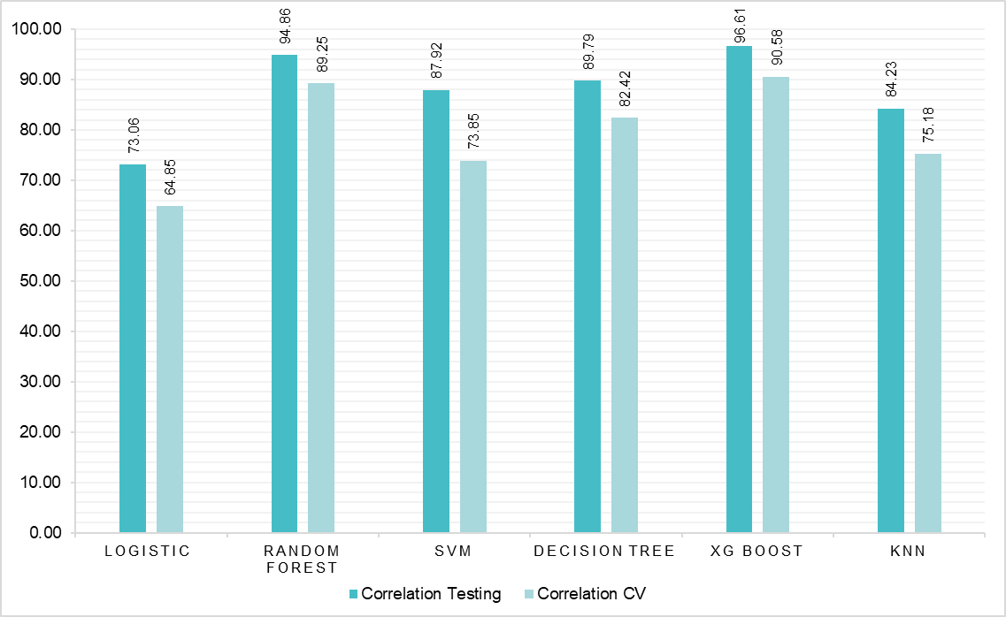

RFE

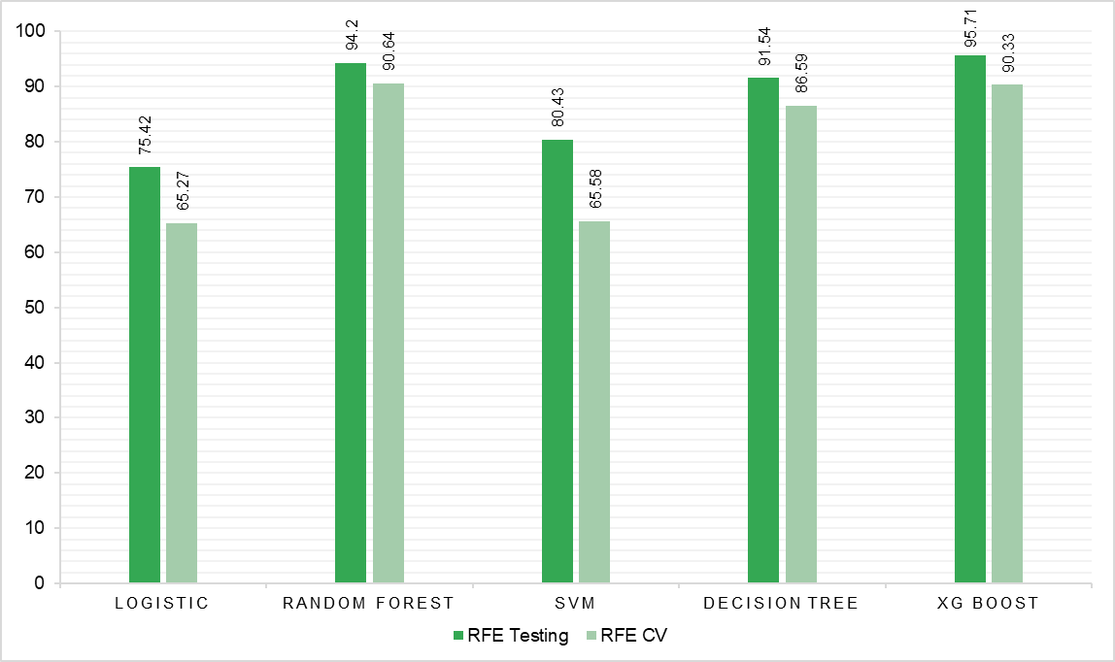

Genetic 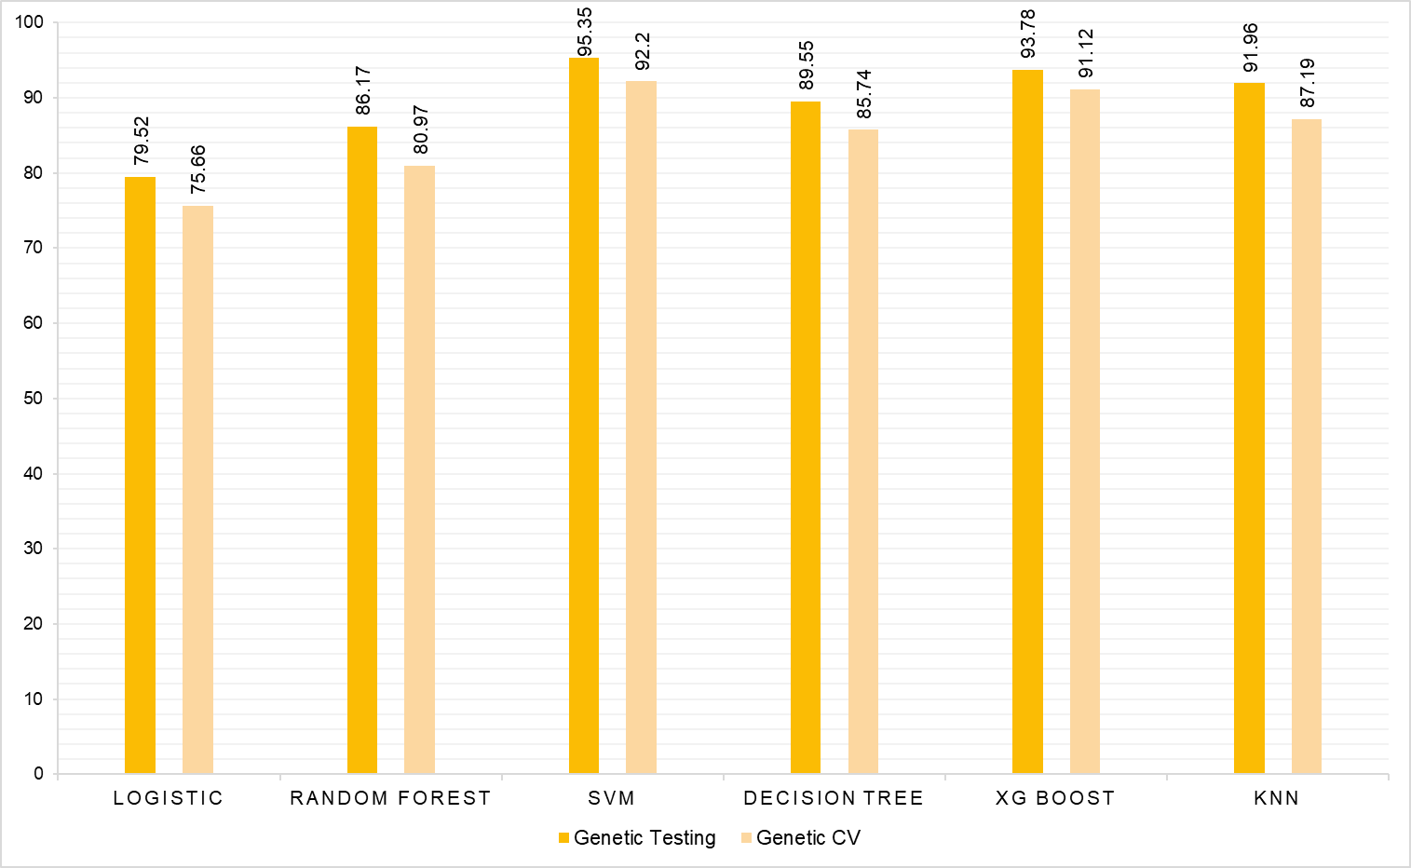

IG 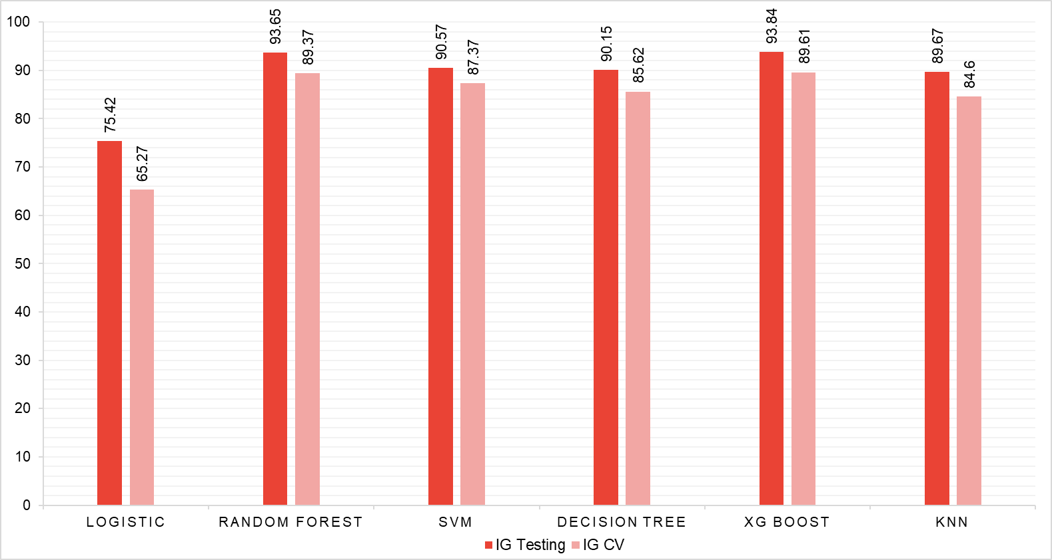

GENETIC Hypertunning

| Models | Training | Testing | CV | Precision | Recall | F1-Score | ROC Curve |
| --- | --- | --- | --- | --- | --- | --- | --- |
| Logistic | 82.78 | 81.94 | 74.88 | 81.39 | 81.94 | 81.54 | 95.29 |
| Random Forest | 100 | 94.26 | 90.64 | 94.34 | 94.26 | 94.29 | 99.61 |
| SVM | 88.7 | 95.65 | 92.51 | 95.71 | 95.65 | 95.63 | 99.86 |
| Decision Tree | 94.7 | 88.7 | 85.08 | 88.77 | 88.7 | 88.71 | 96.7 |
| XG Boost | 100 |  | 90.82 | 90.82 |  | 94.68 | 99.63 |
| KNN | 100 | 90.51 | 82.29 | 90.71 | 90.71 | 90.51 | 98.7 |

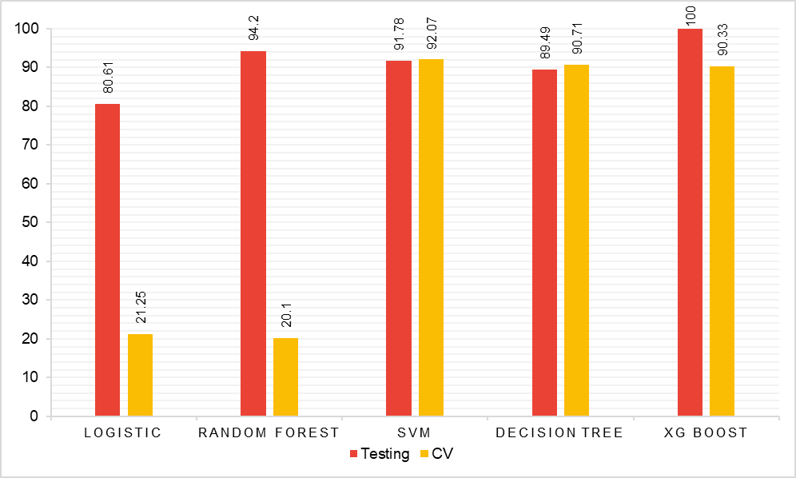

Hypertuning Graphs

1)Correlation

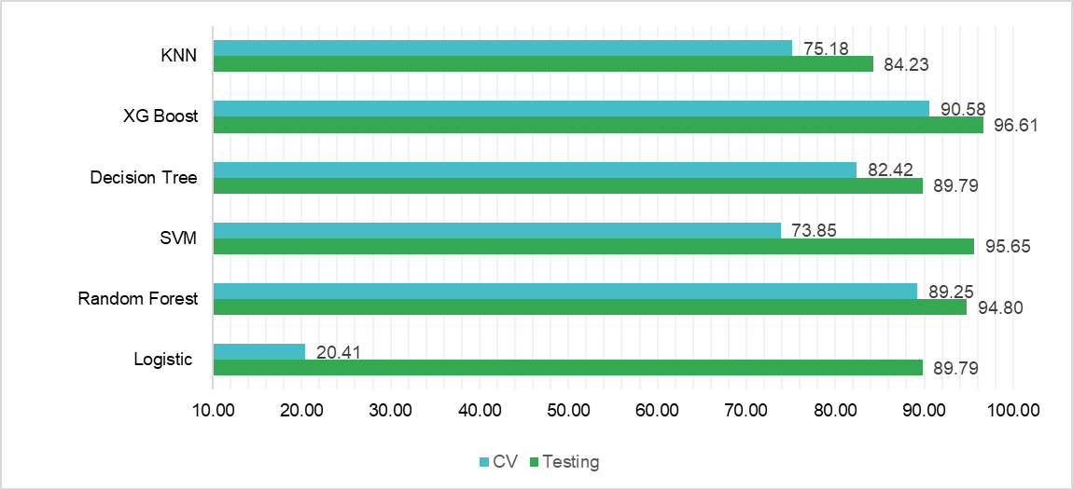

2)RFE 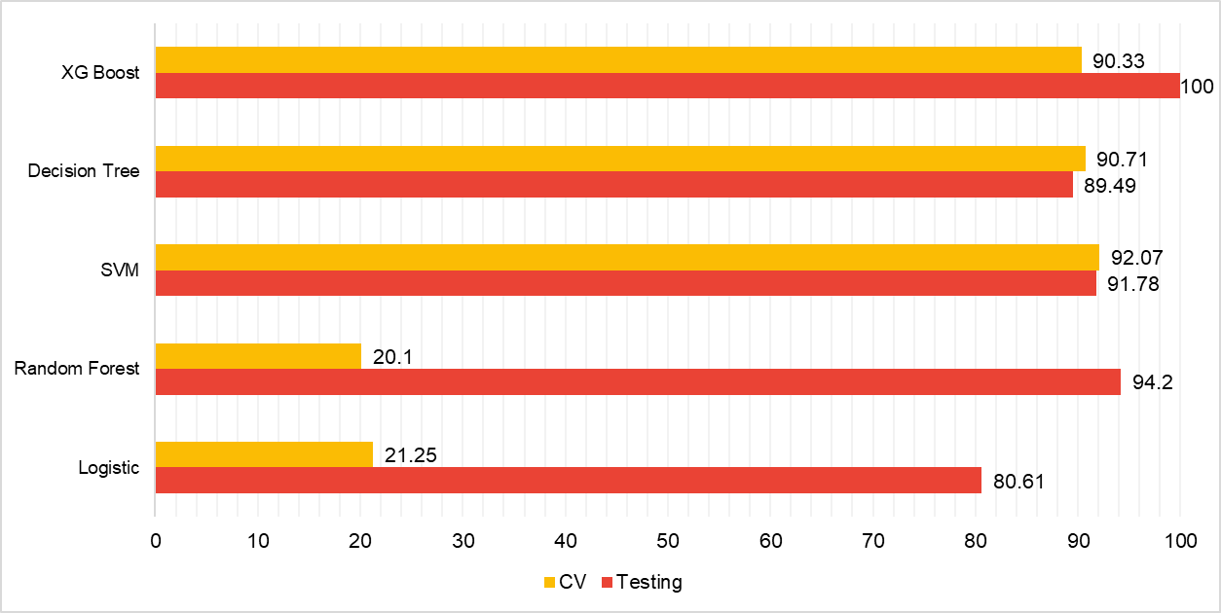

3) Information Gain

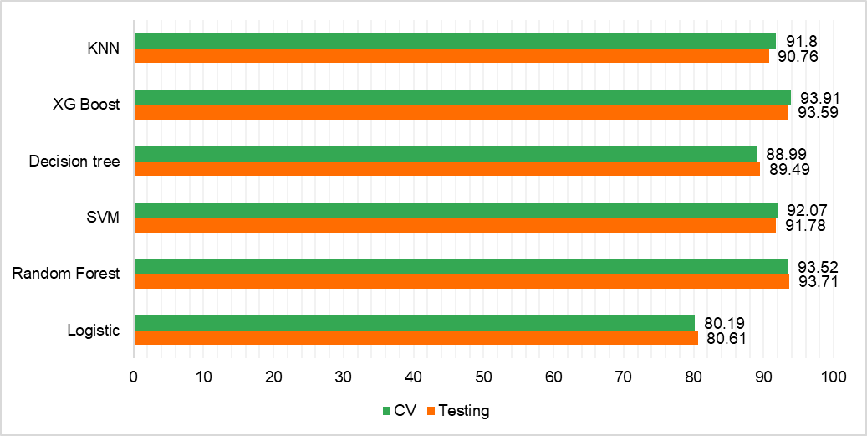

4) Genetic

