Use case: Fuel consumption

Problem statement
- Calculate the average recharge time greater than 5 in each vehicle class
- find the count value for city between 5and 11.3for each model year, make ,model combination
- identify the co2 rating greater than 2.5 from the fuel consumption
- determine the top model with the lowest range of fuel consumption
- compare the average fuel consumption with different number of motor
- use the inner join of the different table in fuel consumption
Table contains :

- battery table
- Consumption table

- Electric table

- fuel table

Relationship ship table:

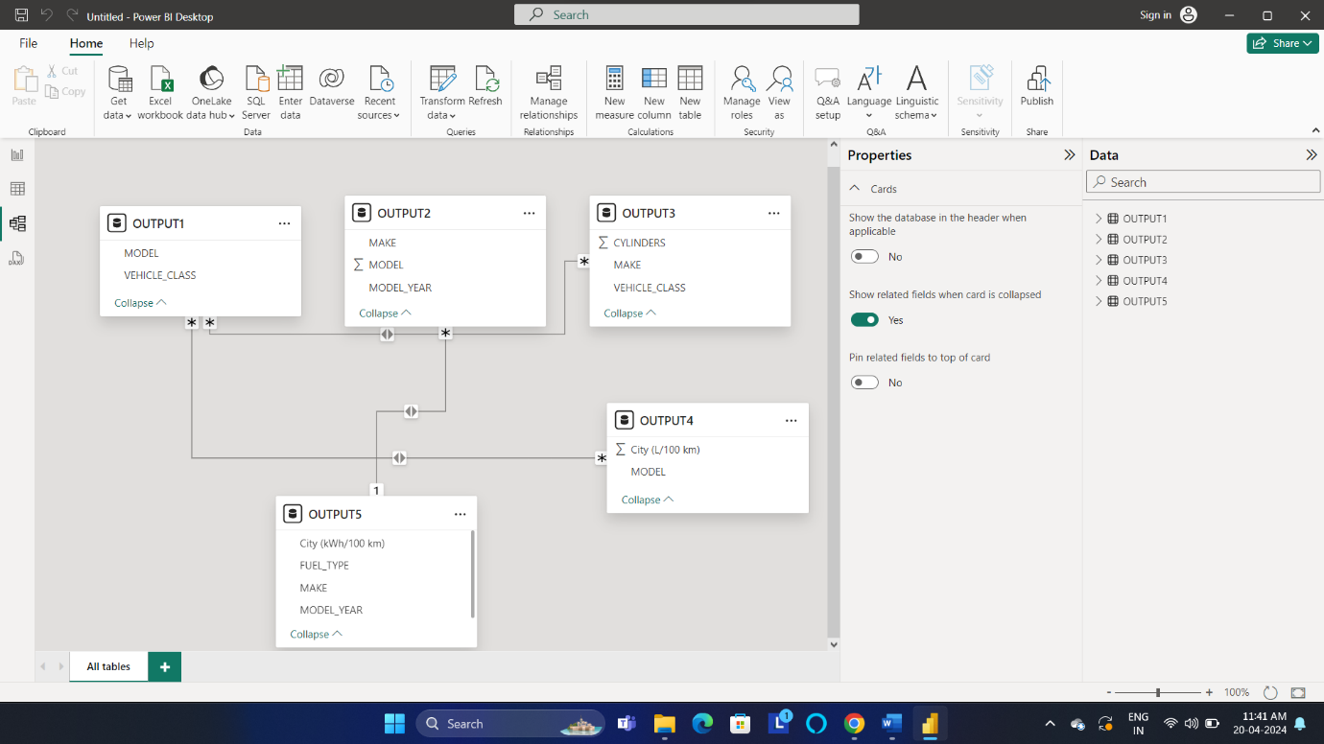

Create datawarehouse,database,schema and in table snowflake

create warehouse chendhuran_college;
create database chendhuran_college_cse;
create schema cse_A;
create schema cse_B;

Problem statement 1:

1.Calculate the average recharge time greater than 5 in each vehicle class
create table cse_B.output1 as select Vehicle_class,model from battery where "Recharge time (h)">5;
select *from output1;

powerBi output:

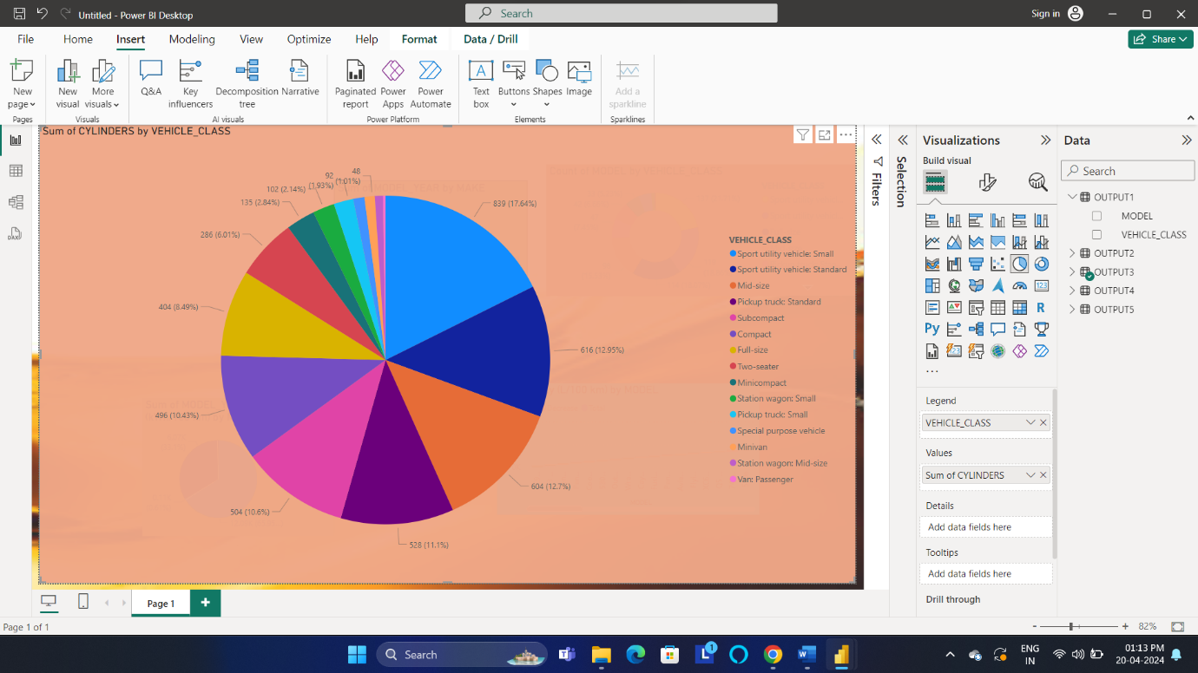
Snowflake output:
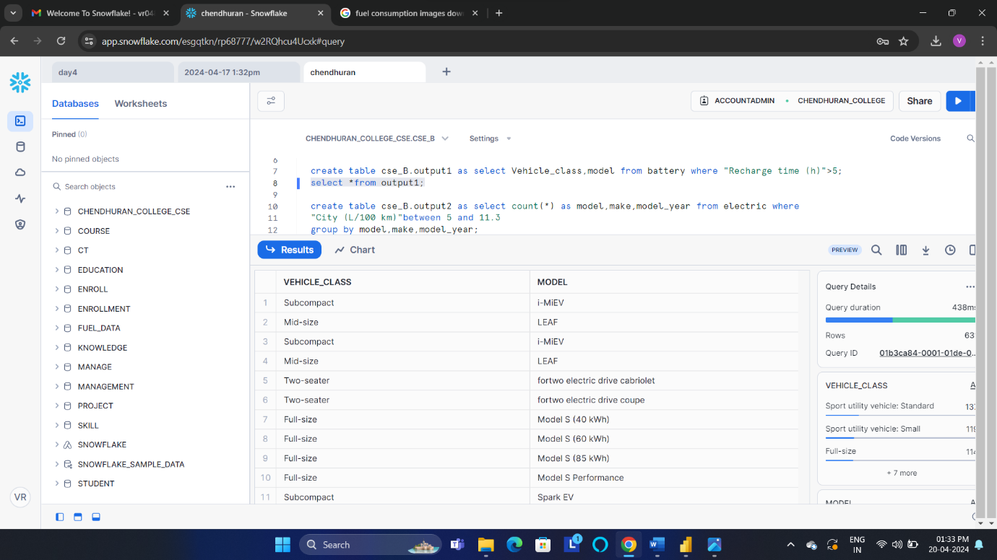

Statement 2:
2.find the count value for city between 5and 11.3for each model year, make , model combination

create table cse_B.output2 as select count(*) as model, make, model_year from electric where
"City (L/100 km)"between 5 and 11.3
group by model, make, model_year ;
select * from output2;

powerBi output:

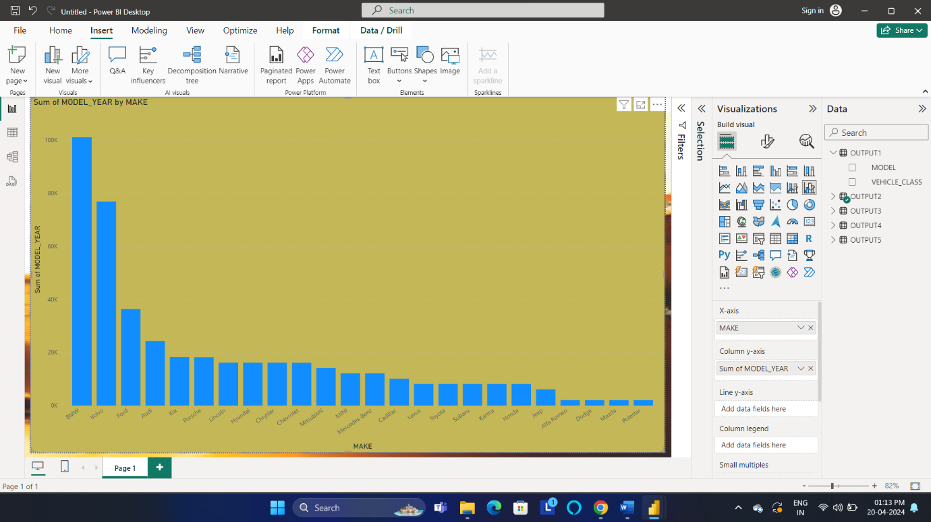

Snowflake output:

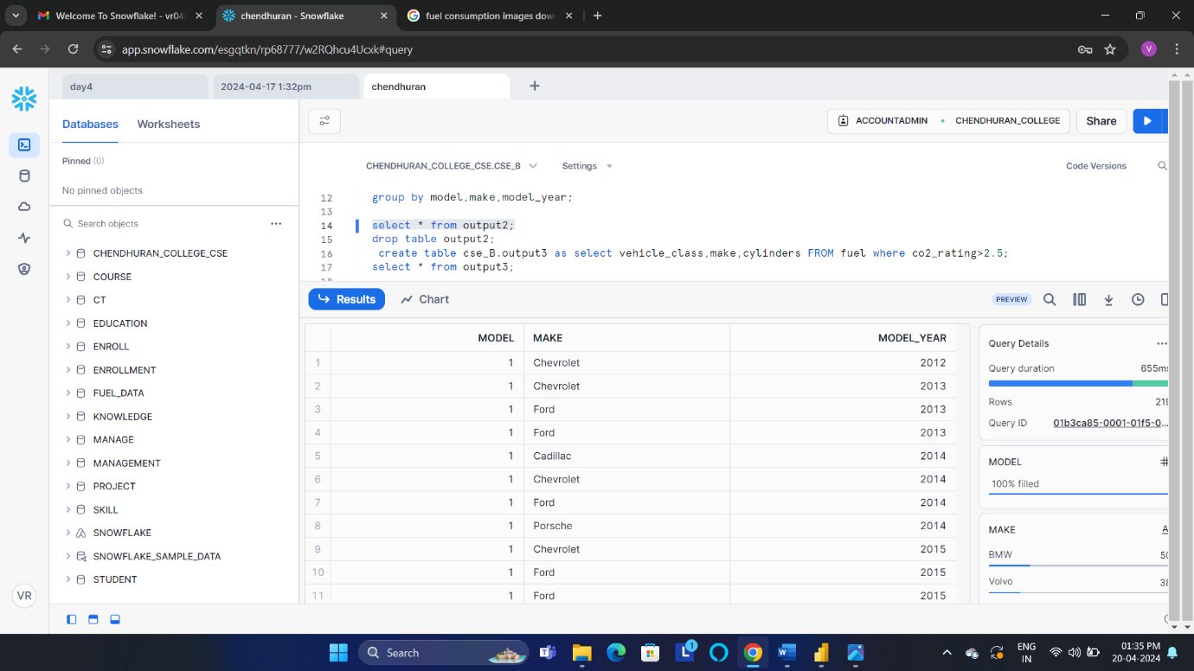

Statement 3:
3.identify the co2 rating greater than 2.5 from the fuel consumption

create table cse_B.output3 as select vehicle_class,make,cylinders FROM fuel where co2_rating>2.5;
select * from output3;

powerBi output:
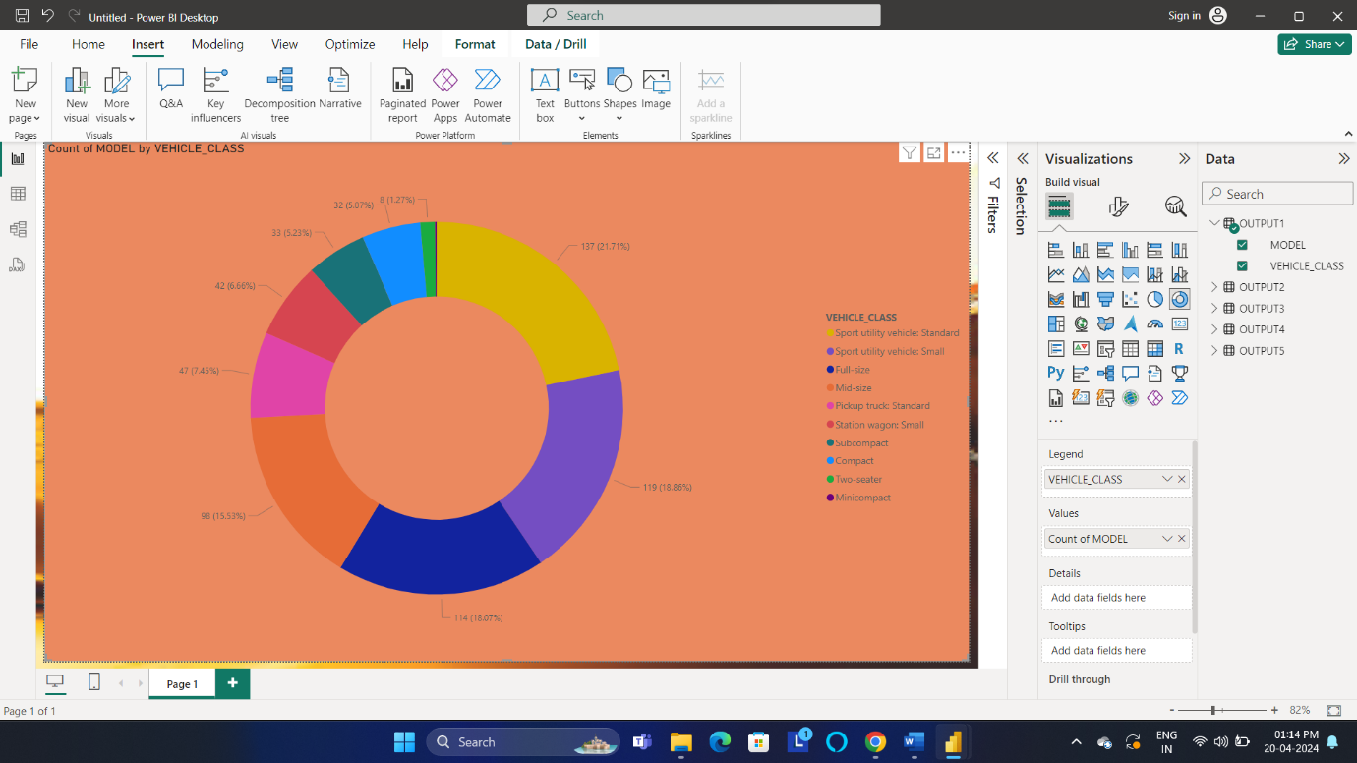
Snowflake output:
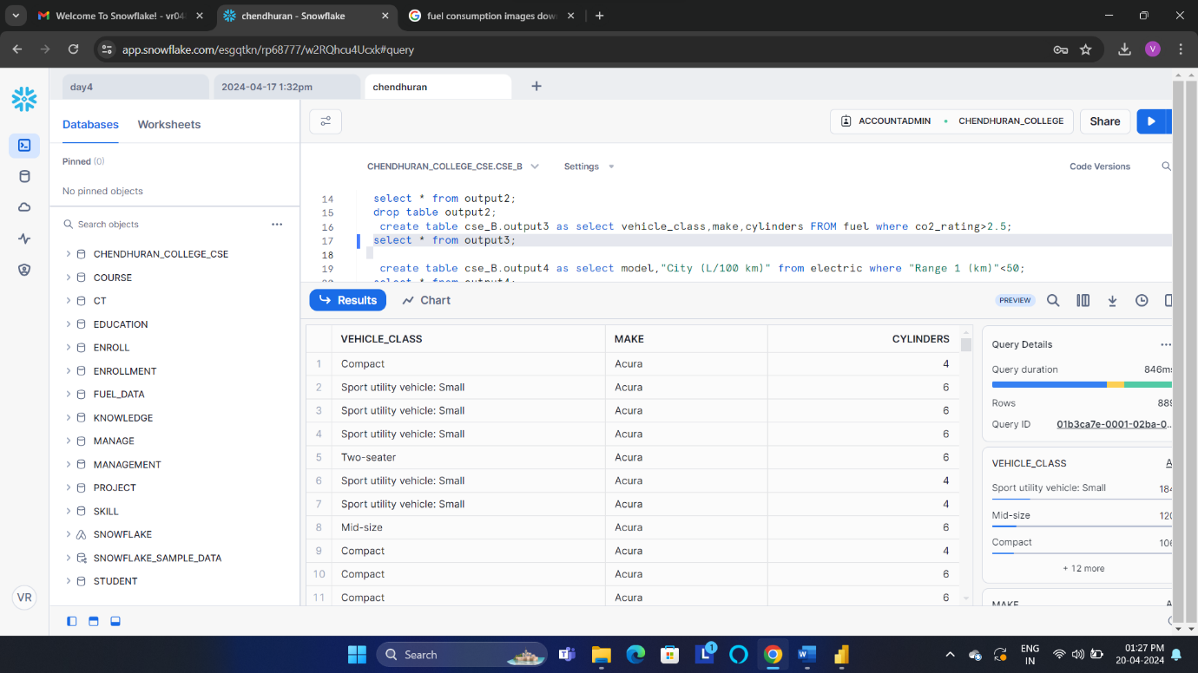

Statement 4:

4.determine the top model with the lowest range of fuel consumption

create table cse_B.output4 as select model,"City (L/100 km)" from electric where "Range 1 (km)"<50;
select * from output4;

Output
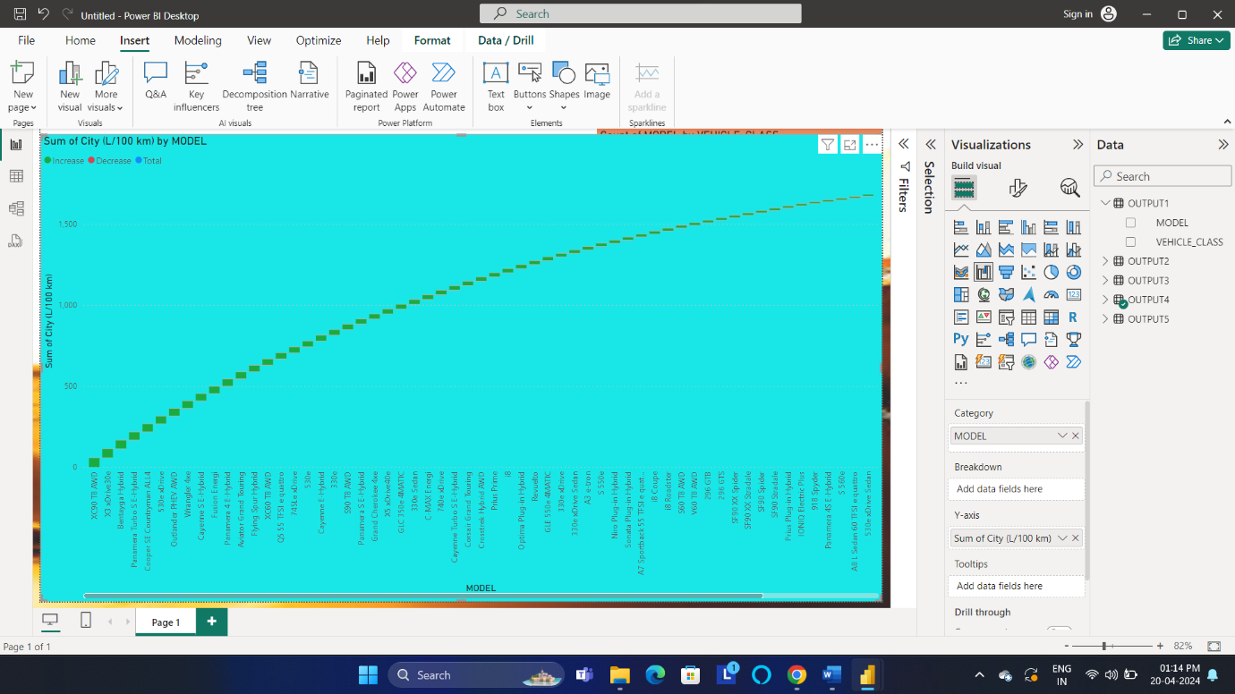

Snowflake output:

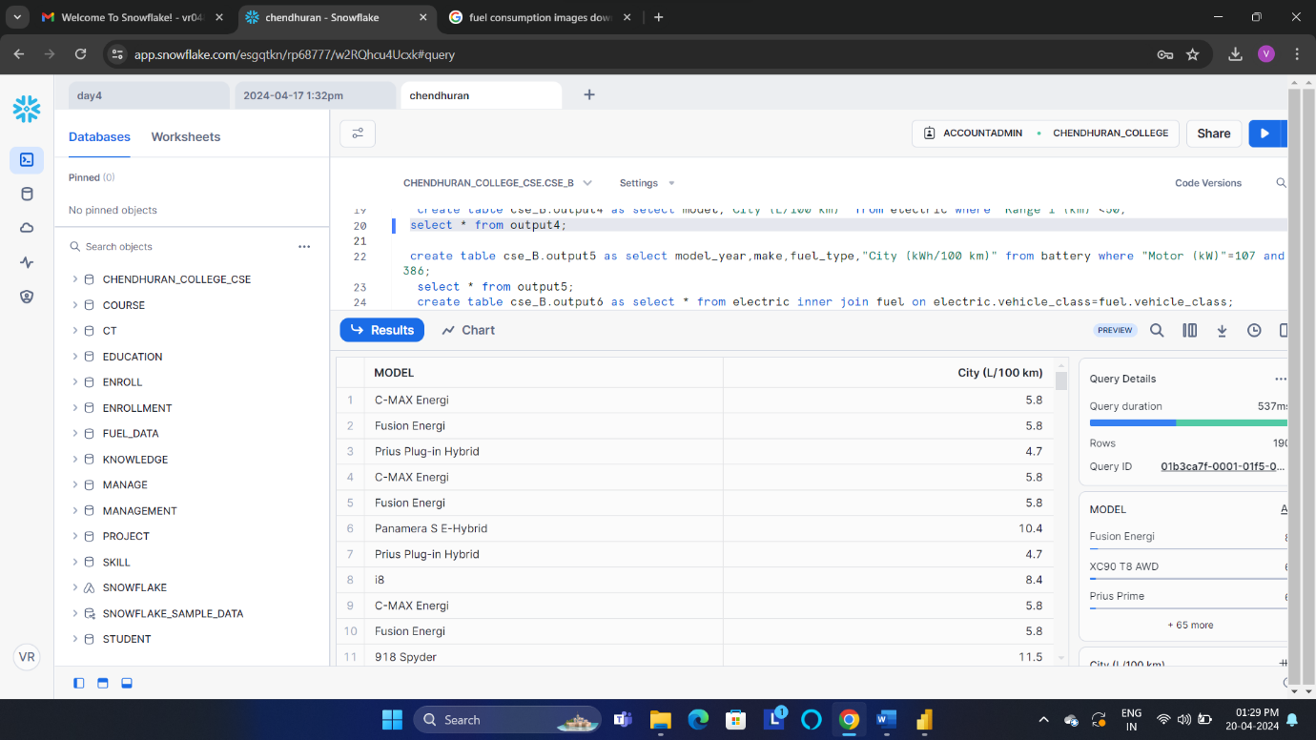

Statement 5:
5.compare the average fuel consumption with different number of motor

create table cse_B.output5 as select model_year,make,fuel_type,"City (kWh/100 km)" from battery where "Motor (kW)"=107 and 386;
select * from output5;

powerBi output:

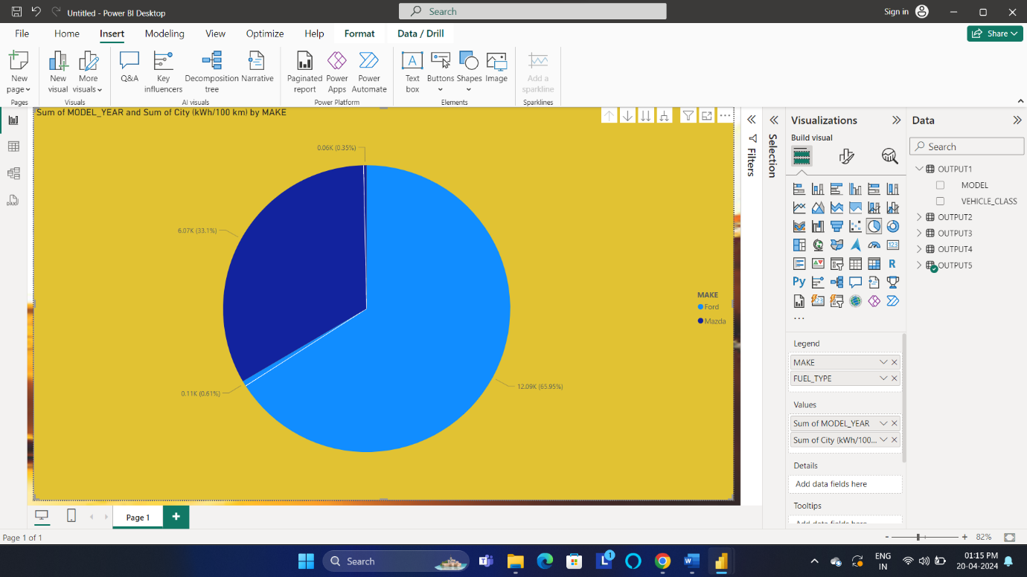
Snowflake output:

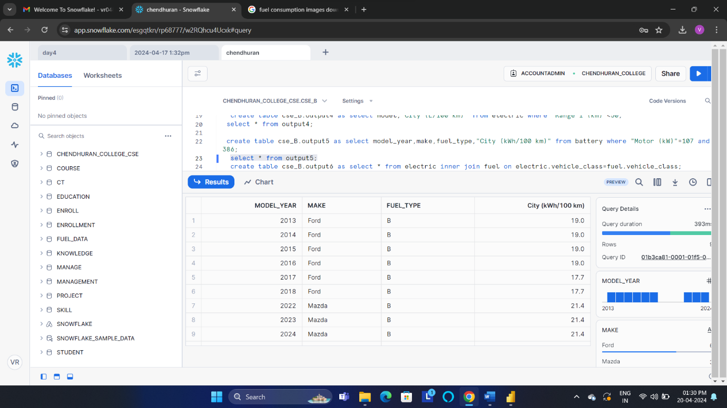

Statement 6:
use the inner join of the different table in fuel consumption

create table cse_B.output6 as select * from electric inner join fuel on electric.vehicle_class=fuel.vehicle_class;
select * from output6;

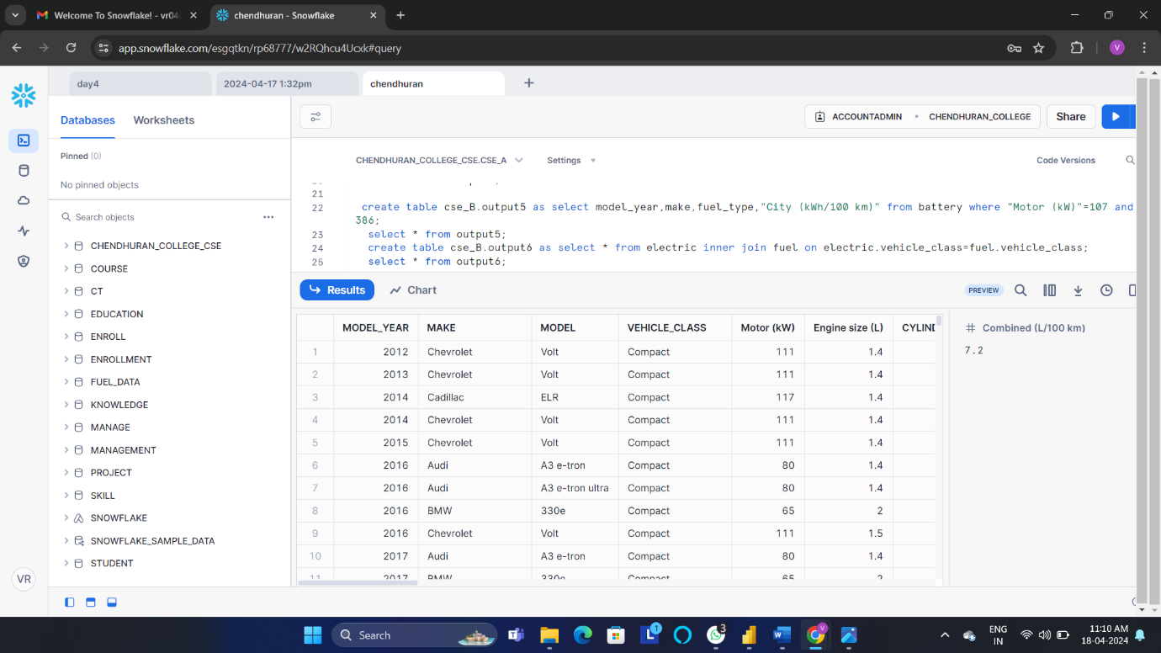

Final output of power Bi:

