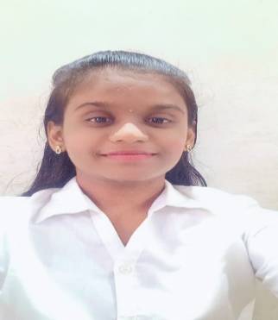

**VAISHNAVI WADKAR**

Plot no.14

state bank colony,

abhaynagar,sangli-416416

vaishnaviwadkar4@gmail.com

https://www.linkedin.com/in/vaishnavi-wadkar-1b2b41222/

+918080024186

**CAREER OBJECTIVE:**

Enthusiastic to work as part of dynamic and progressive team to enhance my interpersonal skills.

**EDUCATIONAL QUALIFICATION:**

|  |  |  |  |  |
| --- | --- | --- | --- | --- |
| **Class** | **Bord/**  **University** | **Year of**  **Passing** | **Institution** | **Percentage** |
| BTech(TY) | DBATU,Lonare | 2023 | Padmabhooshan Vasantraodada Patil Institute of Technology,Sangli | 79.72% |
| HSC | State Board,Kolhapur | 2020 | Willingdon College,  Sangli | 68.77% |
| SSC | State Board,Kolhapur | 2018 | LGR Purohit kanya prashala,Sangli | 86.80% |

**TECHNICAL SKILLS:**

* **Programming Languages :** C,C++ and Basic of python, HTML & CSS.
* **Tools Used :** Dev C++,Visual Studio, Code Block
* **Operating System worked on :** Windows 11

**PROJECT UNDERTAKENS:**

* **“**Food Delivery”
* Food delivery is a convenient service where customers can order meals from a webpage or mobile app. Restaurants prepare the food, and it is delivered by drivers. Feedback is collected through a backend system, allowing customers to provide their opinions the service and quality of the food.
* **“**Crop Yield Prediction using Machine Learning”
* The use machine learning involves the development of models that utilize historical data, weather conditions, soil characteristics and other relevant factors to predict the predict potential crop yield for a given season or location. It help farmers make informed decisions regarding crop planning ,and resource allocation.

**EXTRA-CURRICULAR:**

* Worked as a volunteer in NIRMITI-2k22(Technical Event).
* Established Technical club.
* Worked as a main anchor for cultural department.

**ACHIEVMENTS AND CERTIFICATION:**

* Participated in various Technical and Mathematical competitive exams.
* Second Runner-up for Technical competition at PVPIT.
* Secured A+ Grade in Vedic Maths.
* Machine Learning with Python(Cognitive Class)
* Microsoft Azure AI Fundamentals course.(Microsoft)
* Hacker Rank (Python, SQL Intermediate).
* Data Structure(Apt-Tech).
* German A1(Shri Mahalaxmi Academy, Kolhapur).

**HOBBIES:**

* Math’s puzzle solving.
* Gardening
* Sudoku
* Cycling

**Strengths:**

* Problem solving
* Time-Management
* Team Player
* Analytical thinking

**Personal Details:**

Name : Vaishnavi Wadkar.

DOB : 10-12-2002

Father’s Name : Sambhaji Wadkar.

Languages Known : English , Hindi ,Marathi

**Declaration:**

I hereby declare that the above written particulars are true to the best of my knowledge. I take full responsibility for the correctness of the said information.

**Place: SANGLI**

**Date:**

**VAISHNAVI WADKAR**