**Assignment-1 [12/6/2024]**

1.Created 3 private repositories, each of them having index.html

2. In Jenkins created 3 jobs

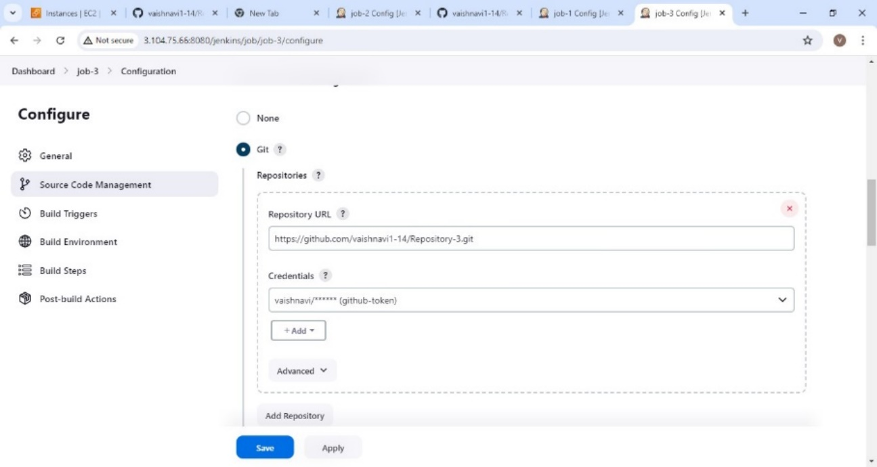

In build steps 🡪 execute shell

yum install httpd -y

service httpd start

cd /root

rm -rf Repository-2

git clone https://github.com/vaishnavi1-14/Repository-3.git

cd Repository-2

cp index.html /var/www/html/index.html

jobs are triggered

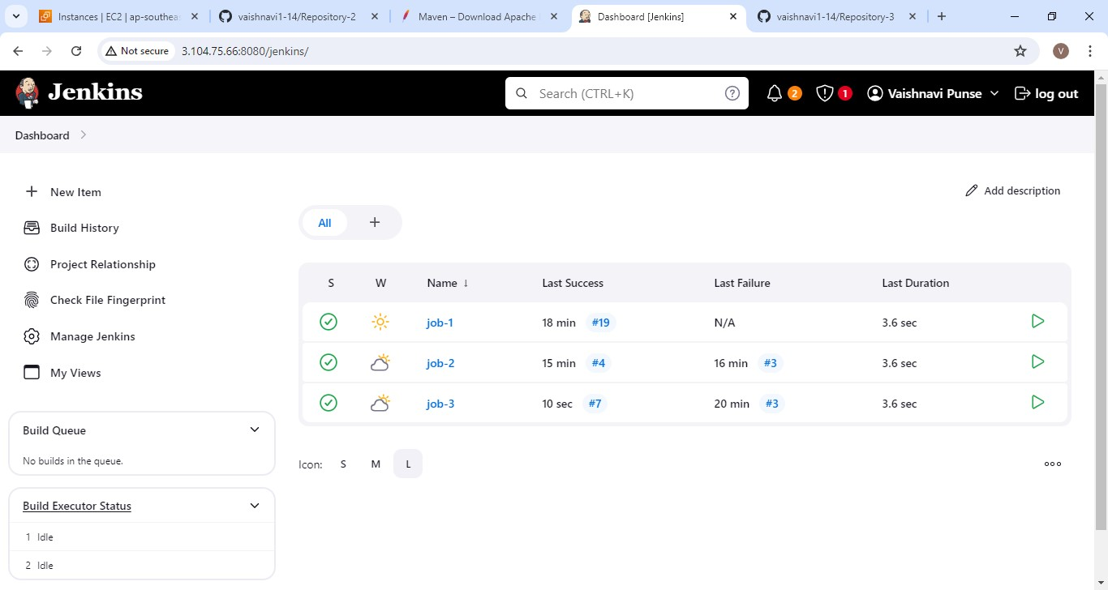

Deployed index.html

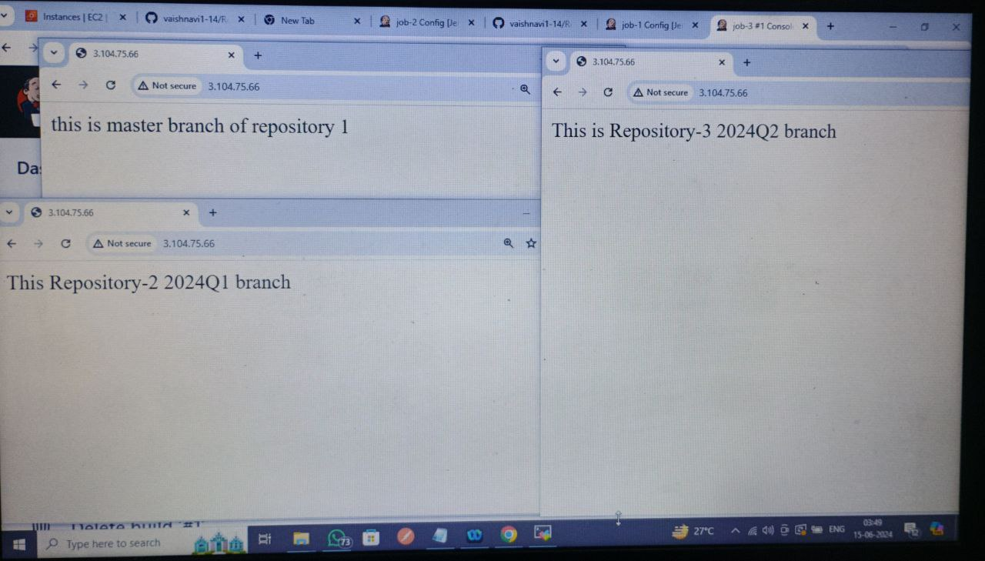

Assignment 12/6/24 -->completed

**Assignment 2 [13/6/24]**

Jenkins-Master having war file which is deployed over two EC2-instances having tomcat server

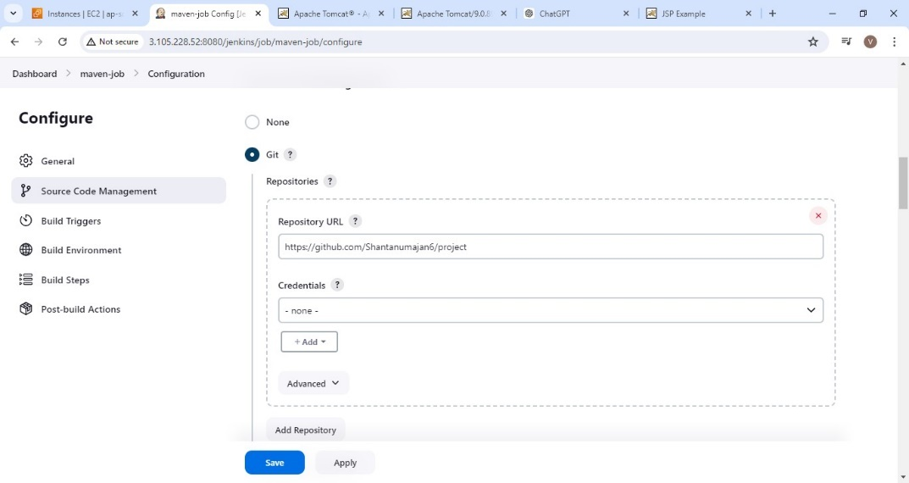

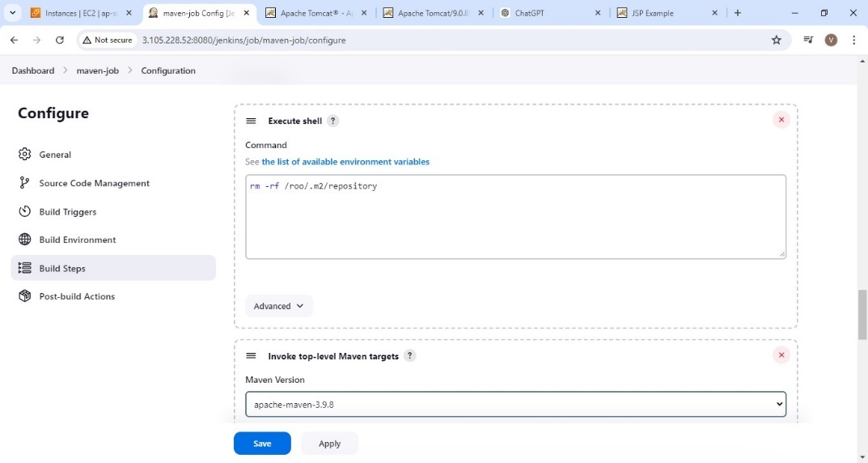

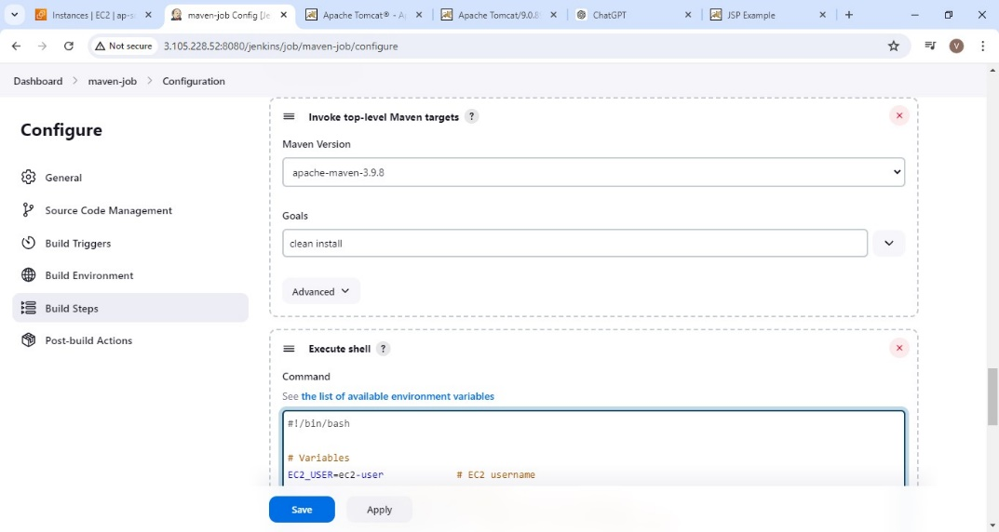

Build step 🡪 execute shell

#! /bin/bash

# Variables

EC2_USER=ec2-user # EC2 username

EC2_HOST=172.31.2.41 # EC2 instance IP

SSH_KEY=/root/kpmobasydney.pem # Path to your SSH private key

WAR_FILE=target/LoginWebApp.war # Path to the WAR file after build

TOMCAT_WEBAPPS_DIR=/mnt/servers/apache-tomcat-9.0.89/webapps

TOMCAT_BIN_DIR=/mnt/servers/apache-tomcat-9.0.89/bin

# Ensure known_hosts file exists

mkdir -p ~/.ssh

touch ~/.ssh/known_hosts

# Add EC2 instance to known_hosts

ssh-keyscan -H $EC2_HOST >> ~/.ssh/known_hosts

# SCP the WAR file to the EC2 instance

scp -i $SSH_KEY $WORKSPACE/$WAR_FILE $EC2_USER@$EC2_HOST:$TOMCAT_WEBAPPS_DIR

# Restart Tomcat on the EC2 instance

ssh -i $SSH_KEY -T $EC2_USER@$EC2_HOST

$TOMCAT_BIN_DIR/shutdown.sh

$TOMCAT_BIN_DIR/startup.sh

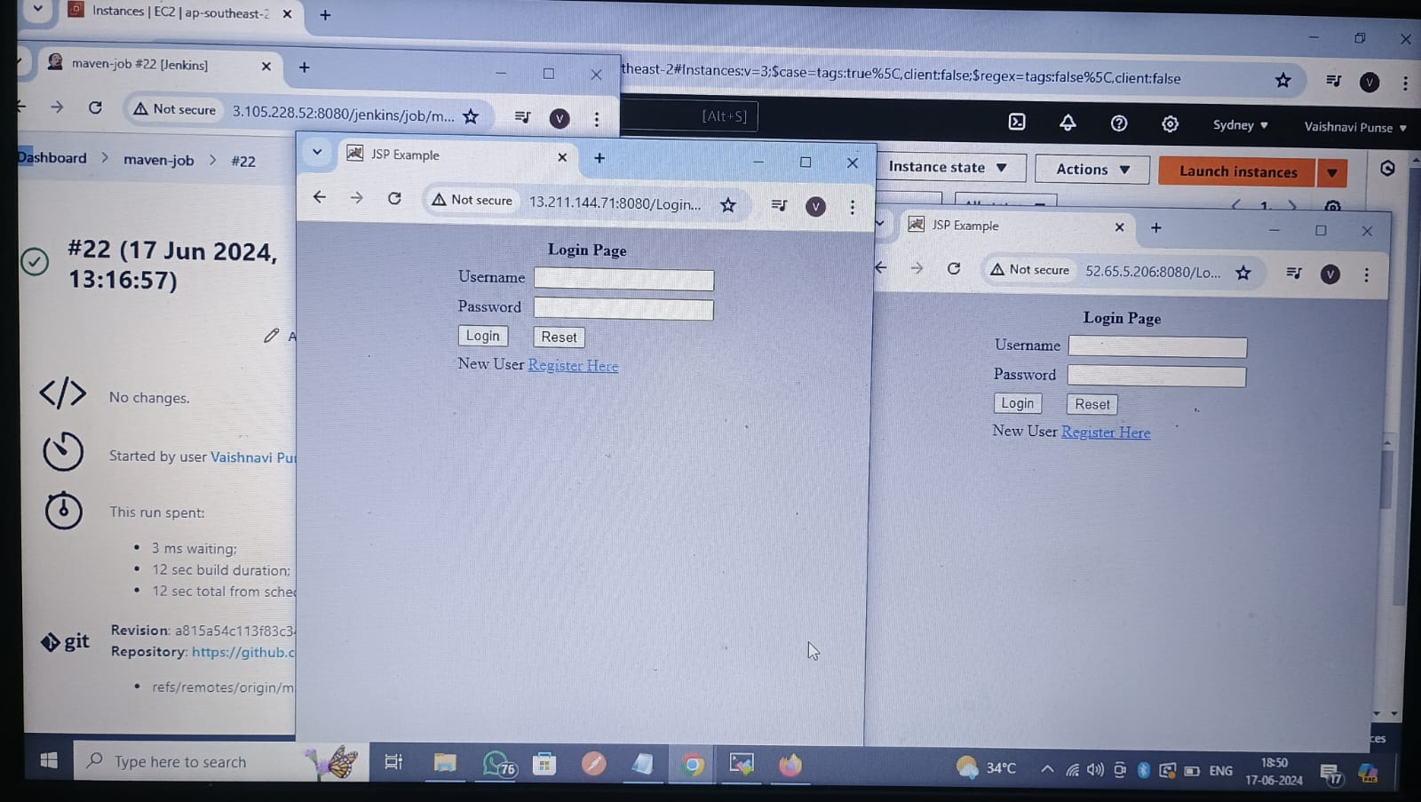

Assignment 2 completed.

**Assignment 3 [14/6/24]**

Created jobs using webhook in GitHub such that whenever the changes are done in repository job will be triggered and index file with latest changes will be deployed over Jenkin-Master with Apache httpd.

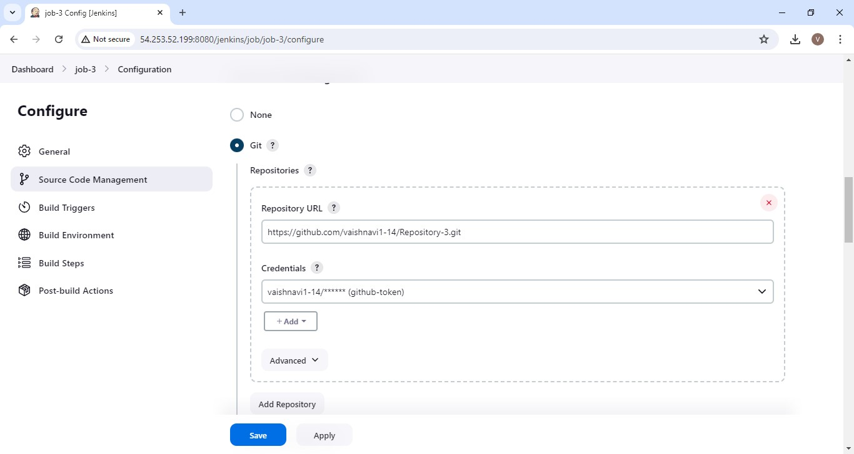

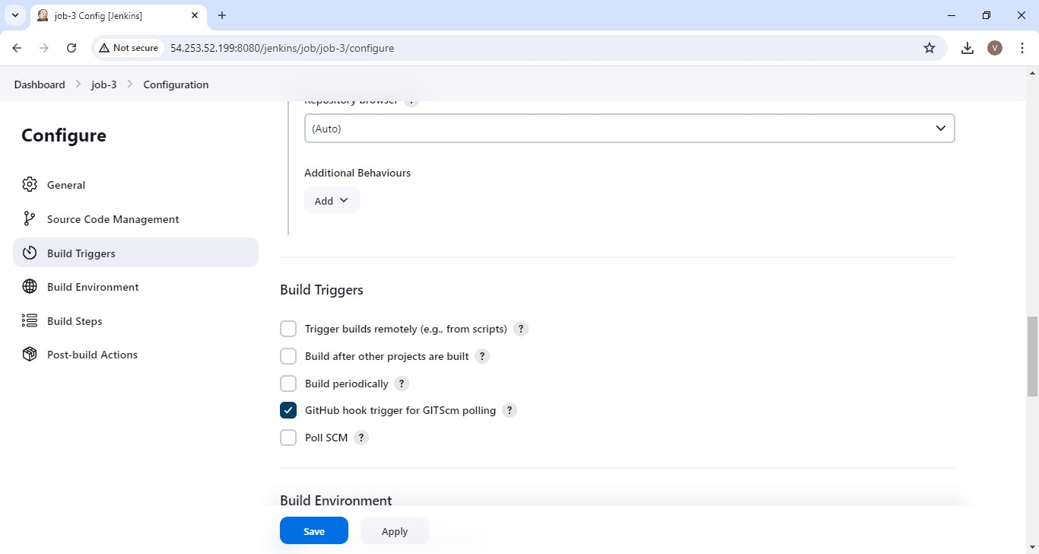

Buil step 🡪 execute shell

yum install httpd -y

service httpd start

cd /root

rm -rf Repository-3

git clone https://github.com/vaishnavi1-14/Repository-3.git

cd Repository-3

cp index.html /var/www/html/index.html

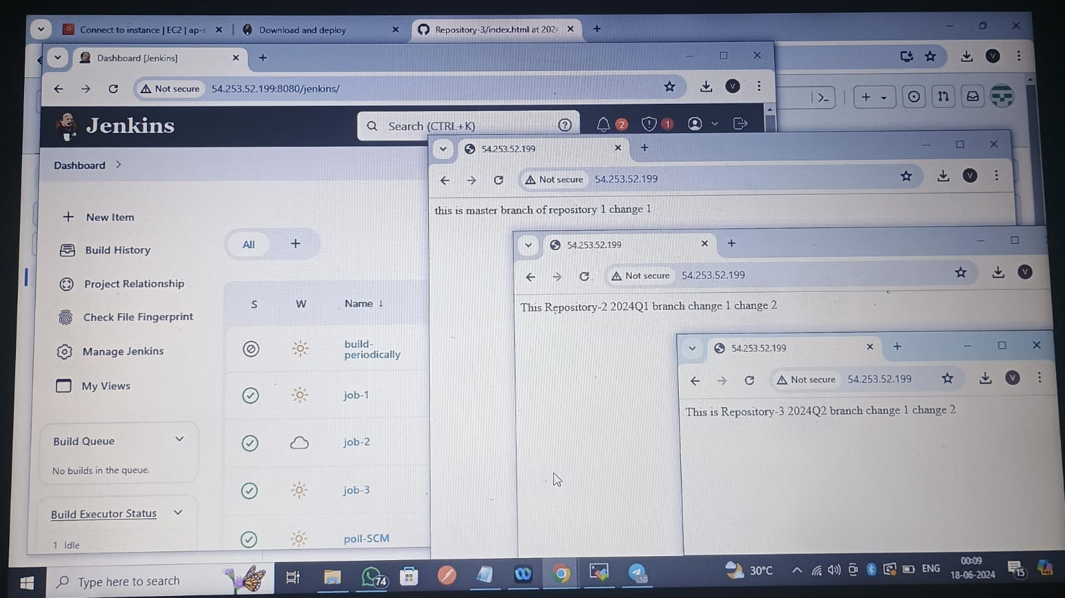

Assignment 3 completed.