UNIT 1
Statistical operations are mathematical techniques used to collect, analyze, interpret, and summarize data. In data analysis, these operations help us understand the central tendency, spread, and distribution of data.
In Python, the Pandas library provides powerful functions to perform statistical operations easily on datasets using DataFrames.

Pandas Introduction

Pandas is an open-source Python library used for data manipulation, analysis and cleaning. It provides fast and flexible tools to work with tabular data, similar to spreadsheets or SQL tables.
Pandas is used in data science, machine learning, finance, analytics and automation because it integrates smoothly with other libraries such as:


Installation
Before using Pandas, make sure it is installed:

pip install pandas

After the Pandas have been installed in the system we need to import the library. This module is imported using:

import pandas as pd

Data Structures in Pandas
Pandas provides two data structures for manipulating data which are as follows:

1. Pandas Series

Pandas Series is a one-dimensional labeled array that can hold data of any type (integer, float, string, Python objects, etc.

import pandas as pd

data = [1, 2, 3, 4]

ser = pd.Series(data)
print(ser)

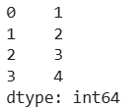
print(ser[:5])
https://www.geeksforgeeks.org/pandas/creating-a-pandas-series/

Pandas DataFrame

A Pandas DataFrame is a two-dimensional table-like structure in Python where data is arranged in rows and columns. It’s one of the most commonly used tools for handling data and makes it easy to organize, analyze and manipulate data. It can store different types of data such as numbers, text and dates across its columns. The main parts of a DataFrame are:
pandas.DataFrame() function is its constructor, used to create and initialize this data structure

Data: Actual values in the table.
Rows: Labels that identify each row.
Columns: Labels that define each data category.

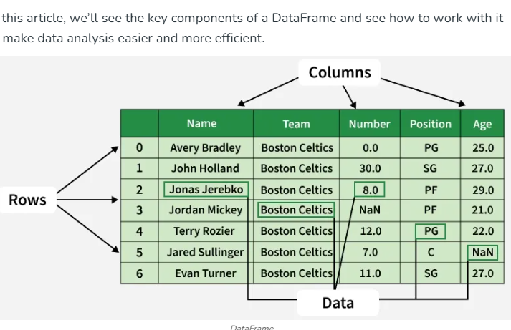
Creating an Empty DataFrame
An empty DataFrame in pandas is a table with no data but can have defined column names and indexes. It is useful for setting up a structure before adding data dynamically. An empty DataFrame can be created just by calling a dataframe constructor.

import pandas as pd

df = pd.DataFrame()

print(df)

Creating a DataFrame from a List
A simple way to create a DataFrame is by using a single list. Pandas automatically assigns index values to the rows when you pass a list.
Each item in the list becomes a row.
The DataFrame consists of a single unnamed column.

pandas.DataFrame() function is its constructor, used to create and initialize this data structure
import pandas as pd

lst = ['Geeks', 'For', 'Geeks', 'is',
'portal', 'for', 'Geeks']

df = pd.DataFrame(lst)
print(df)

​ Creating a DataFrame from a List of Dictionaries
We can also create dataframe using List of Dictionaries. It represents data where each dictionary corresponds to a row. This method is useful for handling structured data from APIs or JSON files. It is commonly used in web scraping and API data processing since JSON responses often contain lists of dictionaries.

import pandas as pd

dict = {'name':["aparna", "pankaj", "sudhir", "Geeku"],
'degree': ["MBA", "BCA", "M.Tech", "MBA"],
'score':[90, 40, 80, 98]}

df = pd.DataFrame(dict)

print(df)

https://www.geeksforgeeks.org/pandas/creating-a-pandas-dataframe/

Dataset and DataFrame
A dataset is a collection of related data values stored in tabular form.
A DataFrame is a two-dimensional labeled data structure in Pandas that contains:
- Rows (records)
- Columns (attributes or features)
Example attributes:
- Student Name
- Age
- Graduation Percentage

Pandas functions are:
Data Input/Output (I/O)
These functions are used to read data from and write data to various file formats.
- pd.read_csv(): Reads data from a comma-separated values (CSV) file into a DataFrame.
- pd.read_excel(): Reads data from an Excel file into a DataFrame.
- df.to_csv(): Writes the DataFrame to a CSV file.
Viewing and Exploration
Functions to get an initial overview of the data's structure, content, and summary statistics.
- df.head(): Returns the first few rows of the DataFrame (default is 5).
- df.tail(): Returns the last few rows of the DataFrame.
- df.info(): Prints a concise summary of the DataFrame, including data types and non-null values.
- df.describe(): Generates descriptive statistics for numerical columns, such as mean, standard deviation, and quartiles.
- df.shape: An attribute that returns a tuple representing the dimensions (rows, columns) of the DataFrame.
Data Cleaning and Preparation
Functions for handling missing data, duplicates, and converting data types.
- df.isnull(): Detects missing values (NaN) and returns a boolean DataFrame.
- df.dropna(): Removes rows or columns with missing values.
- df.fillna(value): Fills missing values with a specified value.
- df.drop_duplicates(): Removes duplicate rows from the DataFrame.
- pd.to_datetime(): Converts an argument to datetime objects, useful for time-series analysis.
Data Selection and Filtering
Methods for selecting specific subsets of data.
- df.loc[]: Used for label-based selection of rows and columns.
- df.iloc[]: Used for integer position-based selection.
- df.isin(): Checks whether values in the DataFrame are contained in a specified list or DataFrame.
Data Manipulation and Transformation
Functions for modifying, merging, and reshaping datasets.
- df.groupby(): Groups rows based on one or more columns for aggregation.
- pd.merge(): Combines two DataFrames based on common columns or indices (database-style joins).
- pd.concat(): Concatenates two or more Pandas objects along a particular axis (rows or columns).
- df.apply(): Applies a function along the axes of a DataFrame or Series.

