**Practical Exercise-6**

**Aim**:-Create a github repository and perform a basic git operation

**Theory:**

**Github:**

GitHub is a cloud-based platform where you can store, share, and work together with others to write code.

Storing your code in a "repository" on GitHub allows you to:

* **Showcase or share** your work.
* **Track and manage** changes to your code over time.
* Let others **review** your code, and make suggestions to improve it.
* **Collaborate** on a shared project, without worrying that your changes will impact the work of your collaborators before you're ready to integrate them.

Collaborative working, one of GitHub’s fundamental features, is made possible by the open-source software, Git, upon which GitHub is built.

**key characteristics:**

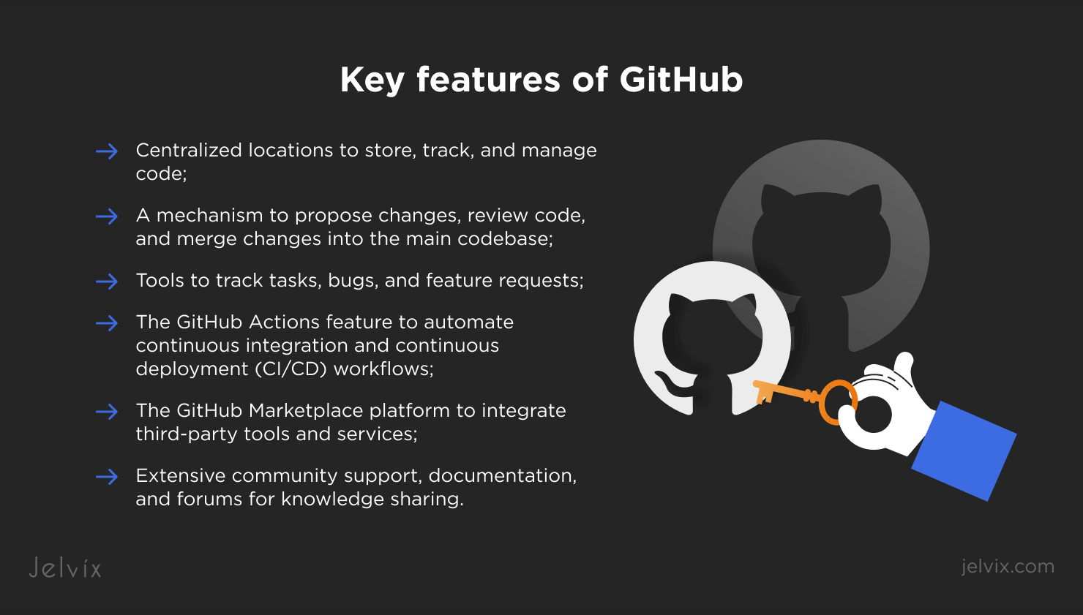

**Facilities that Github gives:**

**1. Version Control System (VCS) Integration**

* Built on **Git**, a distributed version control system.
* Tracks changes in code and maintains a history of modifications.
* Supports branching and merging for parallel development.

**2. Collaboration and Team Management**

* Allows multiple contributors to work on the same project.
* Supports code reviews through **Pull Requests (PRs)**.
* Provides **role-based access control** and permissions for team members

**3. Repository Management**

* Supports **public and private repositories**.
* Offers **forking and cloning** to enable independent development.
* Provides a **commit history log** for tracking changes.

**4. Cloud-Based Platform**

* Accessible from anywhere with an internet connection.
* Supports seamless integration with cloud services and CI/CD pipelines.

**5. Issue Tracking and Project Management**

* Tracks bugs, enhancements, and tasks through **GitHub Issues**.
* Supports **Kanban boards** and **milestones** for project planning.
* Allows labeling, assigning, and linking issues to commits.

**6. Automation and CI/CD Integration**

* **GitHub Actions** for automating workflows, such as testing and deployment.
* Integration with third-party CI/CD tools like Jenkins, Travis CI, and CircleCI.

**7. Security and Access Control**

* Provides **branch protection rules** and **code scanning tools**.
* Supports **two-factor authentication (2FA)**.
* Offers **encrypted communication and data storage**.

**8. Open-Source Community Support**

* Hosts millions of open-source projects.
* Facilitates **contribution through forking and pull requests**.
* Provides visibility to developers and their portfolios.

**9. Code Hosting and File Management**

* Supports multiple programming languages and file types.
* Allows managing large files through **Git Large File Storage (LFS)**.
* Supports **markdown documentation** for README files and wikis.

**10. Analytics and Insights**

* Provides **commit history analysis** and **contributor statistics**.
* Tracks project progress and code quality.

**Use GitHub?**

✅ **Team Collaboration** – Multiple developers can work on the same project.  
✅ **Open-Source Contribution** – Many global projects use GitHub for community-driven development.  
✅ **Code Backup & History** – Keeps track of all code changes over time.  
✅ **Integration Support** – Works with various tools like Slack, Jira, and AWS.