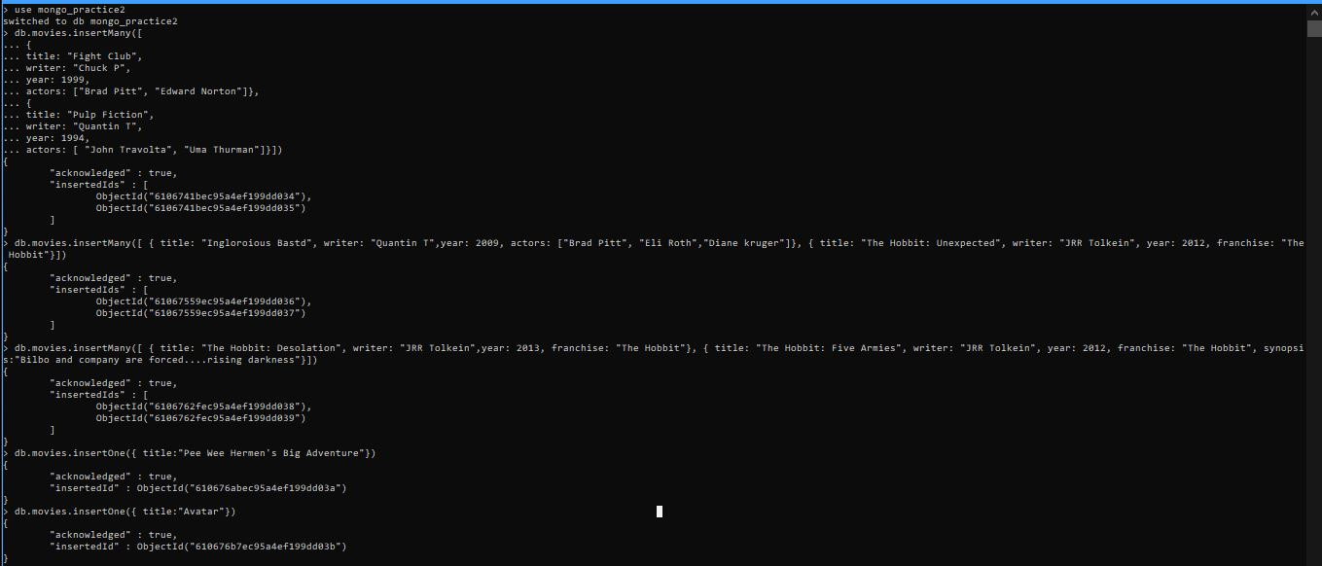









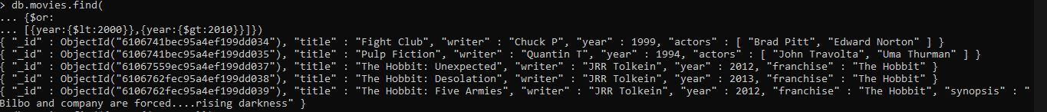

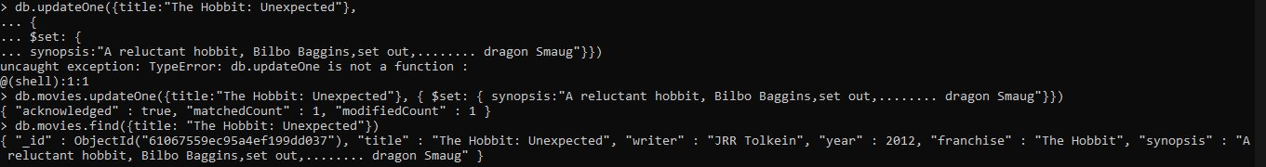



**db.movies.update({_id:ObjectId("6106c186329430635572de67")},{$push:{actors:"Samuel L. Jackson"}})**

