SLE-3: Architectural Design using Full C4 Model
BFS & DFS Graph Search System
Name | Vaishnavi Sudhir Ghodake
PRN / Division | 26UAM315 / A
GitHub link | https://github.com/vaishnavi1211-sg/IAI_SLEs_26UAM315/blob/main/SLE
Date | 08 October 2026
System Description
The BFS & DFS Graph Search System is a Python-based search system developed to implement and compare Breadth First Search (BFS) and Depth First Search (DFS). It searches a graph from a start node to a goal node, records the search path and nodes expanded, and measures execution time for performance analysis.
Connection with SLE-2
This architecture continues the BFS/DFS implementation and empirical performance analysis completed in SLE-2. The C4 model represents the same system at four levels: Context, Container, Component and Code.
Level 1 — System Context
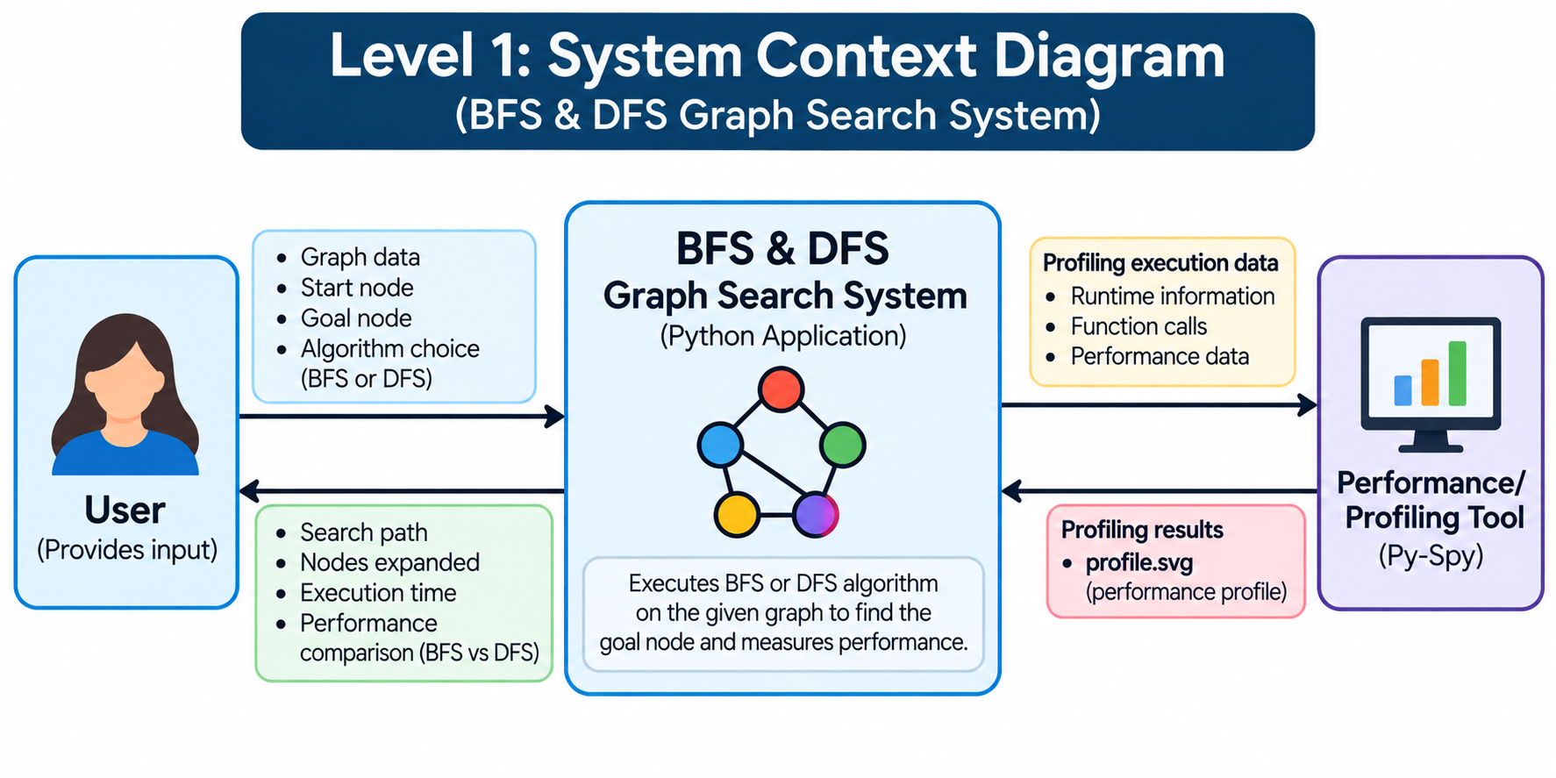
The Context view shows the user interacting with the BFS & DFS system. The system receives graph data, a start node and a goal node, executes BFS or DFS, and returns search and performance information. Py-Spy is used as the external profiling tool.

Level 2 — Container Diagram
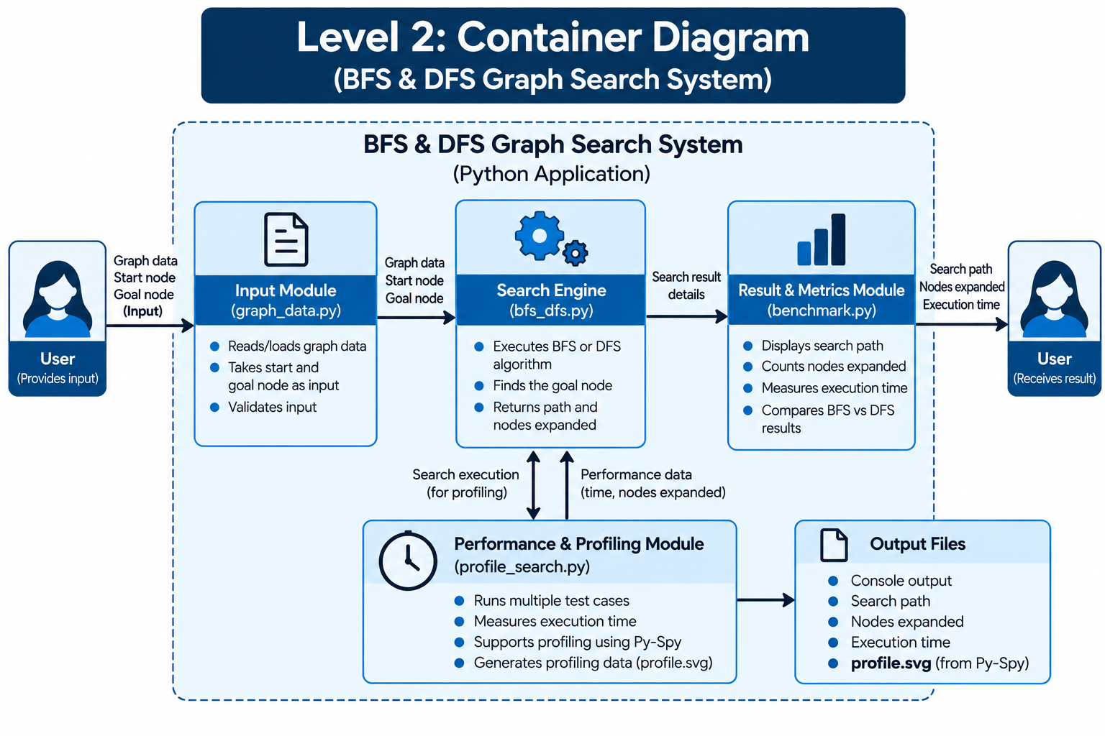
The Container view decomposes the system into five logical building blocks for input, search execution, result measurement, profiling and outputs.

Container | Responsibility
Input Module | Provides graph, start node and goal node.
Search Engine | Executes BFS or DFS and returns search results.
Result & Metrics Module | Produces path, nodes expanded and execution time.
Performance & Profiling Module | Runs repeated tests and supports Py-Spy profiling.
Output | Presents search results and generated profiling output.

Level 3 — Component Diagram

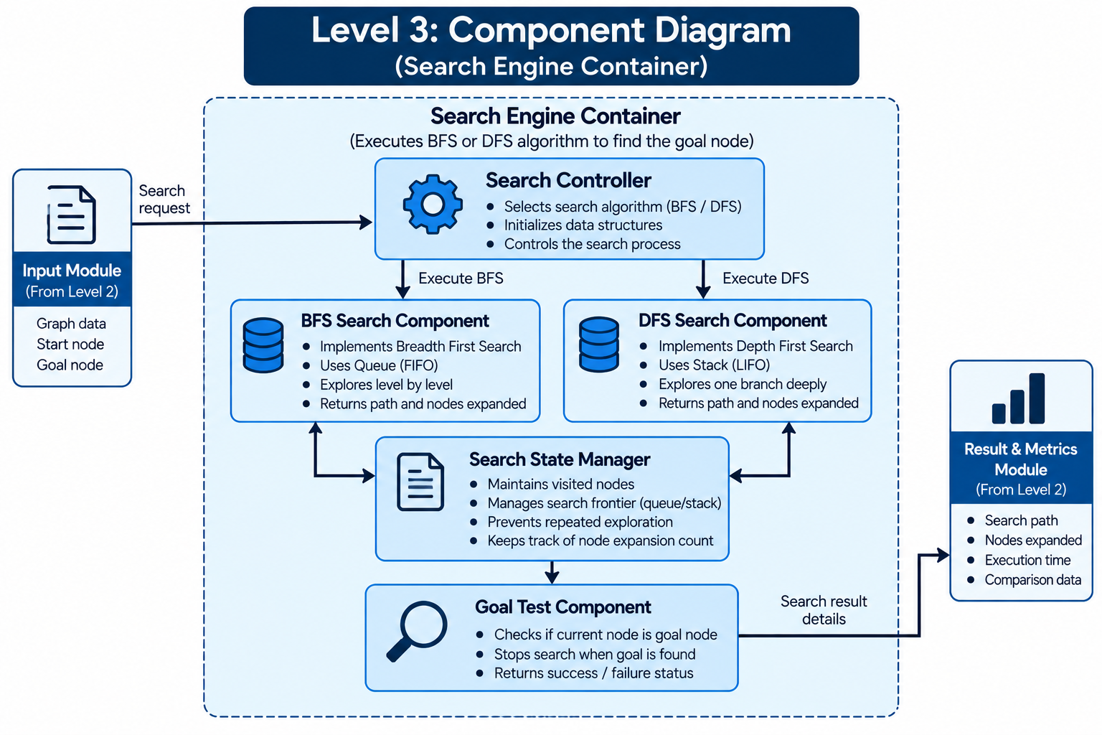

The Component view focuses on the Search Engine container. The Search Controller selects BFS or DFS; the BFS and DFS components perform traversal; the Search State Manager tracks visited nodes and the frontier; and the Goal Test checks whether the current node is the target.
Design Decisions
• BFS and DFS are separate components because BFS uses a queue (FIFO) while DFS uses a stack (LIFO).
• Visited-node tracking avoids repeated exploration.
• The same graph and test conditions are used for a fair comparison.
• Benchmarking and profiling are separated from the core search logic.

Level 4 — Code Level Overview

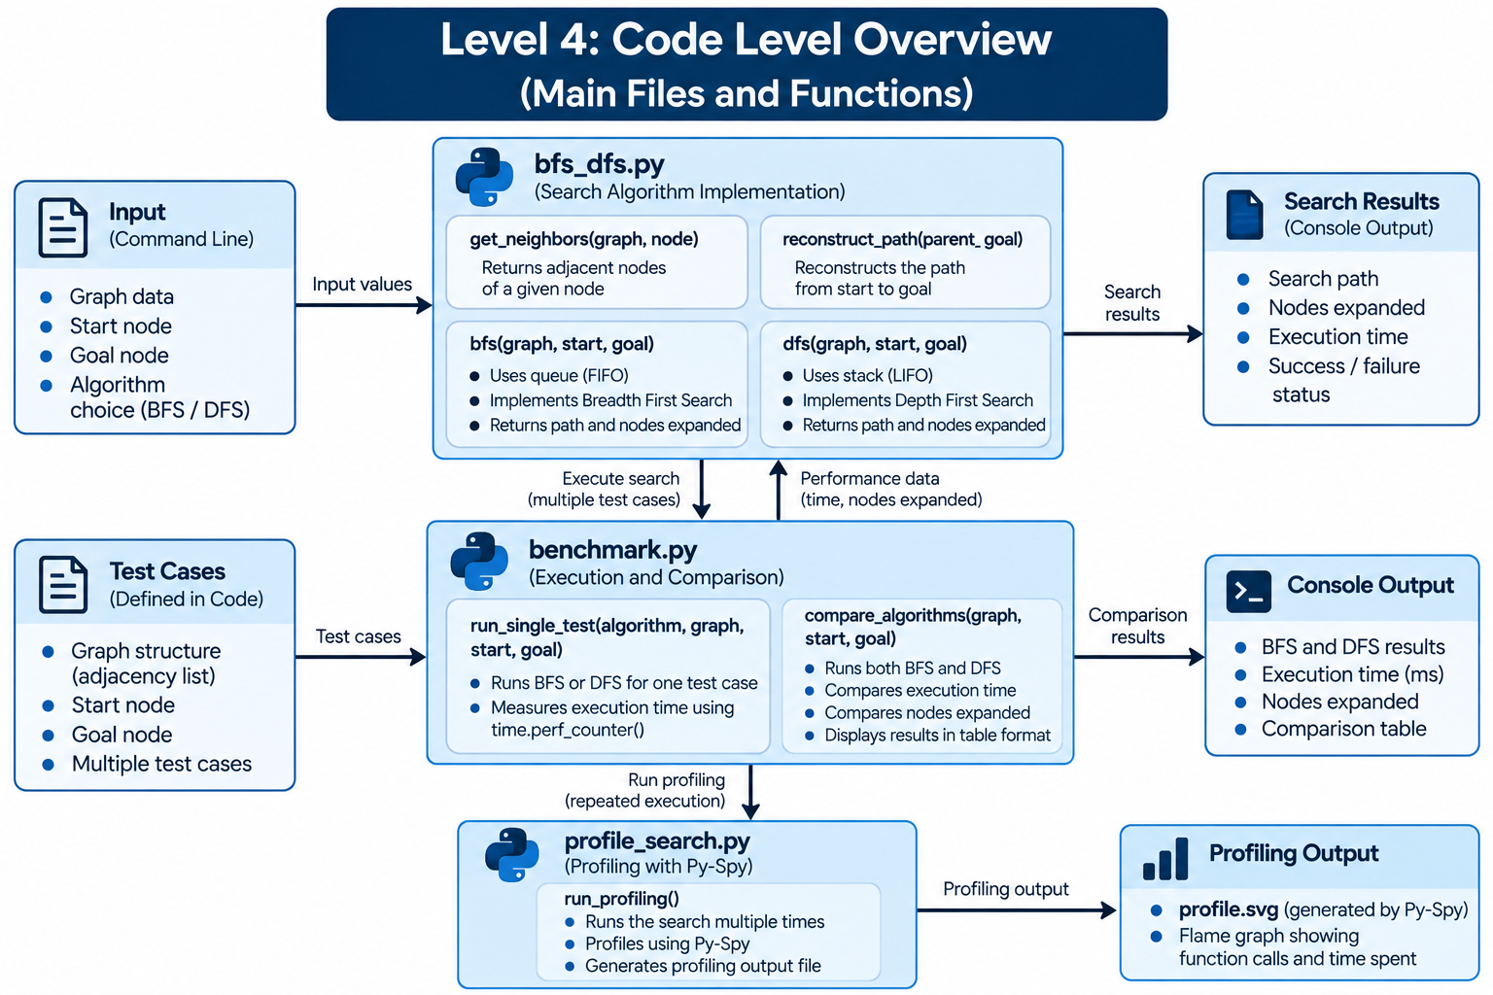

The Code view maps the architecture to the actual repository files used in SLE-2. The main implementation is in bfs_dfs.py, benchmarking is handled by benchmark.py, and repeated execution for Py-Spy profiling is handled by profile_search.py.
File | Role
bfs_dfs.py | Graph definition and BFS/DFS search functions.
benchmark.py | Runs best, average and worst cases; measures execution time.
profile_search.py | Repeats search execution for Py-Spy profiling.
profile.svg | Generated profiling output.
readme.md / contribution.md | SLE documentation and contribution record.

AI Contribution Note
ChatGPT was used to understand the C4 model, organize the existing BFS/DFS work into the four architectural levels, draft explanations, and assist with diagram/report preparation. The student reviewed the SLE-2 implementation, selected the architecture, verified the code structure, and prepared the final submission.
Conclusion
The complete C4 model provides a clear view of the BFS & DFS Graph Search System from user interaction to containers, internal components and Python code. The architecture connects directly to the work completed in SLE-2.

