**WAD Extra Assignment**

Q.1) Illustrate the need for Node MySQL Package

Node MySQL is a popular Node.js package that allows applications to easily connect to MySQL databases.  
It is needed for the following reasons:

* **Database Connectivity**: Node.js alone cannot connect to MySQL databases. mysql package enables the communication between the server-side code and the database.
* **SQL Query Execution**: It provides methods to perform queries like SELECT, INSERT, UPDATE, and DELETE directly from Node.js.
* **Asynchronous Operations**: Node MySQL supports non-blocking asynchronous communication, allowing faster and scalable applications.
* **Connection Management**: It provides connection pools, automatic connection management, and error handling for efficient resource usage.
* **Prepared Statements**: To protect against SQL injection attacks, it allows prepared statements and proper escaping of inputs.
* **Ease of Integration**: Simple to integrate into Node.js applications using npm. It supports callbacks and promises.
* **Broad Support**: Active community, well-documented, and frequently updated, making it reliable for production-grade applications.

Q.2) Implement a small application using Node MySQL (Input, Output)

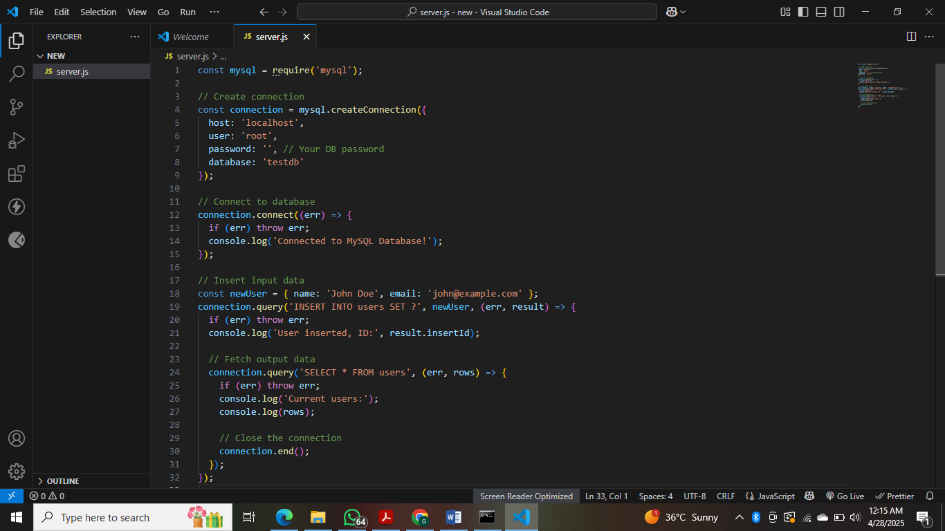

**Create MySQL Database and Table**

CREATE DATABASE testdb;

USE testdb;

CREATE TABLE users (

id INT AUTO_INCREMENT PRIMARY KEY,

name VARCHAR(255),

email VARCHAR(255)

);

Q3) Illustrate the need for Code of Ethics

• **Professional Responsibility**: Developers handle sensitive data. A Code of Ethics ensures that they act responsibly to protect user data and privacy.

• **Building Trust**: Ethical behavior builds trust with clients, users, and stakeholders. It promotes long-term relationships and credibility.

• **Legal Compliance**: Following ethical guidelines often ensures compliance with laws and regulations such as GDPR, copyright laws, and cybersecurity standards.

• **Preventing Misuse**: Without ethical standards, there is a risk of creating harmful software such as malware, phishing sites, or systems that enable discrimination.

• **Promoting Fairness**: Ethics encourages fair treatment, avoids conflicts of interest, and ensures inclusive designs that do not discriminate against any group.

• **Handling Emerging Technologies**: With AI, Big Data, and Cloud Computing, new ethical challenges arise. Developers must ensure transparency, fairness, and accountability.

• **Protecting Intellectual Property**: Ethical guidelines discourage plagiarism, software piracy, and unauthorized use of proprietary code.

**WAD Extra Assignment**

Q.1) Illustrate the need for Node MySQL Package

Node MySQL is a popular Node.js package that allows applications to easily connect to MySQL databases.  
It is needed for the following reasons:

* **Database Connectivity**: Node.js alone cannot connect to MySQL databases. mysql package enables the communication between the server-side code and the database.
* **SQL Query Execution**: It provides methods to perform queries like SELECT, INSERT, UPDATE, and DELETE directly from Node.js.
* **Asynchronous Operations**: Node MySQL supports non-blocking asynchronous communication, allowing faster and scalable applications.
* **Connection Management**: It provides connection pools, automatic connection management, and error handling for efficient resource usage.
* **Prepared Statements**: To protect against SQL injection attacks, it allows prepared statements and proper escaping of inputs.
* **Ease of Integration**: Simple to integrate into Node.js applications using npm. It supports callbacks and promises.
* **Broad Support**: Active community, well-documented, and frequently updated, making it reliable for production-grade applications.

Q.2) Implement a small application using Node MySQL (Input, Output)

