**Git Architecture**

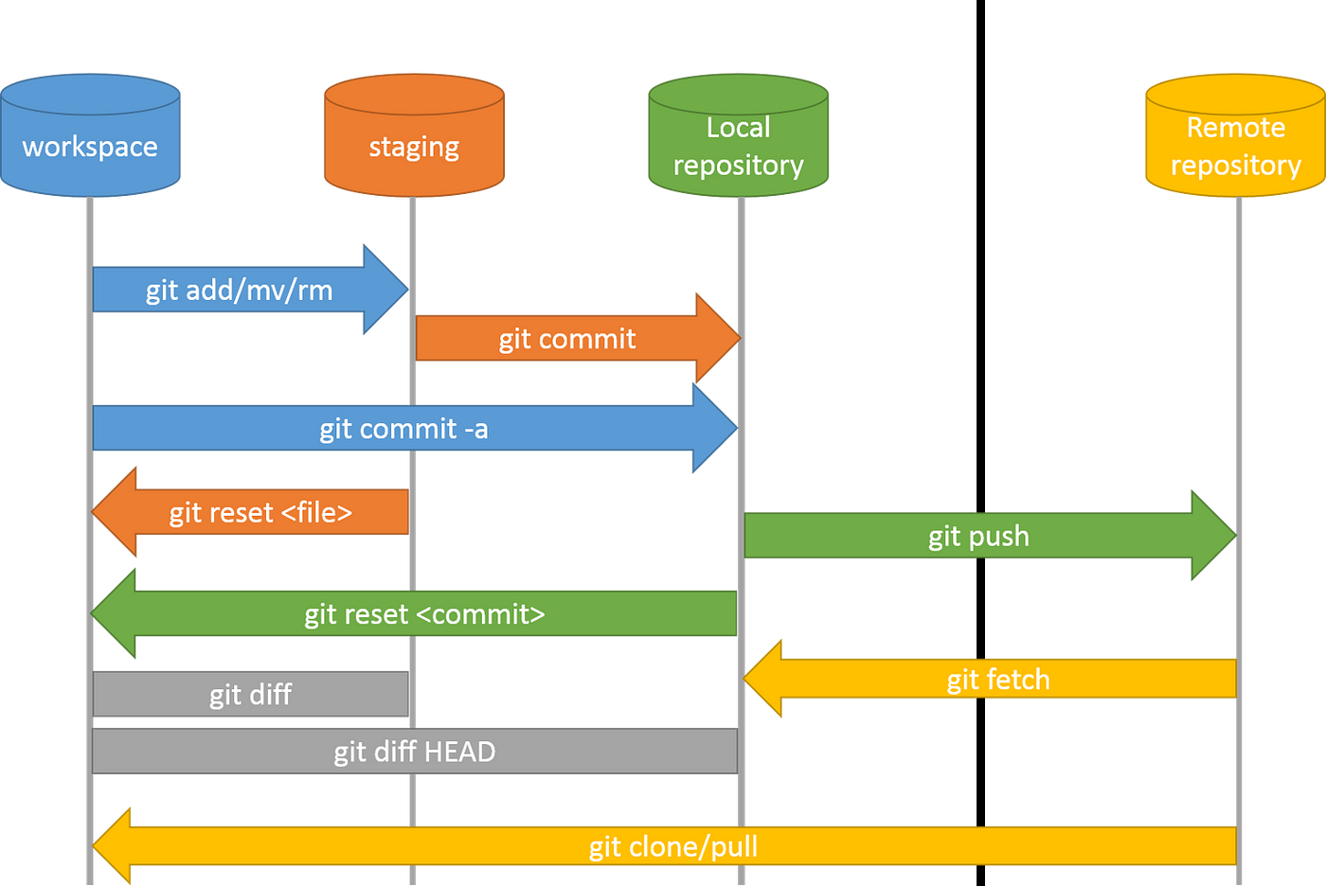

Four-stage architecture—Working Directory, Staging Area (Index), Local repository and Remote Repository—provides a robust system for version control. Developers work in the Working Directory, stage changes in the Index, and then commit those changes to the Repository, which stores the project's complete history. This structure allows for granular control over changes, supports branching and merging for parallel development, and facilitates collaboration through remote repositories. Ultimately, Git's design enables efficient tracking, management, and sharing of code.

