
A PROJECT REPORT
Submitted in partial fulfilment of the requirements for the degree of
BACHELOR OF SCIENCE IN COMPUTER SCIENCE
Kamaraj University
TRAVELGENIE PLANNER
AI-Based Travel Itinerary Generator
Submitted by
R. VAISHNAVI
Register Number: C4S22390
Under the Guidance of
M. RADIKA, MCA
DEPARTMENT OF COMPUTER SCIENCE
NPR ARTS AND SCIENCE COLLEGE
(Affiliated to Kamaraj University)
ACADEMIC YEAR 2026 – 2027

CERTIFICATE
This is to certify that the project work entitled “TravelGenie Planner – AI-Based Travel Itinerary Generator” is a bonafide record of the work done by R. Vaishnavi (Register Number: C4S22390) in partial fulfilment of the requirements for the degree of Bachelor of Science in Computer Science, Kamaraj University, at NPR Arts and Science College during the academic year 2026 – 2027.
Project Guide  M. Radika, MCA | Head of the Department  G. Venkateswaran,  MCA., M.Phil. | Principal  Dr. P. Saravanan,  M.Sc., M.Phil., B.Ed., Ph.D.

Submitted for the viva-voce examination held on ____________________
Internal Examiner | External Examiner
DECLARATION
I, R. Vaishnavi (Register Number: C4S22390), hereby declare that the project work entitled “TravelGenie Planner – AI-Based Travel Itinerary Generator”, submitted to Kamaraj University in partial fulfilment of the requirements for the degree of Bachelor of Science in Computer Science, is a record of original work done by me under the guidance of M. Radika, MCA, NPR Arts and Science College.
I further declare that this work has not been submitted to any other university or institution for the award of any degree or diploma.
Place :
Date :
R. Vaishnavi
ACKNOWLEDGEMENT
I express my sincere gratitude to Dr. P. Saravanan, M.Sc., M.Phil., B.Ed., Ph.D., Principal, and the management of NPR Arts and Science College for providing the facilities needed to complete this project.
I am thankful to G. Venkateswaran, MCA., M.Phil., Head of the Department of Computer Science, for the support and encouragement given during the project work.
I extend my heartfelt thanks to my project guide, M. Radika, MCA, for her valuable guidance, suggestions and constant support throughout the development of “TravelGenie Planner – AI-Based Travel Itinerary Generator”.
I also thank all the faculty members, my friends and my family for their help and encouragement.
R. Vaishnavi
INDEX
CONTENTS PAGE NO.
1. INTRODUCTION 1
1.1 About the Project 1
1.2 Objectives 1
1.3 Scope of the Project 1
1.4 Organization of the Documentation 1
2. SYSTEM ANALYSIS 2
2.1 Existing System 2
2.2 Limitations of the Existing System 2
2.3 Proposed System 2
2.4 Feasibility Study 2
2.5 Requirement Analysis 3
3. SYSTEM ENVIRONMENT 4
3.1 Software Requirements 4
3.2 Hardware Requirements 4
3.3 Technologies Used 4
4. SYSTEM DESIGN 6
4.1 System Architecture 6
4.2 Data Flow Diagrams 6
4.3 Flowchart 7
4.4 Use Case Diagram 8
4.5 API Design 9
4.6 Database Design 10
5. SYSTEM SPECIFICATION – MODULES 11
5.1 Configuration Module 11
5.2 Request Validation Module 11
5.3 Prompt Builder Module 11
5.4 Gemini Integration Module 11
5.5 Response Parsing Module 11
5.6 Error Handling Module 11
5.7 Frontend Module 12
6. SYSTEM IMPLEMENTATION 13
6.1 Backend Setup 13
6.2 Itinerary Endpoint 13
6.3 Prompt Design 13
6.4 Calling Gemini and Parsing the Response 14
6.5 Error Handling 14
6.6 Frontend Setup 14
6.7 Running the Project 14
7. SYSTEM TESTING 15
7.1 Testing Approach 15
7.2 Test Cases 15
8. CONCLUSION 16
9. FUTURE ENHANCEMENT 17
10. BIBLIOGRAPHY 18
11. APPENDIX 19
Appendix A – Screenshots 19
Appendix B – Source Code 19
Appendix C – Project Structure 22

1. INTRODUCTION

1.1 About the Project
TravelGenie Planner is a web application that generates day-wise travel itineraries using Artificial Intelligence. The user enters a destination, the number of days of the trip and, optionally, the interests of the traveller. The application then produces a complete plan for every day of the trip, which is displayed to the user in the browser.
The system follows a client–server design. The user interface is built with React and Vite. The server is a Python Flask application that receives the request, builds a prompt and sends it to Google’s Gemini model through the Gemini API. The reply from the model is converted into a structured JSON itinerary and returned to the user interface.

1.2 Objectives
- To generate a day-wise travel itinerary from a destination, a number of days and optional interests.
- To present each day with a short title, activities for the morning, afternoon and evening, and a helpful tip.
- To separate the user interface (React + Vite) from the server logic (Flask) using a REST-style API.
- To keep the Gemini API key on the server in an environment variable, so that it is never exposed to the browser.
- To validate the request and return clear error messages when the input or the AI response is not valid.

1.3 Scope of the Project
The project covers the generation of an itinerary for a single request. The backend exposes one endpoint, POST /api/generate-itinerary, which accepts the destination, the number of days and the interests, and returns the itinerary in JSON format.
The backend does not contain a database and does not store user data or generated itineraries. Each request is handled independently.

1.4 Organization of the Documentation
Chapter 2 analyses the system and its requirements. Chapter 3 describes the software environment. Chapter 4 presents the system design with the architecture, data flow diagrams, flowchart and use case diagram. Chapter 5 explains the modules. Chapter 6 describes the implementation and Chapter 7 the testing. The conclusion, future enhancements, bibliography and appendix follow.

2. SYSTEM ANALYSIS

2.1 Existing System
Travellers usually prepare a trip plan by searching several websites, blogs and maps and then arranging the places into a day-wise schedule by hand. This process needs time and effort, especially when the traveller is not familiar with the destination.

2.2 Limitations of the Existing System
- Planning takes a long time because information is collected from many different sources.
- The traveller must decide the order of places and the time of the day for each activity.
- The plan is not prepared according to the interests of the particular traveller unless the traveller filters the information manually.

2.3 Proposed System
TravelGenie Planner generates the complete itinerary from only three inputs: the destination, the number of days and the interests. The request is sent to the Flask backend, which asks the Gemini model to create the plan in a fixed JSON structure. Each day of the result contains a day number, a title, activities for morning, afternoon and evening (each with a location and a description) and a tip for the day.

2.4 Feasibility Study

Technical Feasibility
The project uses React, Vite, Python and Flask, which are freely available. The AI part is provided by the Gemini API and needs a valid API key configured on the server. The project can be run on an ordinary computer with Python and Node.js installed.

Operational Feasibility
The user only fills in the trip details and receives the itinerary. No registration or login is required, because the application does not contain user accounts.

Economic Feasibility
All development tools and libraries used in the project are open source. The use of the Gemini API depends on the usage terms and limits of the API key that is used.

2.5 Requirement Analysis

Functional Requirements
ID | Requirement
FR1 | The system shall accept a destination, the number of days and optional interests from the user.
FR2 | The system shall reject a request that does not contain the destination or the number of days.
FR3 | The system shall use a default interest of “General sightseeing, popular attractions, and local food” when no interest is given.
FR4 | The system shall generate a day-wise itinerary using the Gemini model.
FR5 | The system shall return the itinerary as a JSON array in which every day has a title, activities and a tip.
FR6 | The system shall return an error message when the API key is missing or the AI response cannot be parsed.

Non-Functional Requirements
- Security: the Gemini API key is read from the environment (.env file) on the server and is not written in the source code.
- Reliability: the response of the model is checked and parsed before it is sent to the user interface.
- Interoperability: Cross-Origin Resource Sharing (CORS) is enabled so that the React frontend can call the Flask backend.
- Usability: the web page declares a responsive viewport in index.html and provides a page title and description.

3. SYSTEM ENVIRONMENT

3.1 Software Requirements
Component | Details
Frontend framework | React 19 (react, react-dom ^19.2.8)
Build tool | Vite ^8.3.0 with @vitejs/plugin-react ^6.1.1
Frontend libraries | axios ^1.20.0, framer-motion ^13.4.0, lucide-react ^1.47.0
Linter | oxlint ^1.81.0
Backend language | Python
Backend framework | Flask 3.0.3, Flask-Cors 4.0.0
AI library | google-generativeai 0.4.1
Configuration | python-dotenv 1.0.1 (.env file with GEMINI_API_KEY)
AI service | Google Gemini API (model configured in app.py: gemini-3.6-flash)
Web technologies | HTML, CSS, JavaScript
Fonts | Inter and Outfit (Google Fonts)

3.2 Hardware Requirements
Component | Requirement
Processor | Any modern dual-core processor or higher
RAM | 4 GB or more
Storage | Sufficient free space for Python, Node.js and project dependencies
Network | Internet connection (required to reach the Gemini API)
Browser | A modern web browser

3.3 Technologies Used

React
React is a JavaScript library for building user interfaces from components. The project uses React 19 to build the TravelGenie interface.

Vite
Vite is a build tool and development server for frontend projects. In this project the scripts dev, build and preview are defined in package.json, and vite.config.js enables the React plugin.

Python Flask
Flask is a lightweight Python web framework. In this project Flask provides the REST endpoint /api/generate-itinerary, and Flask-CORS allows requests from the React frontend.

Gemini API
The Gemini API gives access to Google’s Gemini models. The backend uses the google-generativeai library to send a prompt to the model and receive the generated text.

HTML, CSS and JavaScript
HTML provides the page structure (index.html, with the root element in which React is mounted), CSS provides the styling and JavaScript (JSX) provides the behaviour of the interface.

Supporting Libraries
- axios – a JavaScript HTTP client listed as a dependency of the frontend.
- framer-motion – an animation library for React.
- lucide-react – an icon library for React.
- python-dotenv – loads environment variables from a .env file.

4. SYSTEM DESIGN

4.1 System Architecture
TravelGenie Planner uses a client–server architecture with three parts: the React + Vite frontend that runs in the browser, the Flask backend, and the external Gemini API. The frontend sends the trip details to the backend as JSON. The backend reads the API key from the .env file, creates the prompt and calls the Gemini model. The reply is checked, converted to JSON and returned to the frontend.
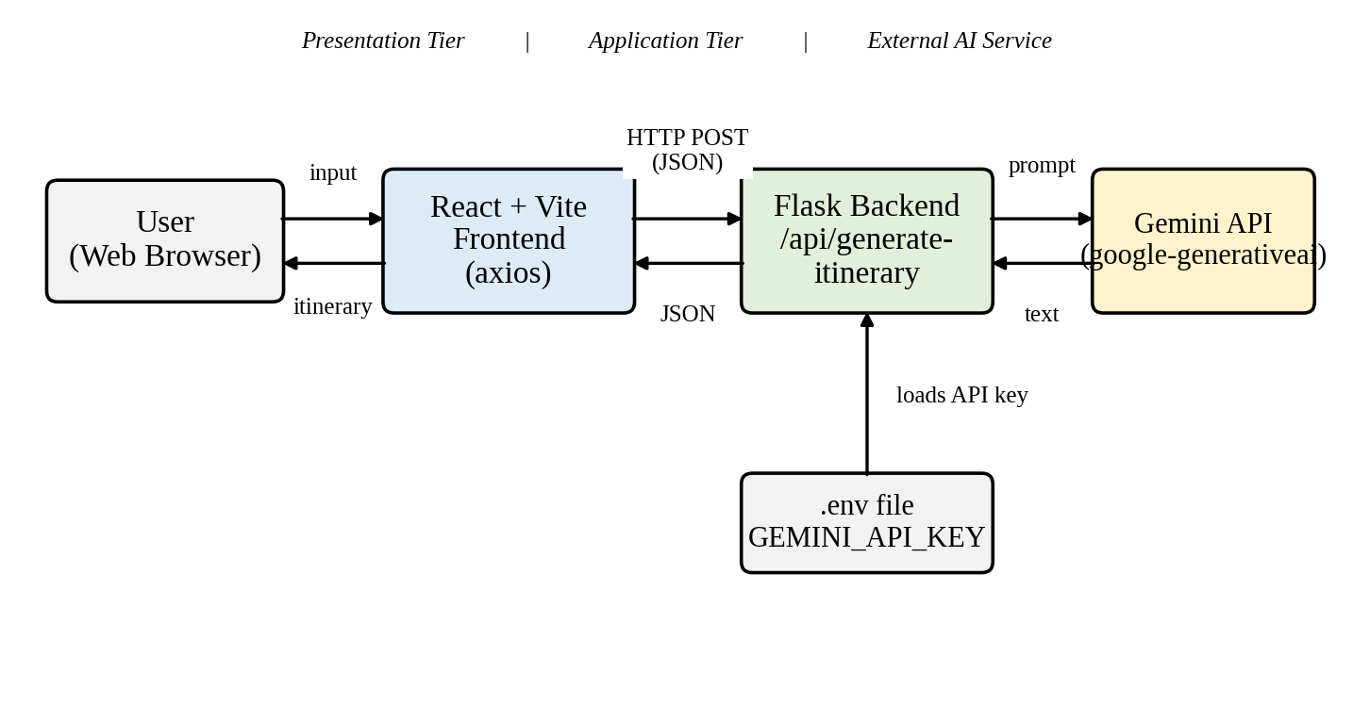
Figure 4.1 System Architecture

4.2 Data Flow Diagrams

Level 0 DFD (Context Diagram)
At the highest level, the user sends the destination, days and interests to the TravelGenie Planner system. The system sends a prompt to the Gemini API, receives the generated text and returns the itinerary, or an error message, to the user.
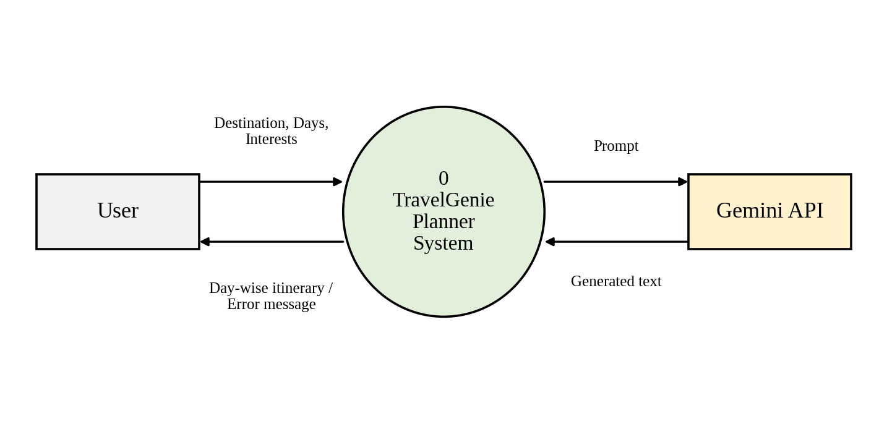
Figure 4.2 Level 0 Data Flow Diagram

Level 1 DFD
The system is divided into four processes: validating the request, building the prompt, generating the itinerary with Gemini, and extracting and parsing the JSON.
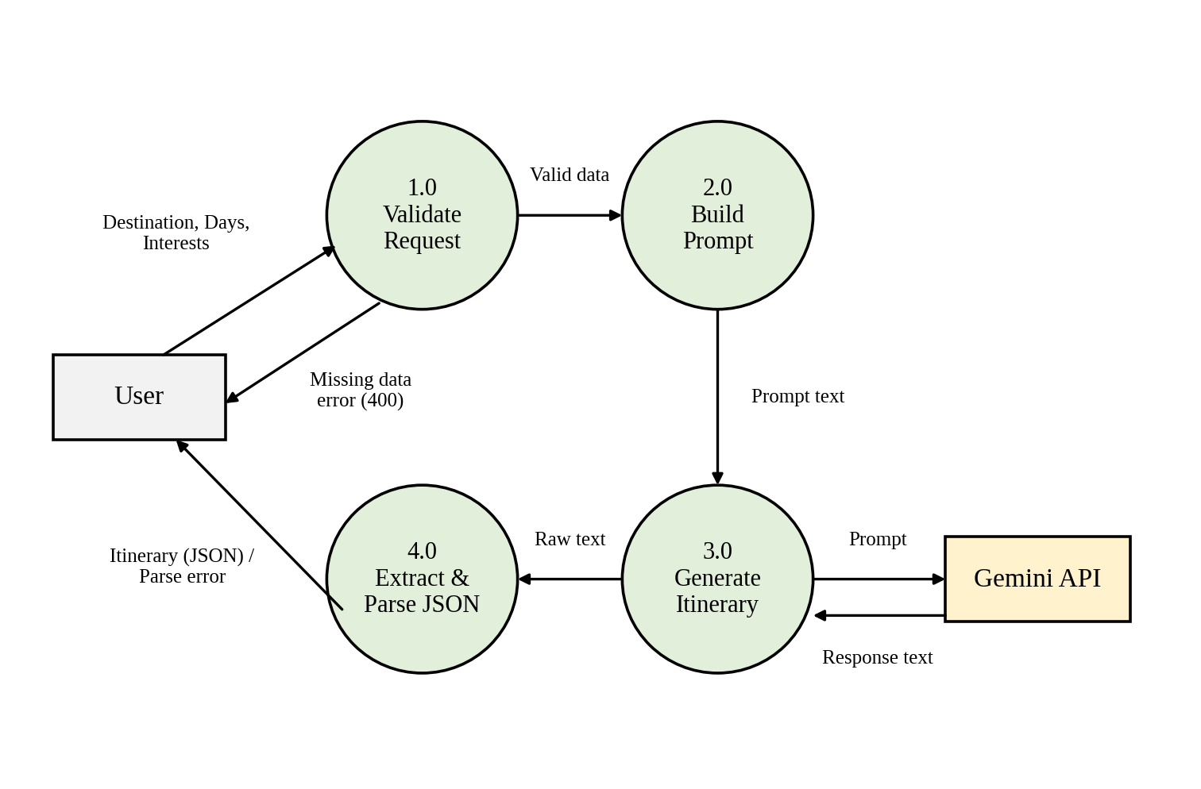
Figure 4.3 Level 1 Data Flow Diagram

4.3 Flowchart
The flowchart shows the steps followed by the backend when a request is received at /api/generate-itinerary.
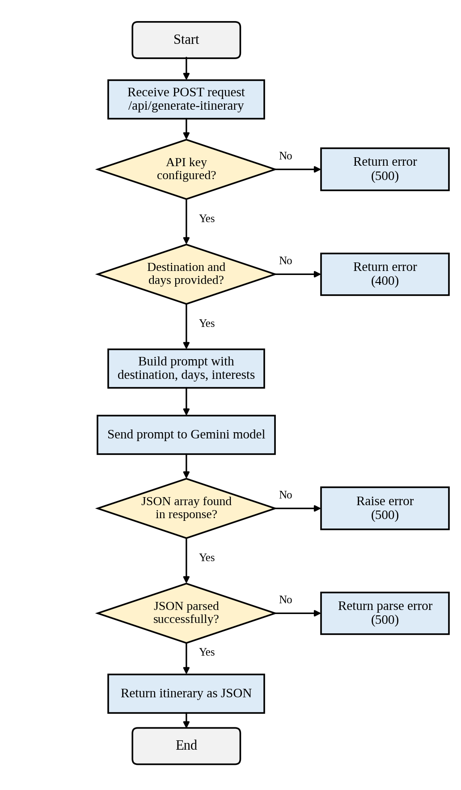
Figure 4.4 Flowchart of Itinerary Generation

4.4 Use Case Diagram
The user enters the destination, the number of days and, optionally, the interests, generates the itinerary and views the day-wise plan. The Gemini API takes part in the use case Generate Itinerary.
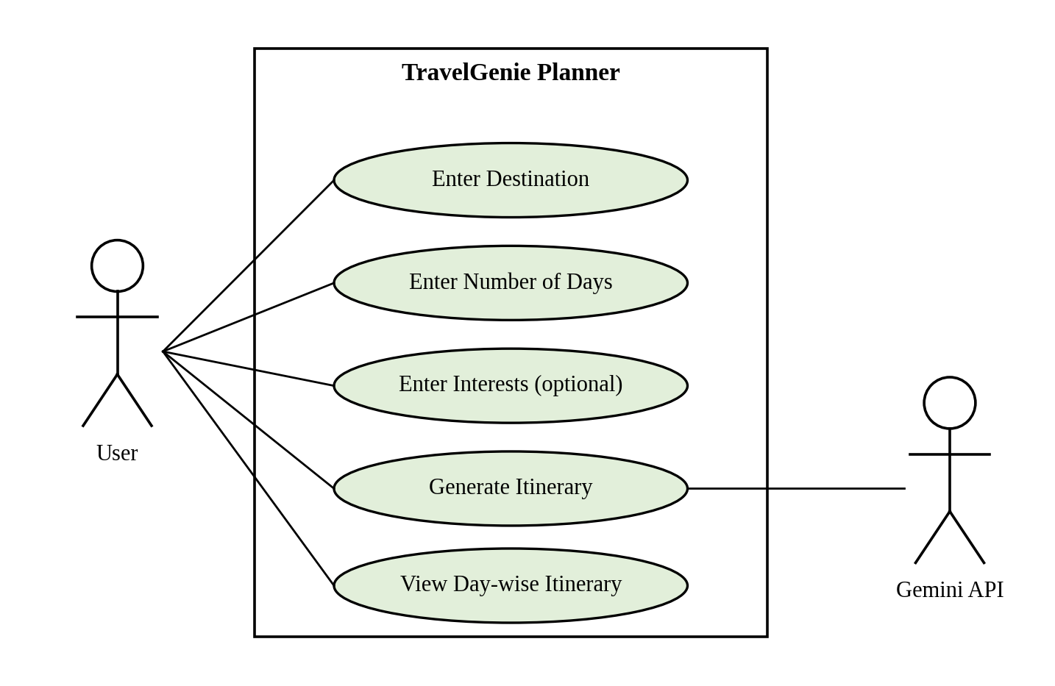
Figure 4.5 Use Case Diagram

4.5 API Design
The backend provides one endpoint.
Item | Description
URL | /api/generate-itinerary
Method | POST
Request body (JSON) | destination (required), days (required), interests (optional)
Success response | HTTP 200 with {"itinerary": [ ... ]}
Error responses | 400 – destination or days missing  500 – API key not configured, AI response could not be parsed, or another error

Structure of one day in the itinerary:
{
"day": 1,
"title": "A short, catchy title for the day",
"activities": [
{ "time": "Morning", "location": "...", "description": "..." },
{ "time": "Afternoon", "location": "...", "description": "..." },
{ "time": "Evening", "location": "...", "description": "..." }
],
"tip": "A helpful tip for the day"
}

4.6 Database Design
The backend files do not use a database. The itinerary is generated for every request and is returned directly to the frontend, so no tables are designed for this project.

5. SYSTEM SPECIFICATION – MODULES
The project is divided into backend modules and a frontend module.

5.1 Configuration Module
This module loads the environment variables using python-dotenv, reads GEMINI_API_KEY and configures the Gemini library. If the key is not found, a warning is printed and the endpoint returns an error when it is called. It also enables CORS for the React frontend.

5.2 Request Validation Module
This module reads destination, days and interests from the JSON body of the request. If the destination or the days are missing, it returns HTTP 400 with the message “Destination and days are required.”

5.3 Prompt Builder Module
This module creates the prompt for the model. The prompt asks for a detailed day-by-day itinerary for the given number of days and destination, based on the interests (or the default interests when none are given). It instructs the model to return only a JSON array in the defined day structure, without markdown formatting.

5.4 Gemini Integration Module
This module creates the generative model object with the model name set in app.py and calls generate_content with the prompt to obtain the response text.

5.5 Response Parsing Module
This module searches the response text for the JSON array (from the first “[” to the last “]”) using a regular expression and converts it into Python objects using json.loads. If no array is found or the JSON is not valid, an error is returned.

5.6 Error Handling Module
This module handles the failure cases: a missing API key (HTTP 500), missing input (HTTP 400), a JSON parsing failure (HTTP 500 with the message “Failed to parse itinerary from AI. Please try again.”) and any other exception (HTTP 500 with the exception message).

5.7 Frontend Module
The frontend is a React + Vite application. Its package.json declares axios for calling the backend, framer-motion for animation and lucide-react for icons. The page is mounted from src/main.jsx into the root element of index.html.
[Pending: component-level description of the frontend – to be completed after the src/ folder files are reviewed.]

6. SYSTEM IMPLEMENTATION

6.1 Backend Setup
The backend is implemented in app.py. It imports Flask, Flask-CORS, google.generativeai and python-dotenv. The environment file is loaded with load_dotenv(), the Flask application is created, CORS is enabled and the Gemini library is configured with the key read from GEMINI_API_KEY.
load_dotenv()
app = Flask(__name__)
CORS(app)

API_KEY = os.environ.get("GEMINI_API_KEY")
if API_KEY:
genai.configure(api_key=API_KEY)
else:
print("WARNING: GEMINI_API_KEY not found in environment variables.")

6.2 Itinerary Endpoint
The route /api/generate-itinerary accepts POST requests. It first checks the API key, then reads destination, days and interests from the request body and validates them.
@app.route('/api/generate-itinerary', methods=['POST'])
def generate_itinerary():
if not API_KEY:
return jsonify({"error": "Gemini API key is not configured on the server."}), 500

data = request.json
destination = data.get('destination')
days = data.get('days')
interests = data.get('interests')

if not destination or not days:
return jsonify({"error": "Destination and days are required."}), 400

6.3 Prompt Design
The prompt is created with an f-string that inserts the number of days, the destination and the interests. The JSON structure of a day is described inside the prompt so that the model returns data that the frontend can use directly. The full prompt is shown in Appendix B (app.py).

6.4 Calling Gemini and Parsing the Response
The model is created with genai.GenerativeModel and the prompt is sent with generate_content. The response text is trimmed, the JSON array is extracted with a regular expression and json.loads validates it before it is returned as {"itinerary": ...}.
model = genai.GenerativeModel('gemini-3.6-flash')
response = model.generate_content(prompt)

text = response.text.strip()
match = re.search(r'\[.*\]', text, re.DOTALL)
if match:
text = match.group(0)
else:
raise ValueError("No JSON array found in response")

itinerary_data = json.loads(text)
return jsonify({"itinerary": itinerary_data})

6.5 Error Handling
A json.JSONDecodeError returns HTTP 500 with a message asking the user to try again, and the raw response is printed on the server for debugging. Any other exception returns HTTP 500 with the error message.

6.6 Frontend Setup
The frontend is created with Vite. vite.config.js registers the React plugin. The scripts in package.json are: dev (vite), build (vite build), lint (oxlint) and preview (vite preview). index.html sets the title “TravelGenie | AI Travel Planner”, the page description, the viewport, and loads the Inter and Outfit fonts from Google Fonts. The React application is loaded from /src/main.jsx.
[Pending: description of the React components and the axios call to the backend – to be completed after the src/ folder files are reviewed.]

6.7 Running the Project
Backend:
pip install -r requirements.txt
# create a .env file containing: GEMINI_API_KEY=<your key>
python app.py # runs on port 5000

Frontend:
npm install
npm run dev

7. SYSTEM TESTING

7.1 Testing Approach
Black-box testing is used to check that the endpoint /api/generate-itinerary gives the expected response for valid and invalid input. The test cases below are based on the behaviour defined in app.py.

7.2 Test Cases
ID | Test Case | Input | Expected Result
TC1 | Valid request with all fields | destination, days and interests given | HTTP 200; JSON with an “itinerary” array containing one object per day
TC2 | Request without interests | destination and days only | HTTP 200; itinerary generated using the default interests
TC3 | Destination missing | days only | HTTP 400; “Destination and days are required.”
TC4 | Days missing | destination only | HTTP 400; “Destination and days are required.”
TC5 | Empty destination | destination = "", days given | HTTP 400; “Destination and days are required.”
TC6 | API key not configured | Valid request, GEMINI_API_KEY not set | HTTP 500; “Gemini API key is not configured on the server.”
TC7 | Response has no JSON array | Model reply without “[ ]” | HTTP 500; error “No JSON array found in response”
TC8 | Invalid JSON in response | Model reply with a malformed array | HTTP 500; “Failed to parse itinerary from AI. Please try again.”
TC9 | Structure of each day | Valid request | Each day has day, title, activities (time, location, description) and tip

[Pending: frontend test cases – to be added after the src/ folder files are reviewed. The actual result and pass/fail status of each test case are to be recorded after running the tests.]

8. CONCLUSION
TravelGenie Planner shows how a generative AI model can be used to prepare travel plans. From a destination, a number of days and optional interests, the system produces a day-wise itinerary with a title, morning, afternoon and evening activities and a tip for each day.
The project uses React and Vite for the user interface, Python Flask for the server and the Gemini API for the AI generation. The API key is kept on the server, the request is validated, and the response of the model is parsed and checked before it is returned. In this way the project reduces the time and effort needed to plan a trip.

9. FUTURE ENHANCEMENT
The present version generates an itinerary for each request and does not store it. The following improvements can be considered in the future:
- Saving generated itineraries, which needs a database and user accounts, since the present backend has neither.
- Downloading or printing the itinerary.
- Allowing the user to edit or regenerate a single day of the plan.
- Adding more inputs, such as the budget or the number of travellers.
- Showing the places of the itinerary on a map.

10. BIBLIOGRAPHY
[1] Pallets Projects, “Flask Documentation,” https://flask.palletsprojects.com
[2] Google, “Gemini API Documentation,” https://ai.google.dev/gemini-api/docs
[3] Meta Open Source, “React Documentation,” https://react.dev
[4] Vite Team, “Vite Documentation,” https://vite.dev
[5] Python Software Foundation, “Python Documentation,” https://docs.python.org
[6] Axios, “Axios Documentation,” https://axios-http.com
[7] Motion, “Motion (framer-motion) Documentation,” https://motion.dev
[8] Lucide, “Lucide Icons Documentation,” https://lucide.dev
[9] Flask-CORS, “Flask-CORS Documentation,” https://flask-cors.readthedocs.io
[10] Mozilla, “MDN Web Docs – HTML, CSS and JavaScript,” https://developer.mozilla.org

11. APPENDIX

Appendix A – Screenshots
[Pending: screenshots of the running application (home page, input form and generated itinerary) are to be inserted here.]

Appendix B – Source Code

app.py
import os
import json
from flask import Flask, request, jsonify
from flask_cors import CORS
import google.generativeai as genai
from dotenv import load_dotenv

# Load environment variables
load_dotenv()

app = Flask(__name__)
# Enable CORS for the React frontend
CORS(app)

# Configure Gemini API
API_KEY = os.environ.get("GEMINI_API_KEY")
if API_KEY:
genai.configure(api_key=API_KEY)
else:
print("WARNING: GEMINI_API_KEY not found in environment variables.")

@app.route('/api/generate-itinerary', methods=['POST'])
def generate_itinerary():
if not API_KEY:
return jsonify({"error": "Gemini API key is not configured on the server."}), 500

data = request.json
destination = data.get('destination')
days = data.get('days')
interests = data.get('interests')

if not destination or not days:
return jsonify({"error": "Destination and days are required."}), 400

try:
# Prompt definition
prompt = f"""
Create a detailed, day-by-day travel itinerary for {days} days to {destination}.
The traveler is interested in: {interests if interests else 'General sightseeing, popular attractions, and local food'}.

Return the itinerary EXACTLY as a JSON array of objects, where each object represents a day.
Each day object must have the following structure:
{{
"day": 1,
"title": "A short, catchy title for the day",
"activities": [
{{
"time": "Morning",
"location": "Name of the place",
"description": "A brief description of what to do there."
}},
{{
"time": "Afternoon",
"location": "Name of the place",
"description": "A brief description of what to do there."
}},
{{
"time": "Evening",
"location": "Name of the place",
"description": "A brief description of what to do there."
}}
],
"tip": "A helpful tip for the day"
}}

Do not include any markdown formatting like ```json or anything else outside the array. Return just the JSON array.
"""

model = genai.GenerativeModel('gemini-3.6-flash')
response = model.generate_content(prompt)

import re
text = response.text.strip()
# Find the first '[' and last ']' to extract just the array
match = re.search(r'\[.*\]', text, re.DOTALL)
if match:
text = match.group(0)
else:
raise ValueError("No JSON array found in response")

# Parse JSON to ensure it's valid before sending it back
itinerary_data = json.loads(text)

return jsonify({"itinerary": itinerary_data})

except json.JSONDecodeError as e:
print(f"Failed to parse Gemini response as JSON: {e}")
print(f"Raw response: {response.text}")
return jsonify({"error": "Failed to parse itinerary from AI. Please try again."}), 500
except Exception as e:
print(f"Error generating itinerary: {e}")
return jsonify({"error": str(e)}), 500

if __name__ == '__main__':
app.run(debug=True, port=5000)

requirements.txt
Flask==3.0.3
Flask-Cors==4.0.0
google-generativeai==0.4.1
python-dotenv==1.0.1

package.json
{
"name": "frontend",
"private": true,
"version": "0.0.0",
"type": "module",
"scripts": {
"dev": "vite",
"build": "vite build",
"lint": "oxlint",
"preview": "vite preview"
},
"dependencies": {
"axios": "^1.20.0",
"framer-motion": "^13.4.0",
"lucide-react": "^1.47.0",
"react": "^19.2.8",
"react-dom": "^19.2.8"
},
"devDependencies": {
"@types/react": "^19.2.18",
"@types/react-dom": "^19.2.7",
"@vitejs/plugin-react": "^6.1.1",
"oxlint": "^1.81.0",
"vite": "^8.3.0"
}
}

vite.config.js
import react from '@vitejs/plugin-react'
import { defineConfig } from 'vite'

// https://vite.dev/config/
export default defineConfig({
plugins: [react()],
})

index.html
<!doctype html>
<html lang="en">
<head>
<meta charset="UTF-8" />
<link rel="icon" type="image/svg+xml" href="/vite.svg" />
<meta name="viewport" content="width=device-width, initial-scale=1.0" />
<title>TravelGenie | AI Travel Planner</title>
<meta name="description" content="Generate beautiful, day-wise travel itineraries using AI. Plan your perfect trip in seconds." />

<!-- Google Fonts -->
<link rel="preconnect" href="https://fonts.googleapis.com">
<link rel="preconnect" href="https://fonts.gstatic.com" crossorigin>
<link href="https://fonts.googleapis.com/css2?family=Inter:wght@300;400;500;600;700&family=Outfit:wght@400;600;800&display=swap" rel="stylesheet">
</head>
<body>
<div id="root"></div>
<script type="module" src="/src/main.jsx"></script>
</body>
</html>

[Pending: source code of the files in the src/ folder (main.jsx, App.jsx, components and CSS).]

Appendix C – Project Structure
The structure below lists only the files supplied for this documentation.
TravelGenie/
├── backend/
│ ├── app.py
│ ├── requirements.txt
│ └── .env (contains GEMINI_API_KEY)
└── frontend/
├── index.html
├── package.json
├── vite.config.js
└── src/
└── main.jsx ... (to be completed)

