Reconnect Design Document

**Table of Contents**

|  |  |  |
| --- | --- | --- |
| **Sr. No.** | **Design Name** | **Page No.** |
| 1 | Class Diagram | 2 |
| 2 | Data Flow Diagram | 3 - 4 |
| 3 | Use Case Diagram | 5 |
| 4 | E-R Diagram | 7 |

1. **Class Diagram**

In software engineering, a class diagram in the Unified Modelling Language (UML) is a type of static structure diagram that describes the structure of a system by showing the system's classes, their attributes, operations (or methods), and the relationships among objects.

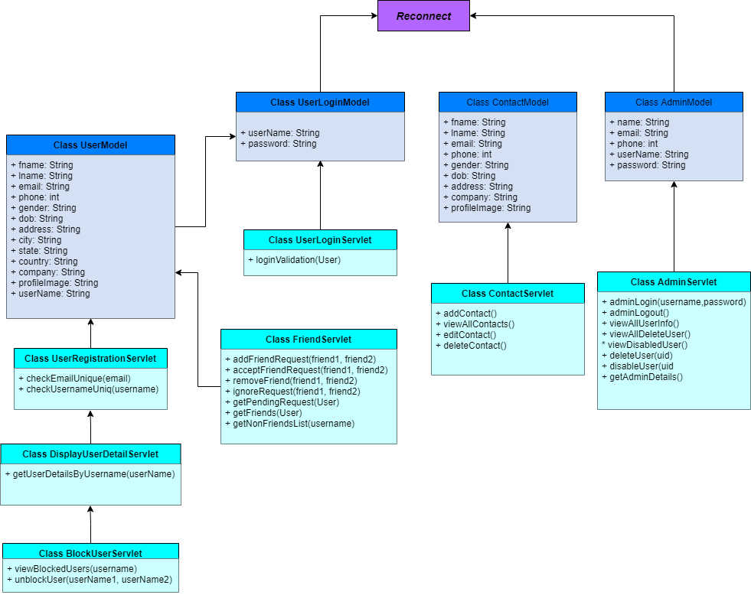

1. **Data Flow Diagram**

A data-flow diagram is a way of representing a flow of a data of a process or a system (usually an information system). The DFD also provides information about the outputs and inputs of each entity and the process itself. A data-flow diagram has no control flow; there are no decision rules and no loops.

***Admin Portal***

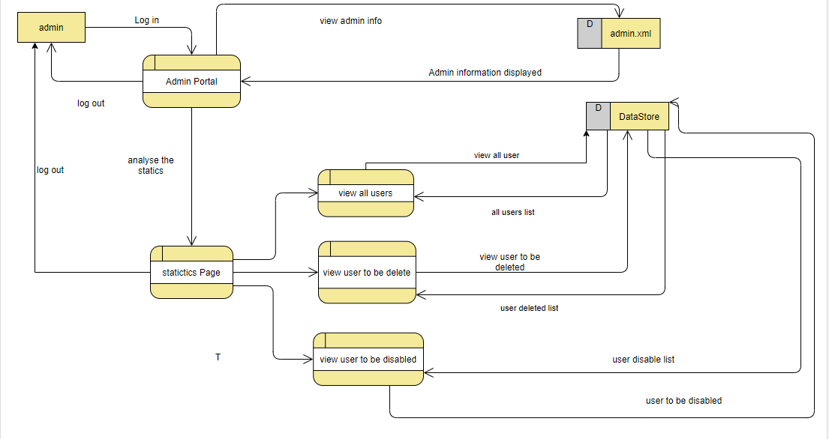

***User Portal***

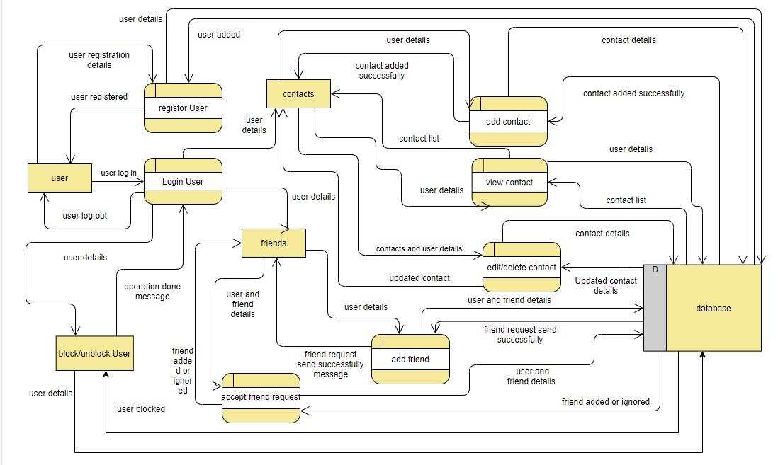

1. **Use Case Diagram**

A UML use case diagram is the primary form of system/software requirements for a new software program underdeveloped. A use case diagram at its simplest is a representation of a user's interaction with the system that shows the relationship between the user and the different use cases in which the user is involved.

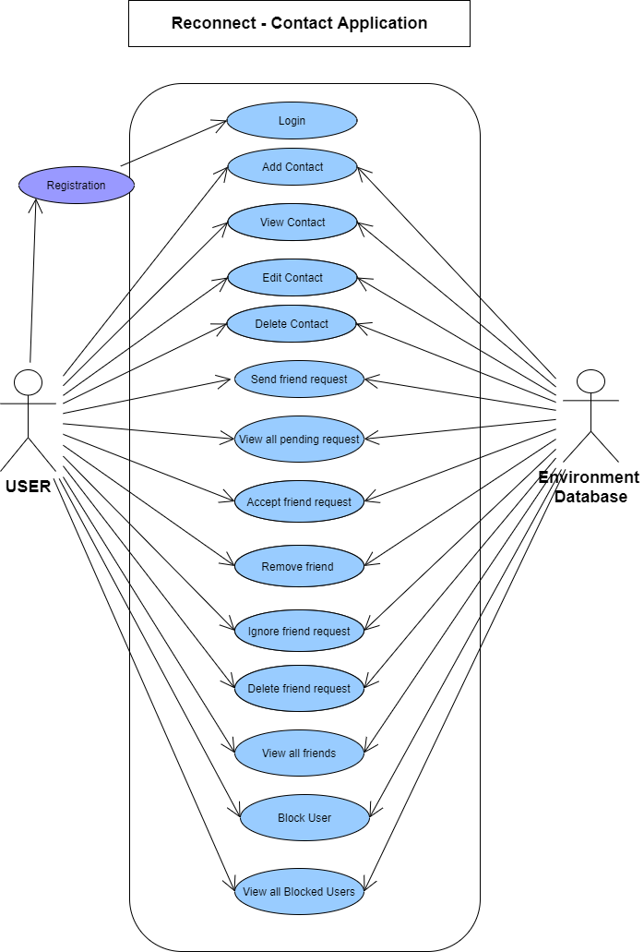

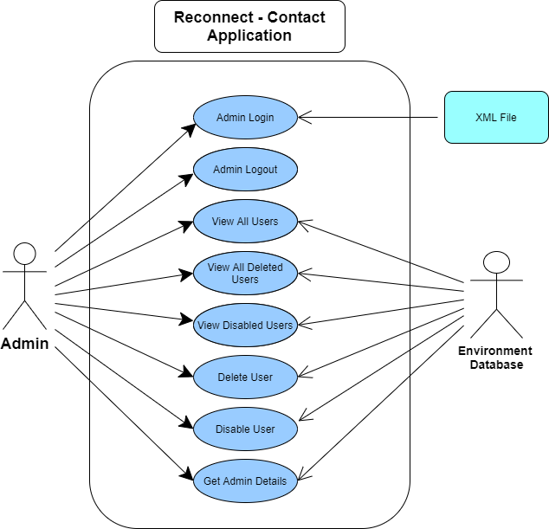

1. **E-R Diagram**

ER-modeling is a data modeling method used in software engineering to produce a conceptual data model of an information system. Diagrams created using this ER-modeling method are called Entity-Relationship Diagrams or ER diagrams or ERDs.

