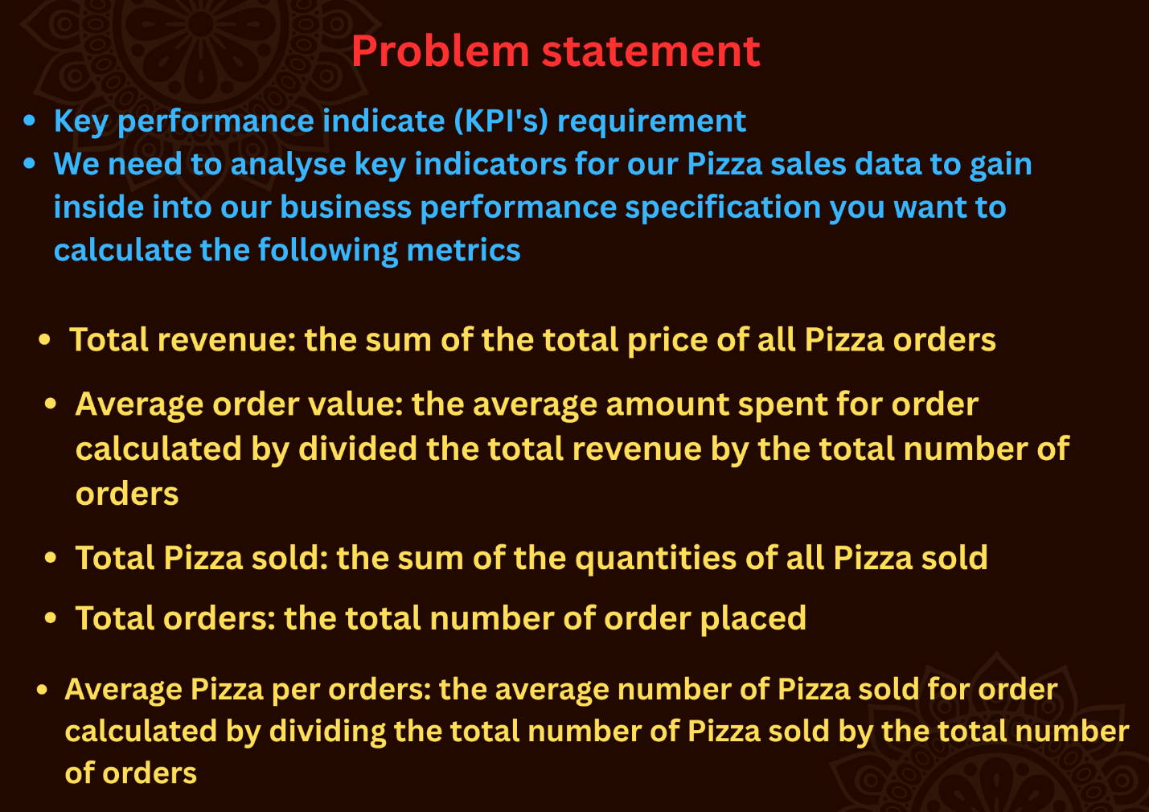

Q.1 Total revenue: The sum of the total price of all Pizza orders

SELECT

sum(total_price) as Total_revenue

FROM pizza_sales

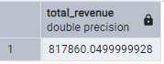

Q.2) Average order value: the average amount spent for order calculated by divided the total revenue by the total number of orders

SELECT

sum(total_price)/count(distinct order_id) as Avg_order_values

FROM pizza_sales

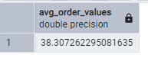

Q.3) Total Pizza sold: the sum of the quantities of all Pizza sold

SELECT

sum(quantity) as Total_pizza_sold

FROM pizza_sales

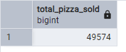

Q.4) Total orders: the total number of order placed

SELECT

count(distinct order_id) as Total_number_order

FROM pizza_sales

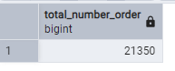

Q.5) Average Pizza per orders: the average number of Pizza sold for order calculated by dividing the total number of Pizza sold by the total number of orders

SELECT

cast (cast (sum(quantity) as Decimal(10,2))/

cast (count(distinct order_id) as Decimal(10,2)) as Decimal(10,2)) as Average_Pizza_per_orders

FROM pizza_sales

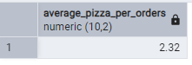

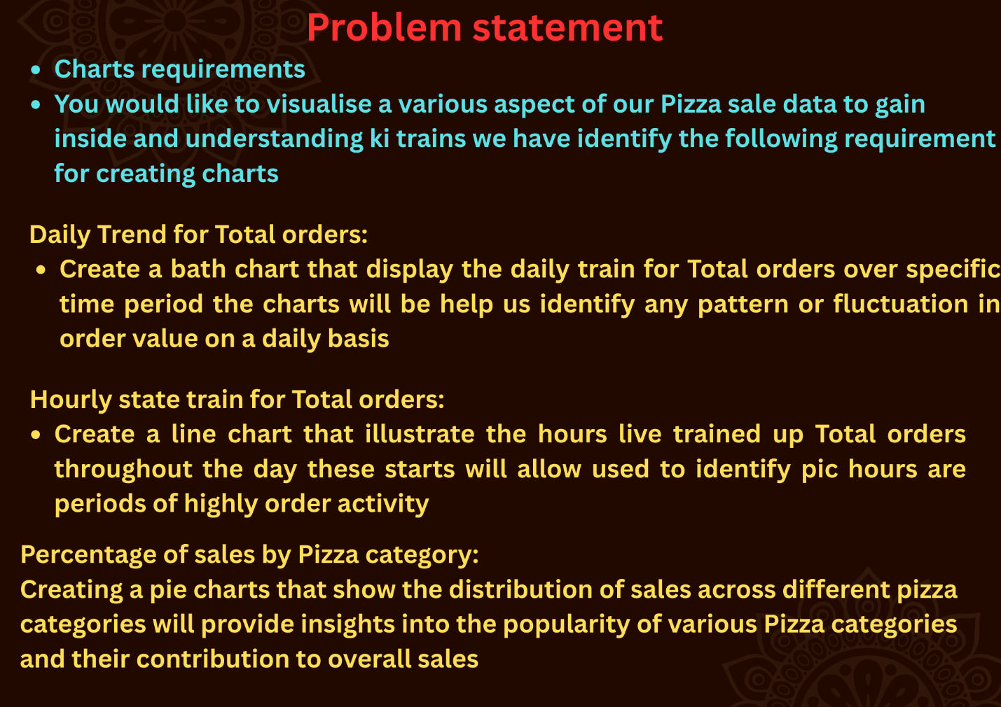

All This Question I Slove my using SQL:

Q.1) Daily Trend for orders

SELECT

TO_CHAR("order_date", 'Day') AS order_day,

COUNT(DISTINCT "order_id") AS total_orders

FROM pizza_sales

GROUP BY 1

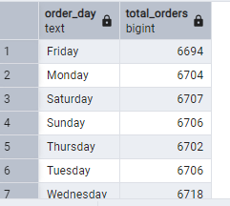

Q.2) Hourly state train for Total orders:

SELECT

EXTRACT(HOUR FROM order_time) as order_hours,

COUNT(DISTINCT "order_id") AS total_orders

FROM

pizza_sales

GROUP BY 1

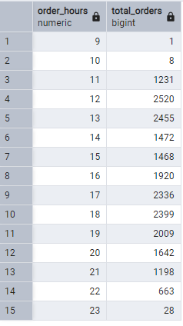

Q.3) percentage of sales by Pizza category:

SELECT pizza_category,

sum(total_price)*100/(select(sum(total_price)) FROM

pizza_sales) as Percentage_sale

FROM

pizza_sales

GROUP BY 1

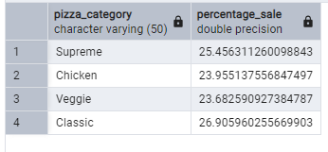

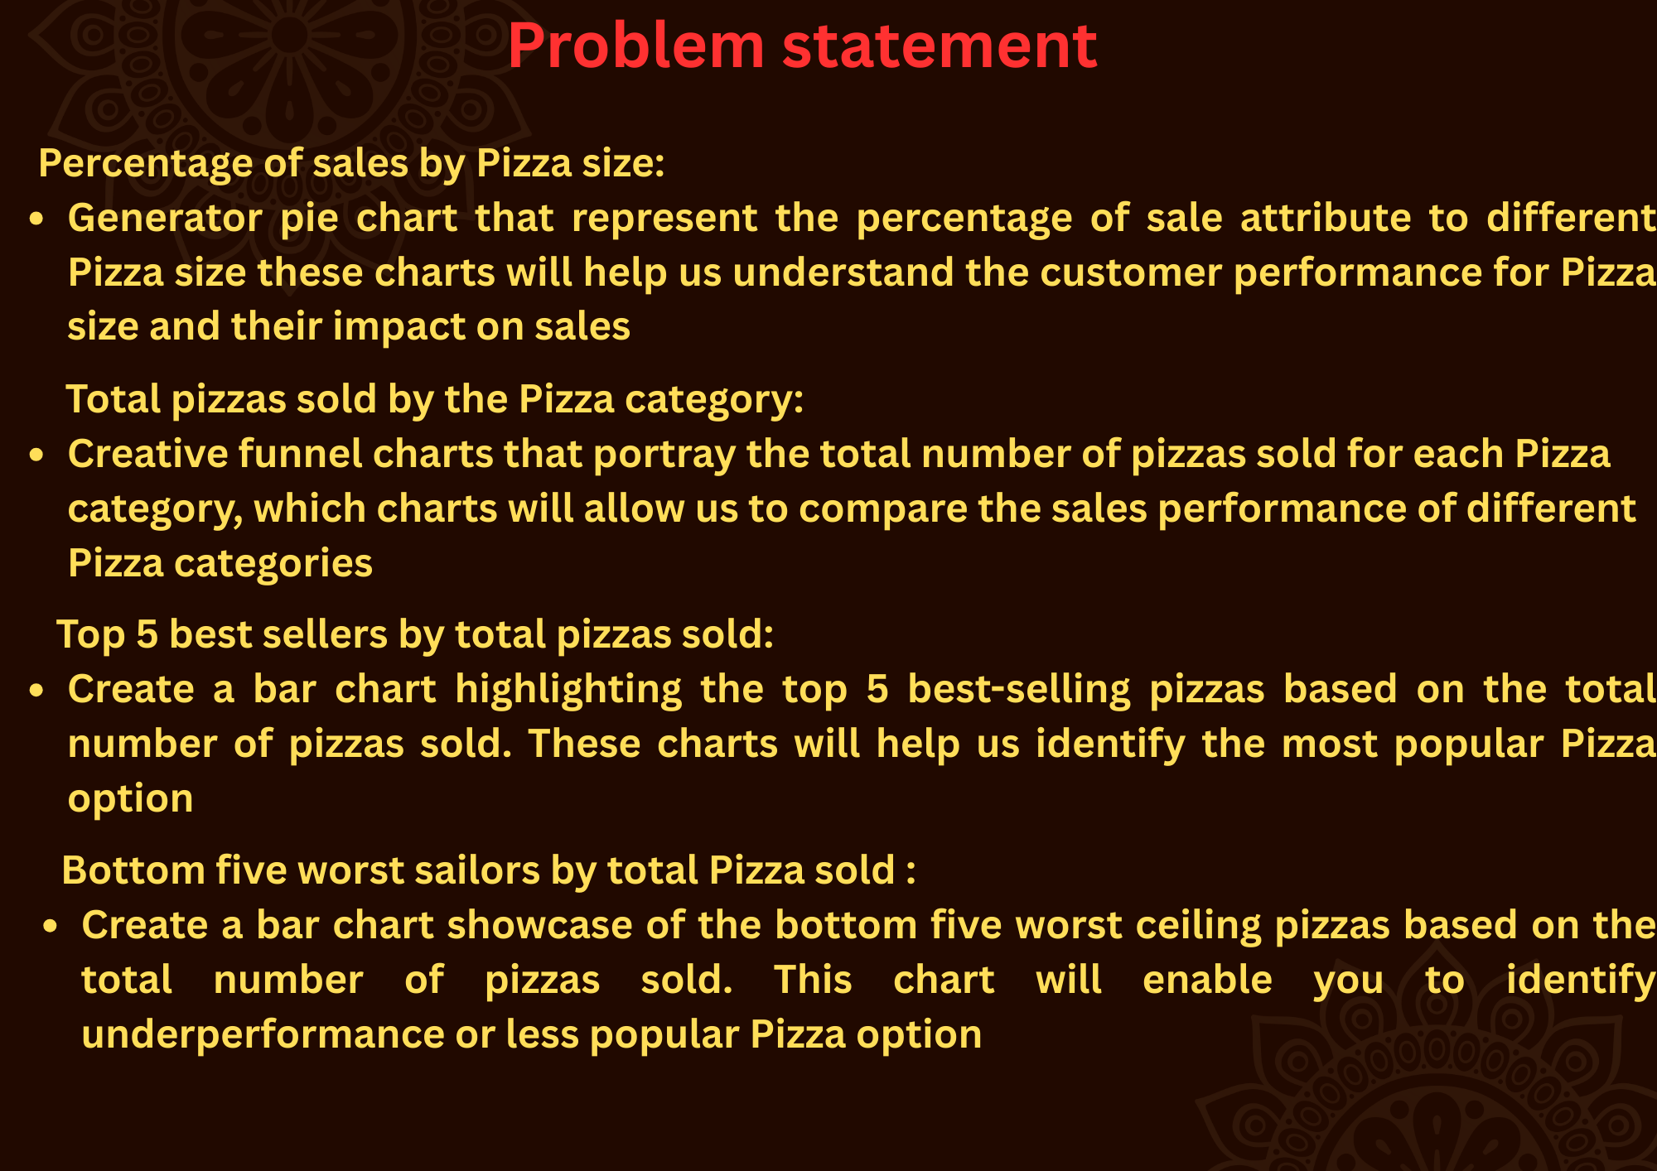

Q.4) percentage of sales by Pizza size:

SELECT pizza_size,

sum(total_price)*100/(select(sum(total_price)) FROM

pizza_sales) as Percentage_sale

FROM

pizza_sales

GROUP BY 1

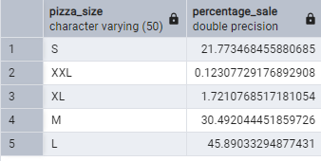

Q.5) --total Pizza sold by Pizza category

SELECT pizza_category,

sum(quantity) total_pizza_sold

FROM pizza_sales

GROUP BY 1

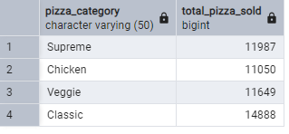

Q.6) Top 5 best seller by total Pizza sold

SELECT pizza_name,

sum(quantity) total_pizza_sold

FROM pizza_sales

GROUP BY 1

order by 2 desc

limit 5

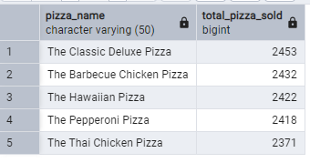

Q.7) bottom five worst sailors by total Pizza sold :

SELECT pizza_name,

sum(quantity) total_pizza_sold

FROM pizza_sales

GROUP BY 1

order by 2 asc

limit 5

