**Experiment:2**

**Arrays,loops and branching**

1.Find the biggest element in array

Code:

import java.util.*;

class BigInArray{

public static void main(String args[]){

Scanner obj = new Scanner(System.in);

int n= obj.nextInt();

int[] a=new int[n];

for(int i=0;i<n;i++){

a[i]=obj.nextInt();}

int b=a[0];

for(int i=0;i<n;i++){

if(a[i]>b){

b=a[i];}

}System.out.println("The largest element is:"+b);

}

}

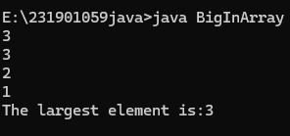

2. Find the sum of N elements

Code:

import java.util.*;

class SumOfN{

public static void main(String args[]){

Scanner obj=new Scanner(System.in);

int i=1,s=0;

int n=obj.nextInt();

while(i<n+1){

s=s+i;

i++;

}System.out.printf("The sum of first %d natural number is: %d",n,s);

}

}



3. Write a code using array which breaks the loop when the number is 5

Code:

public class BranchingStatements {

public static void main(String[] args) {

int[] numbers = {1, 2, 3, 4, 5, 6, 7, 8, 9, 10};

for (int num : numbers) {

if (num == 5) {

break; }

System.out.println(num);

}

}

}

