DATA ANALYYICS WITH TABLEAU

**SUPERMARKET SALES ANALYTICS REPORT**

ASSIGNMENT-1

1. SALES BY CUSTOMER TYPE

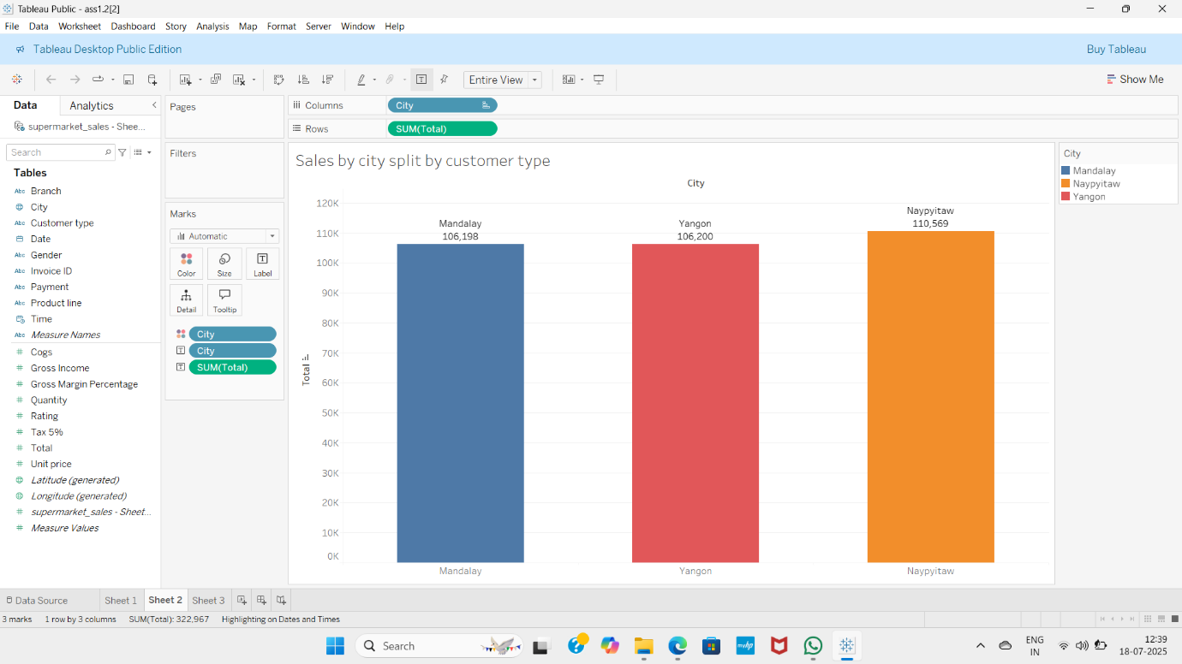

1. DISTRIBUTION OF PAYMENTS METHODS

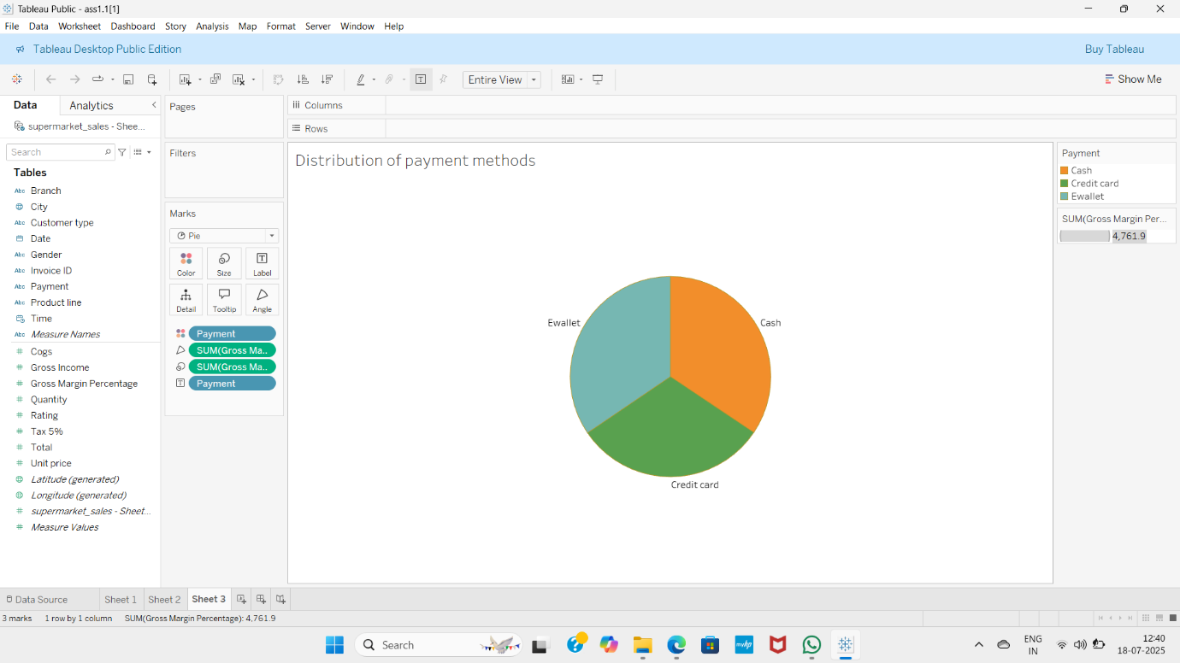

3. TOTAL SALES BY PRODUCT LINE

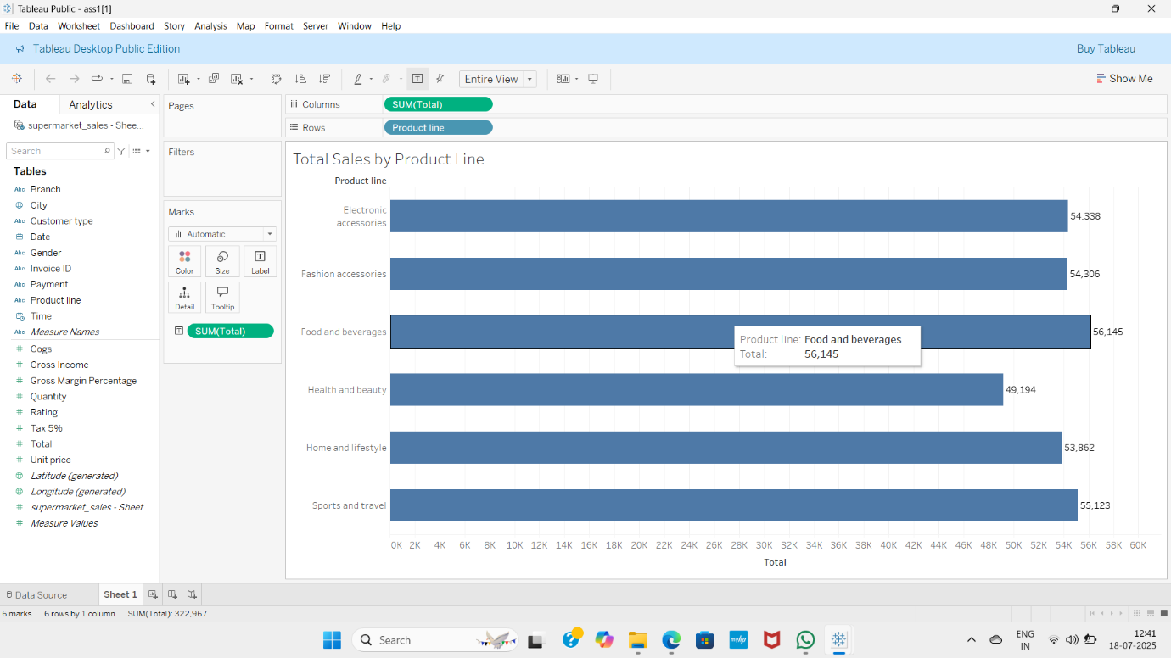

4.TOTAL SALES OVER TIME

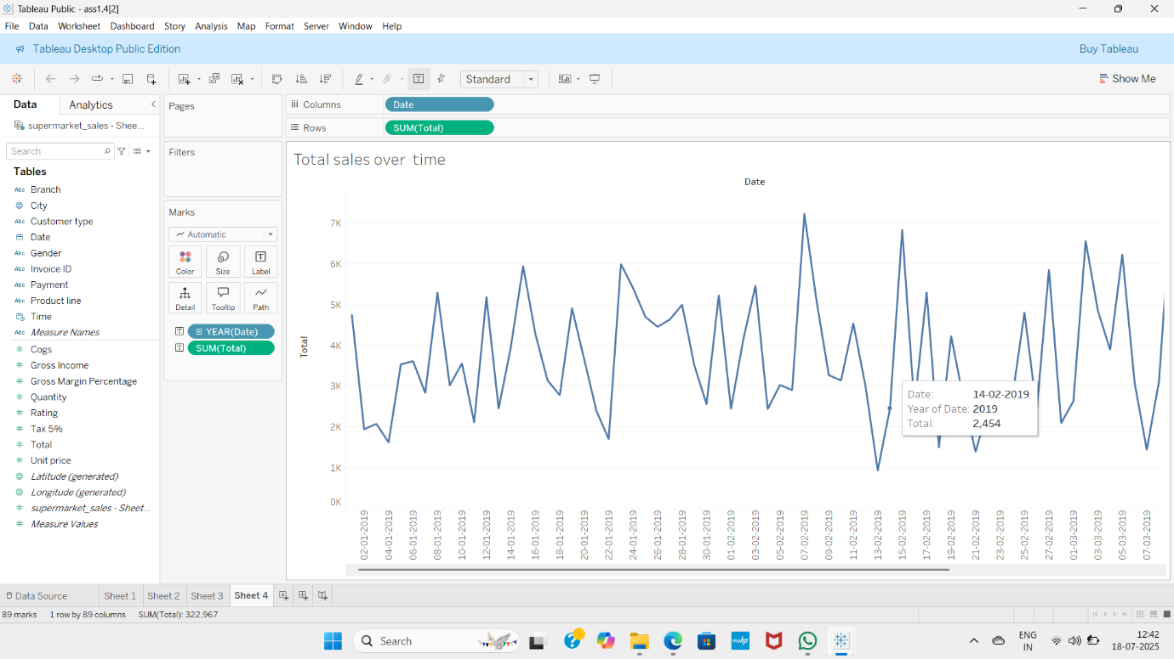

DATA ANALYTICS WITH TABLUEAU

**SUPERMARKET SALES ANALYTICS REPORT**

ASSIGNMENT-2

1.SALES BY PRODUCTLINE BY CITY

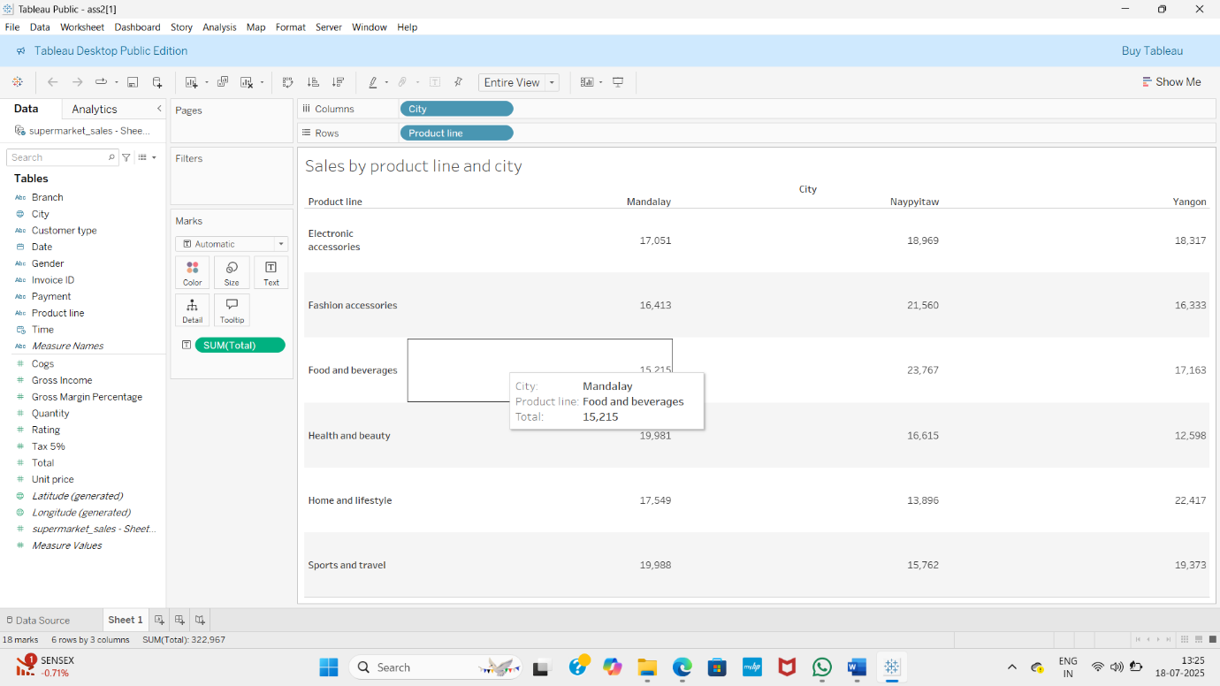

2.AVERAGE RATING BY BRANCH AND GENDER

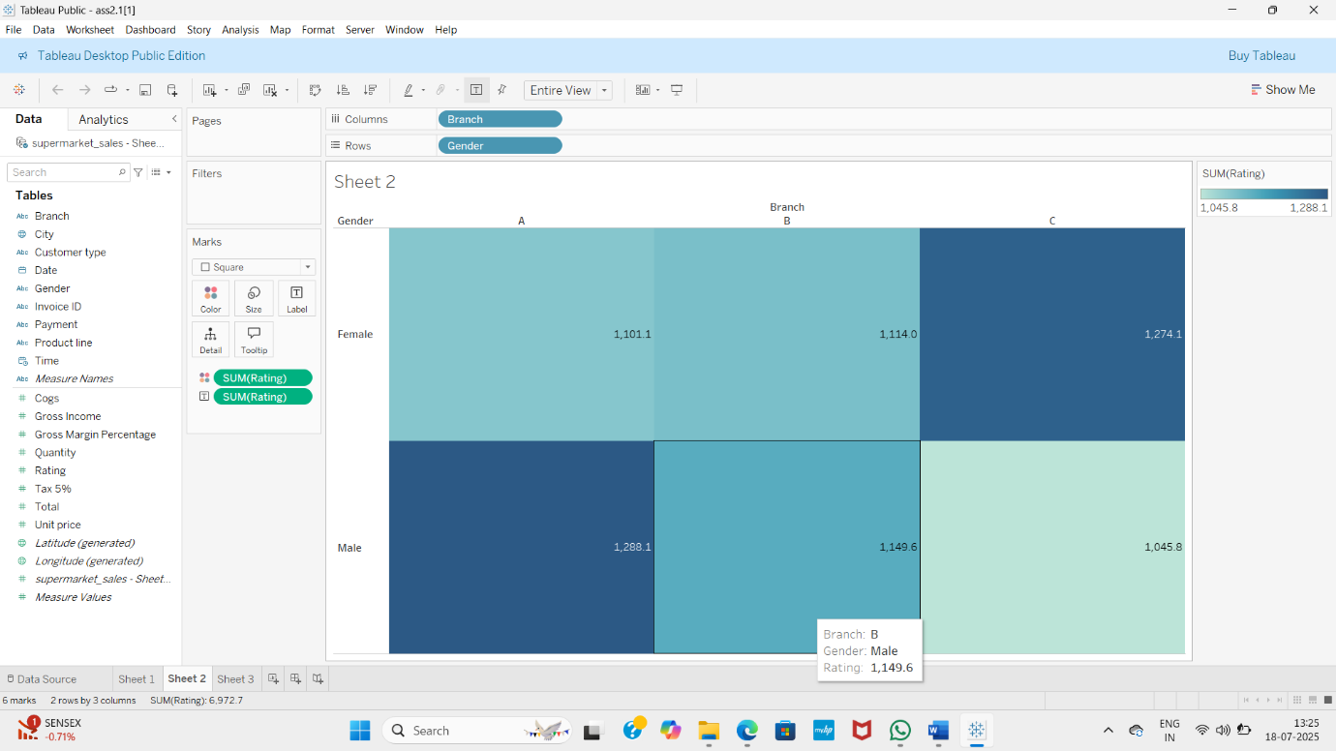

3.TOTAL SALES OVER TIME

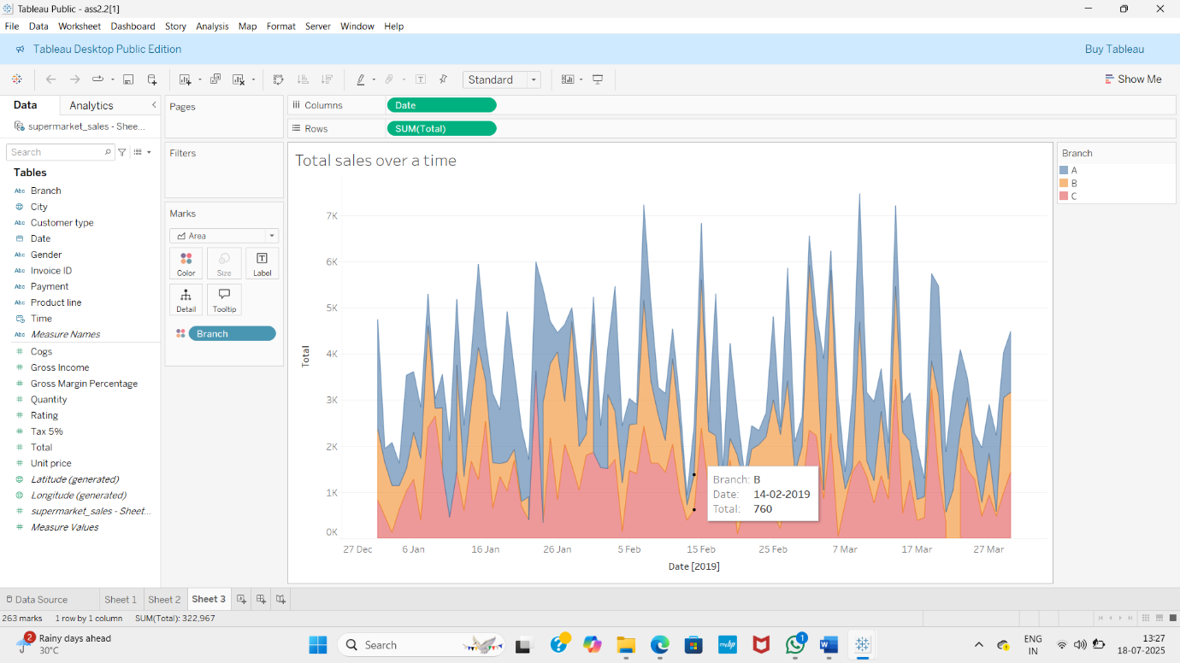

4.PRODUCT POPULARITY

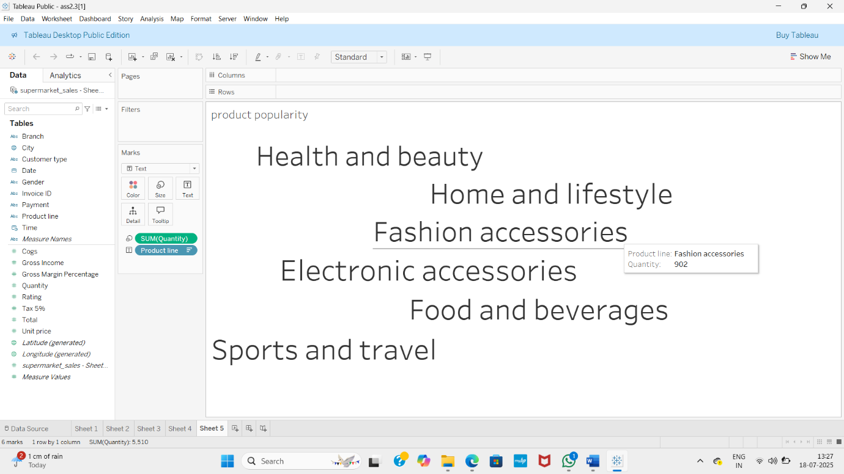

DATA ANALYTICS WITH TABLEAU

SUPERMARKET SALES ANALYTICS REPORT

ASSIGNMENT-3

1.DASHBOARD-1

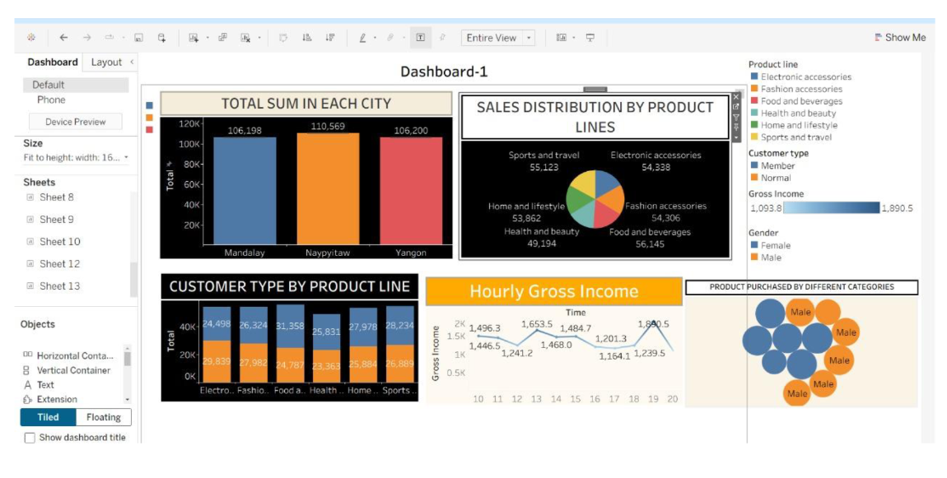

2.DASHBOARD-2

