**MULTIPLE CHOICE QUESTION**

**1 . 4**

**2. 1,2,3,4**

**3. 1**

**4. 3**

**5. 2**

**6. 2**

**7. 3,4,5**

**8. 4**

**9. 1**

**10. 4**

**11. 4**

**12. 1,2,4**

**13. 4**

**14. 2**

**15. 3**

**16. 1**

**17. 2**

**18. 2**

**19. 3**

**20. 4**

1. **Validation Rules (15 Marks)**
2. Only Admins should be allowed to change the account owner.

Error Message : "You are not authorised to transfer the account."  **(5 marks)**

Code:

|  |
| --- |
| AND($User.Id <> PRIORVALUE( OwnerId ), |
|  | $Profile.Name <> "System Administrator" , |
|  | ISCHANGED( OwnerId ) ) |
|  |  |

1. While closing the opportunity ( 'Closed Won') , an Opportunity Line Item should be present. If  opportunity line item is not present under a opportunity ,

it should give the error message "Opportunity Line Item should be present while closing the opportunity." **(10 Marks)**

code:

ISPICKVAL( StageName , "Closed Won") && (HasOpportunityLineItem = FALSE)

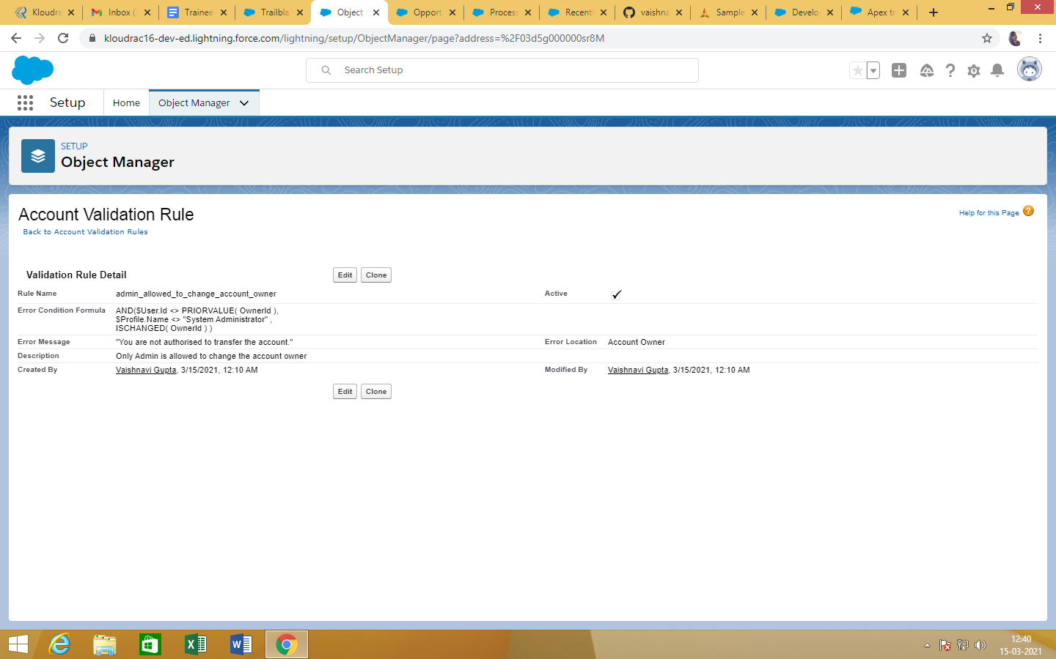

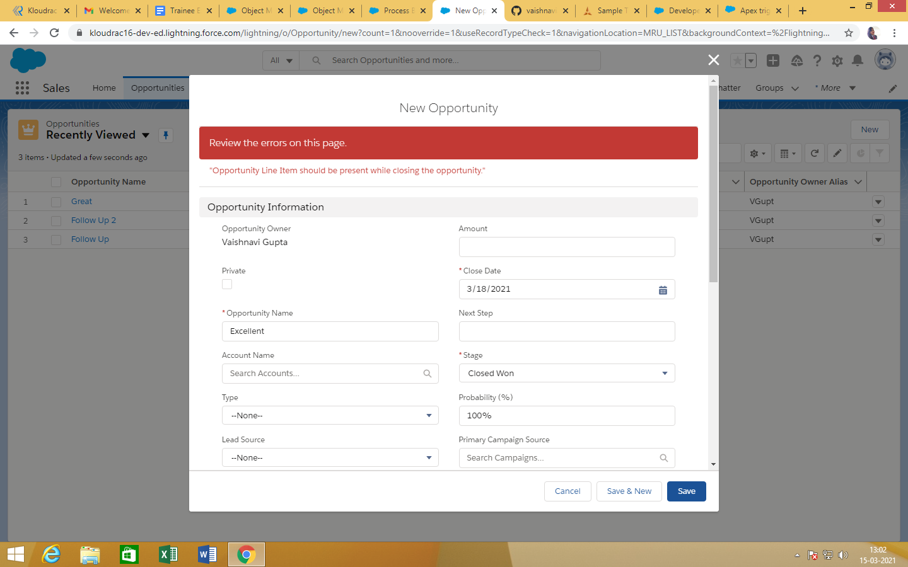

1. **Workflow Rule (5 Marks)**

If Amount > $10,000 send an email alert on opportunity **closed won (Stage field value)** to pgoyal@kloudrac.com and msharma@kloudrac.com

Email Template .

Subject : Deal closed Alert - $Amount - Opportunity Name

Opportunity Name :

Account Name :

Account Owner :

Amount :

Close Date :

Best Regards

Salesforce Team - Kloudrac

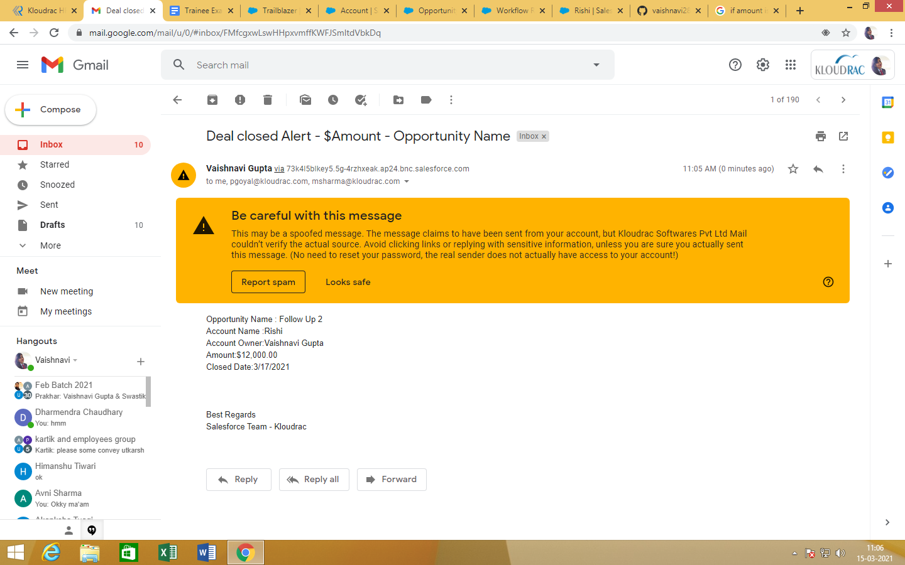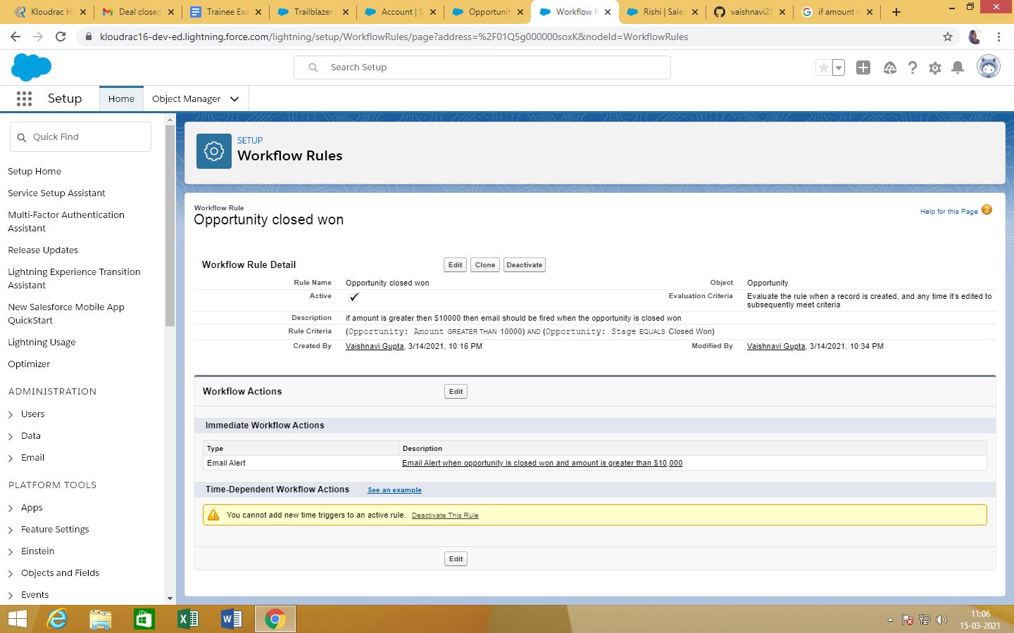

1. **Process Builder (10 Marks)**

Kloudrac Softwares would like to set up a process where an event will get created on opportunity creation and an automated approval will go to the opportunity owner's manager whenever discount > 20% on opportunity.

There is a field Discount, Approval Status on Opportunity.

Default value for Discount - "Approval Not Required".

When Discount is greater than your allowed matrix - "Approval Required"

When submitted for approval - "Approval Pending"

When Approved / Rejected - "Approved / Rejected”

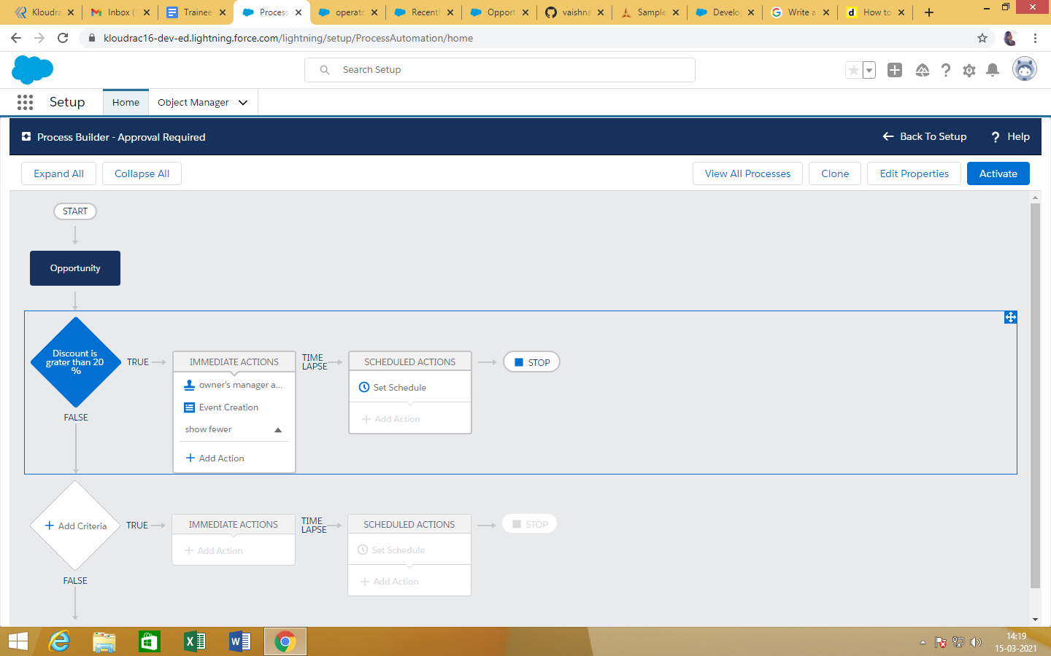

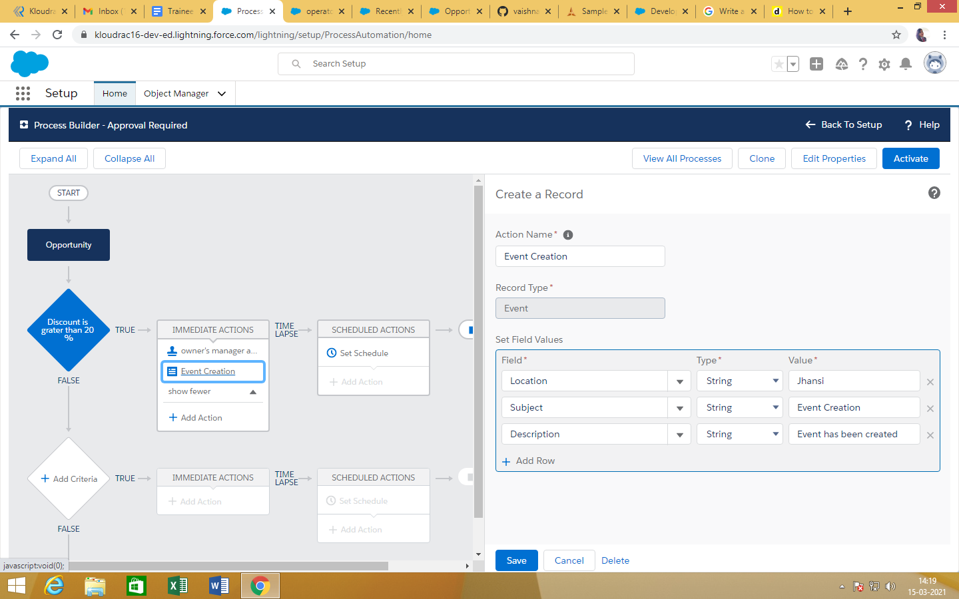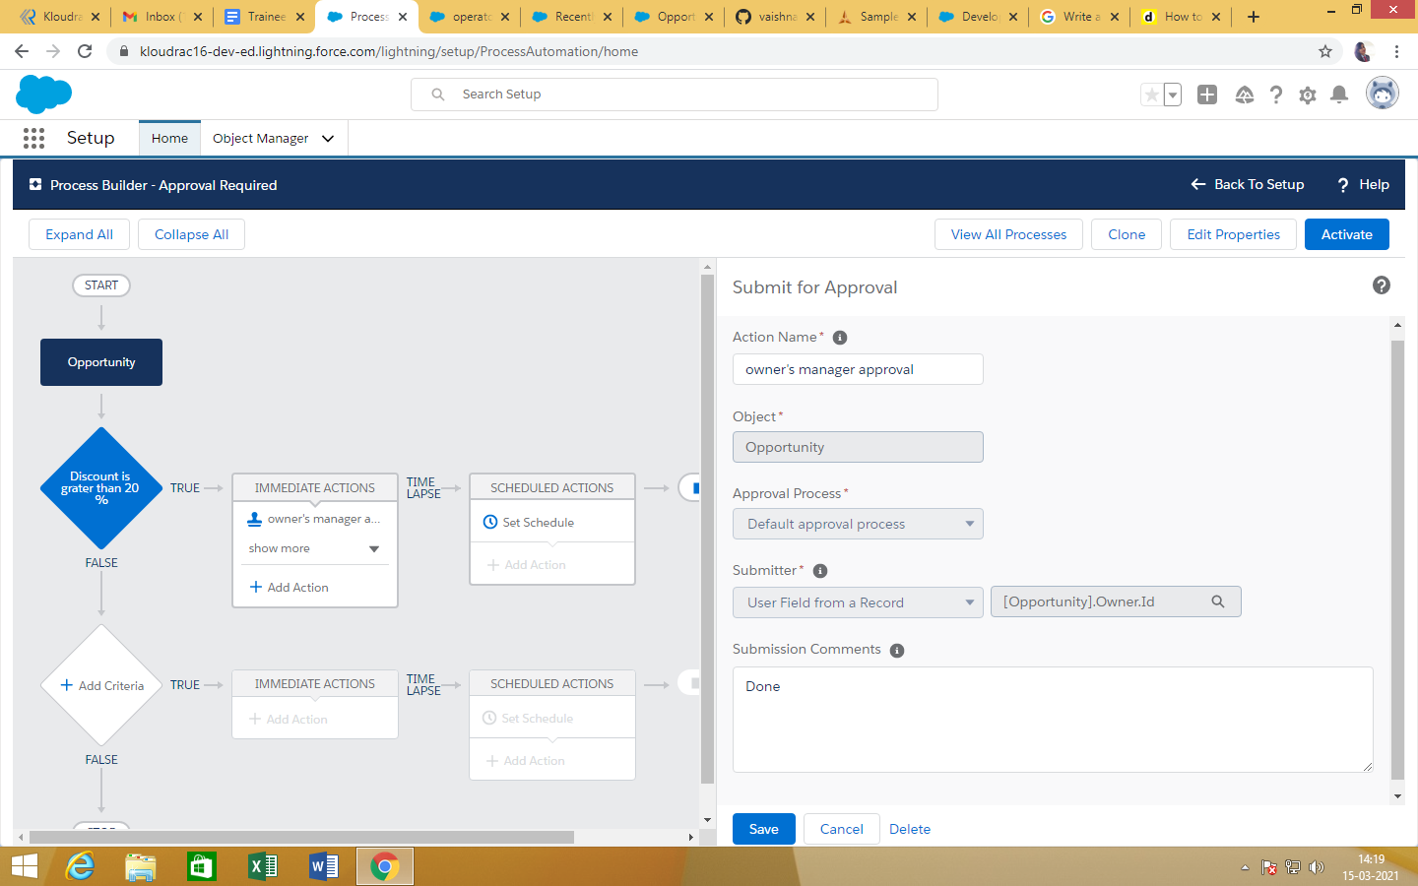

1. While creating a new Opportunity then starting 5 Products should get automatically added under this Opportunity. **(15 Marks)**

Code:

|  |
| --- |
| trigger TriggerProducts on Opportunity (after insert) { |
|  |  |
|  | String priceBookName = 'Standard' ; |
|  | List<String> productCodeList = new List<String>{'GC1040', 'IN7080', 'SL9040','GC3060', 'IN7060'}; |
|  | List<PricebookEntry> pbeList = [Select Product2.ProductCode, UnitPrice, Product2Id, priceBook2Id From PricebookEntry where Product2.ProductCode in :productCodeList and Pricebook2.Name = :priceBookName LIMIT 5 ]; |
|  |  |
|  | if(pbeList.size() > 0 ){ |
|  | ID priceBookID = pbeList[0].priceBook2Id; |
|  | List<OpportunityLineItem> oliList = new List<OpportunityLineItem>(); |
|  | for(Opportunity o: trigger.new){ |
|  | for(PricebookEntry pbe: pbeList){ |
|  | OpportunityLineItem oli = new OpportunityLineItem(); |
|  | oli.OpportunityId = o.id; |
|  | oli.PricebookEntryId = pbe.id; |
|  | oli.Quantity = 1; |
|  | oli.UnitPrice = pbe.UnitPrice; |
|  | oliList.add(oli); |
|  | } |
|  | } |
|  | insert oliList; |
|  |  |
|  | }// if(pbeList.size() > 0 ) |
|  |  |
|  | } |

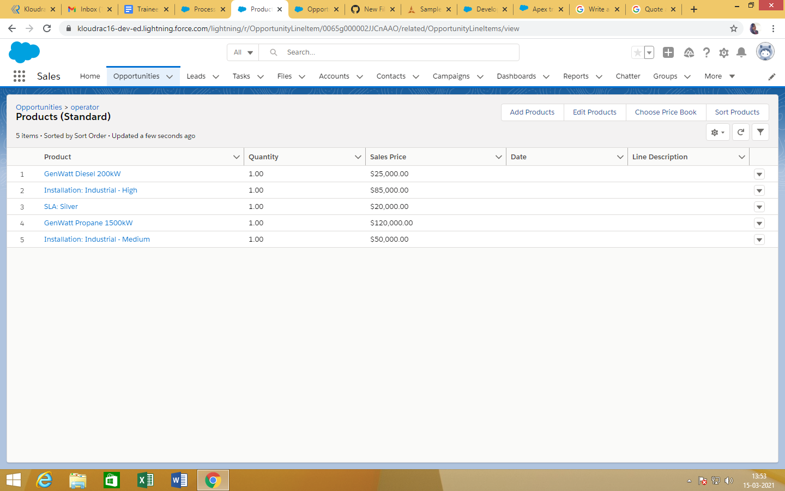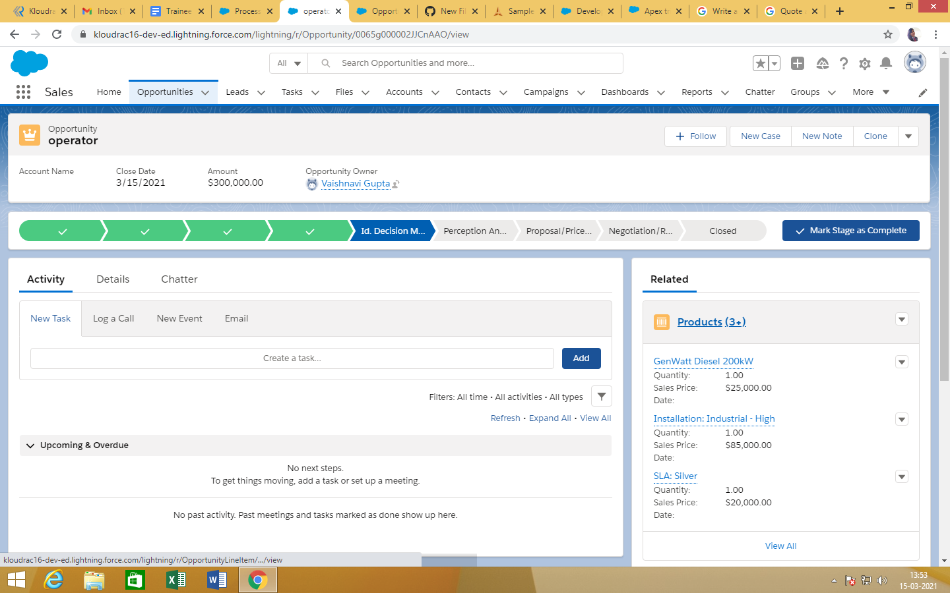

Question 3 :

Quote and Quote Line Item should get auto created while Opportunity revenue is greater than 100000

Code: