EXPERIMENT -3

3. Create a simple cloud software application for Property Buying & Rental process (In Chennai city) using any Cloud Service Provider to demonstrate SaaS.

AIM:
To Create a simple cloud software application for Property Buying & Rental process (In Chennai city) using any Cloud Service Provider to demonstrate SaaS.
PROCEDURE:
step1: Go to zoho.com.
step 2: Log into the zoho.com.
step 3: Select one application step.
step4: Enter application name as property buying & rental.
step 5: Created new application as property buying & rental.
step 6: Select one form
step 7: The software has been created.

IMPLEMENTATION:

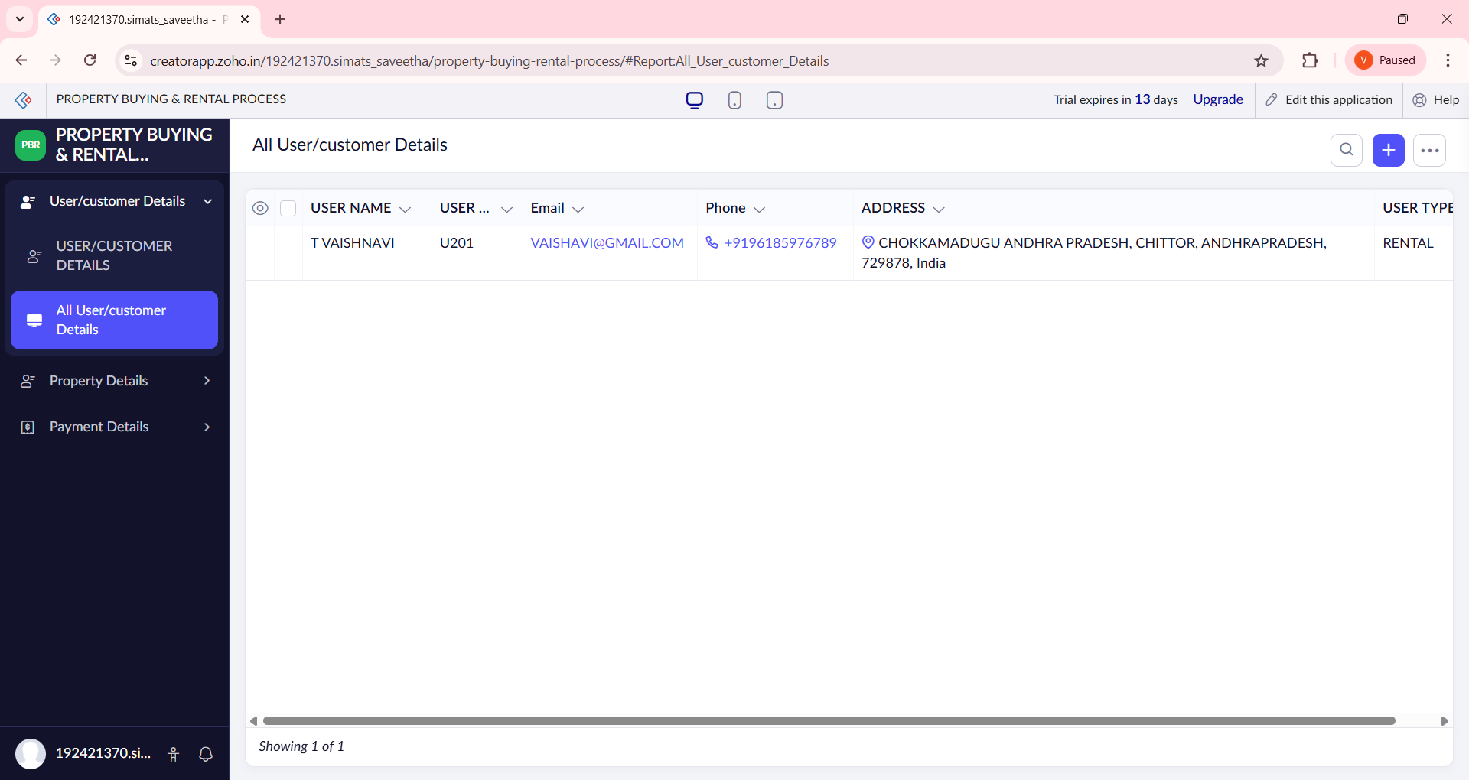

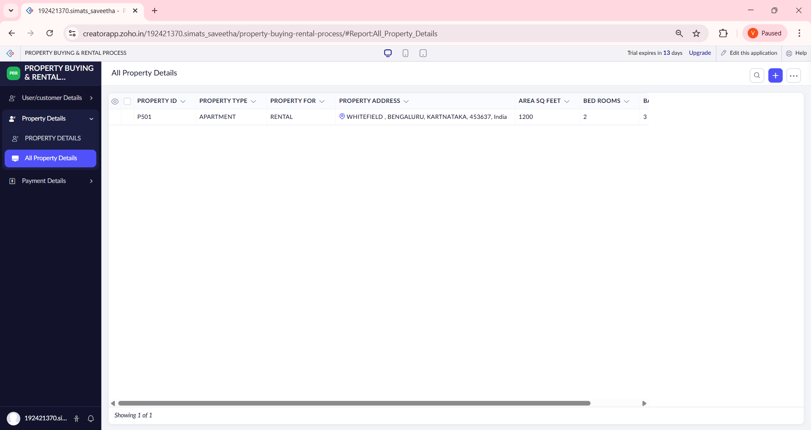

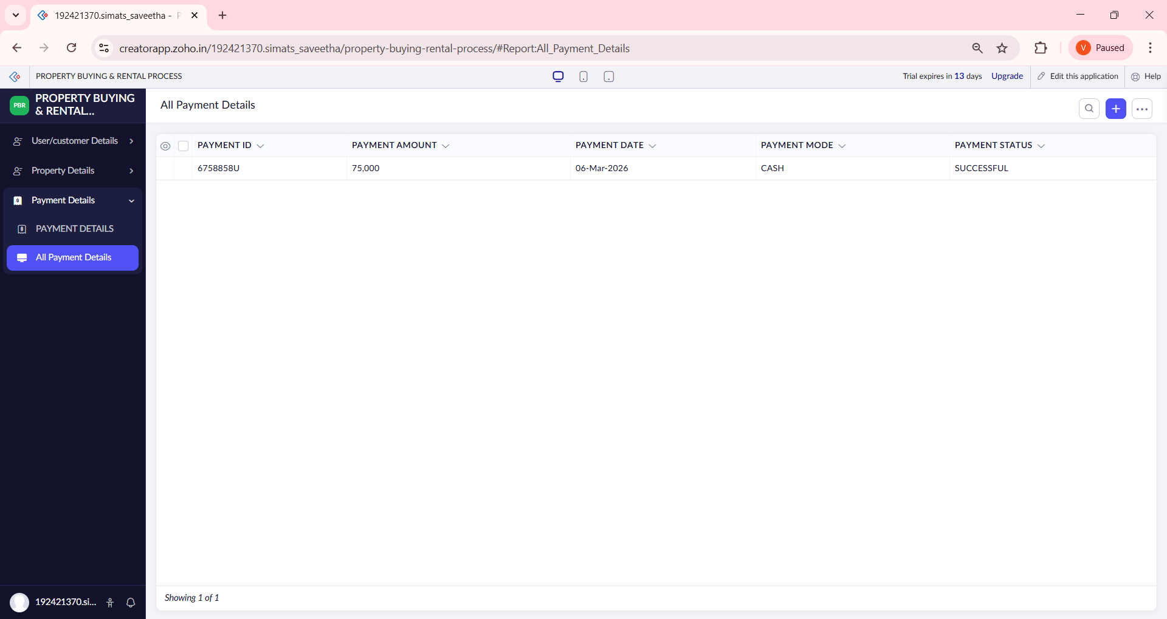

RESULT:
- The Property Buying & Rental Application for Chennai City was successfully created and deployed on the cloud.
- Users can:
  - Add property details (area, buy/rent, price)
  - View available properties instantly
- Property data is stored securely in the cloud database.
- The application is accessible from any device with internet.
- No software installation is required by users.
📌 Hence, the application successfully demonstrates Software as a Service (SaaS).

