Experiment – 22
Question: Create a Simple Web Application using Java or Python and host it in any Public Cloud Service
Provider (Azure/GCP/AWS) to demonstrate Platform as a Service (PaaS).
Answer:
AIM: To create a simple web application using Python and host it on Microsoft Azure App Service to demonstrate Platform as a Service (PaaS).
SOFTWARE REQUIRED:
- Microsoft Azure Account (Free Tier / Student Subscription)
- Python 3.x installed
- Code Editor (VS Code / Notepad++)
- Web Browser
- Azure Portal (https://portal.azure.com)
Procedure:
- Login to Azure Portal
- Click Create a Resource
- Select Web App
- Enter:
- Resource Group: PaaS-WebApp-RG
- Name: simple-python-app
- Runtime Stack: Python 3.x
- OS: Linux
- Pricing Tier: Free (F1)
Click Review + Create → Create

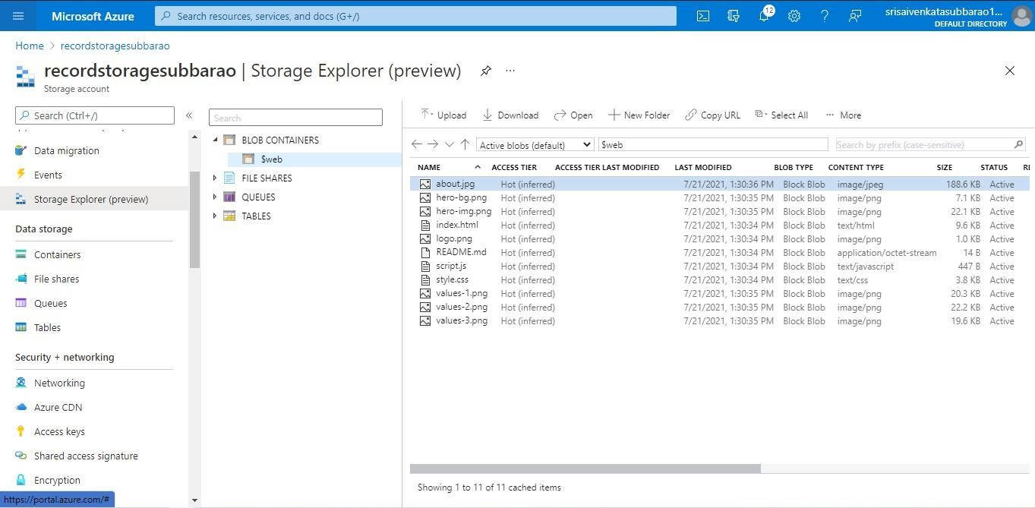

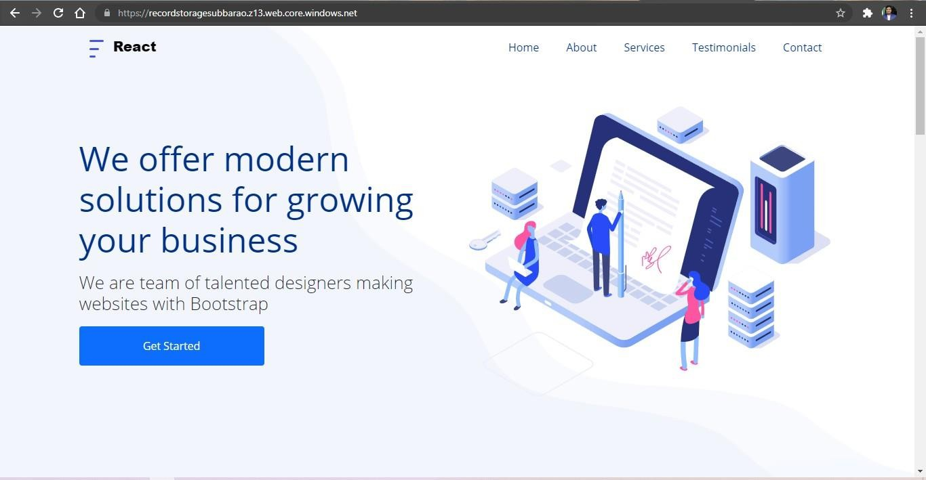

RESULT: The simple Python web application was successfully created and deployed using Microsoft Azure App Service.
Azure managed the platform (OS, runtime, scaling), while only the application code was deployed.
Thus, Platform as a Service (PaaS) was successfully demonstrated.

