Experiment – 6
Question:
Demonstrate virtualization by Installing Type-2 Hypervisor in your device, create and configure
VM image with a Host Operating system (Either Windows/Linux) using virtual box.
Answer:
AIM: To demonstrate virtualization by installing a Type-2 Hypervisor (VirtualBox) and creating a virtual machine (VM) with a host operating system (Windows/Linux).
SOFTWARE REQUIRED: VMware Workstation 17, Ubuntu ISO, Host OS: Windows
PROCEDURE:
Step 1: Install VirtualBox
- Download VirtualBox from the official website.
- Run the installer and follow the setup wizard to install it on your host machine.
Step 2: Launch VirtualBox
- Open VirtualBox from the Start Menu (Windows) or Applications (Linux).
Step 3: Create a New Virtual Machine
- Click “New”.
- Enter Name (e.g., UbuntuVM), Type (Linux/Windows), and Version (Ubuntu 64-bit / Windows 10 64-bit).
- Click Next.
Step 4: Allocate Memory (RAM)
- Choose the RAM size for the VM (minimum 2 GB for Ubuntu, 4 GB for Windows).
- Click Next.
Step 5: Create a Virtual Hard Disk
- Select Create a virtual hard disk now → VDI (VirtualBox Disk Image) → Dynamically allocated → specify size (minimum 20 GB).
- Click Create.
Step 6: Configure VM Settings
- Select the VM → Click Settings → Storage → Add the ISO file under Controller: IDE.
- Optionally, configure Network, Display, and Shared Folders.
Step 7: Start the Virtual Machine
- Click Start → VM will boot from the ISO.
- Follow the OS installation wizard to install the operating system on the VM.
Step 8: Complete Installation
- After installation, remove the ISO from storage settings.
- Restart the VM → OS is ready for use.




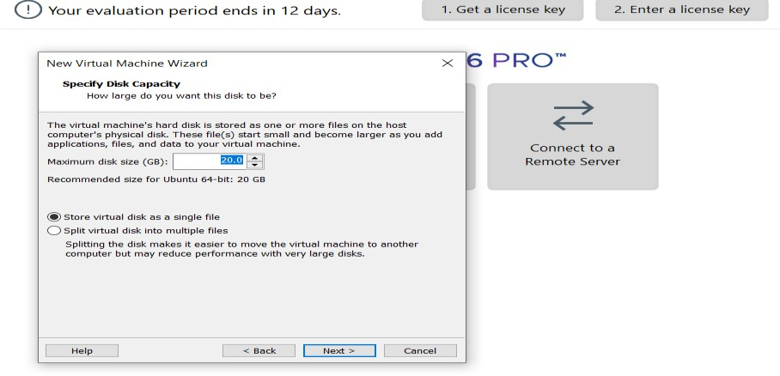
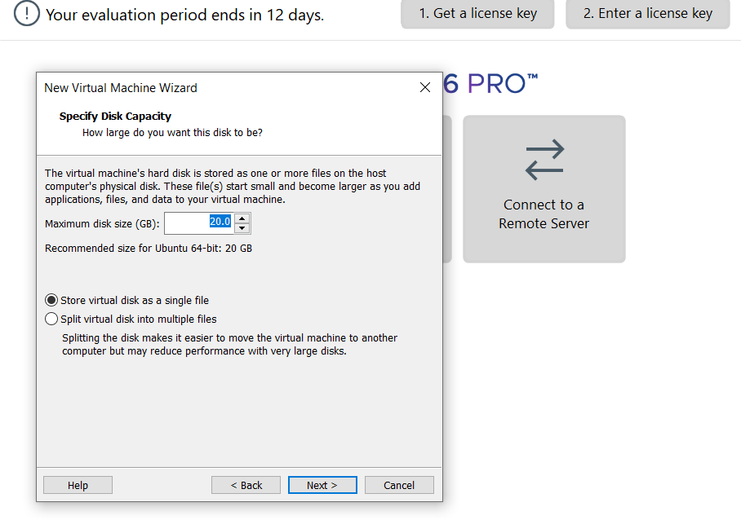

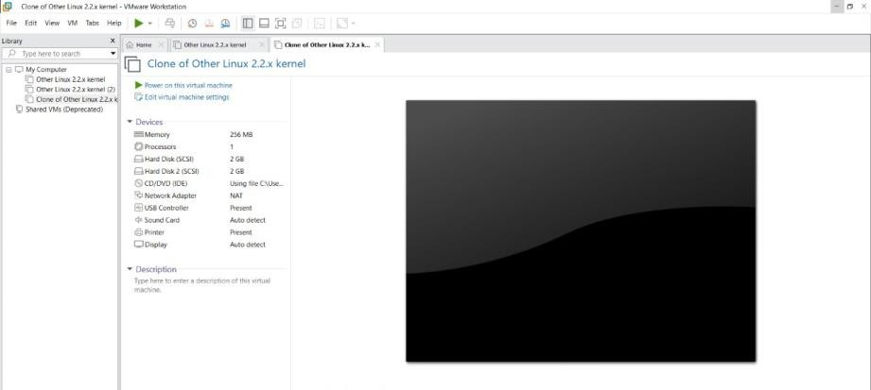

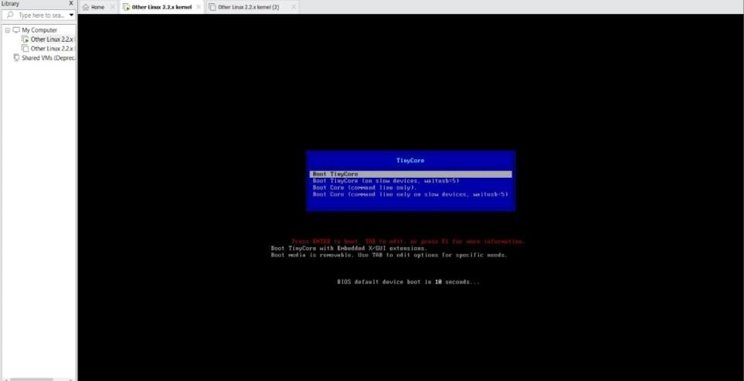

RESULT:
- A Type-2 hypervisor (VirtualBox) was successfully installed.
- A virtual machine with the desired operating system (Windows/Linux) was created and configured.
- The VM runs independently on the host system, demonstrating virtualization technology.

