Experiment – 7
Question:
Create a Virtual Machine with 1 CPU, 2GB RAM and 15GB storage disk using a Type 2
Virtualization Software, using virtual box.
Answer:
AIM: To create a Virtual Machine (VM) with 1 CPU, 2GB RAM, and 15GB storage using a Type-2 hypervisor (VirtualBox).
- SOFTWARE REQUIRED: Oracle VM VirtualBox (latest version) – Type-2 Hypervisor
- ISO image of the operating system (Windows/Linux)
- Host machine with minimum 4GB RAM and sufficient disk space
PROCEDURE:
Step 1: Install and Launch VirtualBox
- Download VirtualBox from VirtualBox.org.
- Install it and open the application.
Step 2: Create a New Virtual Machine
- Click “New”.
- Enter a Name for the VM (e.g., MyVM).
- Select Type (Linux/Windows) and Version (Ubuntu 64-bit / Windows 10 64-bit).
- Click Next.
Step 3: Allocate Memory (RAM)
- Set RAM to 2048 MB (2 GB).
- Click Next.
Step 4: Create a Virtual Hard Disk
- Select Create a virtual hard disk now → Click Create.
- Choose VDI (VirtualBox Disk Image) → Click Next.
- Select Dynamically allocated → Click Next.
- Set Size to 15 GB → Click Create.
Step 5: Configure CPU
- Select the VM → Click Settings → System → Processor tab.
- Set Processor(s) to 1 CPU → Click OK.
Step 6: Mount OS ISO
- Go to Settings → Storage → Controller: IDE → Empty → Click Disk Icon → Choose a disk file.
- Select the OS ISO image you want to install.
Step 7: Start the VM and Install OS
- Click Start → VM will boot from the ISO.
- Follow the operating system installation steps.
Step 8: Complete Installation
- After installation, unmount the ISO from storage settings.
- Restart VM → OS is ready to use.




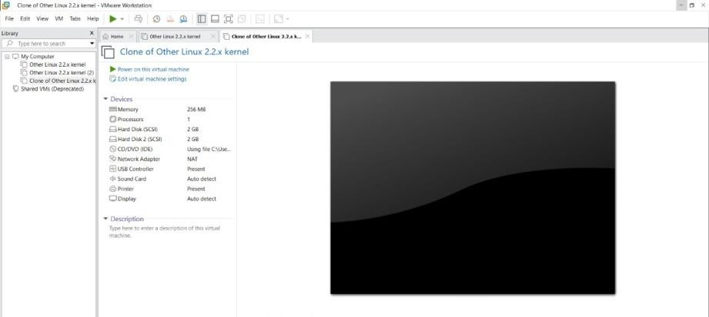

RESULT:
- A Virtual Machine was successfully created with:
  - 1 CPU, 2GB RAM, and 15GB storage.
- The VM runs the chosen operating system independently on the host system, demonstrating Type-2 virtualization.

