Experiment – 8
Question:
Create a Virtual Hard Disk and allocate the storage using virtual box.
Answer:
AIM: To create a virtual hard disk and allocate storage using VirtualBox for use in a Virtual Machine.
- SOFTWARE REQUIRED: VM VirtualBox (latest version) – Type-2 Hypervisor
- Host machine with sufficient disk space (at least 20GB recommended)

PROCEDURE:
Step 1: Open VirtualBox
- Launch Oracle VM VirtualBox on your host machine.
Step 2: Start Creating a Virtual Machine
- Click “New” to create a VM.
- Enter the Name, Type (Windows/Linux), and Version.
- Click Next.
Step 3: Allocate RAM
- Choose the desired memory size (e.g., 2 GB → 2048 MB) → Click Next.
Step 4: Create a Virtual Hard Disk
- Select “Create a virtual hard disk now” → Click Create.
Step 5: Choose Hard Disk Type
- Select VDI (VirtualBox Disk Image) → Click Next.
Step 6: Choose Storage on Physical Hard Disk
- Dynamically allocated: The virtual disk grows as needed up to the maximum size.
- Fixed size: Allocates the full disk size immediately.
- Click Next.
Step 7: Allocate Disk Size
- Set the disk size (e.g., 15GB, 20GB, etc.) → Click Create.
Step 8: Attach the Disk to VM (Optional)
- The virtual hard disk is automatically attached to the new VM.
- You can view or modify it in Settings → Storage → Controller: SATA/IDE.



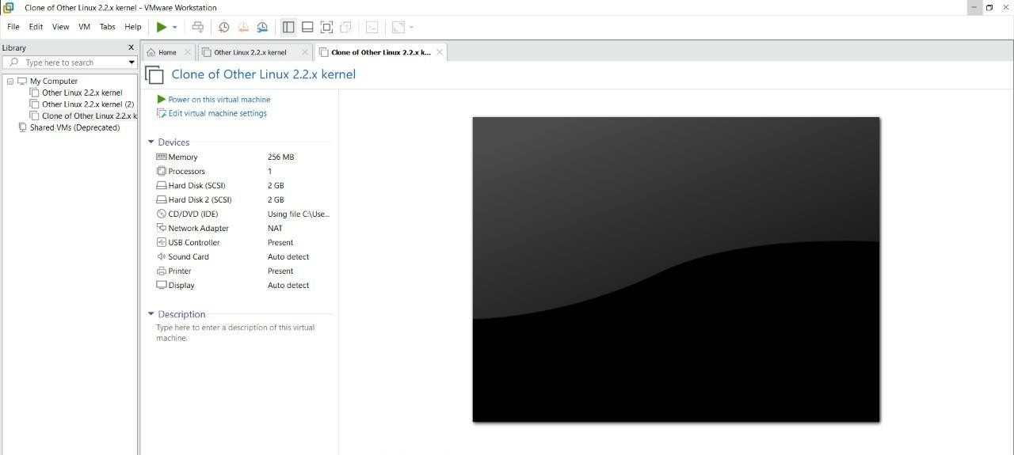

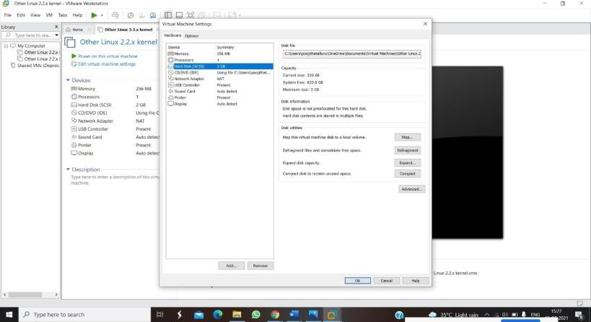
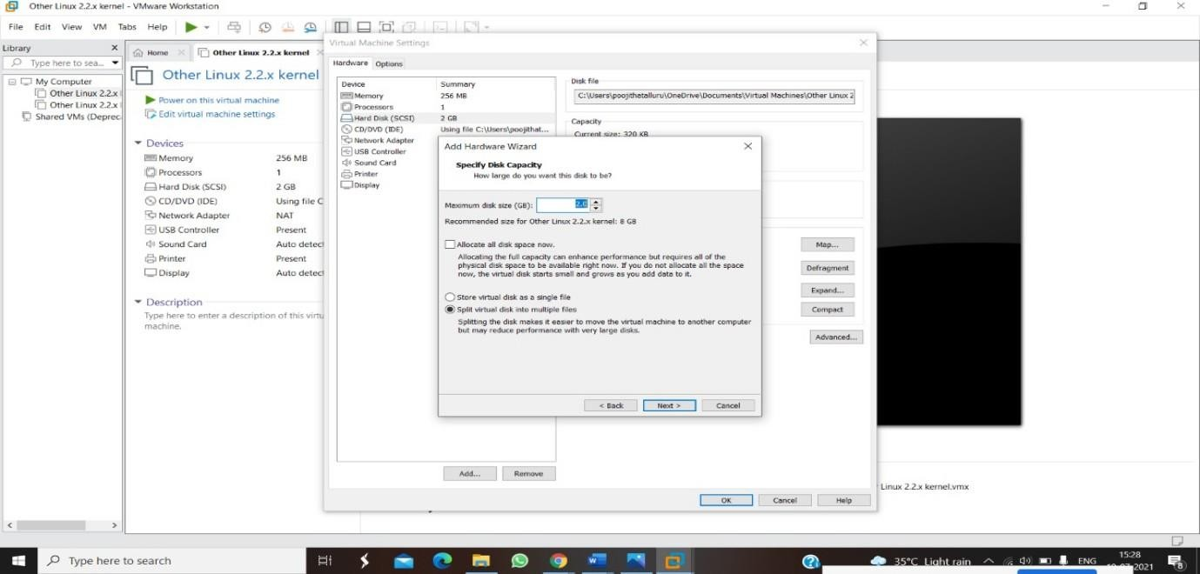

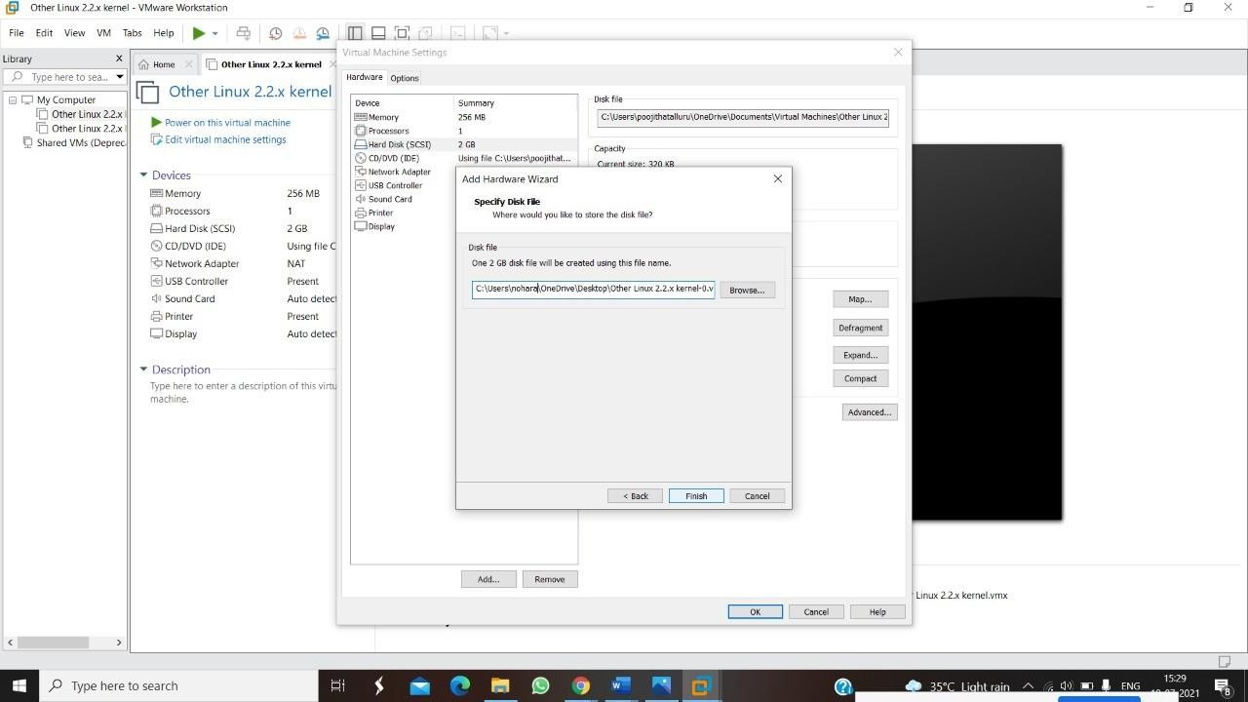

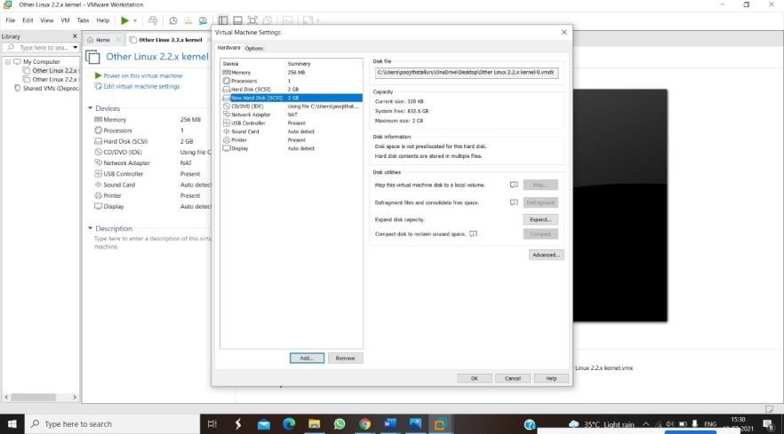

RESULT:
- A virtual hard disk was successfully created in VirtualBox.
- Storage was allocated as per the chosen size.
- The virtual hard disk is ready to install an operating system or store data within the Virtual Machine.

