Experiment – 10
Question:
Create a Cloning of a VM and Test it by loading the Previous Version/Cloned VM using virtual
box.
Answer:
AIM: To create a clone of a virtual machine and test it by loading the cloned VM using VirtualBox.
SOFTWARE REQUIRED:
• Oracle VM VirtualBox (Type-2 Hypervisor)
• An existing Virtual Machine (Windows/Linux)
• Host system with sufficient RAM and disk space
PROCEDURE:
Step 1: Launch VirtualBox
- Open Oracle VM VirtualBox on the host system.
Step 2: Select the Virtual Machine to Clone
- From the VM list, select the existing virtual machine.
- Ensure the VM is in Powered Off state.
Step 3: Start Cloning Process
- Right-click the selected VM → Click Clone.
(Or go to Machine → Clone)
Step 4: Choose Clone Name and Mode
- Enter a New Name for the cloned VM (e.g., Ubuntu_Clone).
- Select Clone Type:
  - Full Clone (Independent copy)
  - Linked Clone (Depends on original VM)
- Select Clone Mode:
  - Current machine state
  - Everything
- Click Next → Finish.
Step 5: Verify the Cloned VM
- After cloning, the new VM appears in the VM list.
Step 6: Start the Cloned VM
- Select the cloned VM → Click Start.
- Verify that the OS loads successfully and operates independently (in case of full clone).




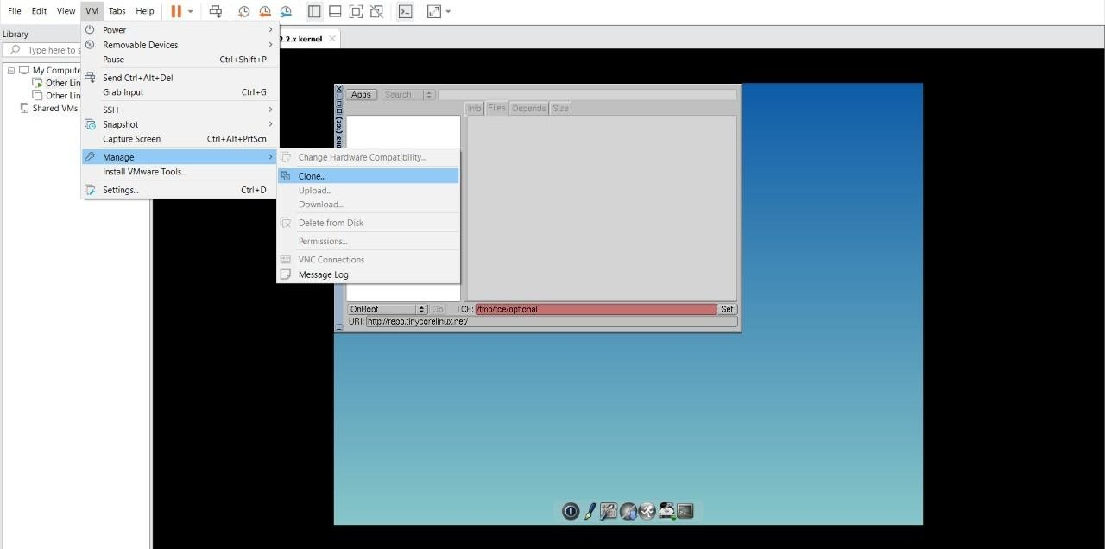

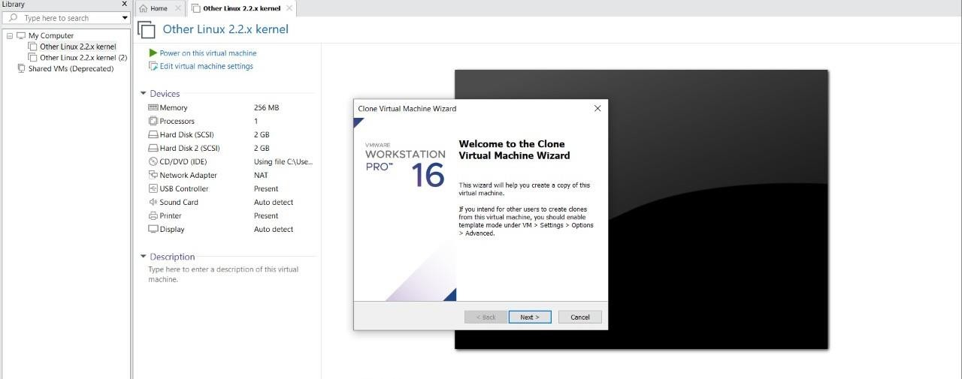
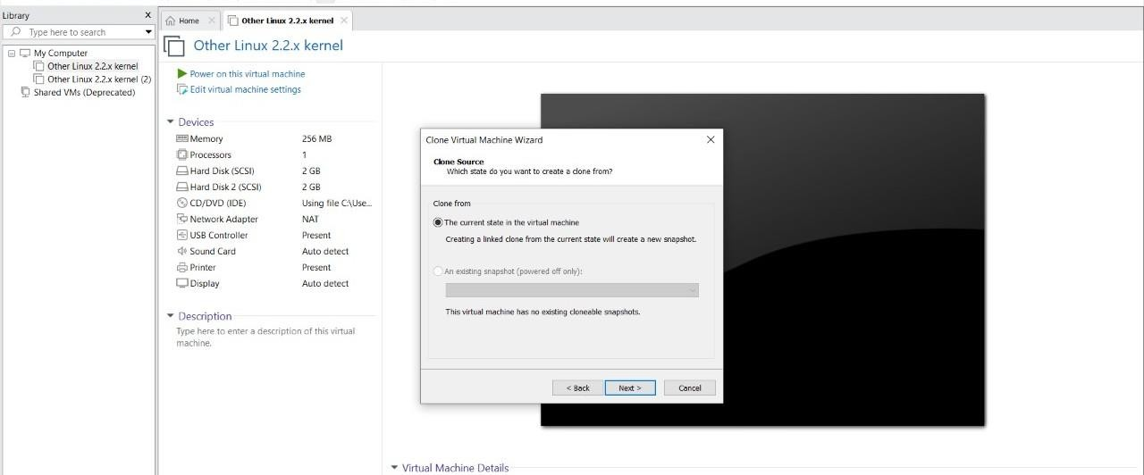
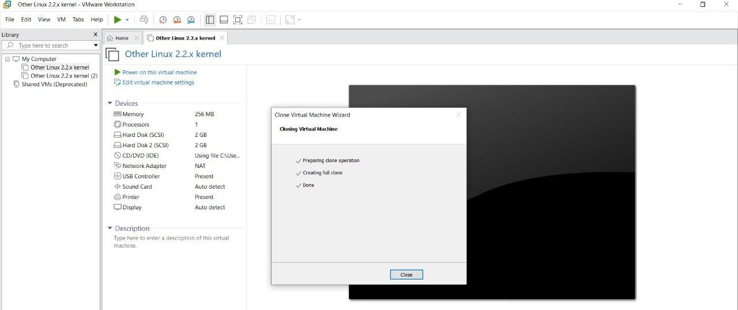
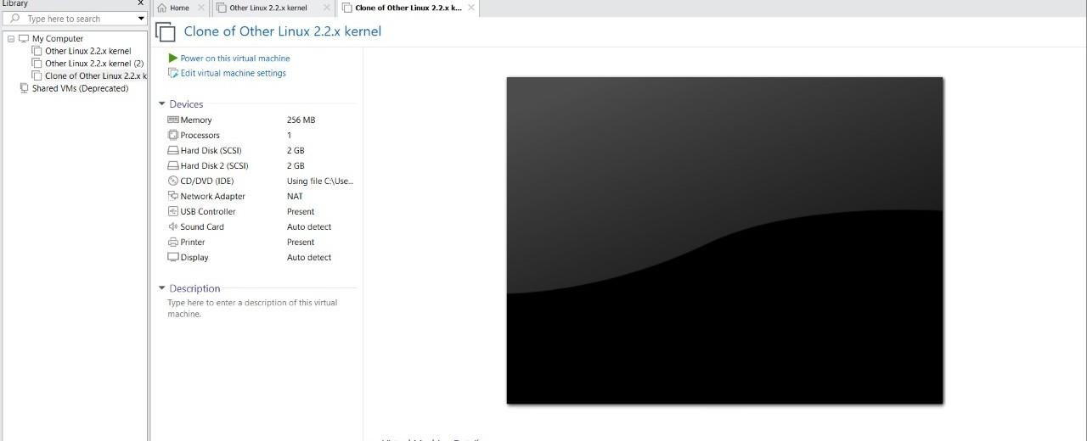

RESULT:
• The virtual machine was successfully cloned using VirtualBox.
• The cloned VM was started and tested successfully.
• The cloned VM operates independently (Full Clone) or dependently (Linked Clone) based on the selected option.

