Experiment – 9
Question:
Create a Snapshot of a VM and Test it by loading the Previous Version/Cloned VM using virtual
Answer:
AIM: To create a snapshot of a virtual machine and test it by restoring the previous version using VirtualBox.
SOFTWARE REQUIRED:
- Oracle VM VirtualBox (Type-2 Hypervisor)
- A configured Virtual Machine with Windows or Linux OS
- Host system with sufficient RAM and disk space
PROCEDURE:
Step 1: Launch VirtualBox
- Open Oracle VM VirtualBox on the host system.
Step 2: Select the Virtual Machine
- Choose the already created and installed VM from the VM list.
- Ensure the VM is in Powered Off or Running state.
Step 3: Create a Snapshot
- Click Machine → Take Snapshot (or right-click VM → Snapshots → Take).
- Enter Snapshot Name (e.g., Initial_State).
- Add a short description (optional).
- Click OK to save the snapshot.
Step 4: Modify the Virtual Machine
- Start the VM.
- Make changes such as installing software, creating files, or changing settings.
- Shut down the VM.
Step 5: Restore the Previous Snapshot
- Select the VM → Click Snapshots.
- Choose the previously created snapshot.
- Click Restore Snapshot → Confirm.
Step 6: Start the VM
- Start the VM after restoration.
- Observe that the VM returns to its earlier state.



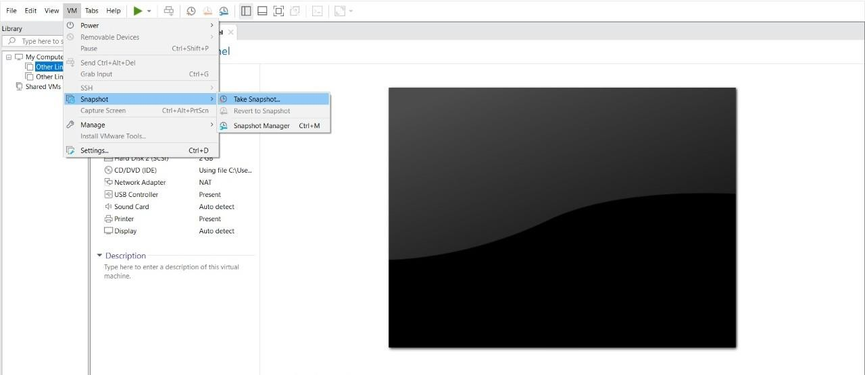
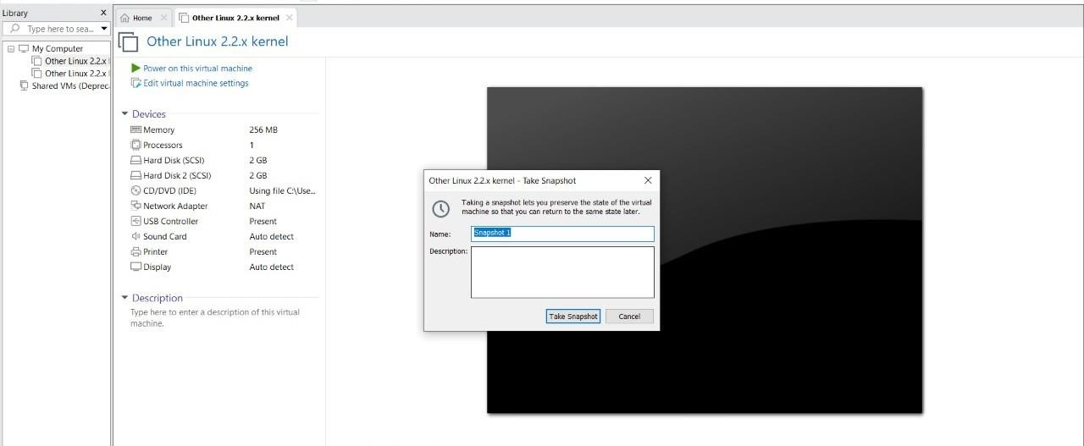
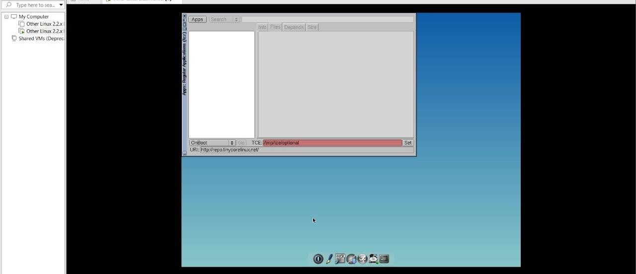

RESULT:
• A snapshot of the virtual machine was successfully created.
• After making changes, the VM was restored to the previous versionusing the snapshot.
• This confirms that snapshots allow recovery and testing of VM states in VirtualBox.

