Experiment – 11
Question:
Change Hardware compatibility of a VM (Either by clone/create new one) which is already
created and configured, using virtual box.
Answer:
AIM: To change the hardware compatibility of an already created and configured virtual machine using VirtualBox by cloning or creating a new VM.
SOFTWARE REQUIRED:
• Oracle VM VirtualBox (Type-2 Hypervisor)
• An existing Virtual Machine (Windows/Linux)
• Host system with sufficient RAM and disk space
PROCEDURE:
Method 1: Change Hardware Compatibility by Cloning the VM

Step 1: Open VirtualBox
Launch Oracle VM VirtualBox on the host system.
Step 2: Power Off the Virtual Machine
Select the existing VM and ensure it is in Powered Off state.
Step 3: Clone the Virtual Machine
Right-click the VM → Click Clone.

Enter a new Name for the cloned VM.
Step 4: Select Clone Options
Choose Full Clone.
Select Everything as the clone mode.
Click Finish.
Step 5: Modify Hardware Settings
Select the cloned VM → Click Settings.
Change required hardware compatibility options such as:
System → Processor (CPU count)
System → Motherboard (RAM, chipset, boot order)
Display → Video Memory
Storage → Controller type (IDE/SATA/NVMe)
Click OK.
Step 6: Start the Modified VM
Start the cloned VM and verify it runs correctly.



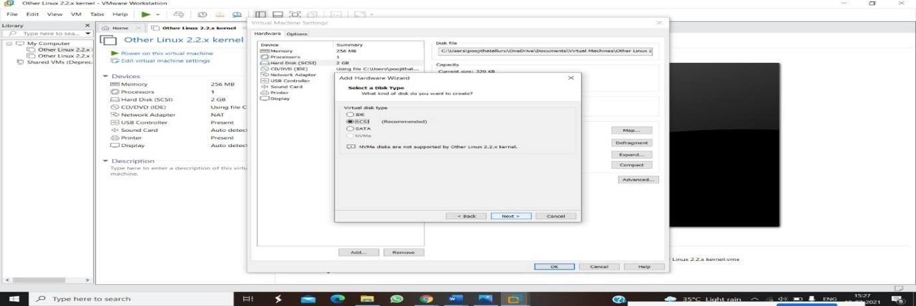
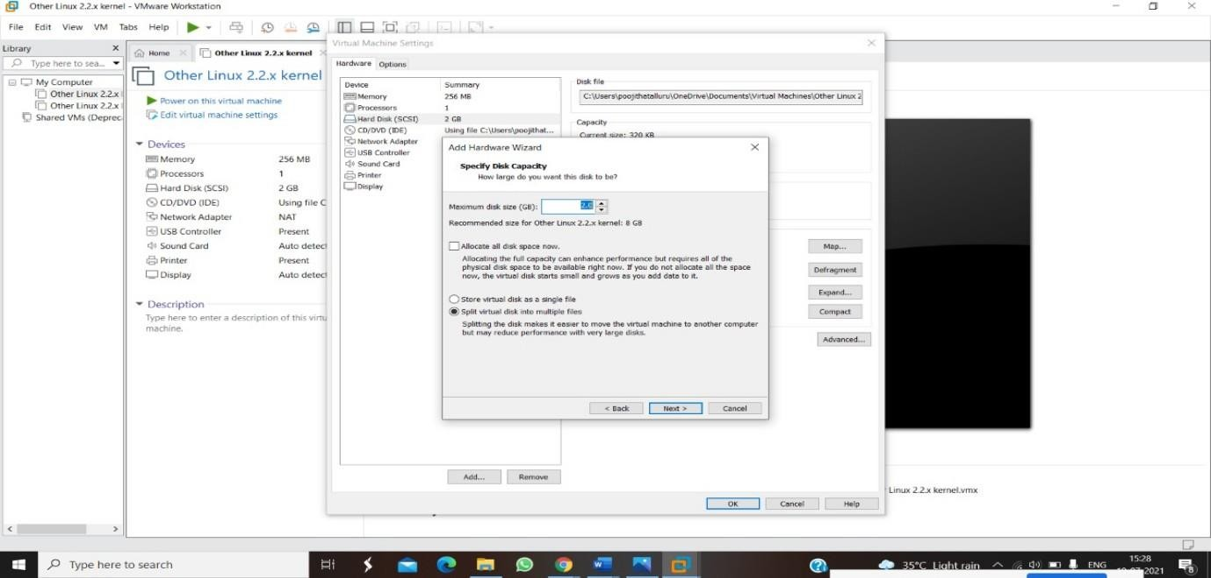

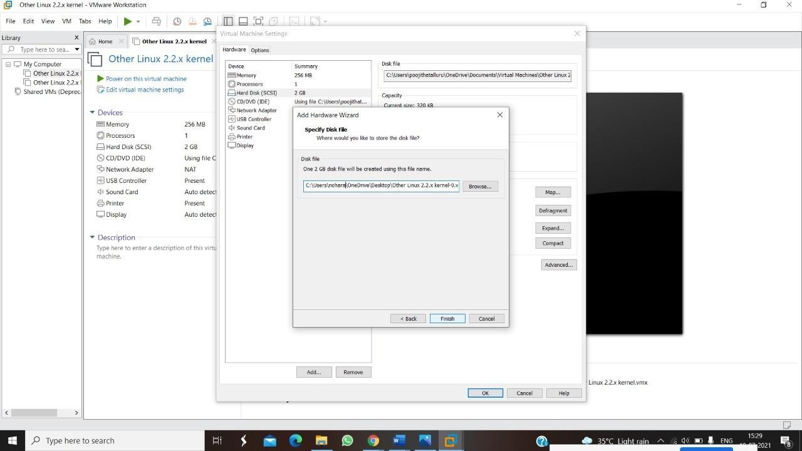

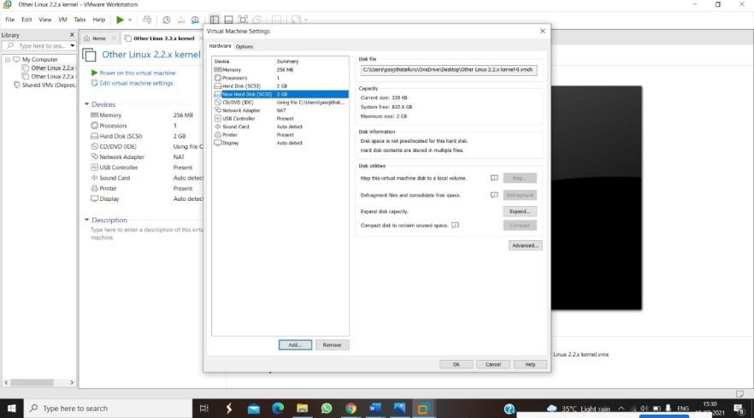

RESULT:
• Hardware compatibility of the virtual machine was successfully changed using cloning or by creating a new VM.
• The modified VM booted successfully with updated hardware configuration.
• This demonstrates flexibility in VirtualBox hardware compatibility management.

